The North East Teen Book Award
‘Getting and keeping, young people reading’.

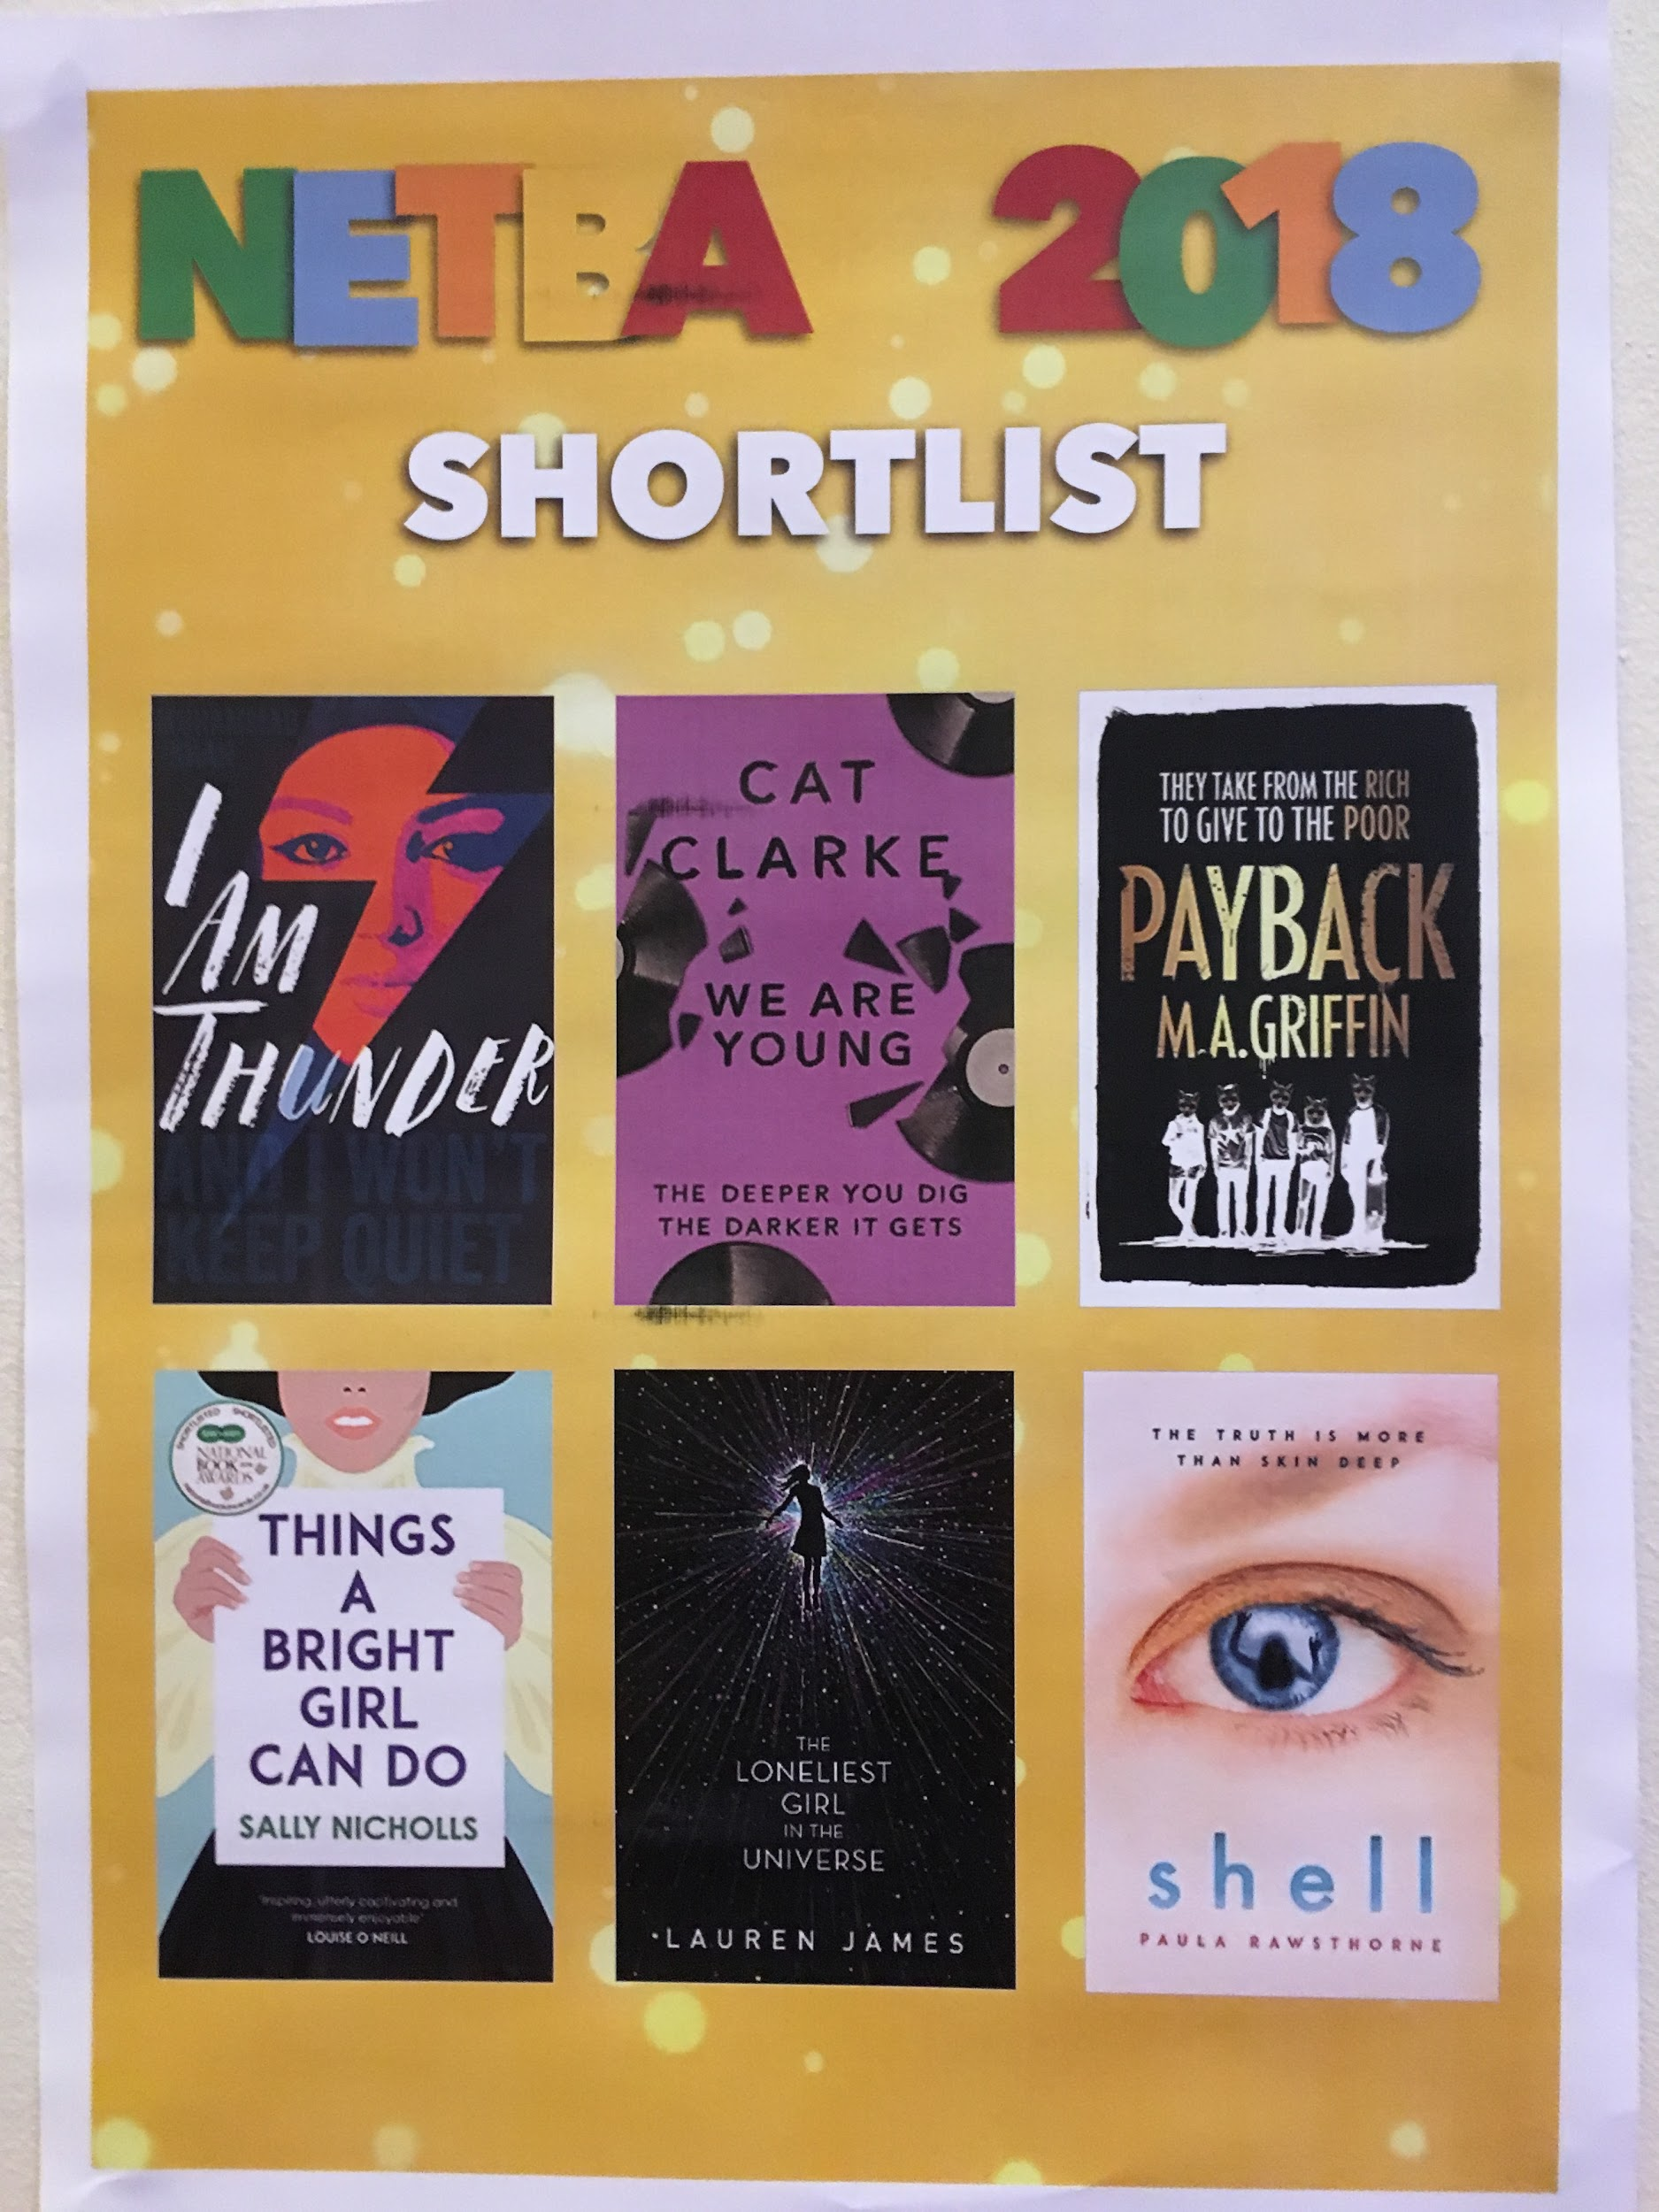

It was NETBA’s twentieth birthday on March 11th and we had a splendid anniversary celebration at the Centre for Life.
Two senior students from Thorp Academy presented their recollections of past NETBAs, and Seven Stories provided an excellent array of titles from which our students could select prizes – recompense for all their hard work over the past four months.
Book Club was invited to present two of the shortlisted authors, Martin Griffin and Sally Nicholls, and we were proud to see a very large proportion of our own work on the six enormous posters displayed around the walls, one poster for each book. Authors take these home as souvenirs of the awards ceremony and we hope they’ll find our comments uplifting when they’re struggling with a particularly tricky bit of plot!

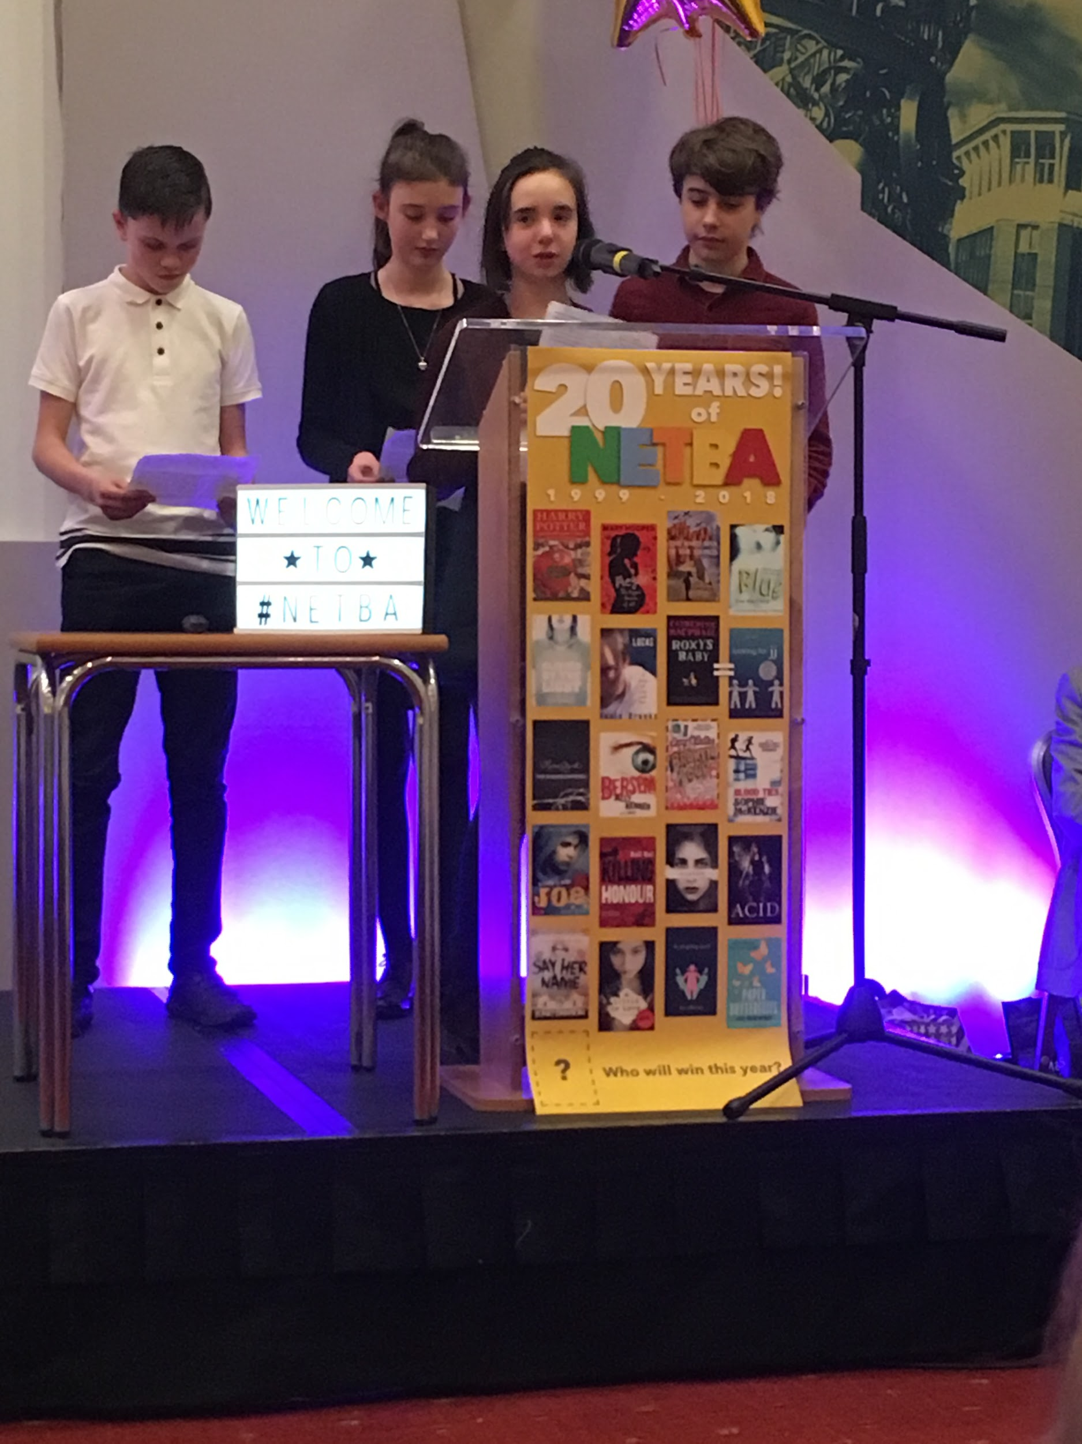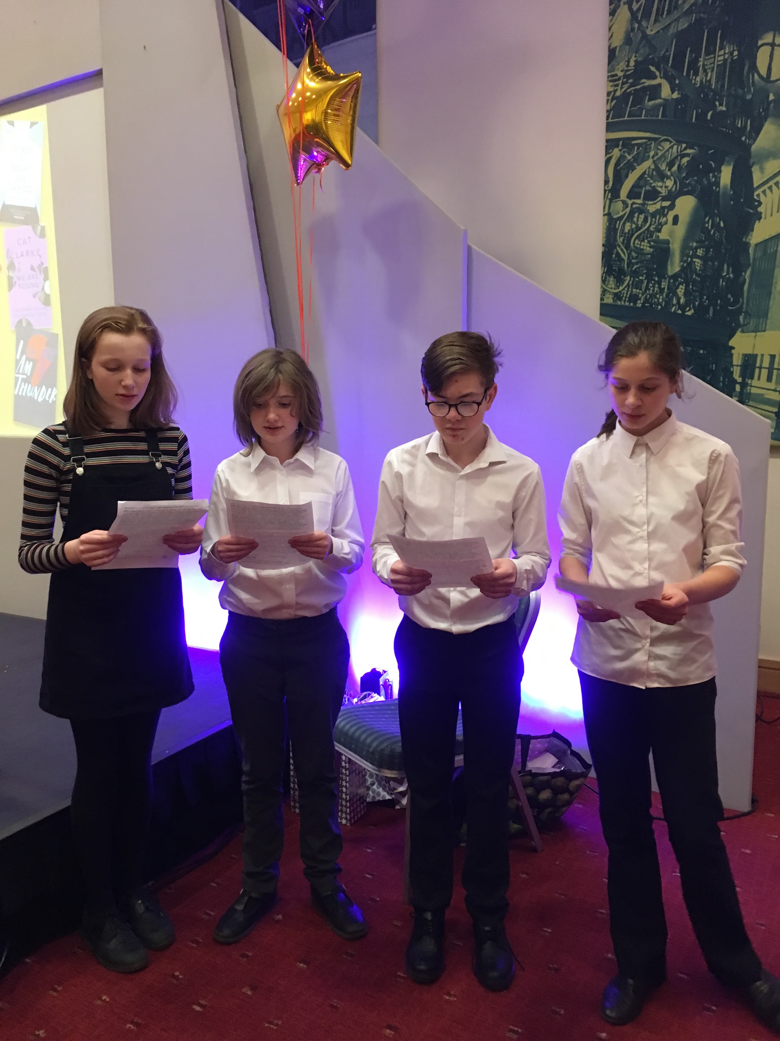

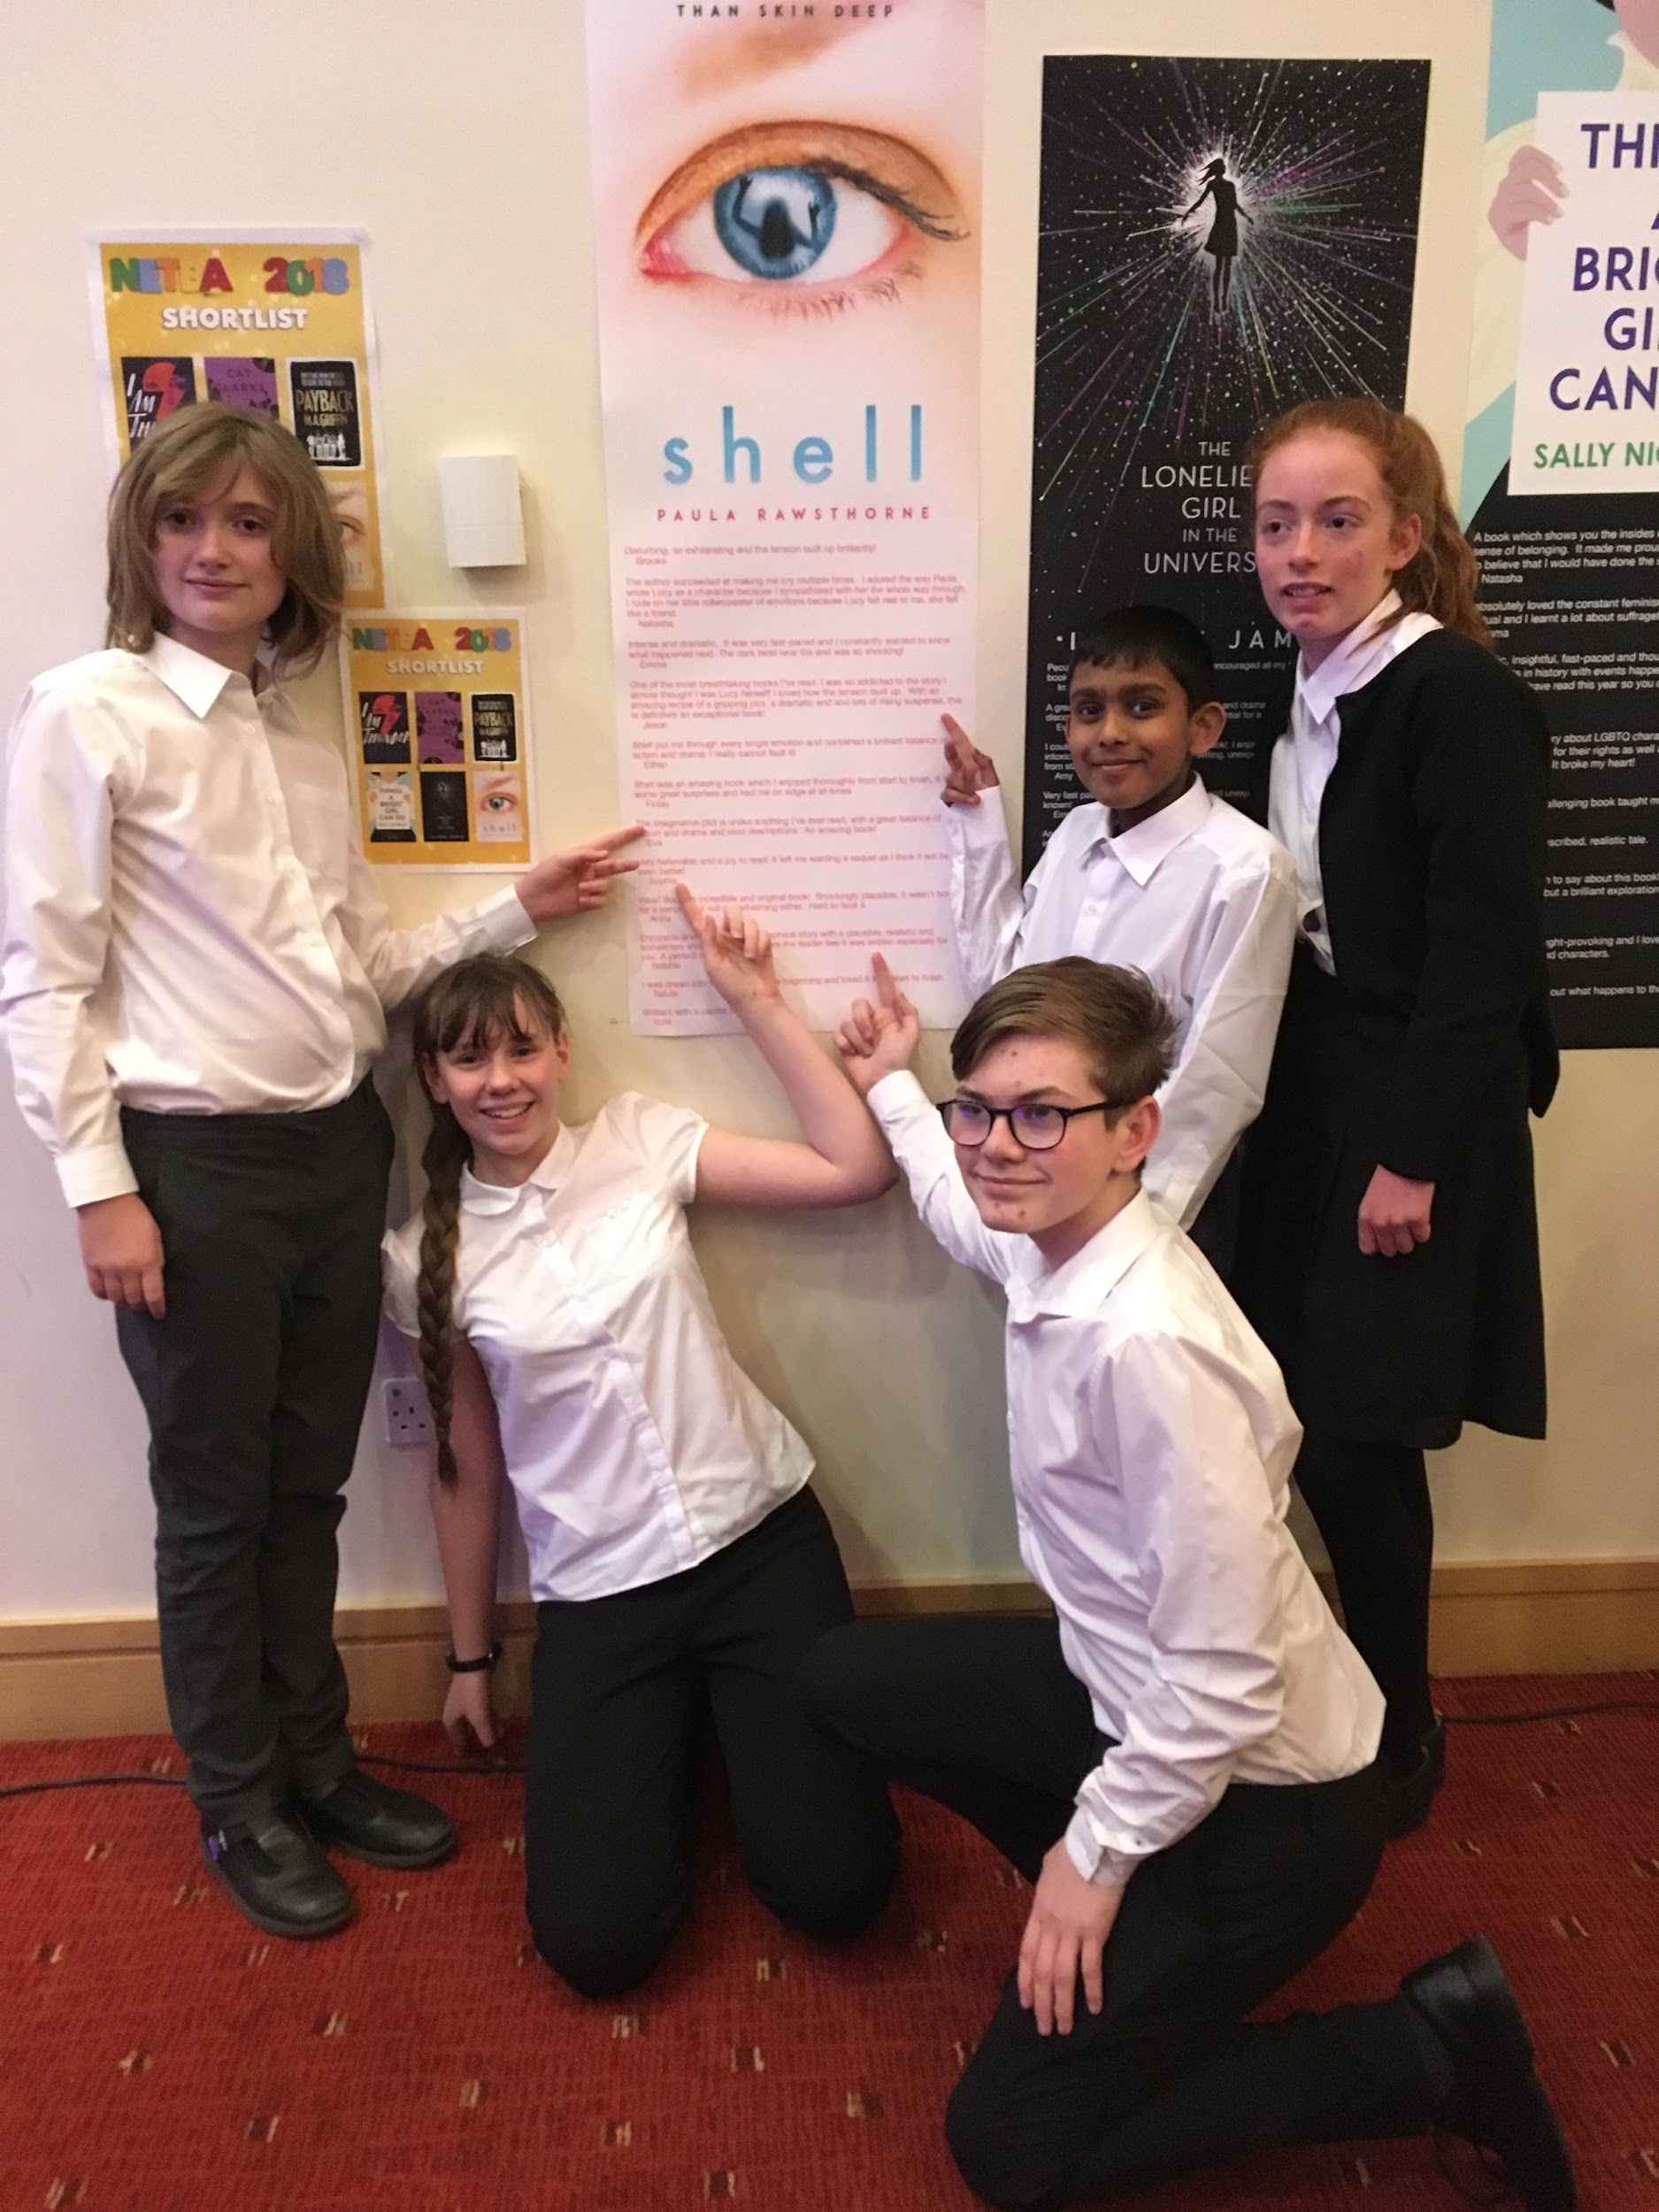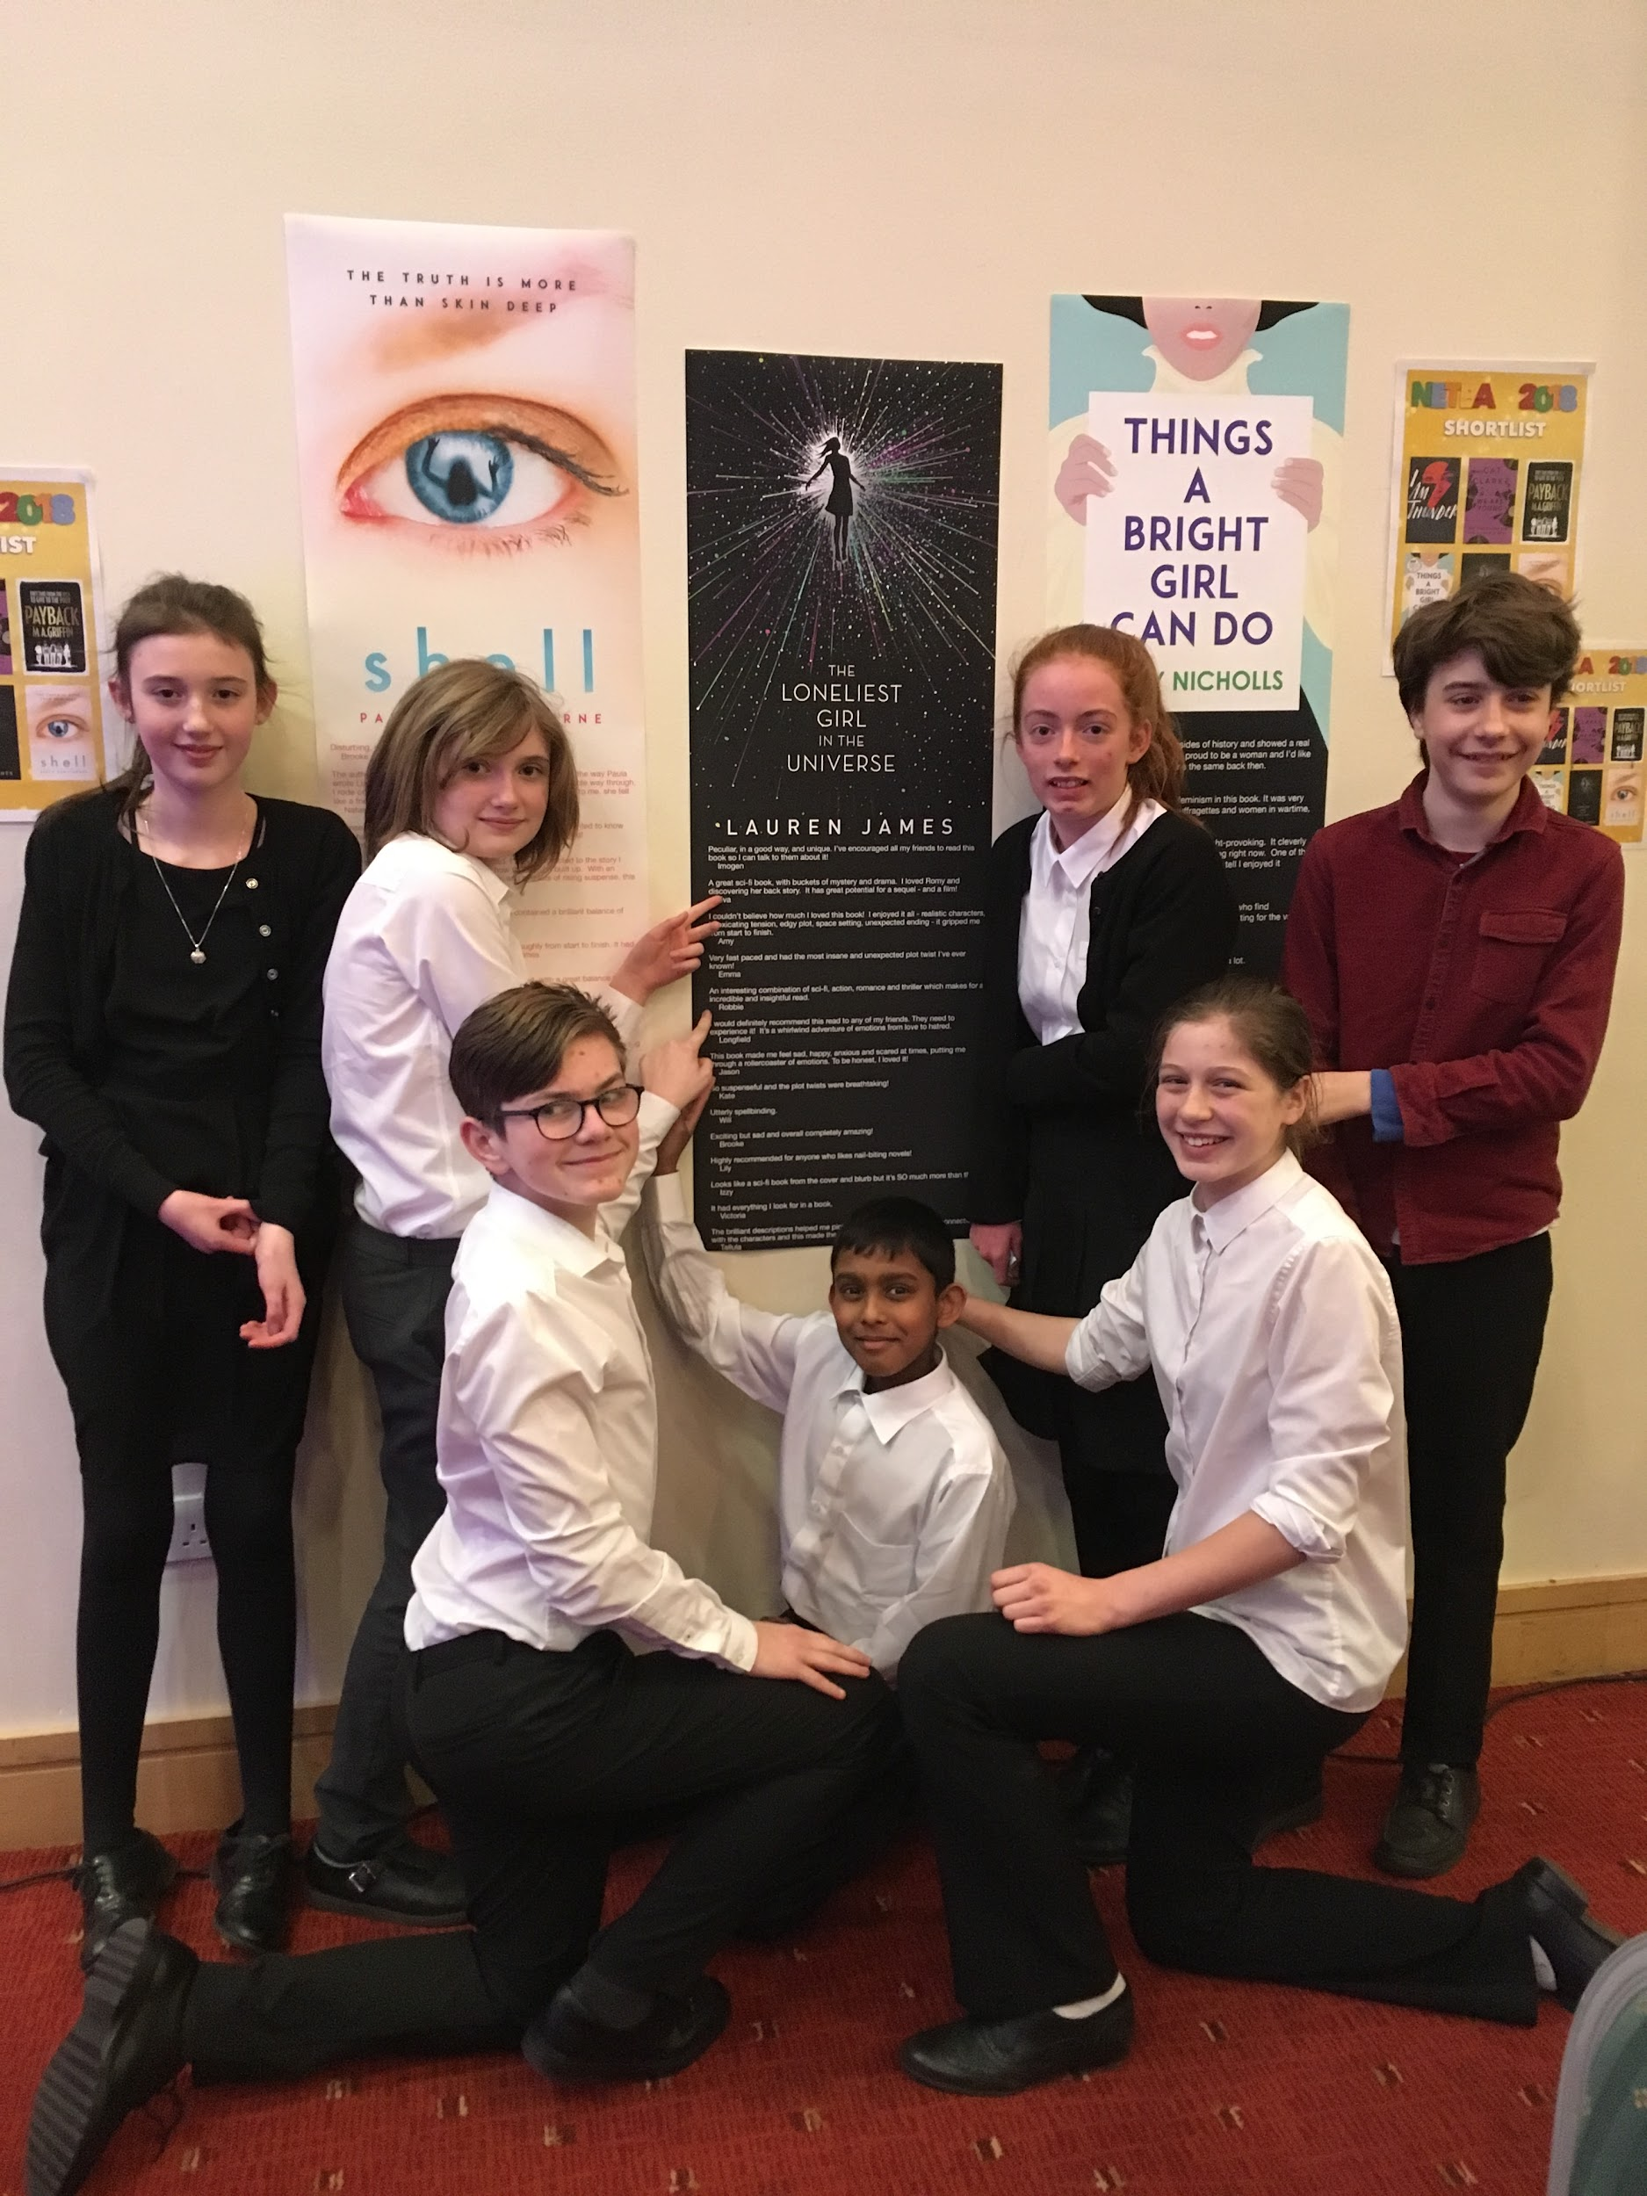
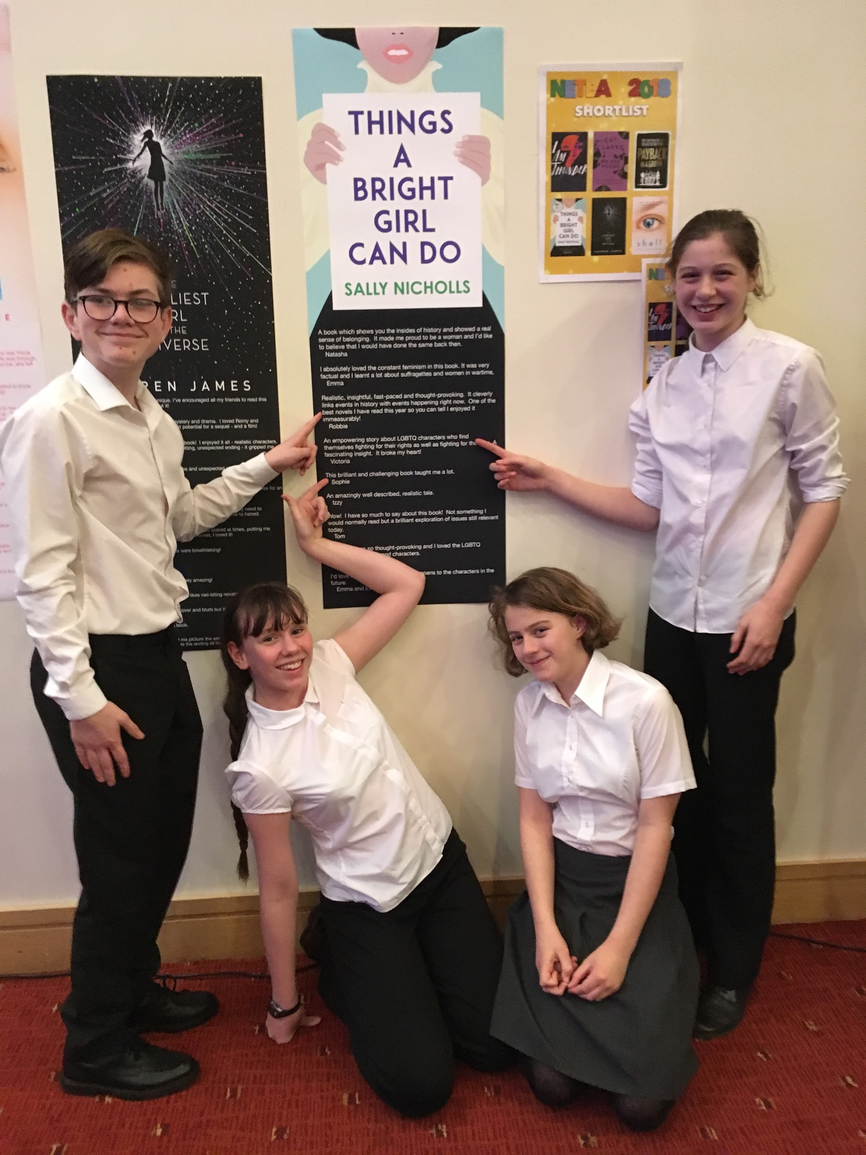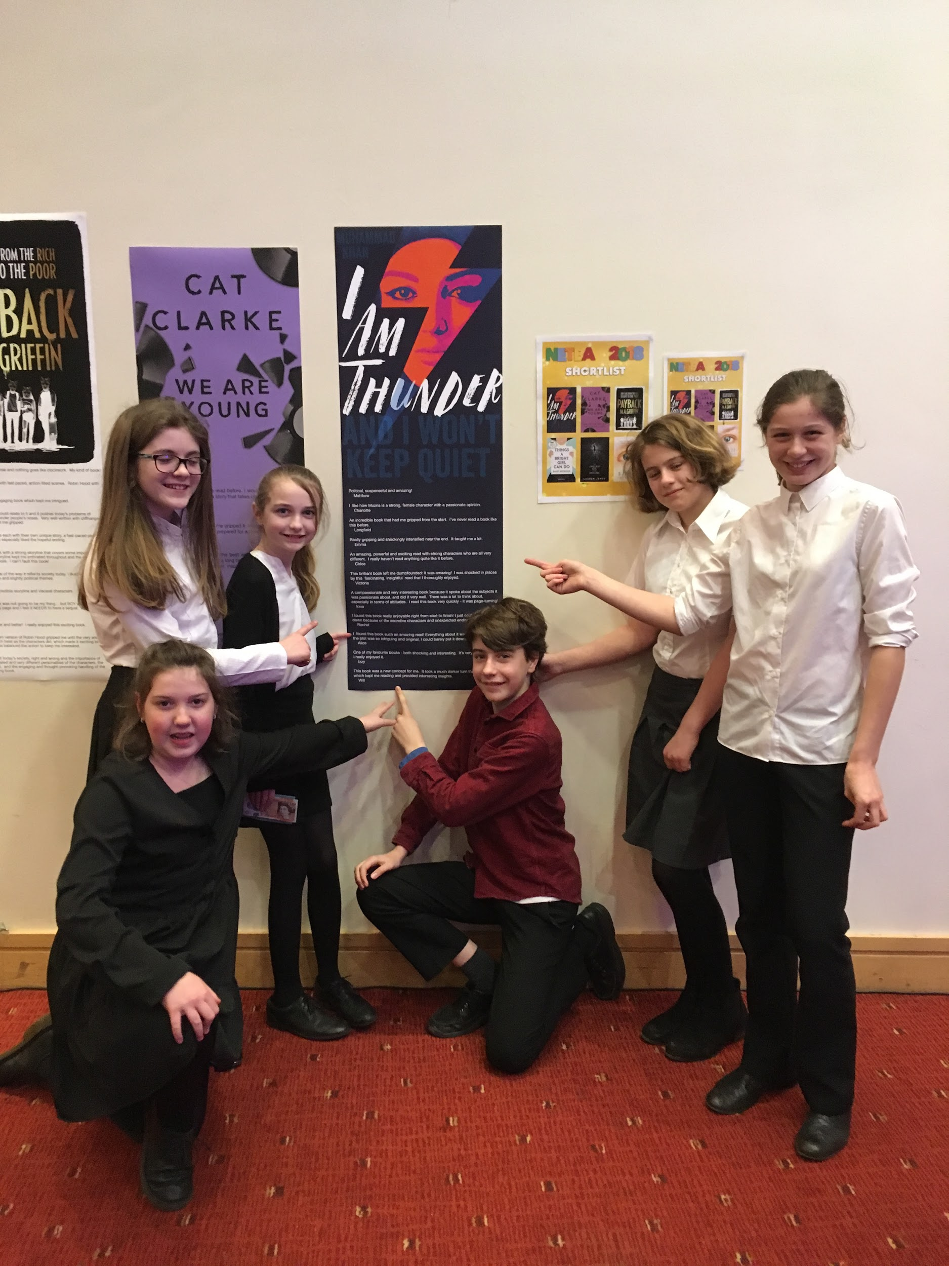
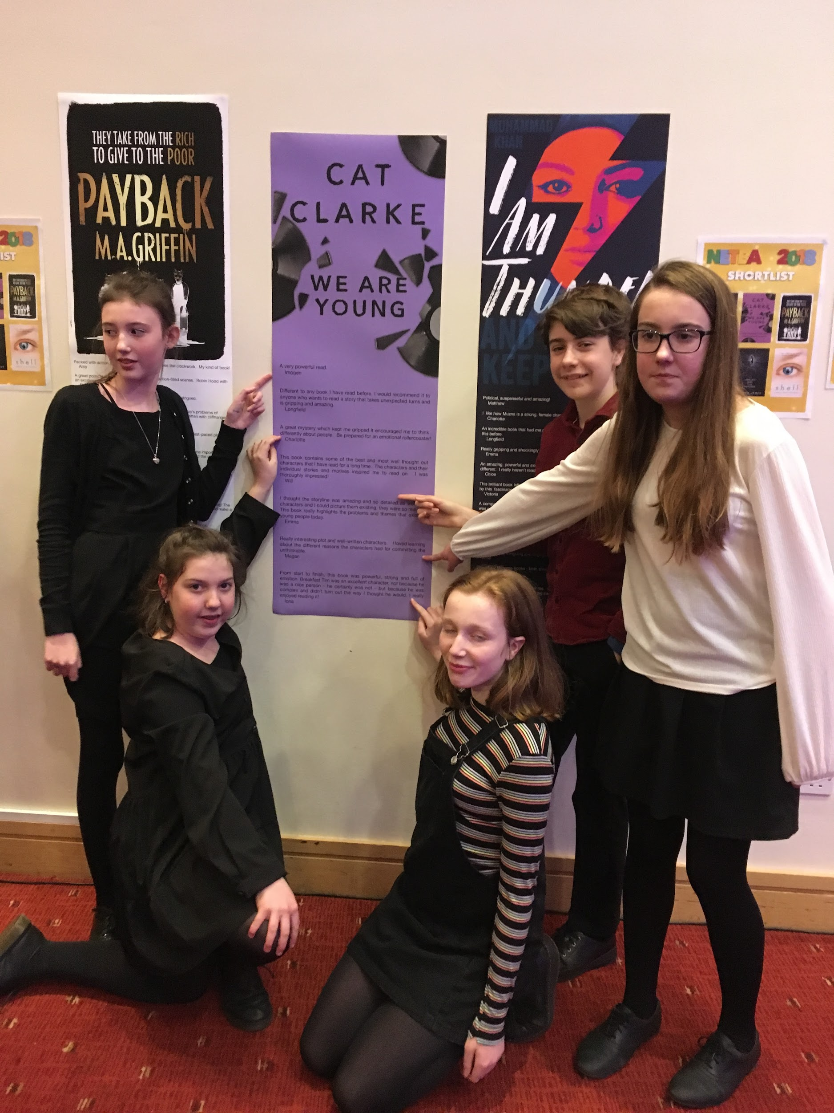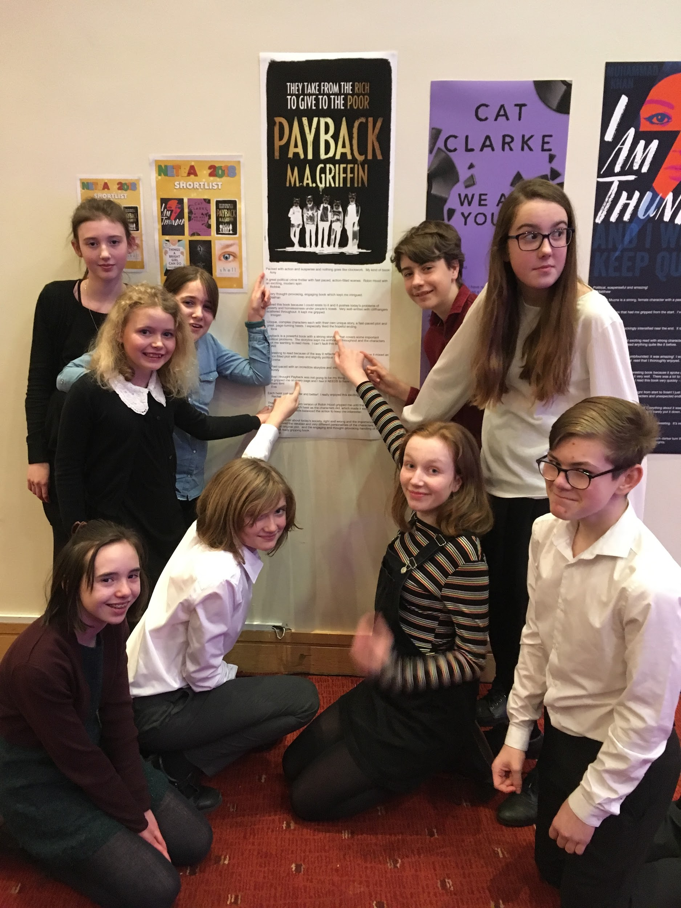
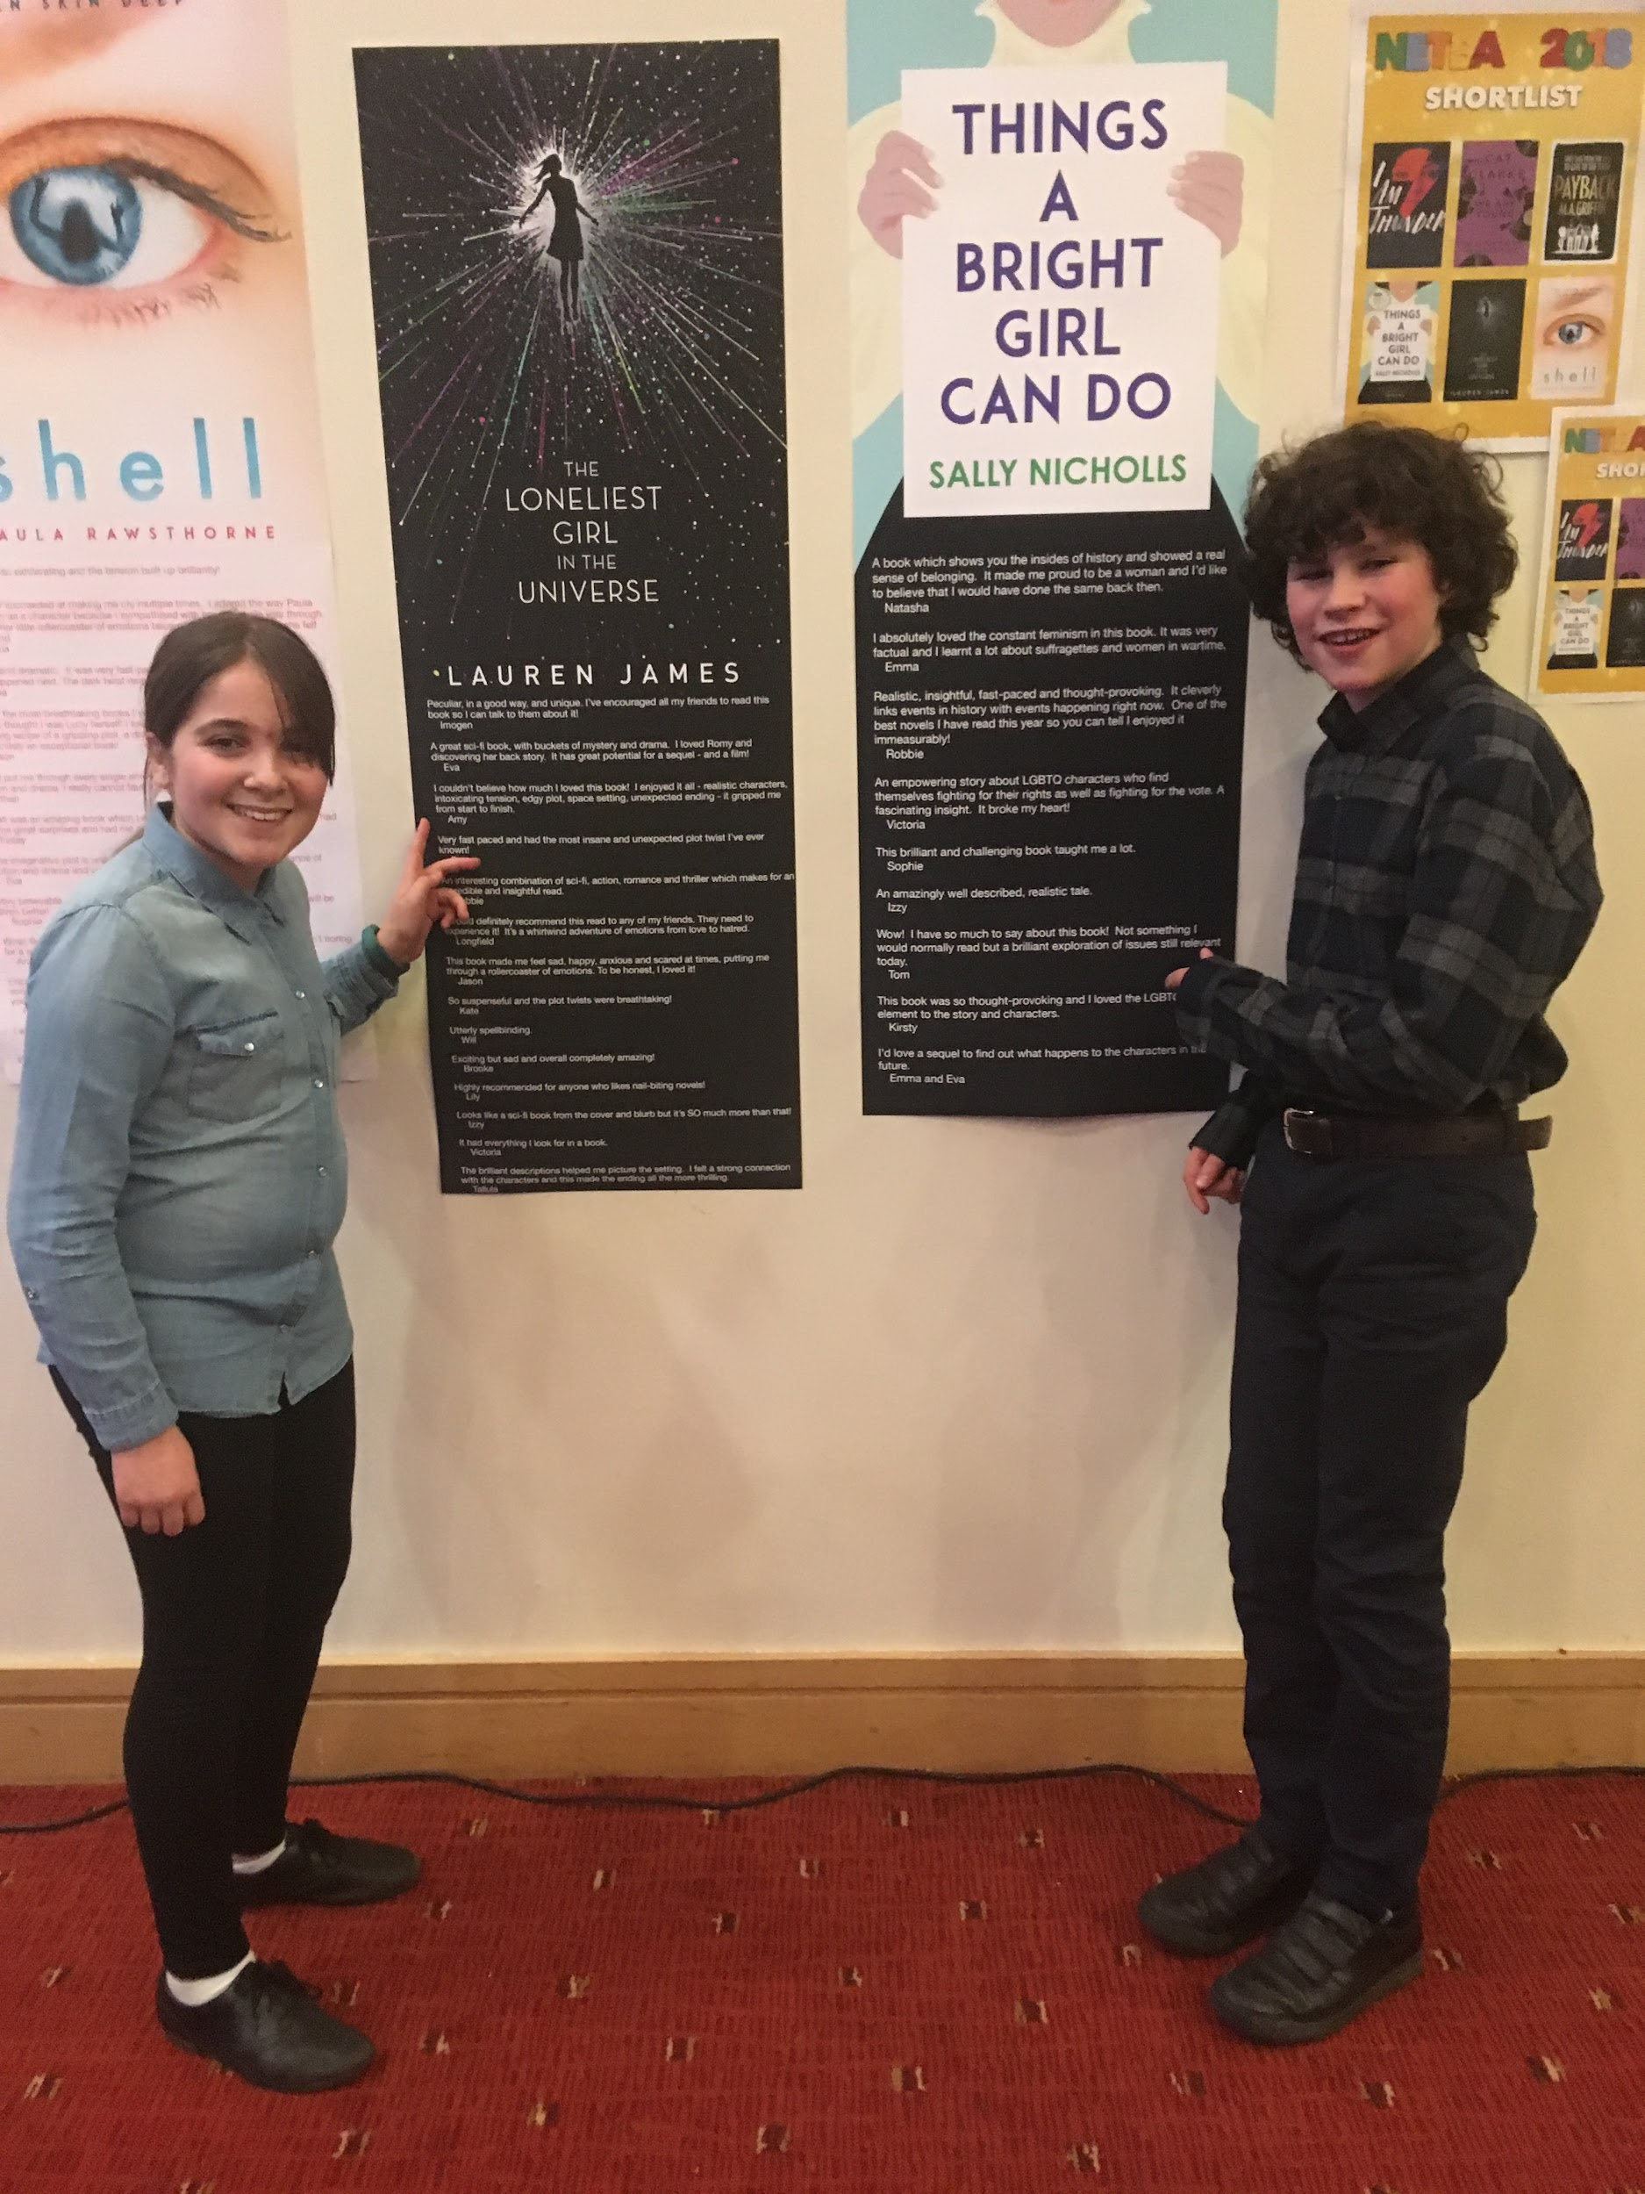

Martin Griffin made us laugh with a story from his student days involving a chainsaw, a Polaroid camera and a very attractive policewoman – a recount that didn’t make it into his book – while Lauren James astounded us with spreadsheets of calculations, which she revealed in answer to a question from the audience. Evidently, her novel – a romantic, sci-fi thriller - was inspired by a calculation she was assigned as part of her physics degree! Relax – the story has nothing to do with maths and is really very readable! Sally Nicholls talked at length about the history of women’s suffrage in Britain and left us with a fascinating fact. The habit of calling female teachers ‘Miss’ derives, apparently, from a law that prevented women from continuing to teach once they married!
There were raffle prizes to be won and prizes taped under seats; party food and tempting bargains at the book stall. All in all, it was an evening for book lovers to indulge and a fitting way to celebrate a twentieth birthday!

