Year 5 Hate Crime Workshops

On Monday 4th February, Year 5 took part in a workshop about Hate Crime as part of our topic about Great Britain and its diversity. These were organised to make them aware of what Hate Crime is and how they can work together to ensure that it doesn’t happen. The children learned that …

“Hate crime is against people from different countries, elderly people, different sexualities and the disabled.”

“People can go to jail because of hate crime and can get 50% added onto their sentences.”

“We learned not to offend people because of their race or colour. Also we shouldn’t make fun of people who have a mental or physical disability.”

The children also discussed how they could put into practice what they had learned from the workshops.

“I will not be mean to people who have a difference.”
“ I will stop other people doing hate crimes and tell them that it is wrong.”
“I will tell my family about all of the things I have learned.”

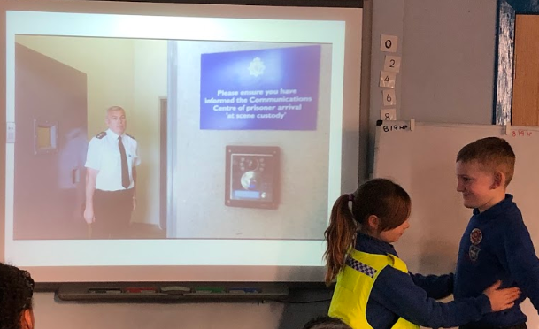
An arrest has taken place after a hate crime has been committed!

