We’ve broken the £3,000 ceiling – Chantry Book Fair 2019 makes a record!

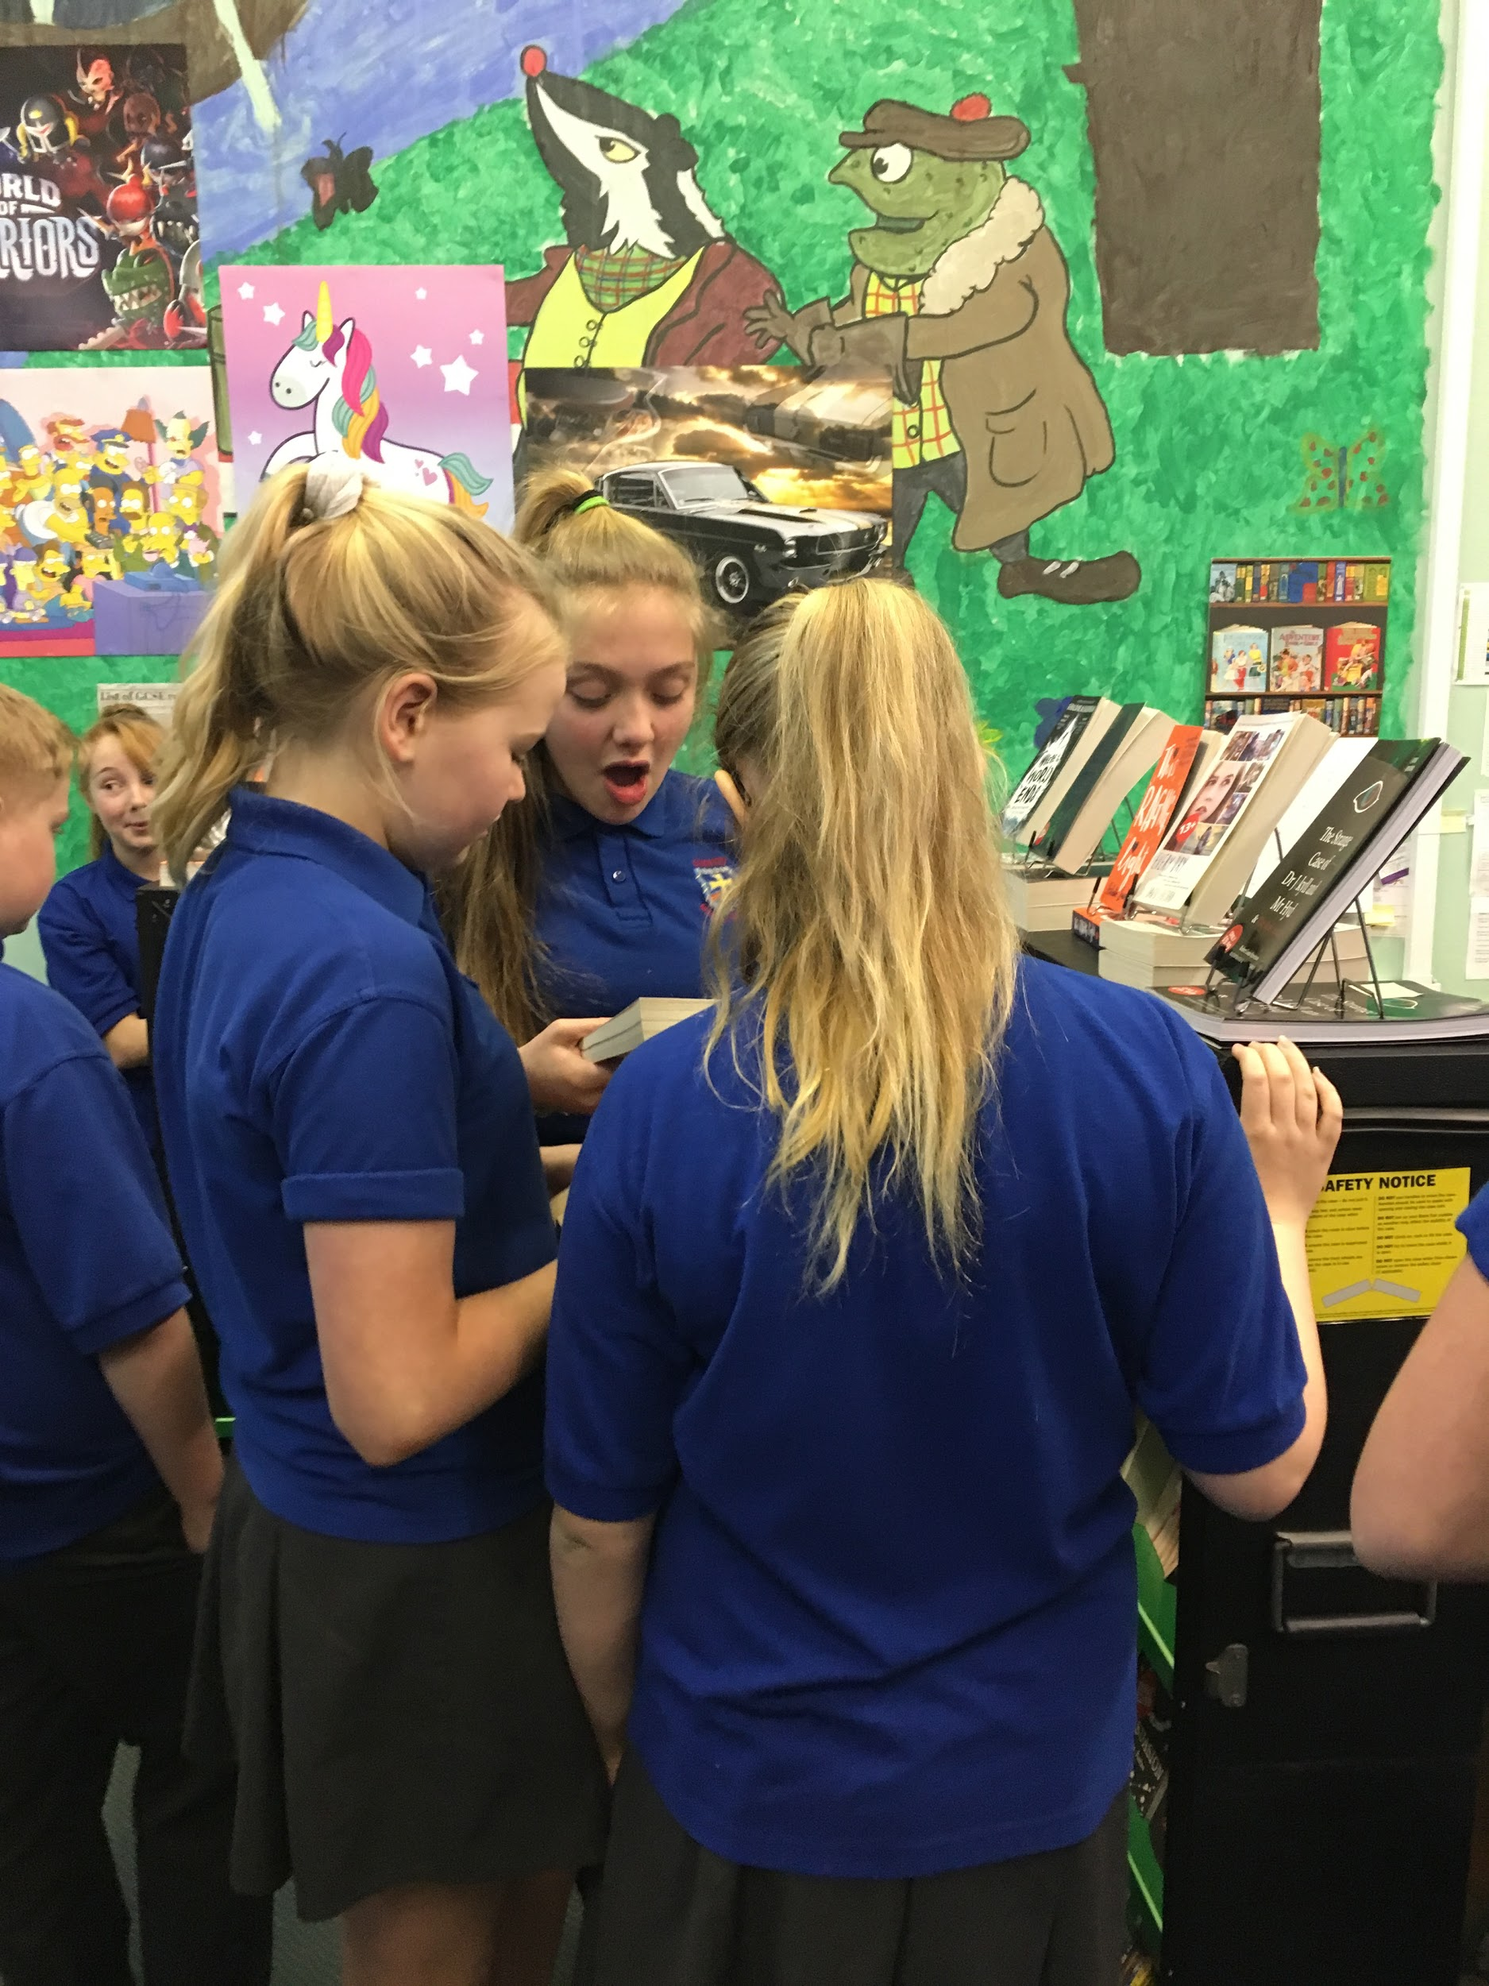
Owing to your tremendous generosity and support, our week long annual Book Fair
has achieved record sales and netted an incredible £3,131!
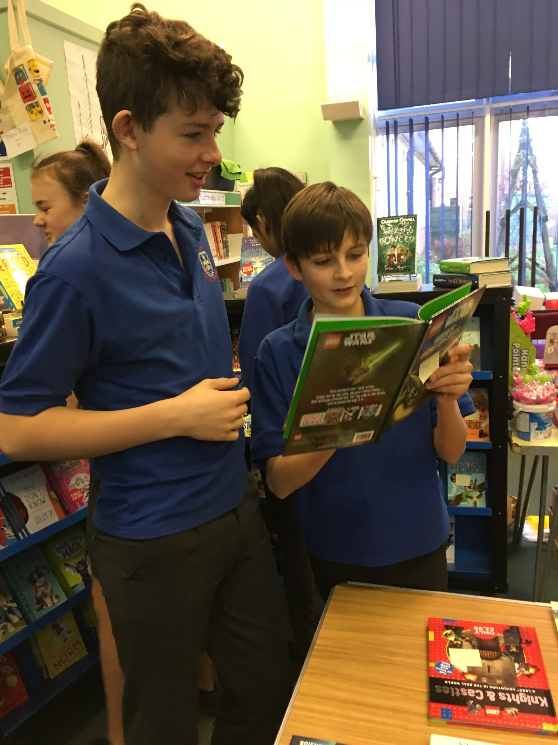

At break times, the library was so full we had to establish a queuing system!
Our children’s enthusiasm and good humour - despite the crush - have been incomparable.
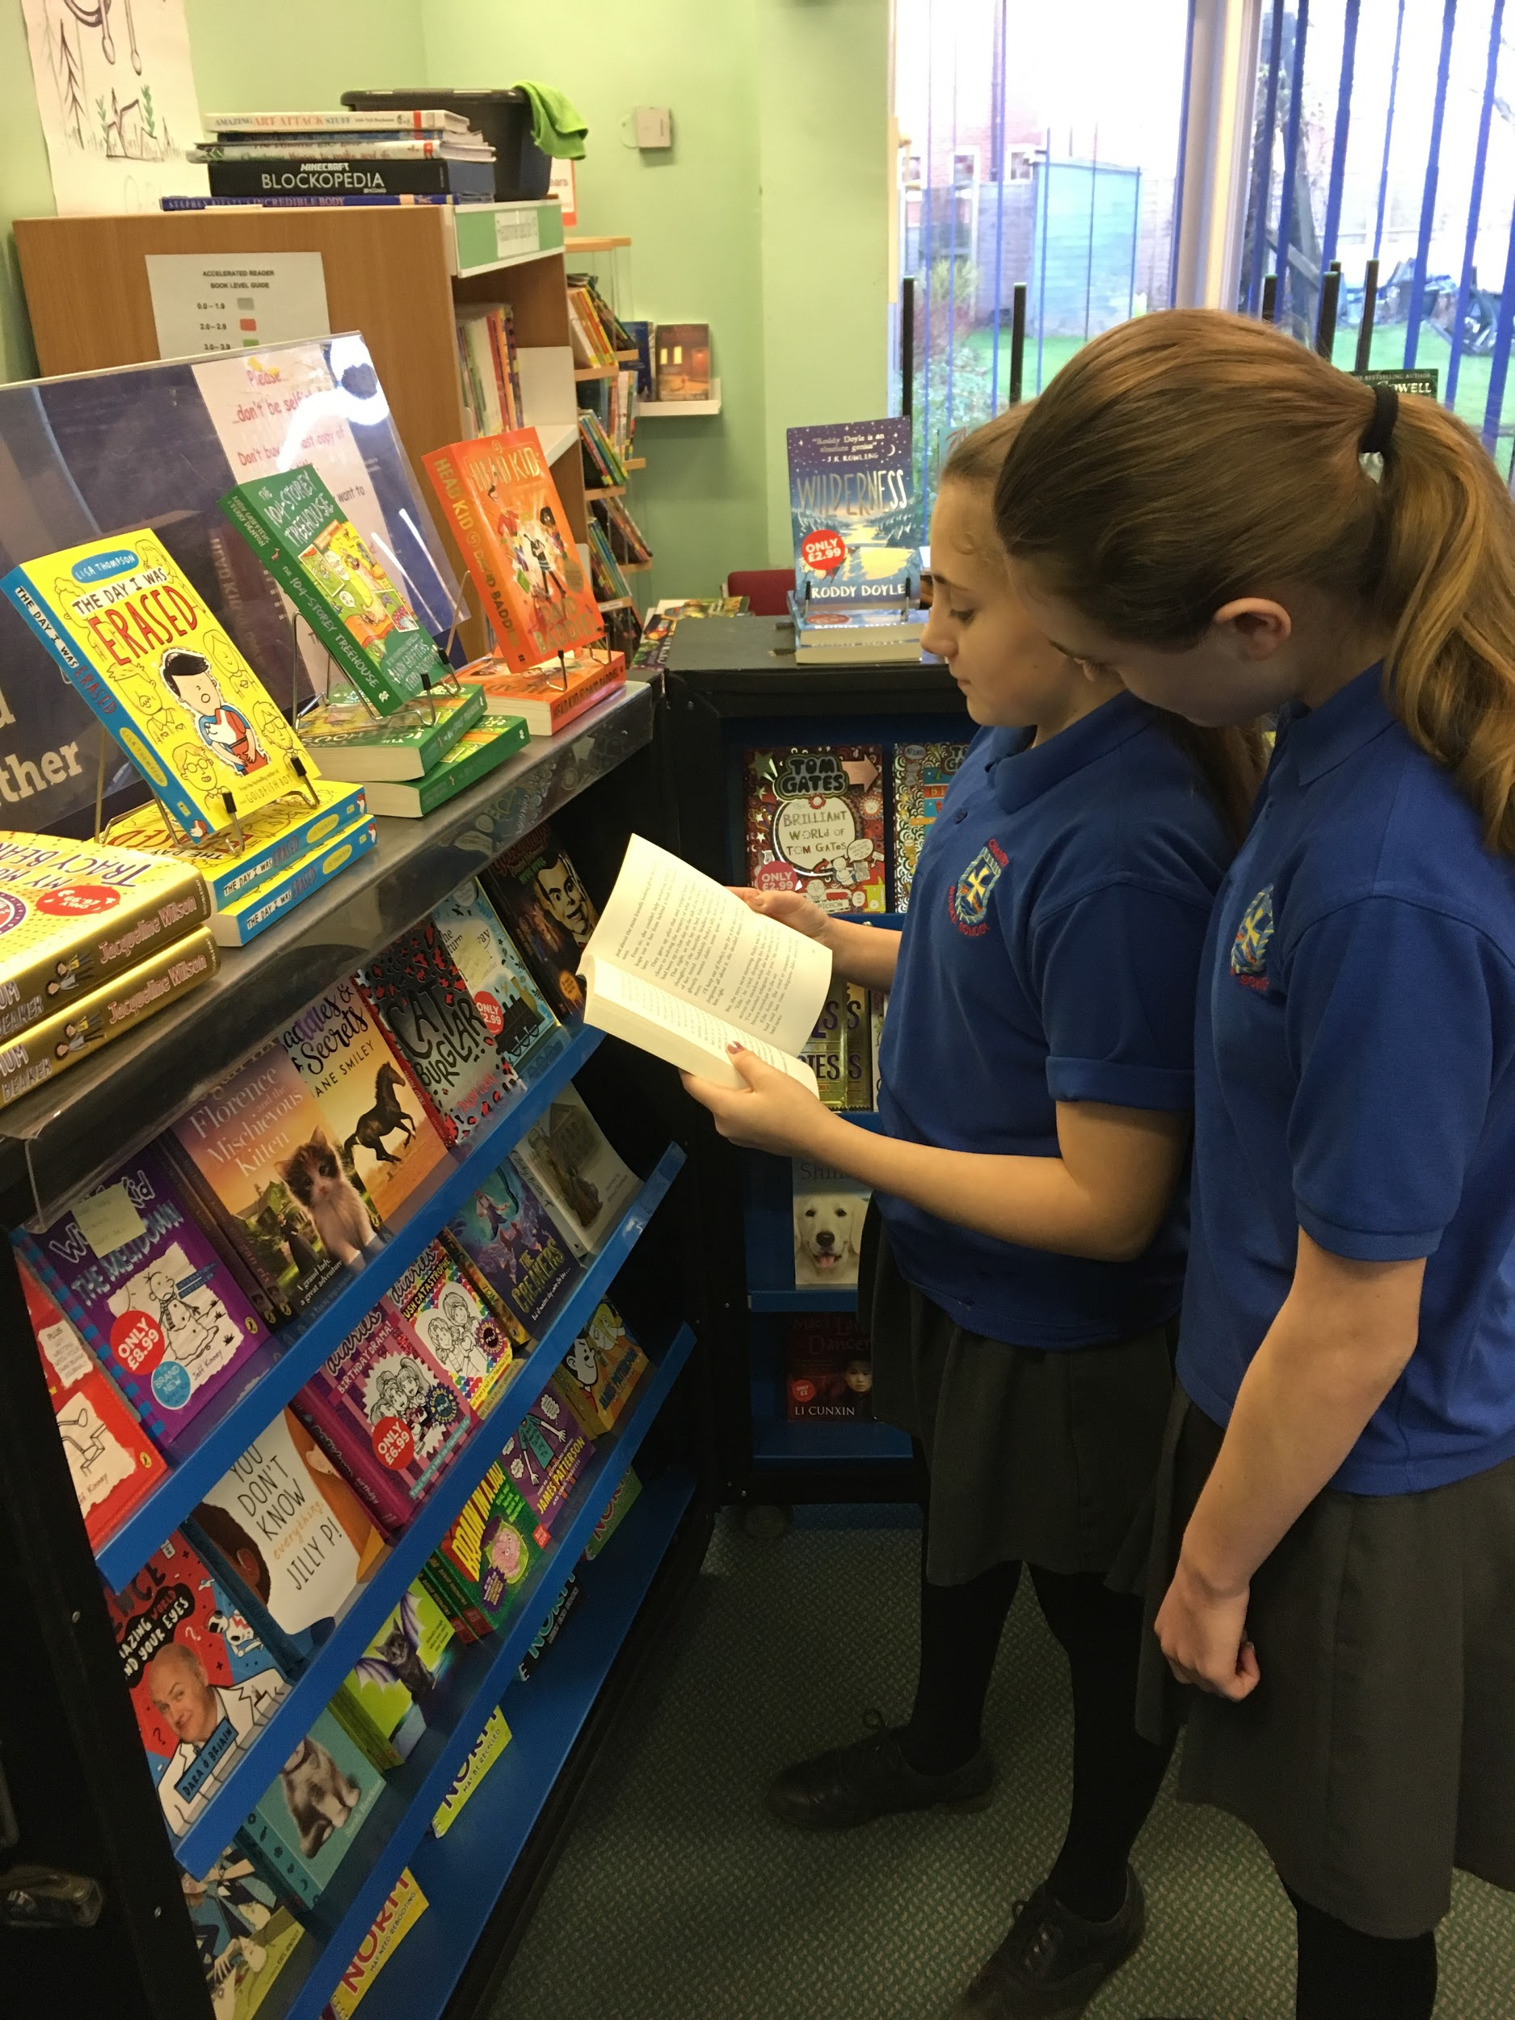

What more can we say except a huge “THANKYOU!”
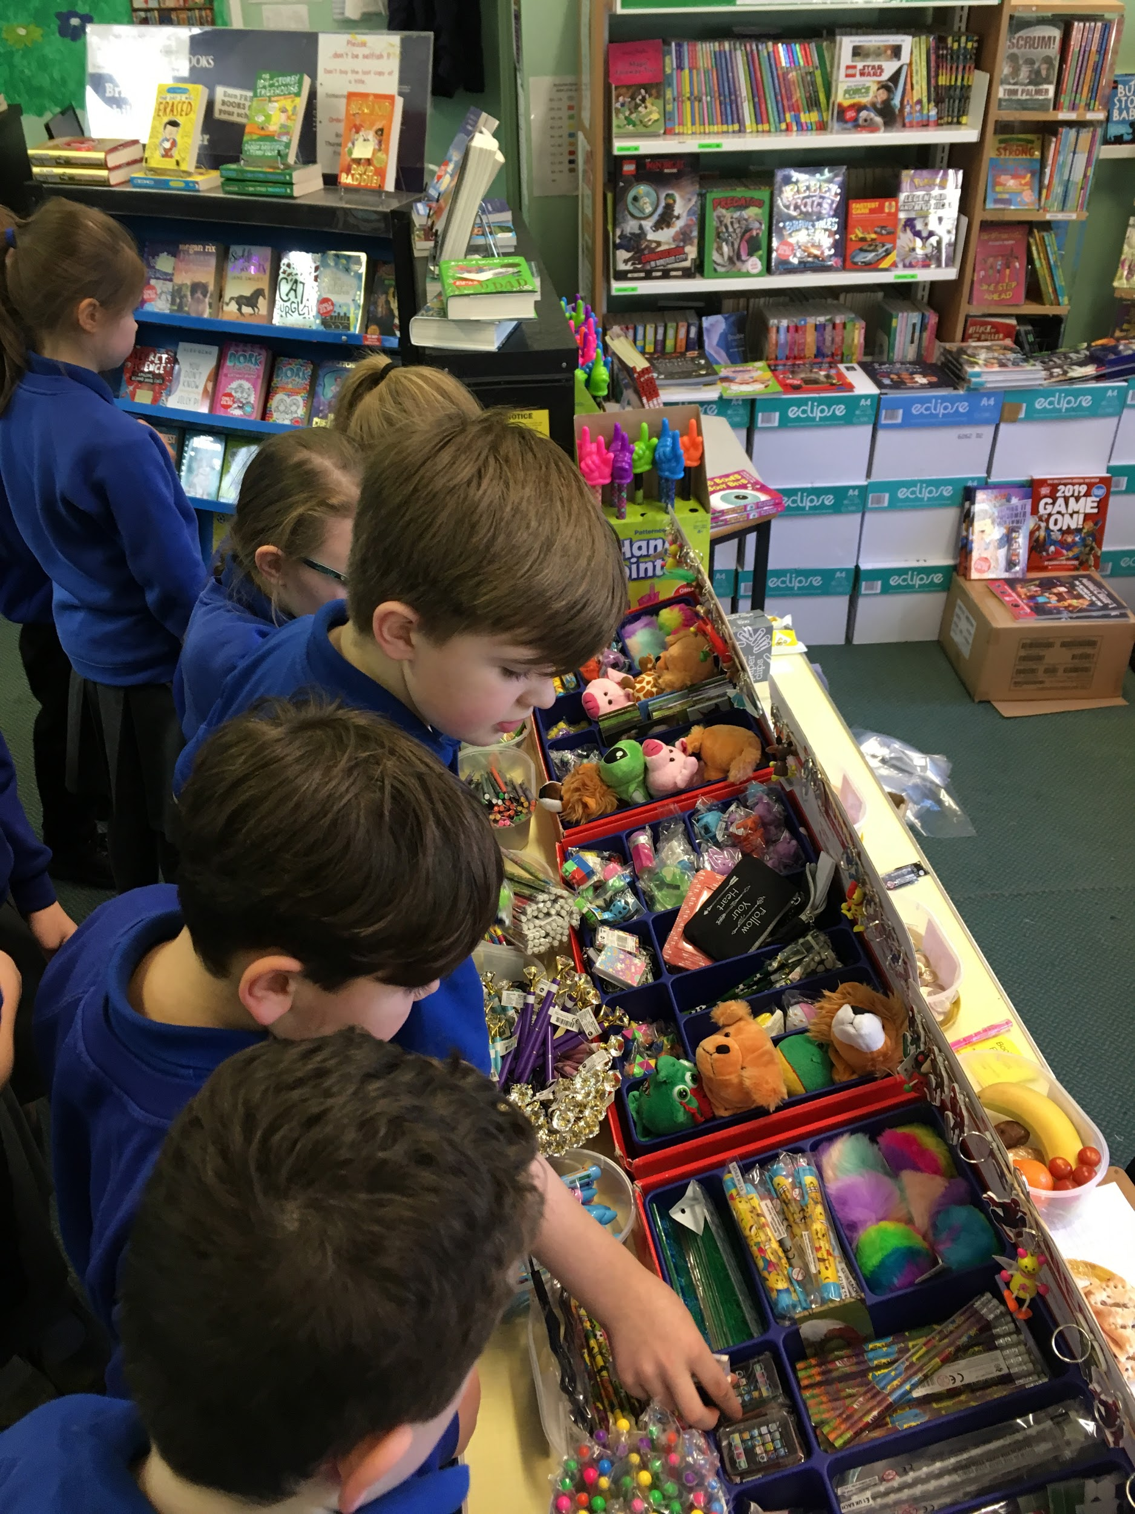

More than 300 books were purchased – another record – and more money-saving e-vouchers were redeemed than ever before!
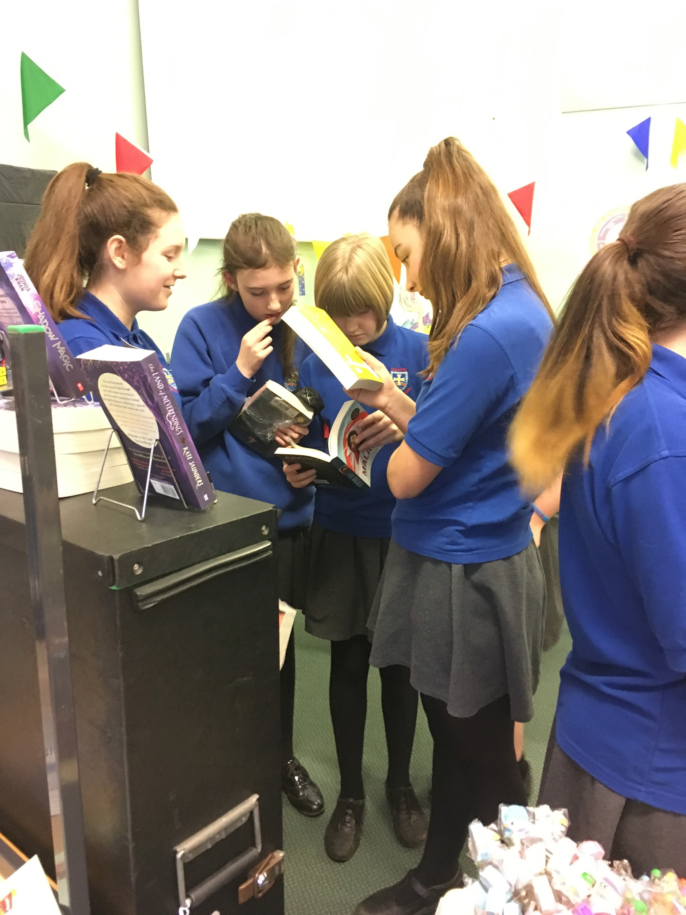

These sales have raised a magnificent £1,879 in commission,
which will be spent on books and resources to stimulate literacy and a love of reading throughout school.
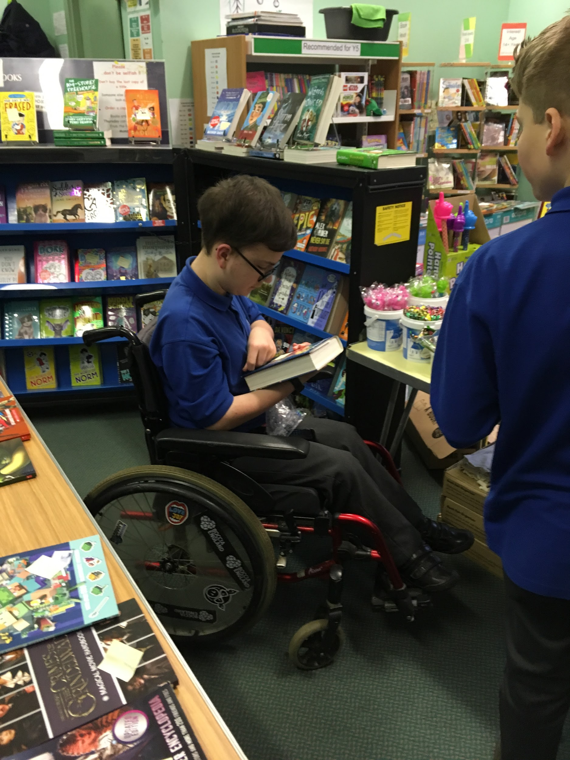

It was a real pleasure to meet those of you who were able to visit the Fair after school!
We do hope that you enjoyed the opportunity of discussing the titles on sale and making your selection in a relaxed atmosphere.

Thank you very much for coming!

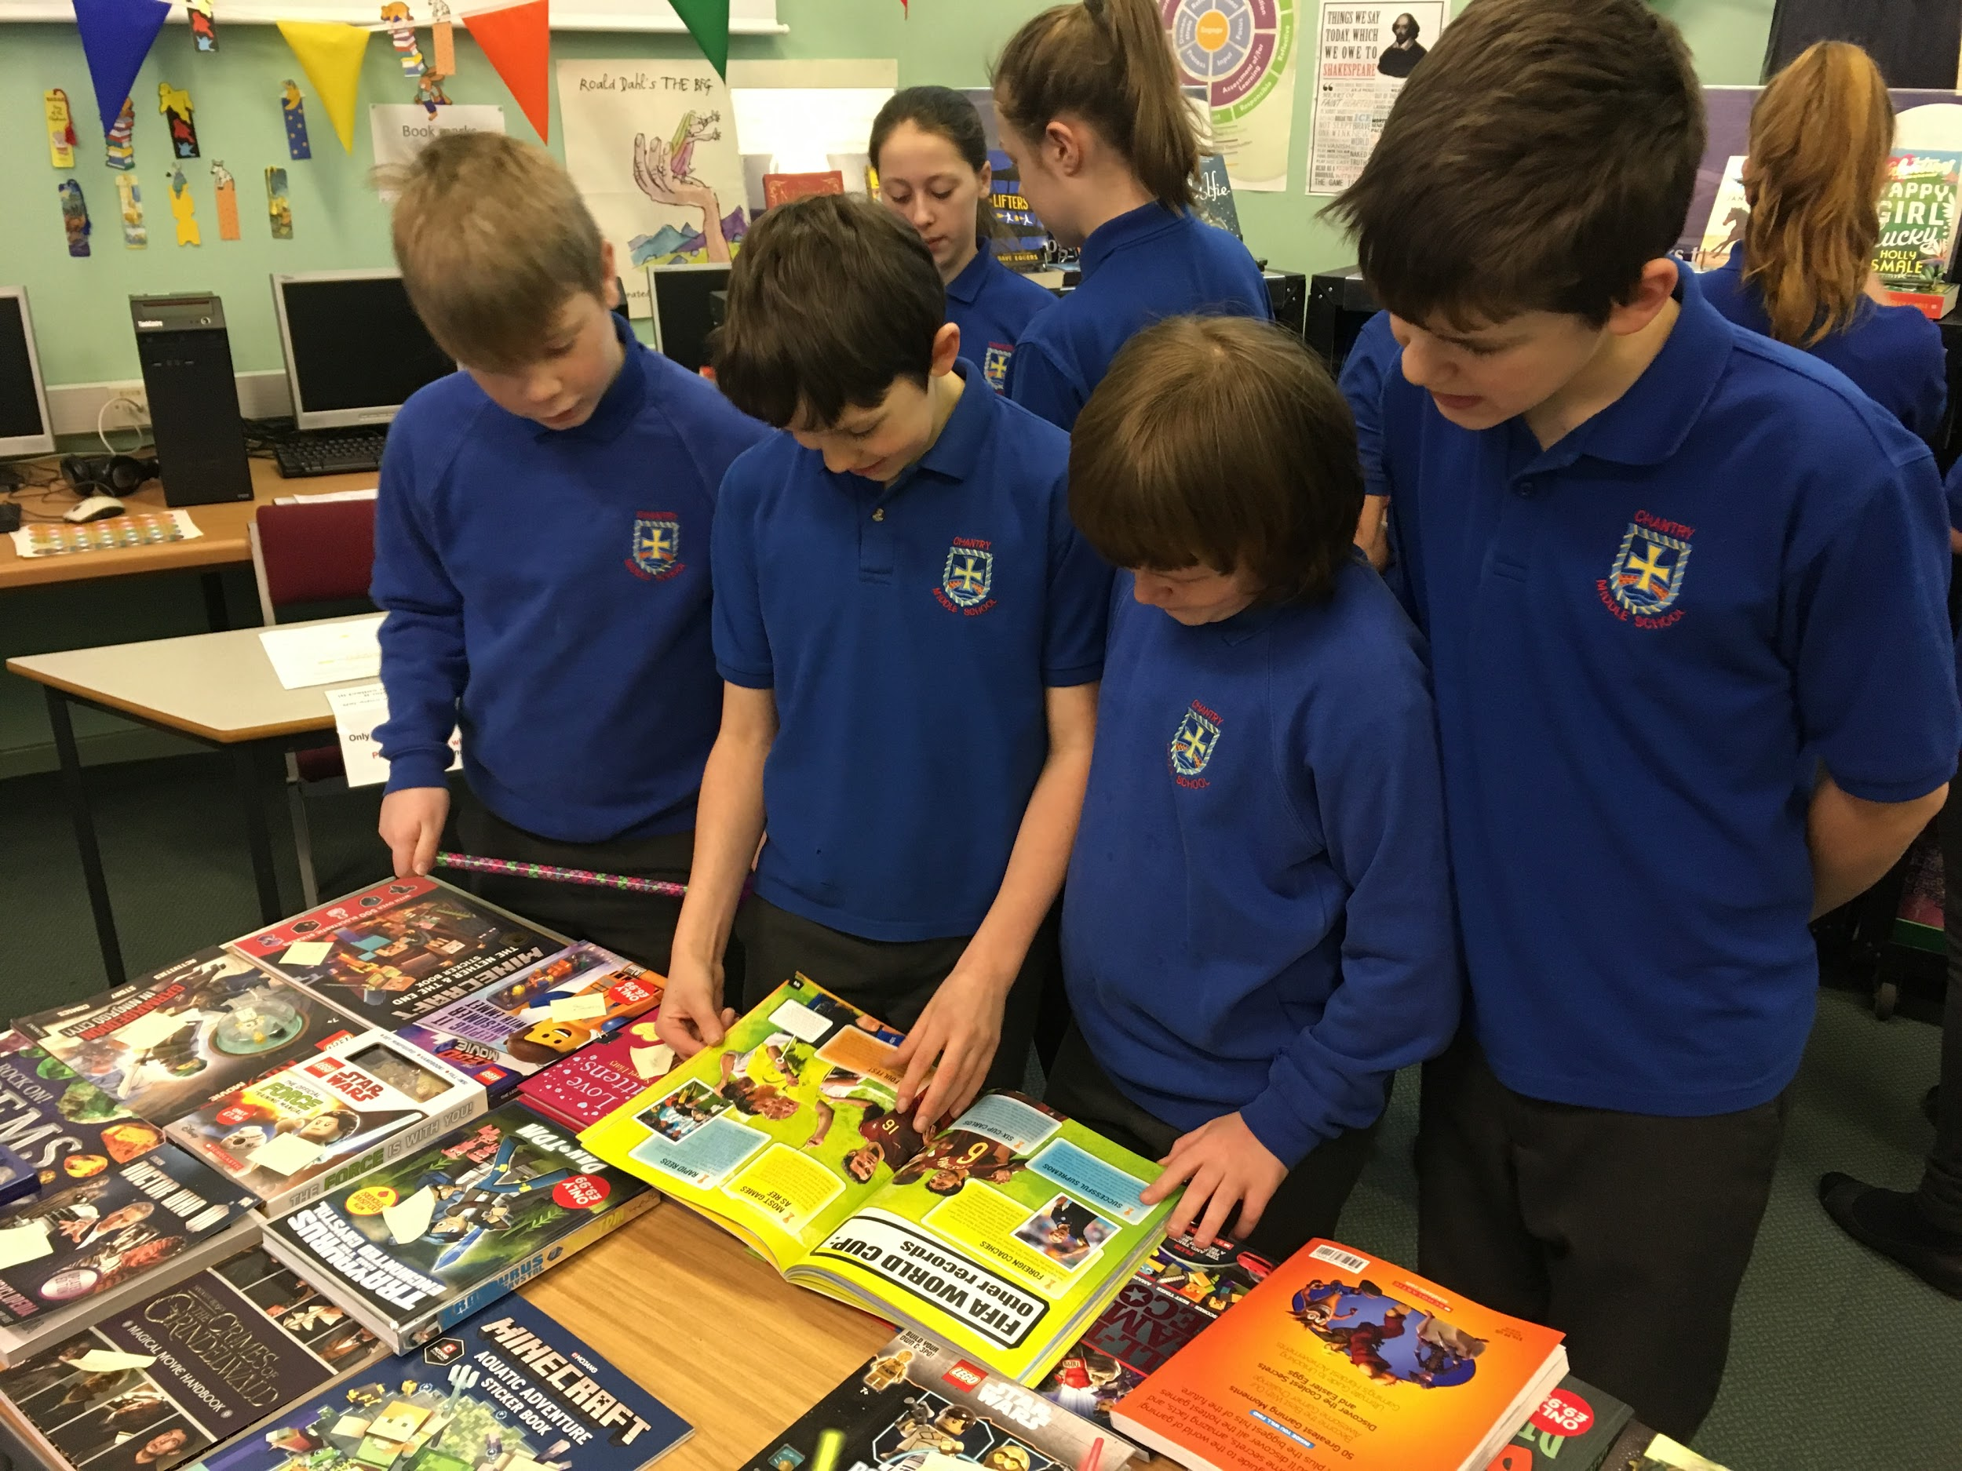

The eco-friendly, fabric book bags will remain on sale throughout the year.

A special “THANK YOU” must go to the following Fair Makers who ensured that everything ran smoothly:

Imogen and Erin, in Y8 and Victoria, Ethan and Eva in Y7 for stapling 530 letters to Book Fair fliers in record time, Mrs Shepherd, who gave up all her breaks to do ’traffic duty’, Ethan, Sophie, Eva, Charlotte and Amy in Y7 for indispensable help setting up and closing down the Fair and Mr Wigham for the ‘heavy stuff’, including digging out a path to allow the Fair to depart!

This wouldn’t have been possible without you!

