BBC Studio Trip
On Tuesday 12th February a group of year 7s went along to the BBC studios in Newcastle. When we arrived, we played some games that have appeared on game shows on CBBC such as ‘Horrible Histories’. We had to remove the body parts from a mummy in a minute. It was tricky but great fun!

When we started the tour around the studios, we firstly got given a talk on the history of the BBC. This was very interesting as it has been around for many years! Then we looked at the library which had all the tape recordings in from almost the beginning of time. Then we went into the green screen room where one presenter presents the whole of the morning show; it was also the room Little Mix had previously been interviewed in. We were lucky enough to go onto the set of ‘Hetty Feather’ which is a CBBC tv show set in the Victorian era. We saw the school set and the exciting costumes that were actually worn by the real actors. During our tour we were able to visit the set of ‘Look North’ and learn how it is presented and set up. It was very exciting to sit on the presenter’s chair! We felt like real reporters. Then we went into the control room with all the buttons and screens in where we could see the ordering of the TV shows and adverts. This was very interesting.

Finally, whilst on our way to the interactive studio to put everything we had learnt into practice, we met Paul Mooney (the weather reporter from Look North). He was very interesting and showed us what the weather was going to be like whilst he was doing his research. The last stop on our tour was the interactive studio. Here we made our own scary story as a group and we read out the script and made a report. E were able to put everything we had learnt on our tour to work. It was fantastic to do present and see behind the scenes. What a brilliant trip!

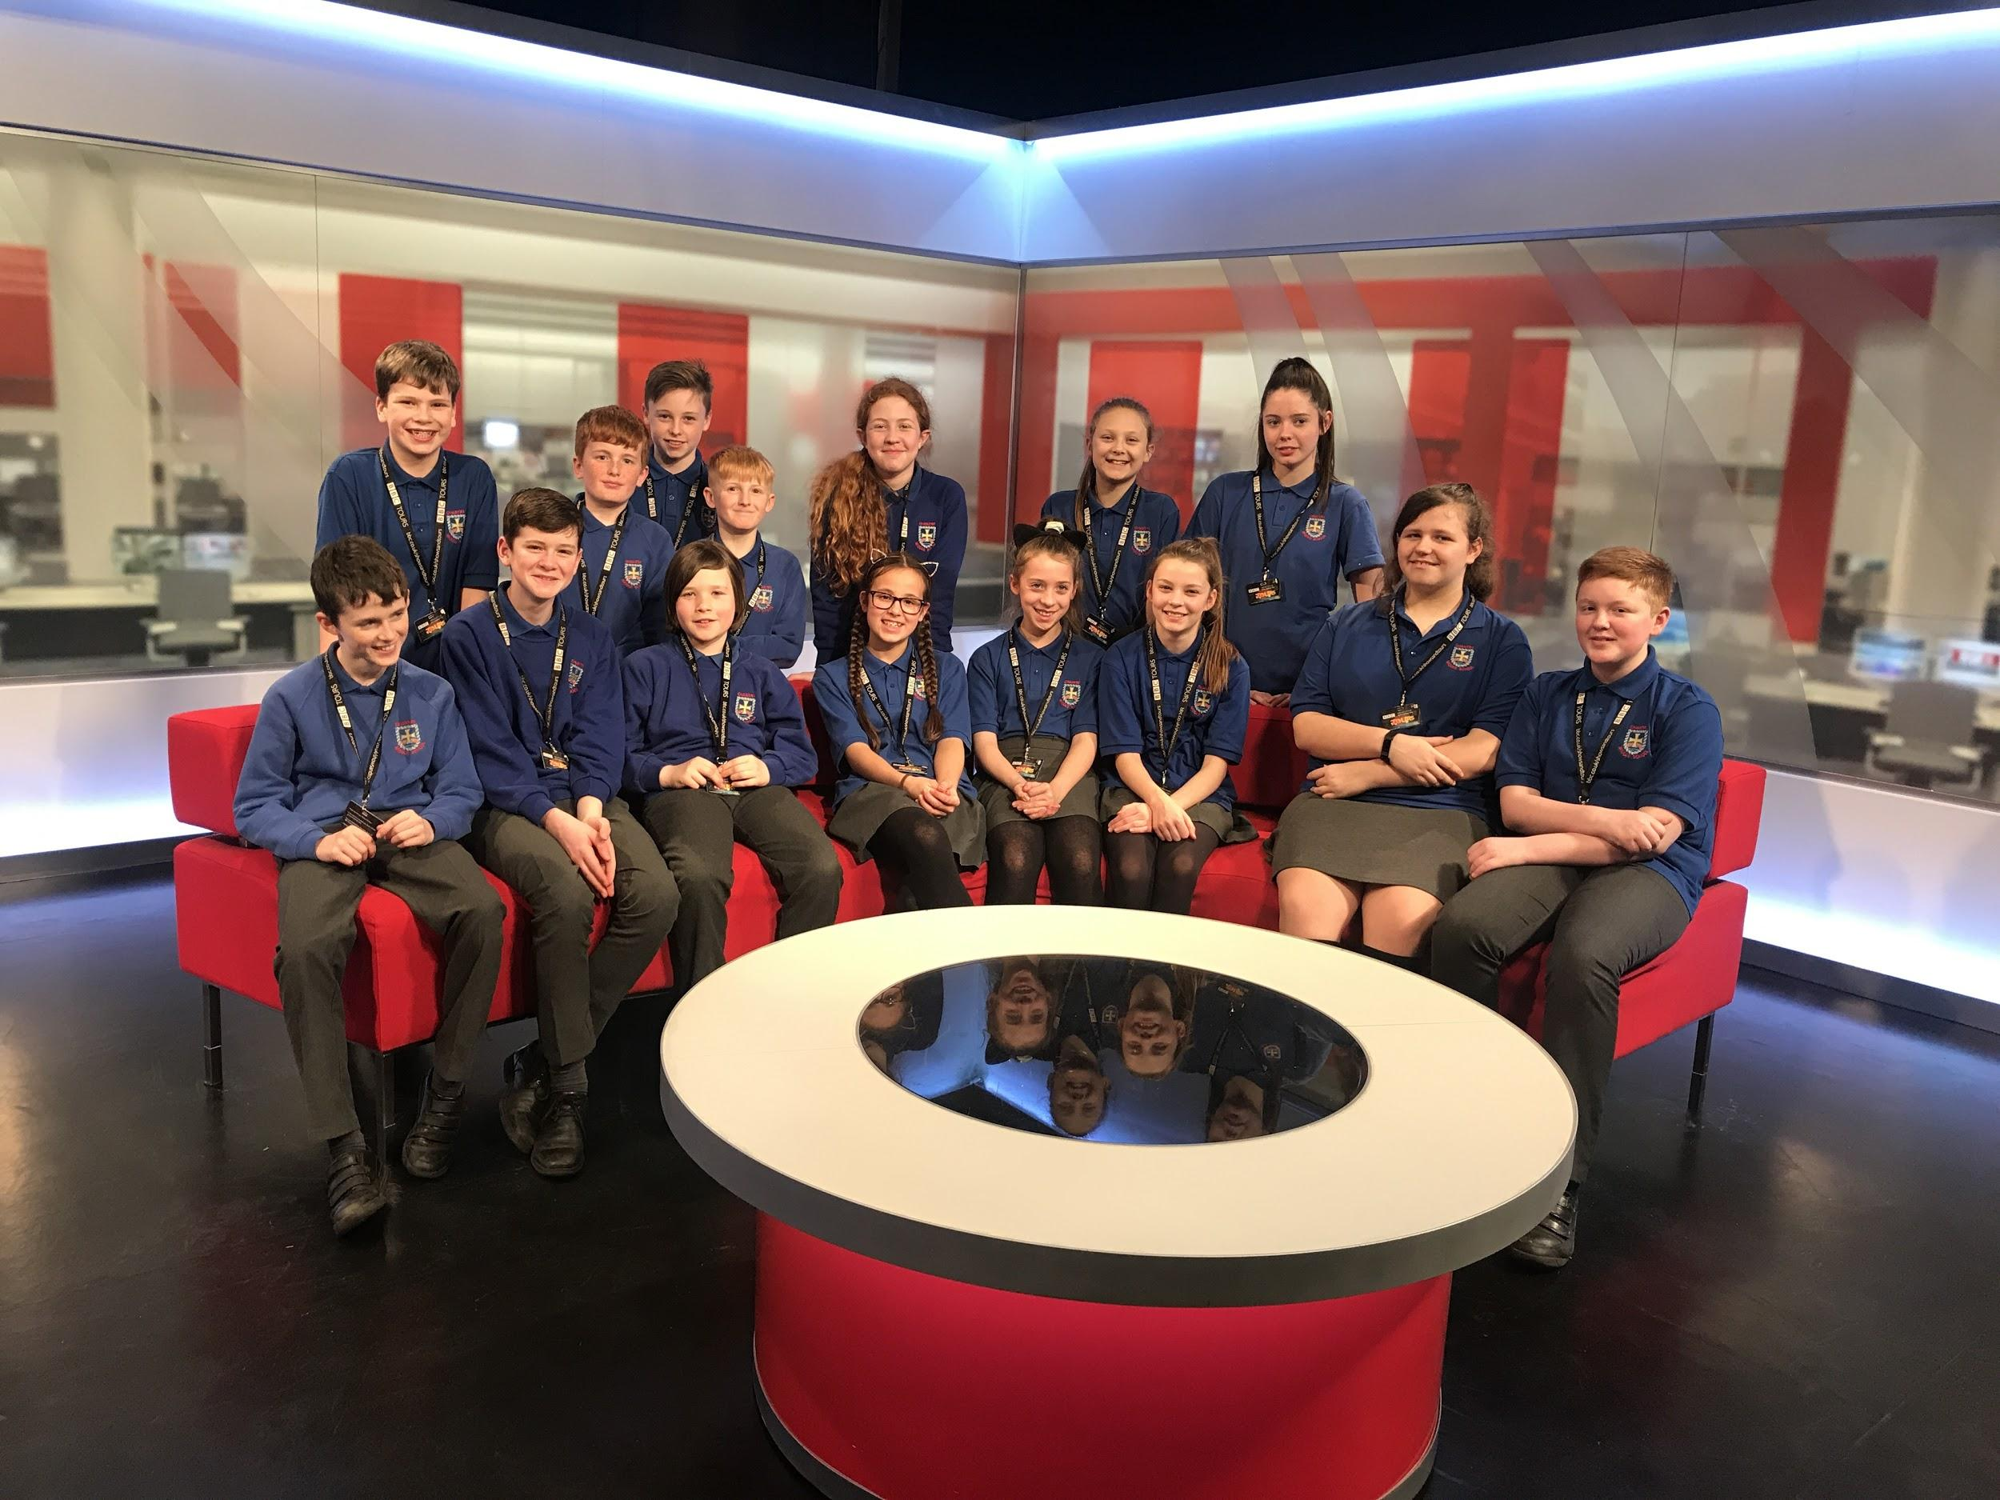
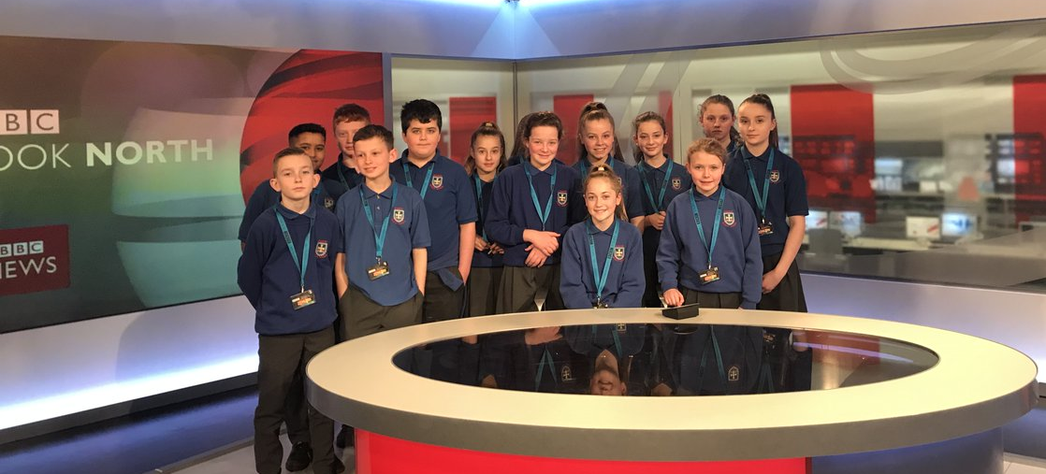
By Millie D. and Rhiannon A.

