Day 2
Facts and information
Pictures and diagrams
Heading
Title

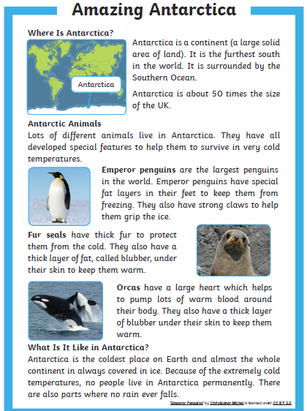

Day 3
My Chosen place is
Heading 1 ______________________________________
Facts

___________________________________________________________
___________________________________________________________

Heading 2 ______________________________________
Facts

___________________________________________________________
___________________________________________________________

Heading 3 ______________________________________
Facts

___________________________________________________________
___________________________________________________________
Heading 4 ______________________________________
Facts

____________________________________________________
___________________________________________________________
Day 4
Stretch each sentence using and, so, or, but, because
If you want to you can use these sentence below to help or you can write your own.
- You NEED to visit _______,because___________________________
_______________________________________________________

- There are lots of interesting things to see there, so ________________

- When visiting _________, you can ____________________________
and ___________________________________________________

- Do you want to stay at home BORED or ________________________
______________________________________________________
Write sentences with super adjectives
Pick 4 nouns from your destination. For example ‘The beach’ I could choose sand, sea, sky and ice cream. Write an expanded noun phrase for each.
The warm, golden sand.
- ___________________________________________

- ___________________________________________

- ___________________________________________

- ____________________________________________

Write persuasive sentences
To make your place sound great use some of these powerful words in your sentences.
need must now amazing have to definitely don’t delay

_________________________________________________________________________________________________________________________________________________________________________________________________________________________________________________________________________________________________________________________________________________________________________________________________________________________________________________________________________________________________________________________________________________________________________________________________________________________________________________________________________________________________________________________
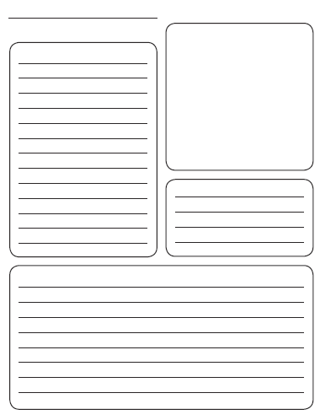
Day 5

