**1.The Guppy**   
*(Ogden Nash)*

an01552_[1]Whales have calves,   
Cats have kittens,   
Bears have cubs,   
Bats have bittens,   
Swans have cygnets,   
Seals have puppies,   
But guppies just have little guppies

**2.The Dog**   
*(Ogden Nash)*

The truth I do not stretch or shove  
When I state that the dog is full of love.  
I've also found, by actual test,  
A wet dog is the lovingest.

**j0436097[1]**

3.Betty Botter's Biting Beaver

*(Bruce Lansky)*

Betty Botter bought a beaver.  
But the beastly beaver bit her.  
So she bought a biting badger.  
And the badger bit the beaver.  
Since the badger bit the beaver,  
now the beaver will not bite her.  
So 'twas better Betty Botter  
bought a beaver-biting badger

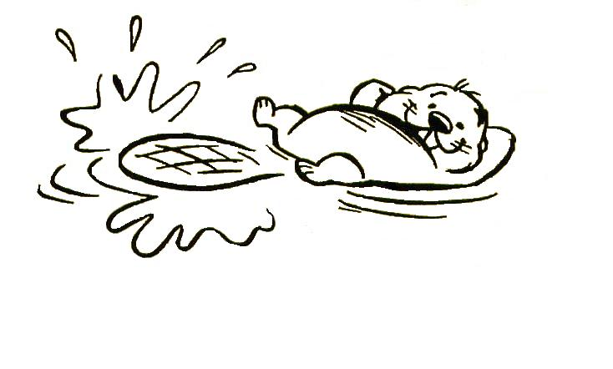

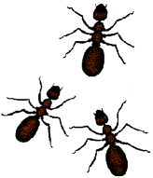4.Ants

*(Laurence Conway)*

**A**nts

 **N**ever

**T**ravel

**S**olo

**

## 5. Bear in There

*(Shel Silverstein)*

There's a Polar Bear

In our Frigidaire--

He likes it 'cause it's cold in there.

With his seat in the meat

And his face in the fish

And his big hairy paws

In the buttery dish,

He's nibbling the noodles,

He's munching the rice,

He's slurping the soda,

He's licking the ice.

And he lets out a roar

If you open the door.

And it gives me a scare

To know he's in there--

That Polary Bear

In our Fridgitydaire

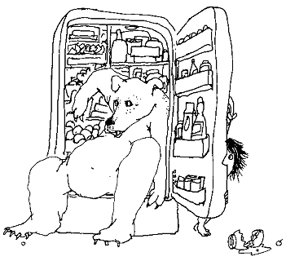6. Pig

*(Arnold Lobel)*

j0417460[1]There was a sad pig with a tail   
Not curly, but straight as a nail.   
So he ate simply oodles   
Of pretzels and noodles,   
Which put a fine twist to his tail.

7. Garden Snake

*(Muriel L. Sonne)*

I saw a snake and ran away…

j0110743[1]Some snakes are dangerous, they say;

But mother says that kind is good,

And eats up insects for his food.

So when he wiggles in the grass

I’ll stand aside and watch him pass,

And tell myself, “There’s no mistake,

It’s just a harmless garden snake!”