Year 3
In our science lessons this half term, Y3 have been learning about plants. We have investigated how water is transported within plants and how temperature affects the growth of a seedling. Linked to our English lessons using the Jack and the Beanstalk story, we have grown mini beanstalks over the last 3 weeks. They have grown very tall! Safwan was our star grower with an overall height of 38cm and it is still growing.
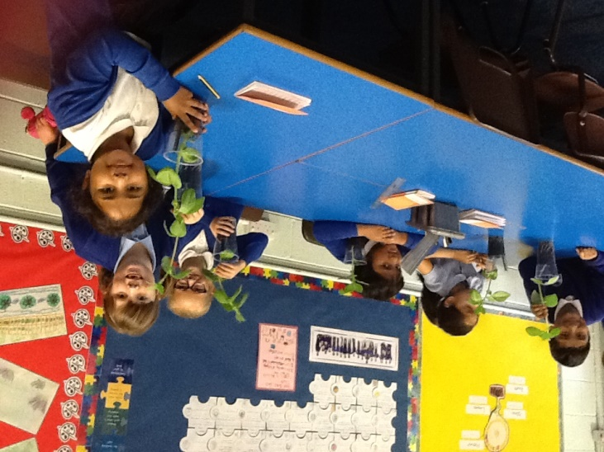

Last Friday, Y3 spent a lovely afternoon in the garden with Emma. We had lots of jobs to do before we eventually ate some delicious chocolate and beetroot muffins. We used the beetroots which had been grown in the garden over the summer.
