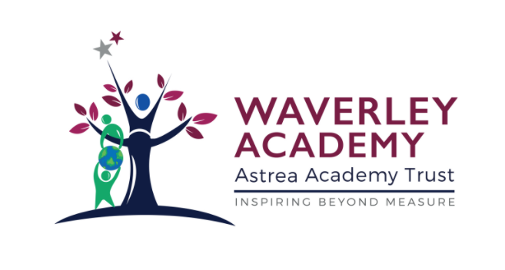

**Teaching, Learning & Assessment Policy**

Policy Adopted: 01 September 2020

Review: 31 August 2021

**Waverley Ethos**

At Waverley Academy, children come first and our priority is to deliver high quality teaching and learning whilst at the same time providing rich and truly enjoyable learning experiences for our community of children.  Everything we do as a school is to ensure that the children achieve their very best, and that they are socially and emotionally ready for academic success. We are deeply aware that children only get one chance at their primary education and it is our job to ensure that they all reach for the highest levels of personal achievement and development.

The vision of the curriculum at Waverley Academy is to give all pupils the knowledge and skills they need to succeed in life. The Waverley Curriculum ethos aims to create a thirst for learning, through first hand experiences and stimulating hooks, that broaden horizons and pushes expected boundaries. Children will leave Waverley Academy successful, with a love of learning that remains with them for their next phase in education.

Waverley Academy aims to provide a curriculum that is broad, balanced, relevant and differentiated to provide for varied abilities. Barriers to learning are removed and we provide suitable learning challenges that respond to diverse needs. This encompasses a variety of exciting, first-hand experiences to enable children to acquire appropriate skills, knowledge and understanding preparing them for today’s world. Through the provision of a stimulating environment, children will develop to their full potential academically, socially and physically.

**Purpose**

This Policy aims to define the ways in which the Academy will ensure high quality teaching, learning and assessment for all children. It outlines the key practices in place at the Academy and how these are intended to impact on the progress, attainment and wellbeing of all children.

**Policy Objectives.**

This policy aims to liberate teachers from unnecessary workload and from a focus on any activity which has low impact in the classroom. It is the express intention that this policy will support the Academy to recruit and retain excellent teachers through a sensible and appropriate approach to workload and through their elevated status as a result of a policy which allows teachers to lead their students’ learning in a direct and effective manner. The benefits to students are clear and are fundamentally outlined throughout the policy.

**Policy Scope**

This policy applies to all teaching staff within the academy. It is the responsibility of all individuals in the academy to familiarise themselves with this policy and comply with its provisions.

**Training and awareness**

The academy will ensure that all individuals understand their responsibilities under this Policy by providing appropriate training, education and guidance. The level of training and the nature of the education and guidance may vary depending upon the role as relevant to the policy.

**Reporting and Non-Compliance**

The impact of this policy will be measured and managed through quality assurance and ultimately through performance management, as engagement with training and development is a cornerstone of performance management targets.

**Statement of Intent**

Our curriculum is designed with the intent:

* That our curriculum should educate children about their role within the community and the positive impact they can have on their own lives and those around them. Therefore our curriculum is built upon a foundation which aims to develop a strong sense of self, of the local and wider history.
* That our children should have access to as many opportunities as possible so that they develop a broad knowledge and understanding of the world and what is possible. We tell our children to aim high- they are the future and they can make a difference.
* That our children should be exposed to activities and situations where they develop a broad range of skills, an understanding of diversity and tolerance. Team working is a vital skill as is the confidence to stand proud – our curriculum aims to develop both of these aspects.
* Our curriculum is underpinned by Astrea’s Core Values (Responsibility and Leadership, Enjoyment and Innovation, Aspiration and Development, Collaboration and Inclusion and Honesty and Integrity) and these are taught on their own and through other areas of the curriculum, including assemblies. The spiritual, moral, social and cultural development of our pupils and their understanding of the core values of our society are woven throughout the curriculum. Each week at our Waverley Rainbow Award assembly we highlight children who have demonstrated their understanding of these values.
* All subject leaders are given training and opportunities to keep developing their own subject knowledge, skills and understanding so they can support curriculum development and their colleagues throughout the school.

Theme weeks, whole school activities and opportunities within and outside school all enrich and develop the children’s learning. After school clubs and events extend these opportunities further. Additional whole school programmes and approaches support quality teaching and learning.

**Teaching and Learning at Waverley**

Teaching staff will always ensure their own positive demeanour. At all times, interactions with any staff member will be positive, friendly and fair. Children will always feel that their work and contribution is valued, they will understand that teaching staff have their very best interest at heart and that teaching staff are committed to their progress.

**Learning**

Children will understand that they themselves are the most important part of their learning. They will be committed at all times to hard work, contribution and achieving their very best. They will learn from the models of best practice they find in adults at Waverley. They will understand that commitment and hard work equates to success.

Waverley staff are learners too, they are committed to the development of their practice and broadening the experiences of our children.

**Rosenshine’s Principals of Instruction**

The Academy supports the ideas laid out in Barak Rosenshine’s paper, Principles of Instruction: Research Based Strategies That All Teachers Should Know. Since learning is something that we cannot, in any material sense, see, we need to take note of the evidence we have at our disposal. In Principles of Instruction, Rosenshine has provided us with a series of strategies that, implemented consistently allow us to make to improve pupil learning.

Rosenshine’s Principles draws research from three key sources:

1. Research in cognitive science

2. Research on the classroom practices of master teachers

3. Research on cognitive supports to help pupils learn complex tasks.

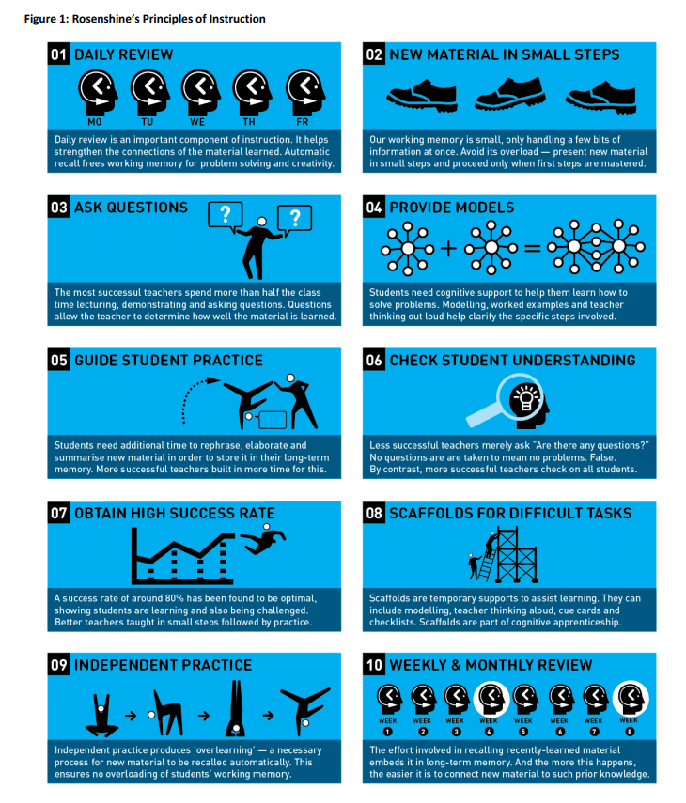

**Staffing**

Children will be assigned to a class group. This class will be led by a qualified teacher. The Academy employs a number of support staff including two Higher Level Teaching Assistants and a Safeguarding and Families Officer.

|  |  |
| --- | --- |
| Key Stage | Staff |
| Nursery | Mr Easton  Mrs Sweeney  Mrs Hilliard |
| Reception | Mrs Stevenson  Mrs Beedle |
| Year One | Miss Wright  Mrs Spencer |
| Year Two | Miss Greenwood  Miss Davies |
| Year Three | Miss Burgin  Mrs Hunt |
| Year Four | Mrs Balazas  Mrs Johnson |
| Year Five | Mr Davies  Mr Wood  Mrs Underwood  Mrs Chappell  Mrs Cooper |
| Year Six | Mr Hays  Miss McLeod |

Support Staff are always deployed for the needs of children including those who need additional support as stated in Educational Health Care Plans and SEND Support Plans. Additionally, a number of support staff are deployed to their skill set including phonic training, Thrive Practitioners and experience.

At various points during the school year, children may be taught in small groups by a teaching assistant such as for additional intervention. Teachers are responsible for the planning, teaching and assessment of the curriculum at Waverley Primary Academy.

**Curriculum**

As an Academy, Waverley has the freedom to decide on how to structure its curriculum and is not statutorily obliged to follow the National Curriculum. Waverley Academy currently follows the provision of the National Curriculum for England & Wales (2014). Details of how teaching and learning is structured can be found later in this document.

**Assessment**

Waverley Primary Academy undertakes national assessments each year. These include: KS2 SATs, normally administered each May to Year 6 children; KS1 SATs, normally administered during May each year to Year 2 children; the Year 1 Phonics Screening Check, normally administered in June to Year 1 children. The Academy also assesses the attainment of children in the Early Years for Good Level of Development in line with the Early Years Foundation Stage.

In addition to these national assessments, the Academy also undertakes termly summative assessments in reading and mathematics. The Academy Trust requires that the Academy uses NTS assessments for this purpose. These tests provide the Academy with clear data about how well children are doing and also provide teachers with vital ‘gap analysis’ for individual children so that teaching can be tailored to specific needs.

The Academy is committed to quality, ongoing formative assessment. This is taking place every day in all classrooms and includes how teachers assess children’s understanding of particular concepts and material. This also includes the marking and feedback provided in each lesson in children’s workbooks and verbally by all teaching staff in school. Details of this practice can be found in our Marking and Feedback Policy.

All evidence gathered from any form of assessment is used to develop the provision experienced by children in classrooms. Waverley staff are committed to ensuring that children’s learning is specifically tailored to their needs and identified gaps in knowledge, skills and understanding.

**Inclusion**

Waverley is resolutely committed to the inclusion of all children, regardless of need. This means that we always strive to identify issues that could demonstrate that a child needs provision that is different from and additional to everyday practice. In this case, the Academy will always communicate with parents, working collaboratively to meet needs. Sometimes it is useful to add a child to the Special Needs Register, meaning that a clearly bespoke and child-centred plan will be created to ensure that children reach their full potential and receive the right support at the right time. This is coordinated by the Academy’s SENDCo. Sometimes, children simply need short term, additional ‘boosts’ and this is a normal part of classroom practice. Waverley adopts Astrea’s Inclusion Policy and further information about SEN-D and Inclusion can be found on the school’s website or by contacting the SENDCo via the School Office.

All teaching and learning is personalised according to need. This may include the use of additional resources, the provision of some adult support, additional intervention or other scaffolding. This is planned by class teachers on a lesson-by-lesson basis and can be identified in teacher planning.

**Reading**

Waverley Academy believes firmly that a child’s ability to read is central to their success in broader life. In line with this, the Academy follows the Read, Write Inc scheme which includes regular, systematic synthetic phonics lessons.

Early Reading

At Waverley Academy we use Read Write Inc as our Phonics scheme for children from Nursery to Year 2.

In Nursery, the Phonics sessions place a huge emphasis on developing children’s love of reading through exciting and enticing story sessions before progressing onto being taught the sounds of letters with the help of mnemonics, to blend the sounds into words and read simple ‘blending books’.

From Reception to Year 2, children are taught in small groups following the Read, Write Inc Scheme. All children access a daily Phonics session and some also receive extra 1:1 tutoring.

Regular assessments are undertaken to monitor progress and to ensure children are being taught within the appropriate group. These assessments also help to prepare children for the Year 1 Phonics Screening Check.

The Reading Week

There is a daily reading lesson at Waverley for all children.

From Year 2 to Year 6, we dedicate a daily 45 minute lesson to the teaching of reading. This Reading approach develops pupils’ capability to support their reading and writing, support pupils to develop fluent reading capabilities, teach reading comprehension strategies through modelling and supported practice. (EEF)

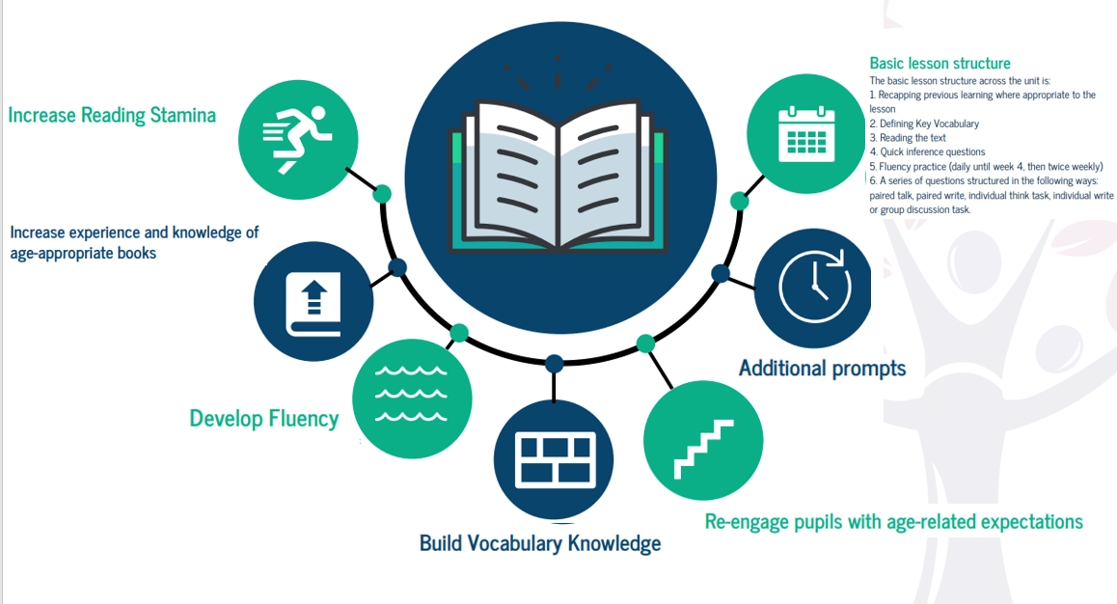

Each session begins with a recap of previous learning and a focus on the key vocabulary to build understanding of the text. Children are then given an opportunity to read the text out loud before jumping into quick inference questions to check understanding. The lesson structure progresses onto fluency practice incorporating text marking to support pupils to read with emphasis before moving onto a series of structured comprehension questions.

**Word of the Day**

At Waverley Academy we believe that ‘words have power.’ A wide range of studies show that vocabulary knowledge is strongly related to reading comprehension across the age span. Therefore, the implementation of a whole-school vocabulary strategy is vital to accelerate academic progress and close the disadvantaged gap. Word of the Day is taught daily from Key Stage one upwards. This is a 10-15 minute lesson which focus on tier 2 words including pronunciation and syllables, child friendly definitions, Word class, exemplar and pupil created sentences, Prefixes, Suffixes, Root Word, Synonyms and Antonyms.

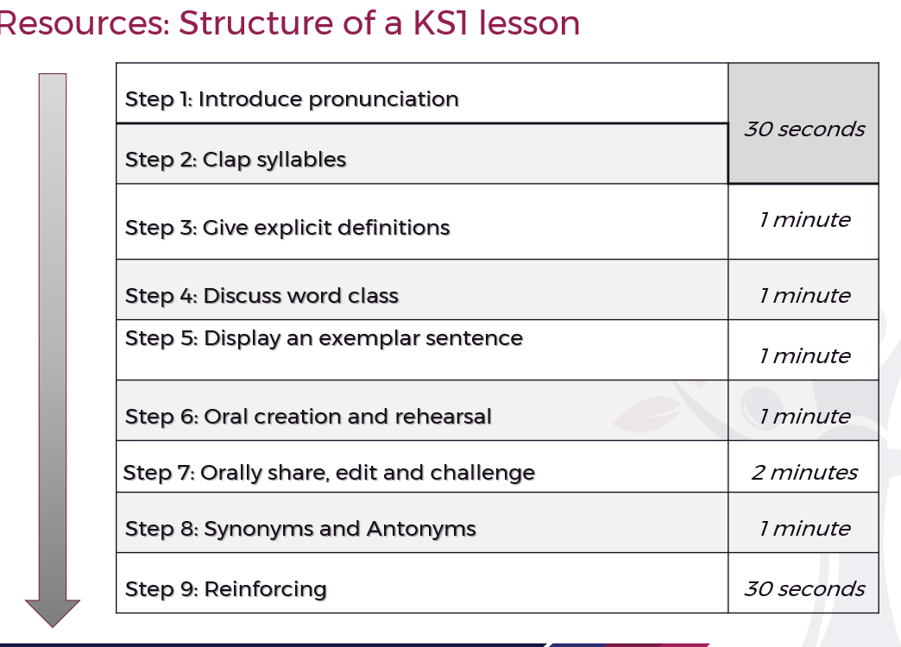

**Writing**

Waverley adopted the Literacy Curriculum’s Literacy Tree approach to the teaching of writing in September 2019. This is a progressive, structured writing programme with an extensive text-based approach. A full long-term plan for this is available in the appendices. Children write regularly and at length relative to their stage at Waverley and clear feedback is provided by teaching staff.

In line with best practice, teachers at Waverley plan regular opportunities for children to write across a range of genres, for different purposes and audiences, across the curriculum and applying their skills in a range of contexts.

There is a daily writing lesson at Waverley for all children.

**Maths**

The intent of our Mathematics curriculum is to deliver a curriculum which is accessible to all and that will maximise the outcomes for every child so that they know more, remember more and understand more. As a result of this they will

* Make rich connections across mathematical ideas to develop fluency, mathematical reasoning and competence in solving increasingly sophisticated problems.
* Be able to apply their mathematical knowledge to science and other subjects.
* Realise that mathematics has been developed over centuries, providing the solution to some of history’s most intriguing problems.
* Know that it is essential to everyday life, critical to science, technology and engineering, and necessary for financial literacy and most forms of employment.
* Understand the world, have the ability to reason mathematically.

**How is Maths taught?**

Waverley adopted a mastery approach to maths, with the support of Arch Maths in September 2020. Teachers use the National Curriculum, Arch Maths Hub, NCETM, Times Tables Rock Stars and Nrich as a basis for implementing the statutory requirements for the study of mathematics. Over a series of Maths lesson, teachers ensure there are opportunities for children to practise their arithmetic, fluency, problem solving and reasoning skills. Our lesson structure incorporates the Maths skills as set out in the EEF toolkit below

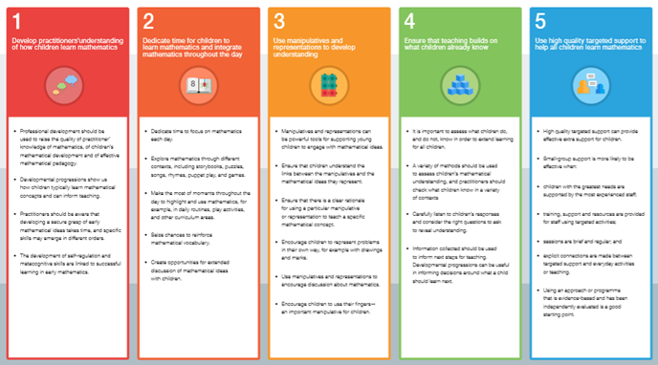

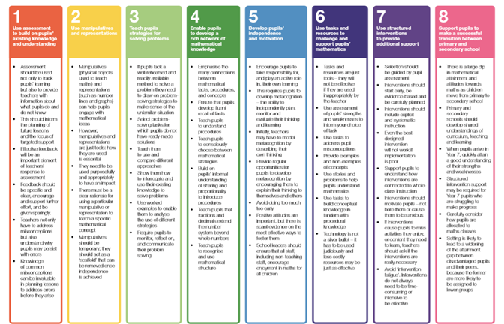

**Times Table Rockstars**

Children from Y1-Y6 have access to a Times Table Rock Stars account. They complete the paper tests three times a week on a Monday, Wednesday and Friday. Ipads will be used as an additional focus both in school and at home, to further consolidate their times tables learning. It is expected that children are fluent in their multiplication tables up to and including 12 x 12 by the end of Year 4 and this is tested by the National Multiplication Tables Check June 2021.

**Our Maths Lessons**

Maths lessons consist of an arithmetic practice called’ Do it Now’ and a main teaching input. During the arithmetic practice, focus will be on reinforcing and consolidating arithmetic skills through tailored teaching from the Calculation Policy. We believe that this plays an important role in the children becoming fluent in the fundamentals of mathematics and develops the children’s ability to recall and apply knowledge rapidly and accurately. It also enables teachers to identify those areas which need revisiting for particular pupils. Intervention for arithmetic will occur during the lesson with any further intervention occurring on the same day.

During the main teaching, pupils will be exposed to concept, fluency, problem solving and reasoning skills. The teacher will model explicitly the methods and thought processes to pupils and will use AFL strategies such as Kagan, use of whiteboards and questioning to provide tailored support and move pupils on quickly and effectively.

You can see further information of what we are learning and why we have chosen this way to teach across school below through our White Rose Scheme of work, Calculation Policy and Maths Policy.

**Science**

The intent of our Science curriculum is to deliver a curriculum which is accessible to all and that will maximise the outcomes for every child so that they know more, remember more and understand more. As a result of this they will

* develop scientific knowledge and conceptual understanding through the specific disciplines of Biology, Chemistry and Physics;
* develop understanding of the nature, processes and methods of Science through different types of science enquiries that help them to answer scientific questions about the world around them;
* be equipped with the scientific knowledge required to understand the uses and implications of Science, today and for the future.
* Develop an enthusiasm and enjoyment of scientific learning and discovery.

Science lessons will take place weekly, with a half termly investigation. Science Knowledge Walls will be throughout school, which focus on key knowledge, vocabulary and questions and exemplify the terminology used throughout the teaching of science in school and other aspects of life including recent scientific discoveries and experiments. **Subject specific vocabulary** will be identified through knowledge organisers and knowledge wall and highlighted to the children at the beginning of lessons and revisited through cold and hot assessments.

**Provision in EYFS**

Children are given a secure grounding in the Prime Areas of learning, ensuring they have a good foundation on which to build through the specific areas, including understanding the World. Areas of provision are enhanced to ensure vocabulary understanding and extension, and develop understanding of themselves and the world around them.

**Fair testing/ bias**

We aim for children to recognise that bias can exist in science experiments particularly those conducted without thinking about variables. Children will be expected to recognise and comment on the validity of their tests and some will be able to explain why a fair test is important.

**Assessment**

Cold and Hot assessments. Teachers track this data and it is then put on the whole school data tracker

.

**Outdoor learning**

We recognise that children learn in a variety of ways, and so where appropriate, children will learn Science outside the classroom.

**Approaches to teaching**

A wide variety of teaching approaches are used in science lessons to ensure children make good progress, and all learning styles are catered for. Class teachers ensure there is a good balance of whole class, group work, as well as time for children to express ideas individually. All classes will have at least 1 science experiment every half term.

**Consistent teaching sequence**

Science lessons will follow a clear and consistent teaching sequence, including putting the learning in the context of the topic and current time.

An emphasis on past and future learning to reconnect with old topics, embed current learning and set up new learning. Specifying new key vocab and using it throughout the learning. Correct modelling of using specific science equipment to not only ensure safety, but also to ensure experiments are carried out properly with children able to recognise and control certain variables.

**Learning environment**

The learning environment is designed to ensure children develop their Science knowledge, and continue to know more and remember more. Knowledge walls and practical engaging experiments are key drivers to this, with teachers making reference to them during lessons and at other regular times during the term, including plenaries and starters.

**Research:**

Each class will use a termly homework project to undertake a research project focusing on their current science topic. This will support independent learning as well as allowing children to improve their working scientifically skills.

**Basic skills**

English, Maths and ICT skills are taught during discrete lessons but are revisited in science so children can apply and embed the skills they have learnt in a purposeful context.

**Cultural Capital**

Each class will take part in a yearly science visit focusing on one of the topics they have covered in that year. We will also use outside resources to come into school and connect the kids with science in a different context to school. We will also provide children with links to STEM careers and opportunities as well as inviting STEM ambassadors in to school to speak with the children.

**Non-Core (Foundation) Subjects**

Waverley follows the Curriculum Plan as outlined in the curriculum policy. This follows the PKC scheme of learning for Geography and History. In Geography, all year groups focus on Spatial Sense for the first half term and then focus in on areas of the UK, then the wider world as the year progresses. In history, children spend each half term (or every alternate half term in KS1) on a focus topic. Both history and geography work is recorded in one humanities book. Children complete a cold task assessment for both subjects at the start of each half term and repeat at the end of the unit of work to monitor progress.

RE, Spanish and PSHE are recorded in a separate humanities book.

Non-core subjects are taught most afternoons at Waverley.

**Physical Education**

Physical Education is taught for two hours per week at Waverley using both indoor and outdoor facilities. Waverley adopted the REAL PE scheme in September 2019.

**ICT**

Children are taught to use ICT for the purpose of research, communication and presentation. Children are taught how to stay safe online and the principles related to working in the digital age.

**Music**

Music is a universal language that embodies one of the highest forms of creativity. A high quality music education should engage and inspire pupils to develop a love of music and their talent as musicians, and so increase their self-confidence, creativity and sense of achievement. As pupils progress, they should develop a critical engagement with music, allowing them to compose, and to listen with discrimination to the best in the musical canon. Children at Waverley receive a 30-minute music lesson each week.

**Minimum Expectations**

Teachers plan lessons for each day of the school year. The Academy holds long term overviews, which can be found in the appendices. The following expectations are the minimum requirements of all children at Waverley.

Reading

A daily lesson in line with the Waverley Reading Week

Writing

A daily writing lesson in line with Literacy Tree programmes of study.

Books marked in line with Feedback Policy by teaching staff daily with evidence of pupil correction / response

|  |  |
| --- | --- |
| **FS** | Daily RWI lessons, with a focus on letter formation.  A ‘writing’ rich environment.  Opportunities for Mark making and Writing. |
| **KS1** | Daily writing opportunities where children record at least 1/2 page or the equivalent in writing books, Year 2 and several sentences in Year 1,  Three extended pieces of writing each half term.  Well presented, legible writing.  A new page for each new day  Response to feedback in Blue ink |
| **LKS2** | One extended piece of independent writing each week  Daily writing opportunities where children record at least a 1/2 page or the equivalent in writing books  Progressing to cursive, joined handwriting  Well presented, legible writing, using Manuscript Pen or pencil as identified by the teacher  Long-hand date and learning objective hand written daily  A new page for each new day  Response to feedback in Blue ink  Evidence of at least twice-weekly word and sentence level development including the teaching of grammatical structures, punctuation and syntax |
| **UKS2** | One extended piece of independent writing each week  Daily writing opportunities where children record at least a ¾ page or the equivalent in writing books  Cursive, joined handwriting  Well presented, legible writing, using Manuscript Pen  Long-hand date and learning objective hand written daily  A new page for each new day  Response to feedback in blue ink  Evidence of at least thrice-weekly word and sentence level development including the teaching of grammatical structures, punctuation and syntax |

Maths

A daily maths lesson in line with the White Rose programmes of study.

Books marked in line with Feedback Policy by teaching staff daily with evidence of pupil correction / response.

|  |  |
| --- | --- |
| **FS** | A daily adult led Maths sessions, focusing on Number and counting starter.  A number rich environment, where children are encouraged to problem solve and develop their critical thinking skills. |
| **KS1** | Daily number / calculation work recorded in maths book (Practical work to be photographed)  Evidence of intervention where appropriate  Weekly problem solving / reasoning tasks recorded in maths book  Evidence of challenge / extension / support / scaffolding where appropriate |
| **LKS2** | Daily number / calculation work recorded in maths book  Evidence of intervention where appropriate  Weekly problem solving / reasoning tasks recorded in maths book  Evidence of challenge / extension / support / scaffolding where appropriate |
| **UKS2** | Daily number / calculation work recorded in maths book  Evidence of intervention where appropriate  Weekly problem solving / reasoning tasks recorded in maths book  Evidence of challenge / extension / support / scaffolding where appropriate |

Non-Core

There will be at least three recorded pieces of work or the equivalent in Non-Core workbooks each week. Non-Core books will be marked and feedback provided to children in line with the Feedback Policy.

**In all cases, for all subjects, workbooks, lessons and planning must reflect clear personalisation for the range of need, regular marking and feedback and response to marking and feedback. All workbooks must be well presented inside and out, without graffiti, dirty marks or any evidence that suggests learning behaviours. Children and staff must take pride in their work and its presentation at all times and in all cases.**

**The presentation of teaching staff in workbooks and the wider environment will be of the highest standard and reflect the Academy’s expectations at all times.**

**Poor presentation and insufficient quantity of work in a lesson will be addressed by teaching staff at all times.**

**Education Beyond the Classroom**

The Academy is committed to the provision of regular and appropriate educational visits. The safety and welfare of children is our primary concern and clear policies are in place to ensure that children are able to undertake regular visits to enhance learning beyond the classroom.

**Attendance**

In order for children to benefit for the high-quality education offered at Waverley, regular attendance is an expectation. Irregular attendance directly impacts on progress. Our expectation is simple – attend school, on time, every day. Where a child is unable to attend school, we expect that parents will communicate with school in a timely manner and provide clear evidence for the reason for any absence.

**Questions and Further Information**

Any stakeholder with questions about this policy or requiring further information should contact the class teacher in school in the first instance. The school website: astreawaverley.org contains a wealth of further information.