English | Maths |  |  |  |  | Science
We will continue to work on a range of strategies to support reading comprehension and will be focusing on reading speed and accuracy and precision of answers relating to what we have read.  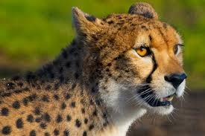  We will be writing non-chronological reports based on the animals we saw at Yorkshire Wildlife Park. These will link with our art work and we would like to showcase this to parents and carers on Wednesday 25th March at 2.30pm (entrance via the school office). We will also be writing our own stories which we will read to our reading buddies in Y2 and writing like scientists when we write up our science experiments. We will also be revising our knowledge of grammar and practising spellings!  For some further challenges, you could also try: https://www.bbc.co.uk/bitesize/articles/zbm8scw Crystal challenge - grammar  https://ictgames.com/mobilePage/spookySpellings/index.html Spooky spellings  Support at home by: Every child will have their own reading book to read at home. Please ensure that children are reading every day and talk to them about what they have read. Children need to complete their reading record and bring this in every day. | This half term we will be…  - Developing understanding of Geometry! We will focus on developing our knowledge of 3D shapes and our confidence in solving problems.  - Finding fractions and solving multi-step problems.  - Linking fractions, decimals and percentages and developing our arithmetic skills so that we can choose the most efficient method to solve a problem.  - Revising our knowledge of Measures! Km/M/cm/mm; Kg/g; £/p; L/ml and converting between measures.  - Looking at graphs and charts and reading these accurately.  - We will be revising all of the topics we have learned so far to build confidence.  Support at home by: Asking your child to explain something they have learned at school. This could be an arithmetic strategy (such as how to work out $\frac{1}{5}+\frac{2}{3})$ or a skill (such as drawing an angle = 43⁰).    Encourage your child to access Sumdog and TTRockstars at home – login details are in reading records.  Please ensure that all homework set is complete and handed-in on time (This is set on Friday and due in on Wednesday). For some further challenges, you could also try:  This game…  https://www.bbc.co.uk/bitesize/topics/zbbtrmn/articles/zn2y7nb  Arithmetic challenges…  https://mathsframe.co.uk/en/resources/resource/486/Y6-Arithmetic-Practice |  |  |  |  | We will be learning about Materials.  We will look again at conductivity and talk about the most suitable material for thermal conductivity as well as analysing different materials and their properties. We will also look at solubility and identify what it means to be soluble and which materials are soluble.    For some further challenges, try:  https://www.bbc.co.uk/bitesize/topics/zryycdm
 |  |  |  |  |  | British Sign Language:
 |  |  |  |  |  | We will focus on developing our understanding of greetings, emotions and will be reviewing our progress so far!
The children are working very hard to prepare for their SATs and have extra revision books which focus on reading comprehension and maths. Please encourage your children to use these and return them to school so that they can be marked with a teacher. If you would like any further information about this week, please speak to Miss Marshall.

Personal Development |  | Art |  | PE
We will be following the Sheffield scheme for RSHE and covering…  * Where should I get my health information?  *Protecting our identity  Additionally, we will be watching the NSPCC Stay Safe Assembly and completing some follow up work about this.  We will also have a special Road Safety session in school.  If you have any questions about this or would like any more information, please speak to Miss Marshall or Mrs Kaufman.  As families begin to find out about secondary school allocations from the 1st March, we know that some children can begin to feel a little apprehensive about upcoming changes. While we will talk about resilience and managing changes as part of our PD sessions, please let school know if you have any questions or concerns. |  | We will be creating images based on our visit to Yorkshire Wildlife Park!  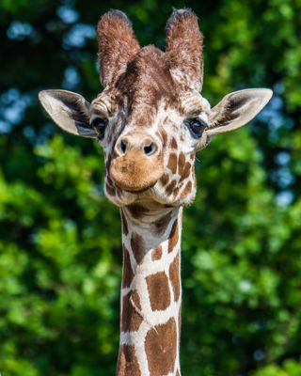 |  | This half term we will be developing our yoga skills during our indoor PE lessons and developing Tennis skills during outdoor sessions.    Please remember that your child needs the correct PE kit in school every day in case of changes to PE times. Children must not wear jewellery. A warm jumper and leggings or jogging bottoms would be very useful for outdoor sessions this term.
Useful Information  Punctuality is really important. For Y6, school starts at 8:45am and the gate will be locked at 8:50am. Breakfast club will be available before this time but must be booked in advance. Please speak to the school office if you wish to book your child in.  Our PE days are Tuesday and Wednesday. Please ensure that your child has the correct clothing with their name in this in school every day.  Homework helps children to get ready for secondary school. Homework is given out every Friday and due back the following Wednesday. Children also need to read at home every day, record a short summary in their reading record and hand this in each day to Mrs Allen.  Revision books are needed every day. Children have received their red revision book for maths and this needs to be brought into school each day. Booster sessions for some children have begun again and will run until Easter. If your child has been awarded a place, please encourage them to attend every session. |  |  |  |  | Dates for your diary:  24th February – Trip to Yorkshire Wildlife Park  26th February 9am Sumdog Parent Event – in the hall  5th March – World Book Day - please dress up in PJs or comfy clothes for a special day in school!  20th March – Red Nose Day  Wednesday 25th March at 2.30pm – Art Showcase in the hall  26th March – Y3-Y6 Easter Disco 4:30-5:45 – book via the app  27th March – Y6 Road Safety session
Website links:  - TTRockstars: https://play.ttrockstars.com/auth/school/student/2498  - Sumdog: https://www.sumdog.com/user/sign_in |  |  | Contacting your child’s teacher  You can speak to your child’s class teacher at the end of the school day or by emailing the school office who will pass on your question so the teacher can contact you.

