English | Maths | SATS preparation
We will continue to work on a range of strategies to support reading comprehension and will be focusing on reading speed and accuracy and precision of answers relating to what we have read.  We will be reading the book, “The Arrival” by Shaun Tan and writing descriptions, narratives and letters based upon this.  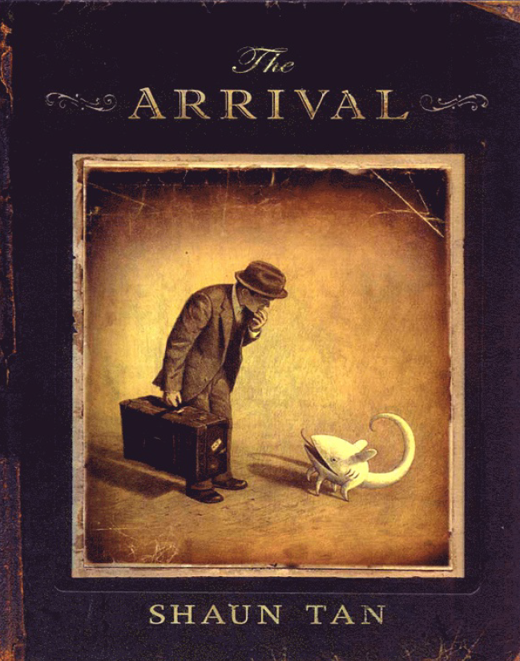  We will also be conducting and writing a science experiment this half term!  Support at home by: Every child will have their own reading book to read at home. Please ensure that children are reading every day and talk to them about what they have read.  Children need to complete their reading record and bring this in every day. Additionally, children will be provided with comprehension homework books. Please encourage children to complete this as part of their homework. If you have any questions, please speak to Miss Marshall.  . | This half term we will be learning about:  - Further strategies we can use to solve problems involving fractions, decimals and percentages  - Area and perimeter  - Geometry! Developing our understanding of angles and shape including learning to use a protractor to measure and draw angles and shapes accurately.  - Strategies we can use to solve problems mentally and how to spot patterns to help us.  Support at home by:  All children have a Sumdog account where personalised work is set weekly for them. Please encourage your child to spend at least 30minutes every week on this. Children also have a TTRockstars account which will help them to practise their multiplication facts if they do not know these. Both login details are inside their reading record.    Does your child know how to tell the time? If they cannot do this using an analogue and a digital clock face, please work with them on this. There are challenges linked to this on Sumdog and see Miss Marshall if you would like more support.  Children also have a TTRockstars account which will help them to practise their multiplication facts if they do not know these. Both login details are inside their reading record.
 |  | Geography
.

In Geography, we will be learning all about Yorkshire and local geography. We will build our understanding of UK geography and look at how human activity has changed landscapes.

Personal Development | Computing |  | Creative | PE
We will be following the Sheffield scheme for RSHE and covering…  *Control and consent  *Empathy and Migration workshop delivered by the British Red Cross.  We will continue to develop and explore online safety and how the pupils keep themselves safe when using technologies online.  Check out:  https://www.youngminds.org.uk/parent/a-z-guide/social-media/  If you have any questions, concerns or would like any more information, please contact the school office and speak to Miss Marshall. | This term we are exploring the concept of variables in programming through games in Scratch. First, children find out what variables are and relate them to real-world examples of values that can be set and changed. Then they use variables to create a simulation of a scoreboard. Children will experiment with variables in an existing project, then modify them, before they create their own project.  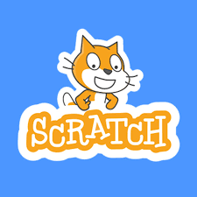 |  |   Art – We will be looking at Chinese brush painting, investigating Ming Dynasty porcelain and how this was made and decorated with cobalt blue.  British Sign Language: We will be developing simple conversations.  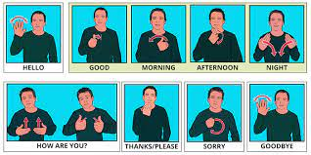 | This half term we will be developing our gymnastic skills during our indoor PE lessons and developing Hockey skills during outdoor sessions.    Please remember that your child needs the correct PE kit in school every day in case of changes to PE times. Children must not wear jewellery. A warm jumper and leggings or jogging bottoms would be very useful for outdoor sessions this term.
Useful Information  Punctuality is really important. For Y6, school starts at 8:45am and the gate will be locked at 8:50am. Breakfast club will be available before this time but must be booked in advance. Please speak to the school office if you wish to book your child in.  Our PE days are Tuesday and Wednesday. Please ensure that your child has the correct clothing with their name in this in school every day.  Homework helps children to get ready for secondary school. Homework is given out every Friday and due back the following Wednesday. Children also need to read at home every day, record a short summary in their reading record and hand this in each day to Mrs Allen and Mr Ruddy.  Revision books are needed every day. Children have received their red revision book for maths and this needs to be brought into school each day. Booster sessions for some children will begin during the week commencing 19th January. If your child has secured a place, you will be informed by Friday 9th January. |  |  |  |  | Dates for your diary:  Wednesday 7th January – 9am, Sumdog Parent Workshop – a short session exploring this online resource and how it can be used to support your child’s learning.
Website links:  - TTRockstars: https://play.ttrockstars.com/auth/school/student/2498  - Sumdog: https://www.sumdog.com/user/sign_in |  | Contacting your child’s teacher  You can speak to your child’s class teacher at the end of the school day or by emailing the school office who will pass on your question so the teacher can contact you.

