English | Maths | Science
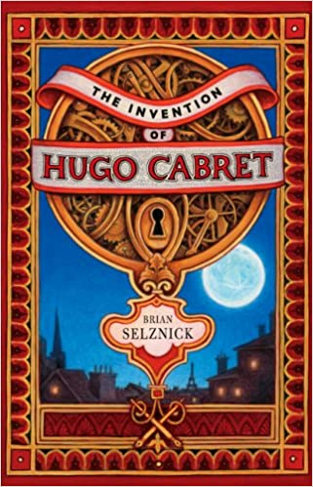  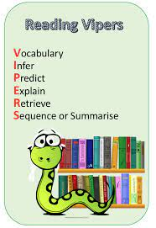  Each week we will study an extract from a well-known book working on key reading skills.  We will be writing diaries, biographies and discussions based on our book “The Invention of Hugo Cabret”  Support at home by: Every child will have their own reading book to read at home. Please ensure that children are reading every day and talk to them about what they have read. Children need to complete their reading record and bring this in every day. | This half term we will be learning about:  - Strategies we can use to solve problems involving multiplication and division  - Fractions! How to add, subtract, multiply and divide fractions; How to simplify fractions and find equivalent fractions and how to convert mixed number to improper fractions  - The link between fractions, decimals and percentages    - Strategies we can use to solve problems mentally and how to spot patterns to help us.  Support at home by:  All children have a Sumdog account where personalised work is set weekly for them. Please encourage your child to spend at least 30minutes every week on this. Children also have a TTRockstars account which will help them to practise their multiplication facts if they do not know these. Both login details are inside their reading record. | In Science, we will be learning about astronomy, and we will explore:  - The Big Bang and the expanding universe.    - How gravity affects our solar system.  - The planets and other celestial bodies.  - The Moon’s phases and the Sun’s role.  - Our galactic neighbourhood and galaxies!
 |  | Creative
Art –Islamic Art and Architecture.

We will be learning about the Taj Mahal, the Dome of the Rock and the Alhambra and using a compass to help us draw and create our own geometric designs.

British Sign Language: We will be developing simple conversations and learning to sign a Christmas song.
Personal Development
We will be following the Sheffield scheme for RSHE and covering…
- How do I accept my friends for who they are?
- Analysing Digital Media
If you have any questions about this or would like any more information, please speak to Miss Marshall or Mrs Kaufman.

Humanities | Computing |  | PE
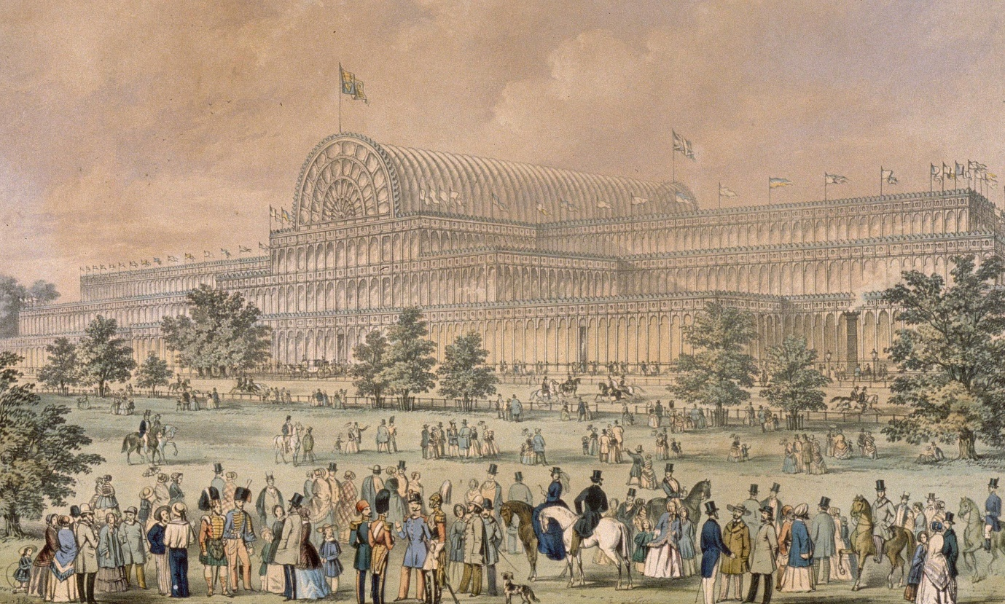  In History, we will be learning all about Victorians. We will learn about Queen Victoria and Prince Albert, the slims and workhouses and what life was like by 1900.  In Geography, we will be learning all about mountains. We will learn about different mountain ranges around the world and how they were formed.  In R.E., we will be looking at charity across religions with a focus on Christianity and Islam. | We will explore the concept of variables in programming through games in Scratch. They will find out what variables are and relate them to real-world examples of values that can be set and changed, and we will experiment with variables. We will continue to discuss with children how to stay safe online. If you have any questions, concerns or would like any more information, please contact the school office and speak to Miss Marshall. |  | This half term we will be focusing on dance and netball.    It is important that children come to school with an appropriate school P.E. kit and avoid wearing jewellery on the days they are doing P.E.
Useful Information  For Y6, school starts at 8:45am and the gate will be locked at 8:50am. Breakfast club will be available before this time but must be booked in advance. Please speak to the school office if you wish to book your child in.  Our PE days are Tuesday and Wednesday. Please ensure that your child has the correct clothing with their name in this in school every day.  Homework – Homework is given out every Friday and due back the following Wednesday. Children also need to read at home every day, record a short summary in their reading record and hand this in each day to Mrs Allen.  Children have received their red revision book for maths. This needs to be brought into school each day. |  |  | Dates for your diary:  We will be holding a Y5/6 Christmas Market on Monday 1st December! We would like to invite parents and carers in from 2:30pm. Further details to follow.  Thursday 4th December – Christmas disco  Wednesday 17th December – Christmas lunch  Friday 19th December – Inset day (school closed for children)
Website links:  - TTRockstars: https://play.ttrockstars.com/auth/school/student/2498  - Sumdog: https://www.sumdog.com/user/sign_in |  | Contacting your child’s teacher  You can speak to your child’s class teacher at the end of the school day or by emailing the school office who will pass on your question so the teacher can contact you.

