English |  | Maths |  |  | Science
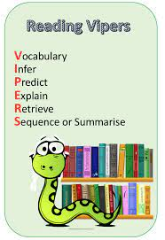  Each week we will study an extract from a well-known book working on key reading skills.    We have had a gorilla running through school! This is linked to our new class book, “Anthony Browne’s King Kong”.  We will be writing descriptions of characters and settings and writing stories.  Support at home by: Every child has their own reading book to read at home. Please ensure that children are reading every day and talk to them about what they have read. Children need to complete their reading record and bring this in every day. |  | This half term we will be learning about:  - Place value – numbers up to 10,000,000, rounding to a required degree of accuracy and estimating  - Addition (e.g. 5 digit + 3 digit e.g. 23451 + 568 and decimals e.g. e.g. 456.4 + 65.12)  - Subtraction (e.g. 5 digit – 3 digit e.g. 23451 – 568 and decimals e.g. 456.4 - 65.2)  - Multiplication (e.g. 2 digit x 2 digit e.g. 45 x 34, 3 digit x 2 digit e.g. 245 x 34 and 4 digit x 1 digit e.g. 3451 x 7)  - Division (4 digit ÷1 digit e.g. 1284 ÷ 4)  - Solving problems using all of the above skills    Support at home by:  - Accessing Sumdog at home – login details are in reading records  - Ensuring all homework set is complete and handed-in on time (set on Friday, due by Wednesday) |  |  | We will be learning about the human body and the function of the heart.  Why not try: https://classroom.thenational.academy/units/human-anatomy-f968
 |  |  |  |  | Computing
During this half-term, we will be focusing on ensuring that children can use technology safely.

Please talk to your child about how they use technology including which apps and sites they regularly use and encourage them to share their passwords with only you so that you can monitor how they interact with the digital world.

Check out: https://www.saferinternet.org.uk/advice-centre

If you have any questions, concerns or would like any more information, please contact the school office and speak to Miss Marshall.
Personal Development | Humanities |  | Creative |  |  | PE
We will be following the Sheffield scheme for RSHE and covering…  - Why are some people unkind?  - How do I save a life?  We will also be thinking about friendships and learning more about online safety.  If you have any questions about this or would like any more information, please speak to Miss Marshall or Mrs Kaufman. | In history we will be learning about the early British Empire.  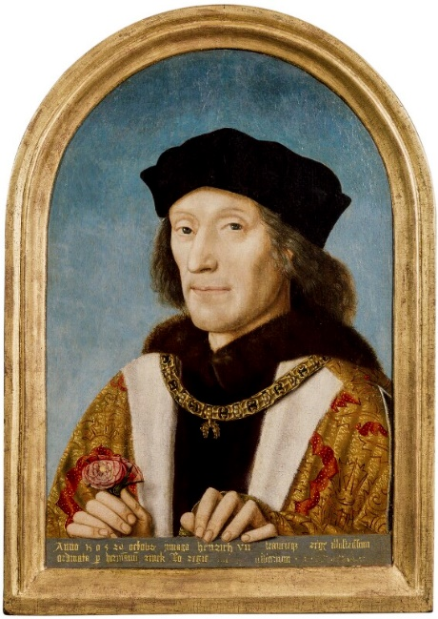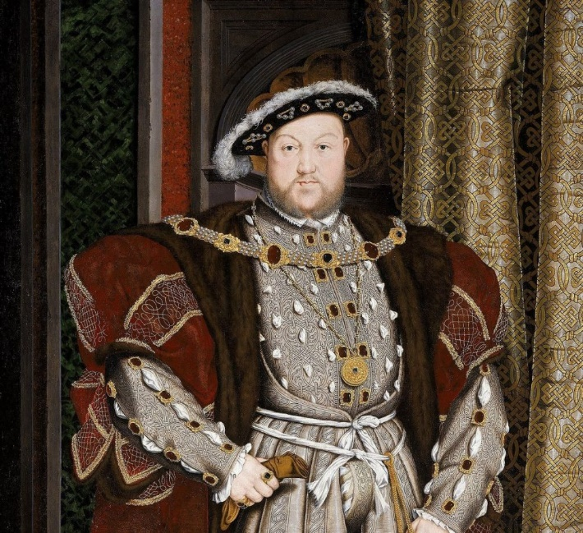  We will look at British Monarchs, global trade, the Mughal Empire, the 7 Years War and motivations behind the building of the empire. |  | 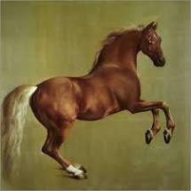  Art – style in art! We will be looking at Rococco and modernist styles. We will be looking at artists such as Stubbs and Munch.  BSL - We will be learning British Sign Language each week. We will be focusing on learning the alphabet, colours and signs we need within the school environment. |  |  |   This half term we will be doing Athletics and Fitness!  Please remember that your child needs the correct PE kit in school every day in case of changes to PE times. Children must not wear jewellery.
Useful Information  For Y6, school starts at 8:45am and the gate will be locked at 8:50am. Breakfast club will be available before this time but must be booked in advance. Please speak to the school office if you wish to book your child in.  Our PE days are Tuesday and Wednesday. Please ensure that your child has the correct clothing with their name in this in school every day.  Homework – Homework is given out every Friday and due back the following Wednesday. Children also need to read at home every day, record a short summary in their reading record and hand this in each day to their teacher.  Children will receive revision books during the Autumn term and booster sessions will be available for some children. More details to follow.  The deadline for applying for secondary schools is 14th October. Please ensure you identify three schools on this: if you do not put three schools and do not get your first or second choice, you are likely to be allocated out of area, meaning your child will need to catch two or more buses to attend. If you are unsure or would like help with this, please speak to Miss Marshall or Miss Wendy in the office. |  |  |  |  |  | Dates for your diary:  We hope you can join us for a parents meeting about this and other information about Y6 on Wednesday 17th September at 9am.  Important information about the year, including SATS and boosters will be shared. If you are unable to attend, please contact the school office and we will provide you with all of the relevant information.  Y6 residential Monday 20th October – Wednesday 22nd October. Further information about this to follow. If you haven’t already booked your place and would like your child to go, please speak to Miss Marshall or Mrs Kaufman.
Website links:  - TTRockstars: https://play.ttrockstars.com/auth/school/student/2498  - Sumdog: https://www.sumdog.com/user/sign_in |  |  |  | Contacting your child’s teacher  You can speak to your child’s class teacher at the end of the school day or by emailing the school office who will pass on your question so the teacher can contact you.

