English |  | Maths |  | Science
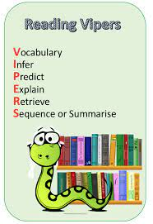  Each week we will study an extract from a well-known book working on key reading skills.  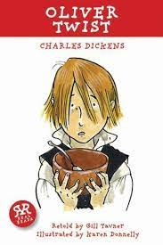  We will be writing a diary entry and persuasive letter based on our book “Oliver Twist”. Additionally, we will write a non-chronological report on an animal from Yorkshire Wildlife Park.  Support at home by: Every child will have their own reading book to read at home. Please ensure that children are reading every day and talk to them about what they have read. Children need to complete their reading record and bring this in every day. |  | This half term we will be learning about:  - Measuring and drawing angels with a protractor.  - Understand and use angle facts to calculate missing angles.  - Read, write, order and compare decimals.  - Round decimals to the nearest whole number.  - Represent, identify, name, write, order and compare fractions (including improper and mixed numbers).  Support at home by:    - Accessing Sumdog to complete maths questions. Please encourage your child to spend at least 20 minutes every week on this.  - Ensuring all homework set is complete and handed-in on time (set on Friday, due by Wednesday). |  | In Science, we will be learning about materials and we will explore:  - How materials are grouped based on their properties.  - What thermal conductivity is.  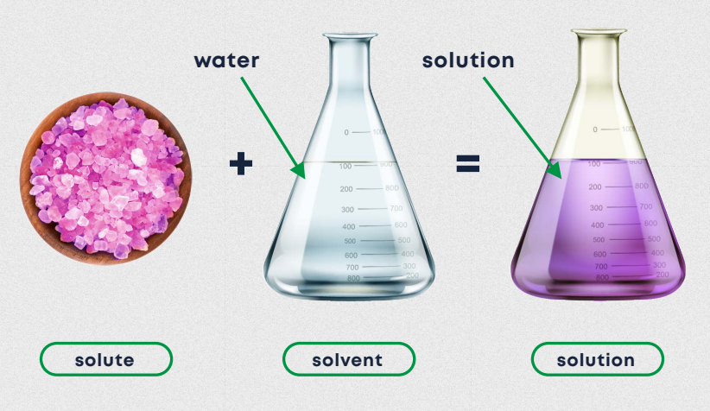  - Different methods of separating mixtures.  - How a solution is formed.  - Reversible and irreversible changes.
 |  |  |  | Computing
 |  |  |  | We will explore the concept of variables in programming through games in Scratch. They will find out what variables are and relate them to real-world examples of values that can be set and changed, and we will experiment with variables. We will continue to discuss with children how to stay safe online. If you have any questions, concerns or would like any more information, please contact the school office and speak to Miss Marshall.
RSHE | Humanities |  | Creative |  | PE
We will be following the Sheffield scheme for RSHE and covering the below:  - Where should I get my health information?  - Protecting our identify. |   In Geography, we will be learning all about Australia. We will explore the different landscapes within Australia and learn about the impacts of colonising.  In History, we will learn about the Suffragettes. We will cover equality, feminism and the Suffragettes impact on society.    In R.E., we will be looking at the question ‘What difference does the resurrection make to Christians?’ |  | 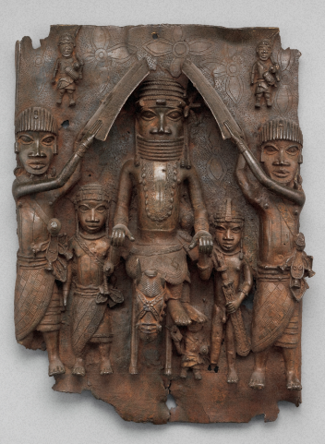  In art, we will be looking at Art from Western Africa. There will be a focus on the Benin plaques before developing the skill of layering to create a relief with meaning. |  | 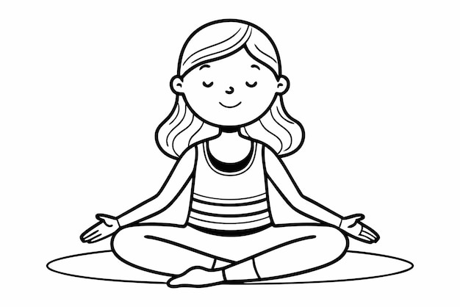  This half term we will be focusing on yoga and tennis.  We will continue to do outdoor PE even when the weather is cold. Please ensure your child has warm clothing for this.  It is important that children come to school with an appropriate school P.E. kit and avoid wearing jewellery on the days they are doing P.E.

Useful Information  School starts at 8:45am and the gate will be locked at 8:50am. Breakfast club will be available before this time but must be booked in advance. Please speak to the school office if you wish to book your child in.  Miss Poppleton’s class – PE days are Tuesday and Friday.  Miss Woodcock’s class – PE days are Monday and Wednesday.  Please ensure that your child has the correct clothing in school every day and double-check they have their name in this. If your child is wearing tights to school, please make sure they have socks in their PE kit.  Homework – Homework is given out every Friday and due back the following Wednesday. Children also need to read at home every day, record a short summary in their reading record and hand this in each day. If children need any help regarding their homework, then please encourage them to speak to their class teacher. |  | Dates for your diary:  Tuesday 24th February – Yorkshire Wildlife Park trip  Friday 27th February (9am) – Sumdog parent engagement  Monday 2nd to Friday 6th March – Bike ability  Thursday 5th March – World Book Day  Friday 20th March – Red Nose Day  Tuesday 24th March (2.30pm) – Art Gallery for parents  Thursday 26th March – Easter Disco
Website links:  - TTRockstars: https://play.ttrockstars.com/auth/school/student/2498  - Sumdog https://www.sumdog.com/user/sign_in  - Internet safety advised by South Yorkshire police for parents https://www.internetmatters.org/parental-controls/ | Contacting your child’s teacher  You can speak to your child’s class teacher at the end of the school day or by emailing the school office who will pass on your question so the teacher can contact you.

