English |  | Maths |  | Science
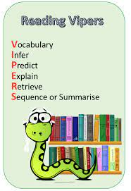  Each week we will study an extract from a well-known book working on key reading skills.  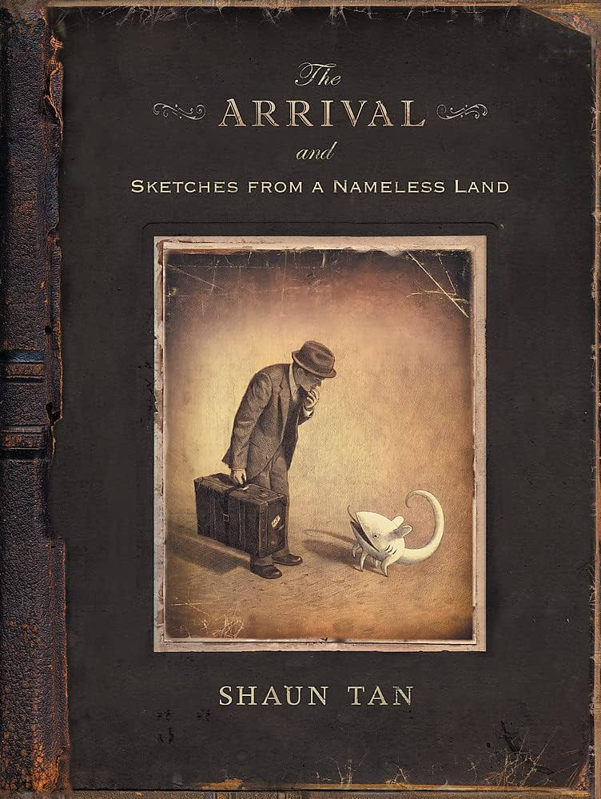  We will be writing a description, narrative and letter based on our book “The Arrival”.  Support at home by: Every child will have their own reading book to read at home. Please ensure that children are reading every day and talk to them about what they have read. Children need to complete their reading record and bring this in every day. |  | This half term we will be learning about:  - Investigating area and perimeter of rectilinear shapes  - Estimating area of nonrectilinear shapes  - Reading, writing, ordering and comparing decimals  - Rounding decimals to the nearest whole number  - Representing, identifying, naming, writing, ordering and comparing fractions (including improper and mixed numbers)  - Calculating fractions of amounts    Support at home by:  - Accessing Sumdog to complete maths questions. Please encourage your child to spend at least 20 minutes every week on this.  - Ensuring all homework set is complete and handed-in on time (set on Friday, due by Wednesday). |  | In Science, we will be learning about living things and their habitats, and we will explore:  - Seasonal changes and ecosystems  - Animal life cycles and metamorphosis  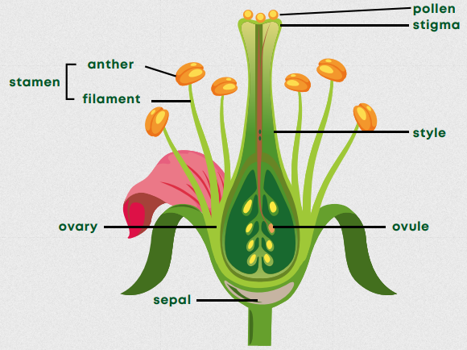  - How plants reproduce and make seeds  - Similarities and differences in how animals grow  - Scientists and careers in science
 |  |  |  | Computing
 |  |  |  | We will explore the concept of variables in programming through games in Scratch. They will find out what variables are and relate them to real-world examples of values that can be set and changed, and we will experiment with variables. We will continue to discuss with children how to stay safe online. If you have any questions, concerns or would like any more information, please contact the school office and speak to Miss Marshall.
RSHE | Humanities |  | Creative |  | PE
We will be following the Sheffield scheme for RSHE and covering the below:  - Online safety  - How do I accept my friends for who they are?  - Control and consent | 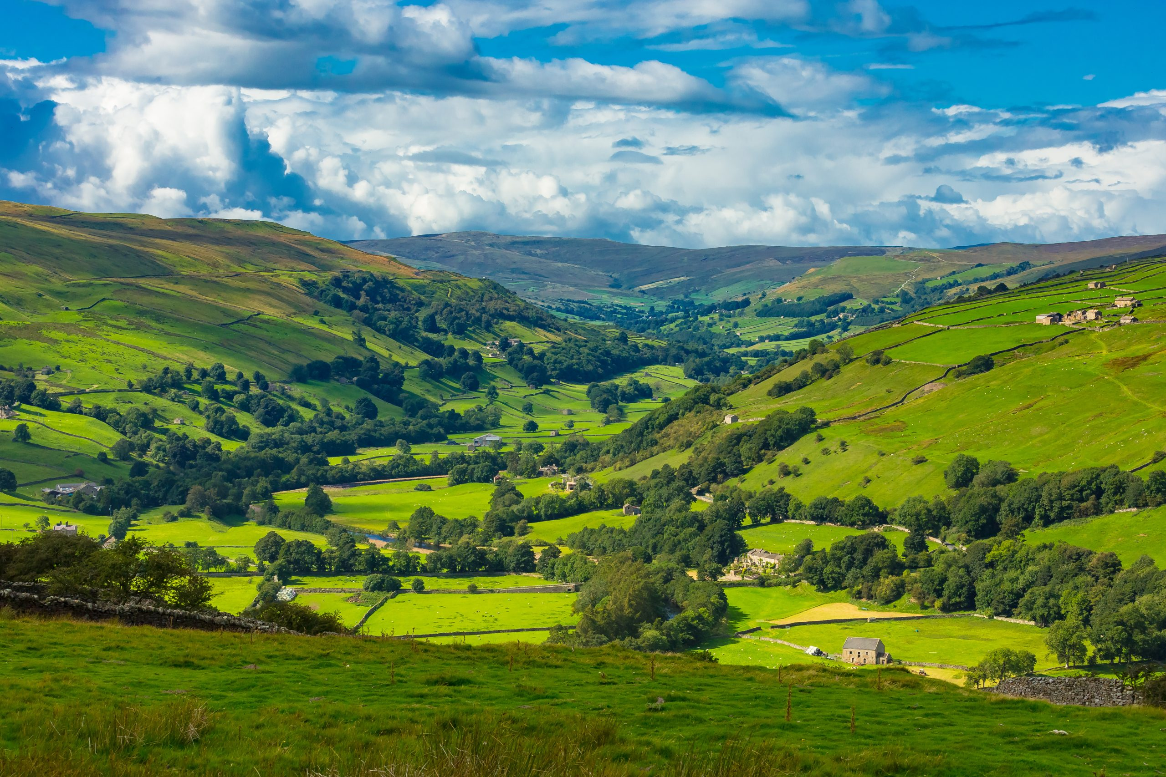  In Geography, we will be learning all about Yorkshire and local geography. We will build our understanding of UK geography and look at how human activity has changed landscapes.    In R.E., we will be looking at Christians and how they live, with a focus on ‘What Would Jesus Do?’ |  | 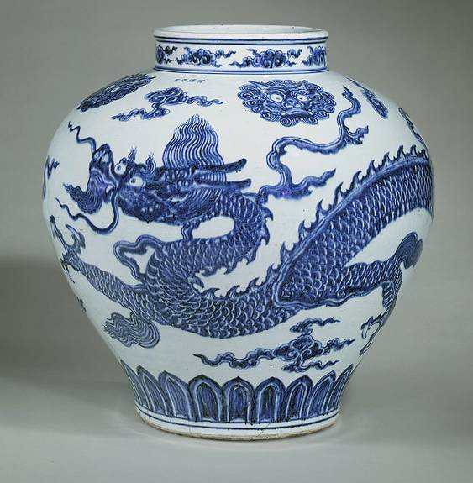  In art, we will be looking at Chinese painting and ceramics. There will be a focus on Chinese brush painting and compositional devices before studying Ming Dynasty porcelain. |  | This half term Miss Woodcock’s class will be focusing on hockey and gym.  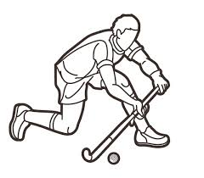  Miss Poppleton’s class will be focusing on basketball and hockey.  We will continue to do outdoor PE even when the weather is cold. Please ensure your child has warm clothing for this.  It is important that children come to school with an appropriate school P.E. kit and avoid wearing jewellery on the days they are doing P.E.

Useful Information  School starts at 8:45am and the gate will be locked at 8:50am. Breakfast club will be available before this time but must be booked in advance. Please speak to the school office if you wish to book your child in.  Miss Poppleton’s class – PE days are Monday and Friday.  Miss Woodcock’s class – PE days are Monday and Wednesday.  Please ensure that your child has the correct clothing in school every day and double-check they have their name in this. If your child is wearing tights to school, please make sure they have socks in their PE kit.  Homework – Homework is given out every Friday and due back the following Wednesday. Children also need to read at home every day, record a short summary in their reading record and hand this in each day. If children need any help regarding their homework, then please encourage them to speak to their class teacher. |  | Dates for your diary:  Friday 9th January – Sumdog meeting  Wednesday 21st & Thursday 22nd January – Parents evening  Wednesday 28th January – Y5/6 Showcase
Website links:  - TTRockstars: https://play.ttrockstars.com/auth/school/student/2498  - Sumdog https://www.sumdog.com/user/sign_in  - Internet safety advised by South Yorkshire police for parents https://www.internetmatters.org/parental-controls/ | Contacting your child’s teacher  You can speak to your child’s class teacher at the end of the school day or by emailing the school office who will pass on your question so the teacher can contact you.

