English |  | Maths |  | Science
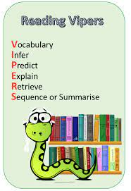  Each week we will study an extract from a well-known book working on key reading skills.  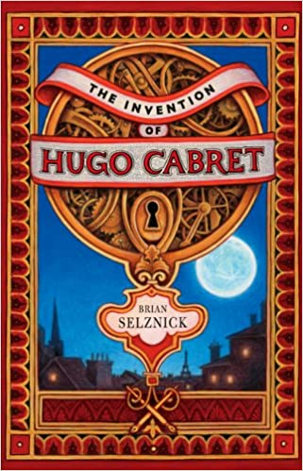  We will be writing diaries, biographies and discussions based on our book “The Invention of Hugo Cabret”.  Support at home by: Every child will have their own reading book to read at home. Please ensure that children are reading every day and talk to them about what they have read. Children need to complete their reading record and bring this in every day. |  | This half term we will be learning about:  - Presenting information as a line graph  - Read and interpret information presented in timetables  - Identify factors and multiples  - Find all factor pairs of a number  - Identify prime numbers up to 100  - Identify factors and multiples  - Multiplying and dividing by 10, 100 and 1000    - Multiplying and dividing mentally, using doubling and halving.  Support at home by:  - Accessing Sumdog to complete maths questions. Please encourage your child to spend at least 20 minutes every week on this.  - Ensuring all homework set is complete and handed-in on time (set on Friday, due by Wednesday). |  | In Science, we will be learning about astronomy, and we will explore:  - The Big Bang and the expanding universe.  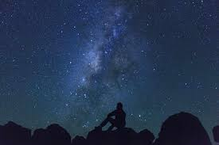  - How gravity affects our solar system.  - The planets and other celestial bodies.  - The Moon’s phases and the Sun’s role.  - Our galactic neighbourhood and galaxies.
 |  |  |  | Computing
 |  |  |  | We will explore the concept of variables in programming through games in Scratch. They will find out what variables are and relate them to real-world examples of values that can be set and changed, and we will experiment with variables. We will continue to discuss with children how to stay safe online. If you have any questions, concerns or would like any more information, please contact the school office and speak to Miss Marshall.
RSHE | Humanities |  | Creative |  | PE
We will be following the Sheffield scheme for RSHE and covering the below:  - How do I accept my friends for who they are?  - Analysing digital media | 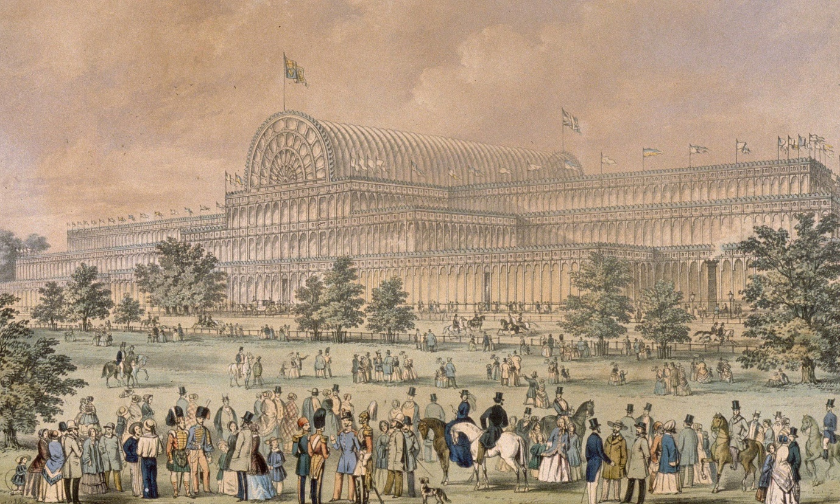  In History, we will be learning all about Victorians. We will learn about Queen Victoria and Prince Albert, the slums and workhouses and what life was like by 1900.  In Geography, we will be learning all about mountains. We will learn about different mountain ranges around the world and how they were formed.  In R.E., we will be looking at charity across religions with a focus on Christianity and Islam. |  |   In art, we will be looking at Islamic Art and Architecture. We will learn about the Taj Mahal, the Dome of the Rock and the Alhambra. |  | This half term we will be focusing on dance and netball.    It is important that children come to school with an appropriate school P.E. kit and avoid wearing jewellery on the days they are doing P.E.

Useful Information  School starts at 8:45am and the gate will be locked at 8:50am. Breakfast club will be available before this time but must be booked in advance. Please speak to the school office if you wish to book your child in.  Miss Poppleton’s class – PE days are Monday and Friday.  Miss Woodcock’s class – PE days are Monday and Wednesday.  Please ensure that your child has the correct clothing in school every day and double-check they have their name in this. If your child is wearing tights to school, please make sure they have socks in their PE kit.  Homework – Homework is given out every Friday and due back the following Wednesday. Children also need to read at home every day, record a short summary in their reading record and hand this in each day. If children need any help regarding their homework, then please encourage them to speak to their class teacher. |  | Dates for your diary:  Tuesday’s after school – Craft club  Monday 1st December – Christmas market  Thursday 4th December – Christmas disco  Wednesday 17th December – Christmas lunch  Friday 19th December – Inset day
Website links:  - TTRockstars: https://play.ttrockstars.com/auth/school/student/2498  - Sumdog https://www.sumdog.com/user/sign_in  - Internet safety advised by South Yorkshire police for parents https://www.internetmatters.org/parental-controls/ | Contacting your child’s teacher  You can speak to your child’s class teacher at the end of the school day or by emailing the school office who will pass on your question so the teacher can contact you.

