English |  | Maths |  | Science
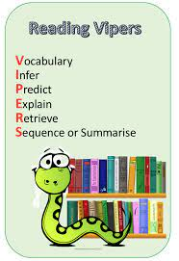  Each week we will study an extract from a well-known book working on key reading skills.    We have had a gorilla running through school! This is linked to our new class book, “Anthony Browne’s King Kong”.  We will be writing descriptions of character, writing stories and writing a campaign speech.  Support at home by: Every child will have their own reading book to read at home. Please ensure that children are reading every day and talk to them about what they have read. Children need to complete their reading record and bring this in every day. |  | This half term we will be learning about:  - Place value – numbers up to 10,000,000, rounding to a required degree of accuracy and estimating  - Addition (e.g. 5 digit + 3 digit e.g. 23451 + 568 and decimals e.g. e.g. 456.4 + 65.12)  - Subtraction (e.g. 5 digit – 3 digit e.g. 23451 – 568 and decimals e.g. 456.4 - 65.2)  - Multiplication (e.g. 2 digit x 2 digit e.g. 45 x 34, 3 digit x 2 digit e.g. 245 x 34 and 4 digit x 1 digit e.g. 3451 x 7)  - Division (4 digit ÷1 digit e.g. 1284 ÷ 4)  - Solving problems using all of the above skills    Support at home by:  - Accessing TTRS to consolidate times table knowledge.  - Ensuring all homework set is complete and handed-in on time (set on Friday, due by Wednesday). |  | In Science, we will be learning about forces, and we will explore:    - Different types of forces, including gravity, friction, air and water resistance.  - Carrying out experiments.  - Hoe levers, pulleys and gears make work easier.  - Fair testing, accurate measuring and sharing their results clearly.
 |  |  |  | Computing
 |  |  |  | We will explore the concept of variables in programming through games in Scratch. They will find out what variables are and relate them to real-world examples of values that can be set and changed, and we will experiment with variables. We will continue to discuss with children how to stay safe online. If you have any questions, concerns or would like any more information, please contact the school office and speak to Miss Marshall.
RSHE | Humanities |  | Creative |  | PE
We will be following the Sheffield scheme for RSHE and covering the below:  - Why are some people unkind?  - How do I save a life?  - Online safety | 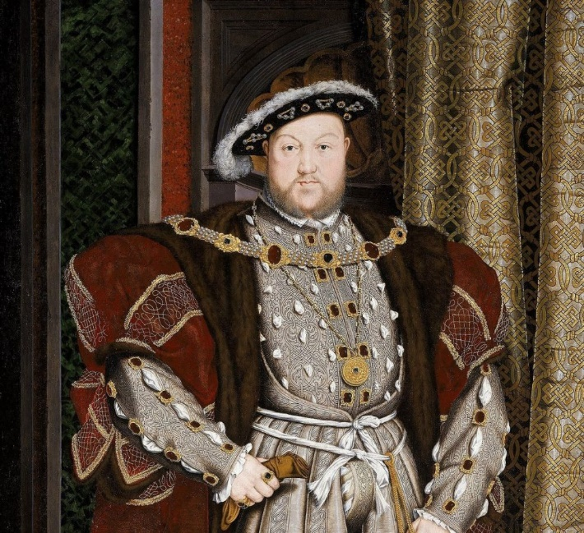  In History, we will be learning all about the early British Empire. We will explore British Monarchs and motivations behind the building of the empire.  In Geography, we will be learning all about spatial senses. We will learn the difference between longitude and latitude, as well as gaining an understanding of relief maps.  In R.E., we will learn about what it means to be a Muslim in Britain today. We will explore the Five Pillars in detail. |  | 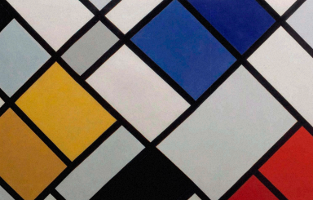  In art, we will be comparing different styles. Our focus will be rococo and modernist styles. |  | 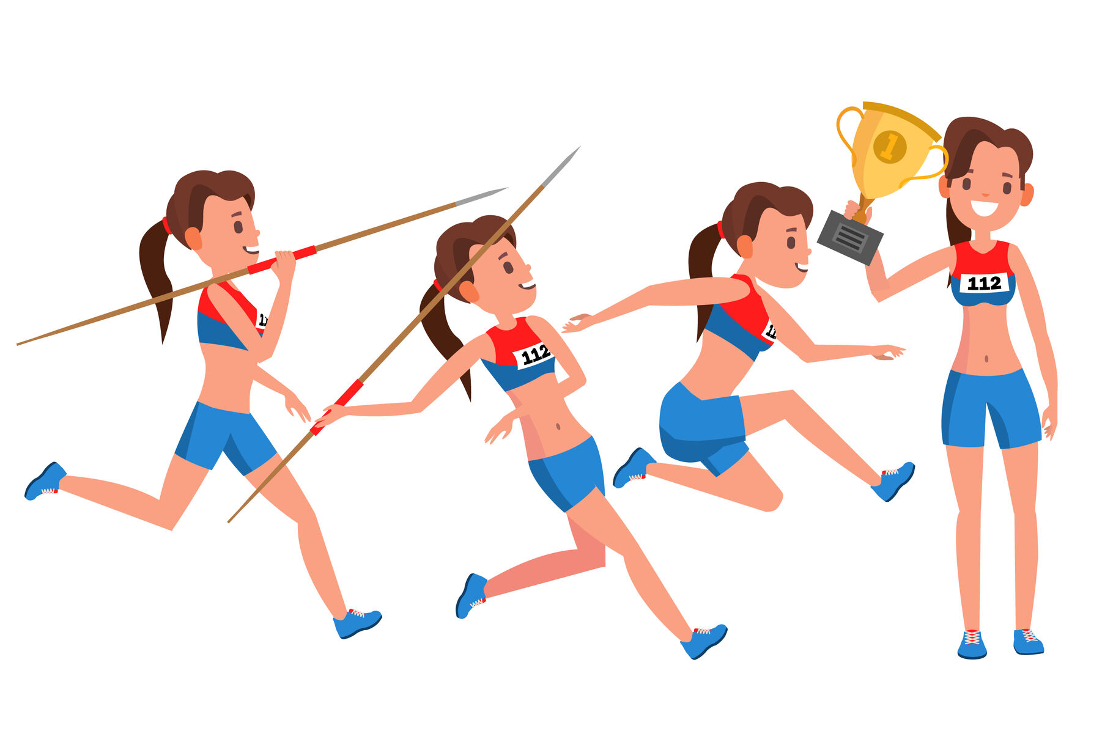  This half term we will be focusing on athletics and fitness.  It is important that children come to school with an appropriate school P.E. kit and avoid wearing jewellery on the days they are doing P.E. Earrings must be taken out.

Useful Information  School starts at 8:45am and the gate will be locked at 8:50am. Breakfast club will be available before this time but must be booked in advance. Please speak to the school office if you wish to book your child in.  Miss Poppleton’s class – PE days are Monday and Friday.  Miss Woodcock’s class – PE days are Monday and Wednesday.  Please ensure that your child has the correct clothing in school every day and double-check they have their name in this. If your child is wearing tights to school, please make sure they have socks in their PE kit.  Homework – Homework is given out every Friday and due back the following Wednesday. Children also need to read at home every day, record a short summary in their reading record and hand this in each day. If children need any help regarding their homework, then please encourage them to speak to their class teacher. |  | Dates for your diary:  Wednesday 8th & Thursday 9th October – Parents evening  Friday 24th October – Inset day
Website links:  - TTRockstars: https://play.ttrockstars.com/auth/school/student/2498  - Internet safety advised by South Yorkshire police for parents https://www.internetmatters.org/parental-controls/  - Sumdog: https://www.sumdog.com/user/sign_in | Contacting your child’s teacher  You can speak to your child’s class teacher at the end of the school day or by emailing the school office who will pass on your question so the teacher can contact you.

