English |  | Maths |  |  |  | Science
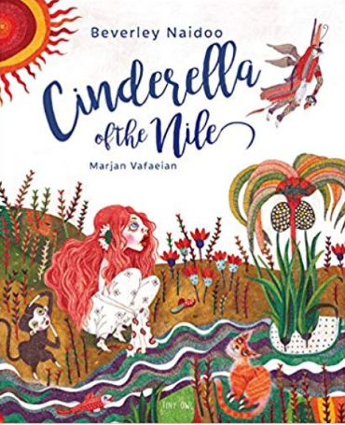  This half term children will be reading the book Cinderella of the Nile by Beverley Naidoo. Children will be researching Ancient Egypt and exploring the characters feelings to go on and write a diary entry and persuasive letter. They will develop skills of inference before exploring the author’s use of literary language and the effect that this has on the reader.  Children will also explore The Story of Tutankhamun during this term. They’ll learn about Ancient Egypt, discover Howard Carter’s famous find, and hear stories about the curse of Tutankhamun’s tomb. The unit ends with children writing a non-chronological report.  In reading we are following a scheme called VIPERS, which stands for vocabulary, inference, prediction, explain, retrieve and summarise. Each week we will use these skills to focus on different texts.  Support at home by:  - Looking at other stories with Stone Age settings  - Discuss and share favourite story characters  - Compare settings of familiar stories  - Reading a variety of stories and ask questions |  | In year 3, we will be learning about graphs and how to collect, interpret and present data using charts and tables. We will also be focusing on using a range of mental strategies and formal written methods (column), to work out addition and subtraction calculations. Following on from this, we will learn about length and perimeter.  In year 4, we will be learning about multiplication and division. We will be focusing on mental multiplication and division strategies using place value and known and derived facts. We will be learning about the distributive property including multiplying three 1-digit numbers. We will then move on to short multiplication and division.  Times tables will again be a focus, and children should constantly practise these at home to underpin their learning in other areas of maths. In school, we will be following the Rockstars scheme for practising and improving times table knowledge.  Each day there will be a maths meeting when children reinforce their learning and once a week there will be a lesson focussing on arithmetic skills.  Support at home by:  - Oak academy  - TTRockstars  - Sumdog |  |  |  | This half term we will be looking at life cycles in nature. This will include looking at how the earth’s tilt creates seasons and how each season alters the nature around us. The children will learn how animals migrate during each season and why. After this we will look at the life cycle of a frog from frogspawn, tadpoles hatch. Tadpoles undergo a process called metamorphosis, which means a complete change. They lose their tails, grow arms and legs, and become frogs. To finish the topic, we will look at how flowering plants produce pollen and the life cycle of plants.
 |  |  |  |  |  | Computing
 |  |  |  |  |  | This half term the children will use a range of techniques to create a stop-frame animation using tablets. Next, they will apply those skills to create a story-based animation. This unit will conclude with learners adding other types of media to their animation, such as music and text.
Personal Development | Humanities |  | Creative |  | PE
We will be following the Sheffield scheme for RSHE and covering…  - Anti-bullying  - Firework safety  - Road Safety  In RE this half term, we will be continuing to look at the religion Hinduism. Children will explore the different beliefs and gods Hindus believe in as well as looking at how they celebrate Diwali. | In History this term, we will be learning about the Ancient Egyptians. Children will find out about archaeological discoveries, such as Howard Carters discovery of Tutankhamun’s tomb and the discovery of the Rosetta Stone. We will also learn about what it would be like to live in Egypt at this time - looking at how archaeologists have been able to find out about the food they ate, the clothes they wore, the houses they lived in and the jobs they did.  In Geography, we will be learning about settlements. We will explore population maps and will use keys to interpret information about population density. We will look at maps of the local area and consider land use in different locations. |  | This half term in art children will be looking at still and life form. Children will explore how artists use different techniques to show the form of an object. They will practise using different pencil techniques to show form and then draw their own still life from observation using cross-hatching.  During this term in BSL, we will be learning signs for colours, clothing and food. We will also be learning signs for key events such as Christmas. |  | Please make sure your children have appropriate PE kit available in school. This term, we will be focusing on dance for Indoor PE and hockey for Outdoor PE.  Year 4 will be going for swimming lessons this term every Friday. Please remember to send children to school with their swimming costumes and a towel, and with any earrings taken out.  Miss Lane  Indoor PE – Tuesday  Outdoor PE - Wednesday  Miss Jones  Outdoor PE – Wednesday  Swimming - Friday  Mrs Bakshi  Indoor PE – Friday  Outdoor PE – Monday
Useful Information  Homework – Homework is given out every Friday and due back the following Wednesday. Children also need to read at home every day, record a short summary in their reading record and hand this in each day to their teacher. |  |  |  |  | Dates for your diary:  4th December – School disco  15th and 16th December – Christmas play  19th December – INSET Day
Website links:  - Y2 – Y6 TTRockstars: https://play.ttrockstars.com/auth/school/student/2498  - Y3 – Y6 Sumdog www.sumdog.com |  |  |  | Contacting your child’s teacher  You can speak to your child’s class teacher at the end of the school day or by emailing the school office who will pass on your question so the teacher can contact you.

