English |  | Maths |  |  |  | Science
This half term in English, we will be exploring Jim – A Cautionary Tale and The First Drawing. Through Jim, the children will create warning posters, retell the story as a narrative, and write their own cautionary poems. With The First Drawing, they will develop character descriptions and write diary recounts, imagining life in the prehistoric world  In reading we are following a scheme called VIPERS, which stands for vocabulary, inference, prediction, explain, retrieve and summarise. Each week we will use these skills to focus on different texts.  Support at home by:  - Looking at other stories with Stone Age settings  - Discuss and share favourite story characters  - Compare settings of familiar stories  - Reading a variety of stories and ask questions |  | Throughout this half term Year 3 will be looking at developing number sense and exploring calculation strategies. We will aim to understand our number system, investigating and using number bonds. We will then move on to using addition and subtraction methods. Followed by solving money problems.  In year 4, this half term we will be learning about place value. We will be comparing, ordering and representing 4-digit numbers. We will be rounding numbers to the nearest 10,100 and 1000. We will then move on to addition and subtraction, using a range of methods and representations.  Each day there will be a maths meeting where children reinforce their learning and once a week there will be a lesson focussing on arithmetic skills.  Times tables will again be a focus, and children should constantly practise these at home to underpin their learning in other areas of maths. In school, we will be following the Rockstars scheme for practising and improving times table knowledge.  Each day there will be a maths meeting when children reinforce their learning and once a week there will be a lesson focussing on arithmetic skills.  Support at home by:  - Oak academy  - TTRockstars  - Sumdog  Reminders of these logins will be sent home with your child. |  |  |  | This term, children will be learning more  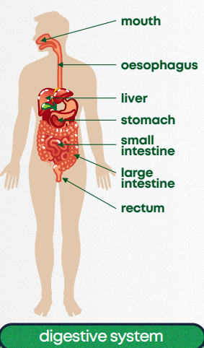  about how their bodies work. They’ll  explore muscles, bones, joints, and how  the brain and nerves help us move and  react. They’ll also learn about the  digestive system and why a balanced  diet is important. By the end of the unit,  they’ll understand how all the body’s  systems work together to keep us healthy  and active.
 |  |  |  |  |  | Computing
 |  |  |  |  |  | This half term the children will develop their understanding of digital devices, with an initial focus on inputs, processes, and outputs. They will begin by comparing digital and non-digital devices, before being introduced to computer networks that include network infrastructure devices like routers and switches.
Personal Development | Humanities |  | Creative |  | PE
In RSHE this term, the children will be learning how to manage their feelings and stay safe online, particularly around strangers. They will also be taught the importance of road safety and how to keep themselves safe in everyday situations.  In RE this half term, pupils will find out about parables from the Bible and learn about different ways that Christians may interpret these texts, exploring how believers put their beliefs into practice in a variety of ways, including through worship and service to the community | 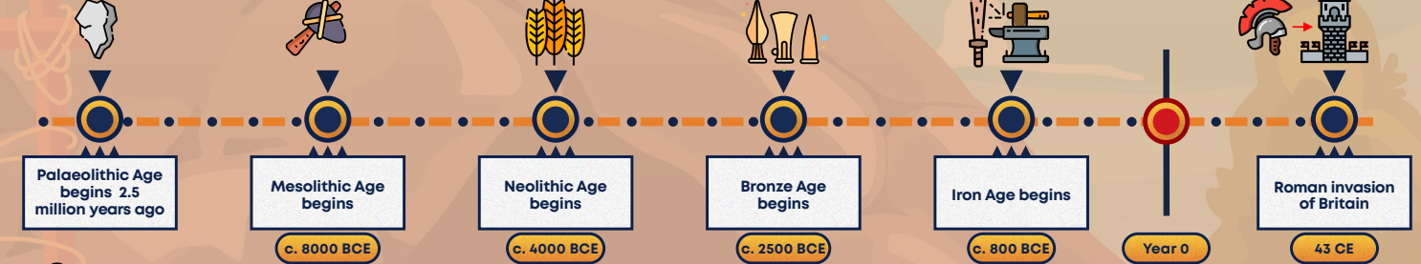  History - This term, children will explore life in prehistoric Britain, from the Stone Age to the Iron Age. They'll learn how people lived, how life changed over time, and how archaeologists use evidence like tools and remains to discover the past. Exciting finds like Skara Brae and Cheddar Man will help bring history to life.  Geography - This term in Geography, children will build on their map skills by learning to use eight-point compasses and grid references. They’ll explore how maps give us information about places, using Ordnance Survey symbols and comparing different locations. Along the way, they’ll learn and use new geographical vocabulary to help explain their ideas. |  | This term in Art, children will revisit the concept of line, exploring how artists use different types of lines to show shape, texture, and tone. They’ll study famous artists like Hokusai and practise new drawing techniques. The unit ends with a printmaking project, building on skills learnt in Year 2, helping to develop their creativity and confidence with different materials. |  | Please make sure your children have appropriate PE kit available in school. This term, we will be focusing on dance for Indoor PE and Fundamentals for Outdoor PE.  Year 4 will be going for swimming lessons this term every Friday starting on the 12th September. Please remember to send children to school with their swimming costumes and a towel, and with any earrings taken out.  Please make sure your children have appropriate PE kit available in school.  Miss Lane(Y3) – Indoor- Tuesday Outdoor -Wednesday  Mrs Bakshi (Y3/4)- Indoor-Friday Outdoor – Monday  Miss Jones(Y4) – Swimming- Friday Outdoor - Tuesday
Useful Information  Homework – Homework is given out every Friday and due back the following Wednesday. Children also need to read at home every day, record a short summary in their reading record and hand this in each day to their teacher. |  |  |  |  | Dates for your diary:  2nd October – Census Day  8th &9th October – Parents evening  24th November – INSET day
Website links:  - Y2 – Y6 TTRockstars: https://play.ttrockstars.com/auth/school/student/2498  Sumdog - https://www.sumdog.com/user/sign_in |  |  |  | Contacting your child’s teacher  You can speak to your child’s class teacher at the end of the school day or by emailing the school office who will pass on your question so the teacher can contact you.

