English |  | Maths |  |  |  | Science
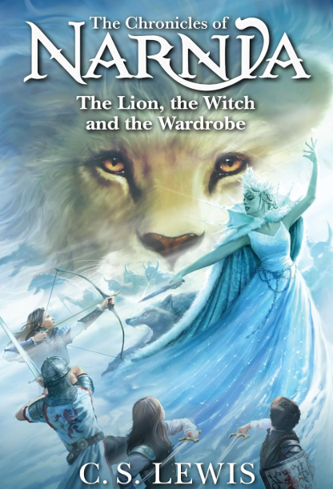  This term we will be studying ‘The Lion, The Witch and The Wardrobe’ by C.S Lewis. The children will begin by writing in the role of Lucy, explaining how she felt when she first found Narnia. They will use informal language, thoughts and feelings and past tense to write a diary entry. From there the children will focus on the skills needed to create their own fantasy story based on the book. They will learn how to use inverted commas for direct speech and how to use adjectives to add interest. |  | This half term we will be learning about Angles and Shapes (Y3). Children will start to look at what angles are and will be able to identify what type of angles shapes have.  Decimals (Y4) We will continue to explore fractions and start to look at decimals. Comparing and ordering numbers with one and two decimal places and rounding them to the nearest whole number. We will then go on to Multiplying and dividing decimals by 10 and 100.  Times tables will again be a focus and children should constantly practise these at home to underpin their learning in other areas of maths.  Support at home by:  - Practising times tables regularly  - Playing maths games on Topmarks  TT Rockstars: https://play.ttrockstars.com/auth/school/student/2498  Sumdog: https://www.sumdog.com/user/sign_in?to=%2Fschool |  |  |  | This half term we will be studying plants. The children will look at the features of flowers and their functions. From there we will look at different types of flowers and conduct experiments to test each of their features.
 |  |  |  |  |  | Computing
 |  |  |  |  |  | Learners will develop their understanding of what a branching database is and how to create one. They will use yes/no questions to gain an understanding of what attributes are and how to use them to sort groups of objects. Children will create physical and on-screen branching databases.
RE and PD | Humanities |  | Creative |  | PE
This term our key question will be ‘Why do Christians call the day Jesus died Good Friday?’. They will find out about the main events of holy week and offer suggestions about how people at the time might have felt and responded to these key events.  In personal development we will look at dreams and goals. We will also look at friendships online. | In Geography this term, children will study Yorkshire and the peak district. They will look at tourism and how this impacts the areas. We will look at the coast and coastal erosion and how different areas are split into rural and urban. |  | In art we will be looking at Anglo-Saxon art with a focus on the Bayeux tapestry. The children will learn the skills involved with collage. From there they will plan and create a collage based on the work they have studied. |  | Please make sure your children have appropriate PE kit available in school. All jewellery must be removed on the days your child has P.E.  This term, we will be focusing on dance for Indoor PE and rounders for Outdoor PE.  Year 4 will be going for swimming lessons this term every Friday. Please remember to send children to school with their swimming costumes and a towel, and with any earrings taken out.  Miss Lane  Outdoor PE – Wednesday  Indoor PE - Monday  Mrs Bakshi  Indoor PE – Friday  Outdoor PE – Monday  Miss Jones  Outdoor PE – Tuesday  Swimming – Friday
Useful Information  Homework – Homework is given out every Friday and due back the following Wednesday. Children also need to read at home every day, record a short summary in their reading record and hand this in each day to their teacher. |  |  |  |  |  | Dates for your diary:  Geography day – 18th March  World Book Day – 5th March  Red nose day – 20th March  History workshop – 23rd March  Easter Disco – 26th March
Website links:  Sumdog: https://www.sumdog.com/user/sign_in?to=%2Fschool |  |  |  | Contacting your child’s teacher  You can speak to your child’s class teacher at the end of the school day or by emailing the school office who will pass on your question so the teacher can contact you.

