English |  | Maths |  |  | Science
This half term we will be reading the stories ‘The Magic Bed’ by John Burningham and ‘Rosie Revere, Engineer’ by Andrea Beaty. With these books we will learn the importance of being able to think, say and independently write sentences.  It is important children know:  Capital letters, finger spaces, full stops, question marks and exclamation marks to demarcate sentences and commas (Y2) used to separate items in a list.  Apostrophes (Y2) to mark where letters are missing in spelling, and to mark singular possession in nouns  Here is a list of words that the children will be learning to use and understand:  sentence, conjunction, noun, compound, suffix, adjective, adverb, tense, apostrophe and comma.  Support at home by:  Reading with your children regularly. Five minutes a day will make all the difference. Asking questions and talking about what the children have read will also support them in their understanding of the book. Please add a comment in your child’s reading record. |  | Year 1: This term, we will be learning fractions where children will identify $\frac{1}{2}$ and $\frac{1}{4}$ of a shape or object. They will also learn to measure length and mass by comparing and measuring lengths and mass using cm and kg.  Year 2: Children will be learning about money where they will learn to recognise coins and notes. Use £ and p accurately and calculate change. They will also learn about face, shapes and patterns; lines and turns where they will explore, sort and describe 2-D shapes. Then they will be able to compare and sort 2-D and 3-D shapes.  Support at home by:    Using Sumdog regularly, practising quick recall of number bonds to 20 and 100 doubling and halving numbers, looking for odd and even numbers and playing with money lots – adding amounts and giving change. |  |  | Taking Care of the Earth  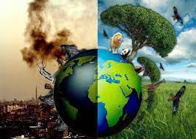  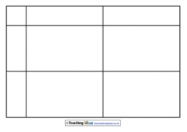  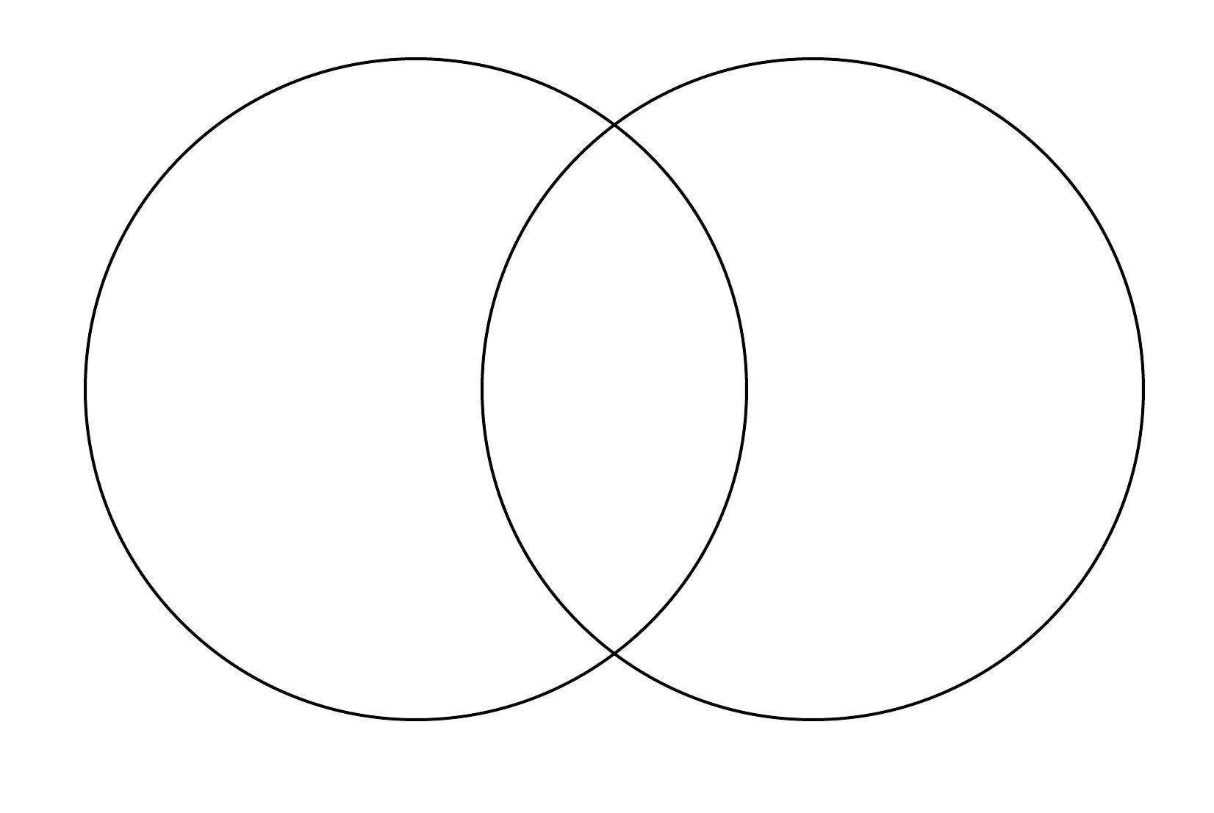  In this unit the children will learn to describe different ways that we can take care of our planet. We will explore the natural and manufactured resources that people on Earth use. We will begin to understand that logging is a way of harvesting the Earth’s natural resources, and that people create pollution which can harm the environment. In addition, we will be looking at how we can take care of our planet by recycling and reusing everyday items.
 |  |  |  |  | Computing
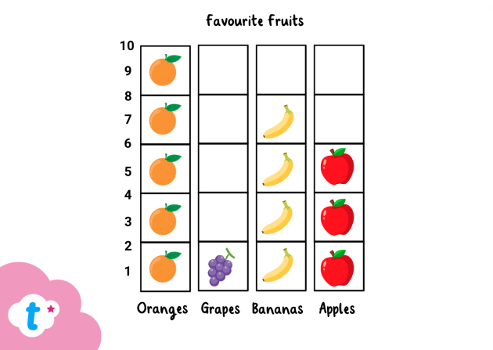
In computing this half term, we will be learning about pictograms. Children will be collecting data in tally charts and using attributes to organise and present data on a computer.

RSHE/RE | History |  | Creative |  |  | PE
RSHE  This half term, the children will be covering how to lead a healthy lifestyle. They will learn about how to keep their bodies healthy, including how to decide what to eat and how to stop themselves from getting ill.  RE  In this unit, pupils will continue to find out about Islam, key beliefs, and ways of living for many Muslims. Pupils will learn about some of the key Muslim beliefs about God, the teachings of the Prophet, the 5 pillars of Islam and the importance of prayer. Whilst pupils have had the opportunity to explore Islam in previous thematic units, this will build upon and deepen previous learning. | 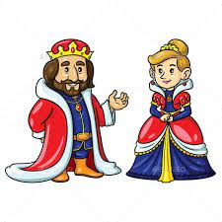  Kings and Queens and Leaders  In this unit, children will explore how the power of the British monarchy has changed over time. It looks at how early monarchs once had total control, and how their role has gradually become limited and mostly symbolic today. Learning this will help children to better understand modern British society and politics. |  | Style in Art/Narrative Art  This unit introduces two separate subject areas within one unit: style in art, and narrative art. The children will explore techniques, reflecting on the effect that they have on the viewer. The activities also allow them to practise mixing tints, revisiting the knowledge and skills gained.  Narrative Art (art which tells stories) is an introduction to the wider concept of history painting. The children will learn, by looking at paintings representing the story of St George and the Dragon, that artists can show different characteristics and personalities by the way they draw and paint. |  |  | 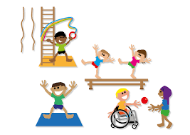  Indoor P.E. lessons will focus on Dance skills  Outdoor P.E. lessons will focus on Net and Wall. They use and develop skills such as throwing, catching, tracking and hitting a ball.  Please remember to have the correct P.E. kit in school every day in case of changes to P.E. times.  All jewellery must be removed on the days your child has P.E.  Please look in the useful information box to see when your child has P.E.
Useful Information  P.E. days: Miss May – Tuesday and Thursday, Mrs Turner – Wednesday and Thursday, Mrs Birch – Thursday and Friday and Miss Bingham – Monday and Thursday.  Homework will be given out on a Friday and we ask that it is returned to school by the following Wednesday so it can be marked. |  |  |  |  |  | Dates for your diary:  05.03.26– World Book Day  WB 09.03.26 – Assessment Week  20.03.26 – Red Nose Day  26.03.26 – DT Day  26.03.26 – Easter Disco  27.03.26 – Break up for Half term
Website links:  - Y1 – Y6: Sumdog https://www.sumdog.com/user/sign_in?to=%2Fcity |  |  |  | Contacting your child’s teacher  You can speak to your child’s class teacher at the end of the school day or by emailing the school office who will pass on your question so the teacher can contact you. Thank you.

