English |  | Maths |  |  | Science
This half term we will be reading the stories ‘Beegu’ by Alexis Deacon and ‘The Odd Egg’ by Emily Gravett.  It is important children know about:  Capital letters, finger spaces, full stops, question marks and exclamation marks to demarcate sentences and commas (Y2) to separate items in a list.  We will be learning about the different types of sentences such as statements, exclamations, questions and commands. We will be focusing on punctuating these types of sentences correctly using full stops, question marks and exclamation marks.  Here is a list of words that the children will be learning to use and understand:    Sentence, conjunction, noun, verb, statement, question, exclamation, command, compound, suffix, adjective, adverb, verb, tense, apostrophe and comma.  Support at home by:  Reading with your children regularly. Five minutes a day will make all the difference. Asking questions and talking about what the children have read will also support them in their understanding of the book. Please add a comment in their reading record. When your child has read at least 3 times at home, they will get a rocket in our rocket reader jar! Look out for our reading at home certificates. |  | Year 1  Time  Read, write and tell the time to o’clock and half past on analogue clock •Sequencing daily activities •Whole and half turns linked to time.  Exploring calculation strategies within 20  Model, explain and choose addition and subtraction strategies  Numbers to 50  2-digit numbers – represent, sequence, explore, compare. •Count in 2s, 5s and 10s •Describe and complete number patterns  Year 2  Time  Tell the time on an analogue clock: quarter past, quarter to and five-minute intervals •Calculate durations of time in minutes and seconds •Sequence daily events •Minutes in an hour and hours in a day  Fractions  •Part-whole relationships •Fractions as part of a whole or a whole set •Relate to division •Equivalent fractions  Addition and subtraction of 2-digit numbers  •Illustrate, represent and explain addition and subtraction involving regrouping including ‘Make Ten’, ‘Round and adjust’ and near doubles strategies |  |  | Seasons and Weather  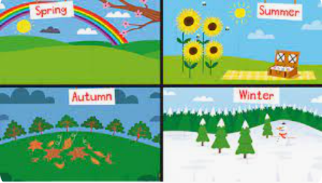  In science this half term, the children will learn about the four seasons, why they occur and what the weather is like for us during these seasons. We will look at weather data and how to represent it in a graph for comparison so that we can understand weather better. Children will also learn about the three main types of clouds and their links to the weather. Finally, children will look at weather forecasts, the symbols used within them and how to interpret them.
 |  |  |  |  | Computing

This term in computing sessions, the children will be learning about Robot algorithms. Children will also learn what they are and how to create and debug programs, using logical reasoning to make predictions.

RSHE and R.E. | Geography |  | Art |  |  | PE
R.E.  In this unit, pupils will find out about Islam, key beliefs, and ways of living for many Muslims. Pupils will learn about some of the key Muslim beliefs about God, the teachings of the Prophet, the 5 pillars of Islam and the importance of prayer. Whilst pupils have had the opportunity to explore Islam in previous thematic units, this is their first systematic encounter and will build upon and deepen previous learning.  R.S.H.E.  This half term we will be exploring ‘Aspirations’ – looking at dreams and goals.  We will also be exploring a unit of work called ‘Screen Time’, learning what it is and how we can stay safe when using devices which have screens. | 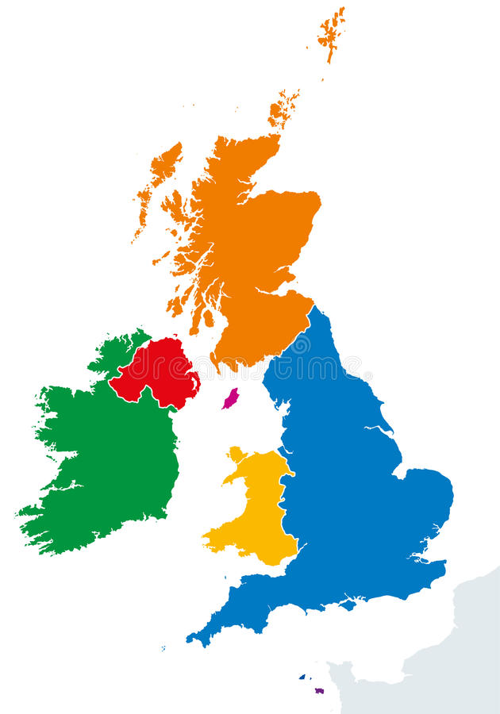  This term the children will be learning about the UK. The children will be introduced to the name, location and characteristics of the four countries and capital cities of the United Kingdom. They will look at the formation of the Union Jack and identify it as the flag of the United Kingdom. They will look at physical and human features of the countries within the UK and will use maps to identify coastlines, hills, rivers, lakes, towns and cities. They will identify seasonal and daily weather patterns in the UK. Children will use maps and atlases to locate the United Kingdom and will recognise the location of the countries within the UK. |  |   This term we will learn about Architecture. The children will be introduced to the art of designing buildings. They will look at famous London landmarks (St Paul’s Cathedral, Westminster Abbey and The Houses of Parliament) to explore definitions for architecture and architects. Children become visually familiar with these buildings by producing line drawings of them. The purpose and features of these different buildings will then be considered, providing the children with an opportunity to explore working with different materials: collage to recreate a rose window and modelling clay to make a gargoyle. |  |  | INDOOR PE  In our indoor PE sessions this half term, we will be focusing on Gymnastics. The children will learn, explore and develop basic gymnastic actions on the floor and applying them onto apparatus. They will develop gymnastic skills of jumping, rolling, balancing and travelling individually and then in combination to create short sequences and movement phrases.  OUTDOOR PE  In our outdoor sessions, the children will be learning about Invasion games. They will learn that invasion games are where there are two teams and two goals. The children will develop their understanding of the principles of defending and attacking for invasion games. They will use and develop skills such as sending and receiving with both feet and hands, as well as dribbling with both feet and hands.
Useful Information  PE days: PE days: Mrs Birch – Thursday and Friday, Mrs Turner – Wednesday and Thursday, Miss May – Monday and Thursday and Miss Bingham – Tuesday and Thursday. All PE kit must be named. Please can earrings be removed on PE Days. Please can children bring appropriate clothing for both indoor and outdoor PE lessons.  Homework will be given out on a Friday and we ask that it is returned to school by the following Wednesday so it can be marked.  Please ensure book bags are brought to school everyday and all RWI books and reading records are kept safely in the book bags.  Please read with your child and comment in their reading records. |  |  |  |  |  | Dates for your diary:  05.01.25 – Return to school  20.01.24 – Sumdog parental engagement Y2  21st and 22nd – Parents Evening  27.01.25 – Sumdog parental engagement Y1  14.02.24 – Finish for half term
Website links:  - Y1-Y6 – Sumdog - https://www.sumdog.com/user/sign_in?to=%2Fcity |  |  |  | Contacting your child’s teacher  You can speak to your child’s class teacher at the end of the school day or by emailing the school office who will pass on your question or queries so the teacher can contact you.  Thank you.

