Literacy |  | Communication and Language |  | Maths
This half term we will listen to stories, sequence the beginning, middle and end, retell and take part in shared and independent writing. We will look at stories such as: ‘Little Red Riding Hood’, ‘Hairy Maclary’ and ‘The Night Pirates’.  In Read, Write Inc we will continue to learn letter sounds. We will learn how to recognise and write them. We will also learn how to blend words. Some children will bring home a sound blending book to help them to blend simple words. Some children will bring home a ditty sheet or a red ditty storybook to help them to blend words and read a story. Your child needs to read at least three times a week to become a rocket reader. Please write in your child’s Reading Record when you have done so.  Children also choose a library book for you to read to them. This shouldn’t be recorded in their reading record. |  | We will enjoy listening to stories and we will be trying to remember what happens. When talking with children we will be encouraging them to use longer sentences (4-6 words).  We will continue to enjoy listening to core stories in Literacy and additional stories such as ‘The Train Ride’, ‘Little Red’, ‘Whatever Next’ and ‘Mr Gumpy’s Motorcar’  We will sing songs daily including traditional nursery rhymes, number songs and themed songs for example- ‘The wheels on the bus’, ‘Row Row Row your boat’, ‘Down at the station’ and ‘A sailor went to sea sea sea’. |  | This half term we will focus on numbers to 15. We will create representations of numbers 0-15 using different resources such as counters, bead string and numicon.  We will encourage children to count accurately whilst using each different resource. We will also place numbers 0-15 in order.  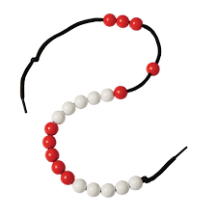  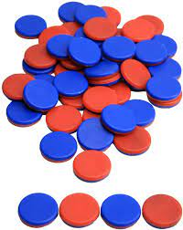  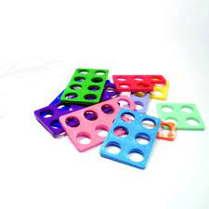  We will also focus on grouping and sharing. We will solve problems and explore the relationship between grouping and sharing.
Personal, Social and Emotional Development | Understanding the World |  | Expressive Art |  | Physical Development
We will also continue to support children to talk about and recognise their feelings. We will also discuss different ways to help children to regulate their emotions and a number of different strategies they could use to do so.  We will continue to use the Zones of Regulation.  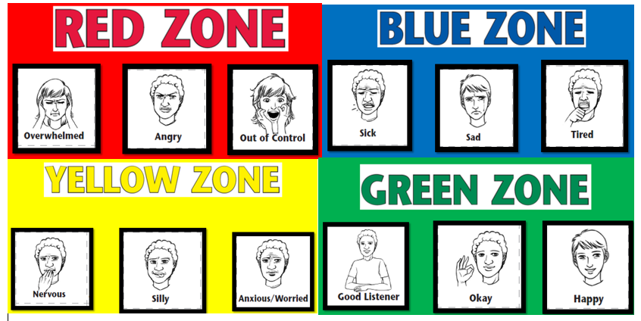  We will encourage children to show resilience and perseverance. | We will explore Journeys. We will do so through stories such as ‘Whatever Next’ and ‘The Night Pirates’, information texts and nursery rhymes such as ‘The Wheels on the Bus and ‘A Sailor went to Sea Sea Sea’. We will draw our own journey to school and look at maps.  We will also explore the journeys taken by and the vehicles used by Christopher Columbus and Neil Armstrong.  We will continue to observe the seasons and how the world around us changes from Winter to Spring. |  | We will continue to use a range of different media and materials creatively including: pens, pencils, crayons, paint and chalk.  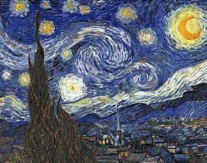  We will explore how to add detail to paintings and drawings. We will also look at the artist Vincent Van Gogh and his painting of the starry night. |  | PE- This half term we will continue to focus on Gymnastics. We will practice jumping and landing safely, balancing and taking weight on different body parts.  We will practice getting changed independently for PE- getting undressed and dressed (please encourage your child to this independently at home).  We will zip up and unzip our coat independently (please encourage your child to this independently at home).  We will use a knife and fork at dinner time.
Important things to consider
PE kit – named and in a bag
Book bags- named and in every day. Please check them often
Water bottle- named and FULL of water (not juice)
We go outside to play everyday– please make sure your child is suitably dressed for this e.g. waterproof coat, hat, scarf
Uniform- ALL children need to wear school uniform. If you have any questions please speak to class teacher (please ensure the uniform is named including school shoes)
How you can support your child at home:  Home learning will be provided weekly- your child will receive their home learning on Fridays to be brought back by Wednesday at the latest. Home learning will include: English/ RWInc or Maths and details of how to complete each piece will be given.  Your child will choose a reading book each week. This will be a fiction or non-fiction text, which you can share together. Books will be changed weekly on a Friday- therefore please ensure the book is in your child’s book bag ready to be changed.  Encourage your child to be independent by- using a knife and fork to eat with, getting dressed and zipping up and unzipping their coat |  |  |  | Contacting your child’s teacher  You can speak to your child’s class teacher at the start or end of the school day (we may need to ask you to wait) or by phoning or emailing the school office who will pass on your question so the teacher can contact you.

