Literacy |  | Communication and Language |  | Maths
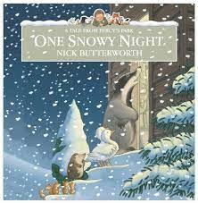  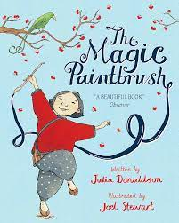  This half term we will listen to stories, sequence the beginning, middle and end, retell and take part in shared and independent writing. We will share stories such as ‘One Snowy Night by Nick Butterworth’ and ‘The Magic Paintbrush by Julia Donaldson’  We will now write our full name daily.  In Read, Write Inc we will continue to learn letter sounds. We will learn how to recognise and write them. We will also learn how to blend words. Your child will bring home a Speed Sound book of Read Write Inc sounds they have learnt. More information about how to use the speed sound book with your child can be found inside the front cover.  Some children will bring home a sound blending book to help them to blend simple words. Your child needs to read their sound blending book at least three times a week. Please write in your child’s Reading Record when you have done so. |  | 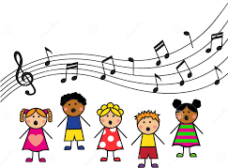  We will enjoy listening to stories and we will be trying to remember what happens. When talking with children we will be encouraging them to use longer sentences (4-6 words). We will sing songs daily including: traditional nursery rhymes, number songs and themed songs for example- ‘If you’re happy and you know it’, ‘I’m a little snowman’ and ‘Teddy bear, teddy bear’. |  | This half term we will focus on numbers within 10. We will represent, place numbers in order and explore more and fewer than numbers within 10.  We will learn to add and subtract numbers within 10.  We will also explore grouping and sharing by counting in equal groups of fives and tens.  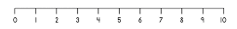
Personal, Social and Emotional Development | Understanding the World |  | Expressive Art |  | Physical Development
We will continue to discuss F2’s rules and routines which have been clearly established.  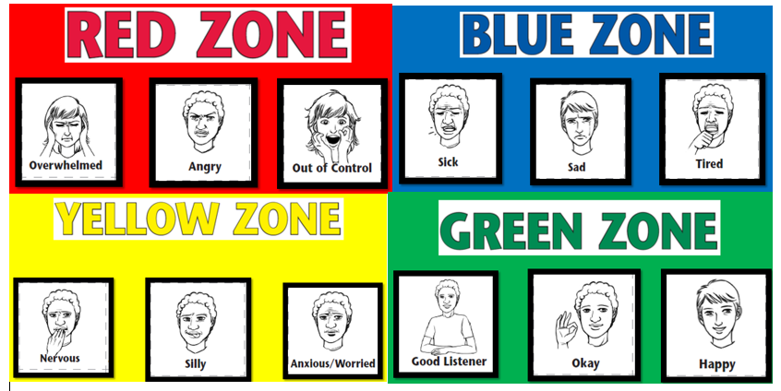  We will also continue to support children to talk about and recognise their feelings. We do so through the Zones of Regulation.  We will encourage children to show resilience and perseverance. | This term, we will look at ‘Houses and Homes’. We will compare houses now and in the past. We will do so through stories such as ‘Peepo’, information texts and nursery rhymes such as ‘Polly Put the Kettle on’.  The season is now Winter. We will look for signs of Winter and how it changes the world around us. Additionally, we will have a go at a freezing and melting experiment.  We will learn about important celebrations such as Chinese New Year |  | We will continue to use a range of different media and materials creatively including: pens, pencils, crayons, paint and chalk. We will explore the painting ‘The Magpie’ by Claude Monet. 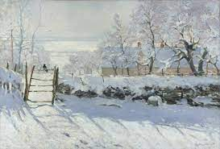 We will begin a whole class project to create a winter scene of houses. To do so, we ask you to provide your children with a SMALL cardboard box (e.g a cereal box, not a shoebox). Please provide this by Friday 19th January. |  | PE- This half term we will continue to focus on Fundamentals. We will practise balancing, running, stopping and changing direction.  We will practice getting changed independently for PE- getting undressed and dressed (please encourage your child to this independently at home).  We will zip up and unzip our coat independently (please encourage your child to this independently at home).  We will use a knife and fork at dinner time.
Important things to consider  PE kit – named and in a bag  Book bags- named and in every day. Please check them often  Water bottle- named and FULL of water (not juice)  We go outside to play everyday– please make sure your child is suitably dressed for this e.g. waterproof coat, hat, scarf  Uniform- ALL children need to wear school uniform and it must be named, including shoes. If you have any questions please speak to class teacher |  |  |  |  |  | Contacting your child’s teacher  You can speak to your child’s class teacher at the start or end of the school day (we may need to ask you to wait) or by phoning or emailing the school office who will pass on your question so the teacher can contact you.
How you can support your child at home:
Home learning will be provided weekly- your child will receive their home learning on Fridays to be brought back by Wednesday at the latest. Home learning will include: English/ RWInc or Maths and details of how to complete each piece will be given. Your child will choose a reading book each week. This will be a fiction or non-fiction text, which you can share together. Books will be changed weekly on a Friday- therefore please ensure the book is in your child’s book bag ready to be changed.
Encourage your child to be independent by- using a knife and fork to eat with, getting dressed and zipping up and unzipping their coat

