
Reception – Autumn 2, 2025
Literacy |  | Communication and Language |  | Maths
This half term, we will listen to stories, discuss what is happening and why, sequence and retell them.  We will share stories such as: Pumpkin soup, Bringing the rain to Kapiti Plain, I am Henry Finch and The Gingerbread Man.  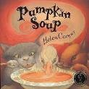  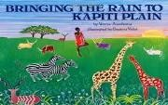  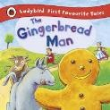  Now we know how to write lots of letters, we will write our first name daily.  In Read, Write Inc we will continue to learn letter sounds. We will learn how to recognise and write them. We will also learn how to blend words to read simple two and three letter words  Reading books  Most children will bring home a sound blending book to help them to blend simple words. Your child needs to read their sound blending book at least three times a week. Please write in your child’s Reading Record when you have done so. Reading records are checked on a Friday.  Rocket Reader stickers and raffle tickets are given out then for the children who have read at least 3 times during the week. |  | We will enjoy listening to stories and we will be trying to remember what happens.  When talking with children we will be encouraging them to use longer sentences (4-6 words). we expect children to ask and answer simple questions developing conversational skills.  We will sing songs daily including: traditional nursery rhymes, number songs and themed songs for example London’s Burning, 5 little fireworks standing in a row and an African call and response song- Toom bah ee lero.  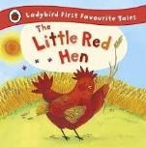  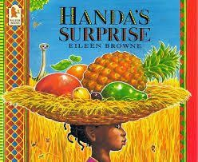  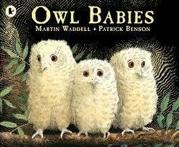 |  | This half term, We will practice counting to 20 each day.  We will mainly focus on numbers within 10.  Recognising, ordering and writing numerals 0-10  Counting amounts 0-10  We will add and subtract two single-digit numbers, introduce the concept of 0 and represent and use number bonds to 5.  To support your child to learn their number bonds you can sing along with ‘Jack Hartmann on Youtube – number bonds within 5.  We will use a range of resources such as numicon, counters and objects to support our maths learning.  We will also learn to recognise and sort shapes.  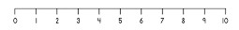
Personal, Social and Emotional Development | Understanding the World |  | Expressive Art |  | Physical Development
We will continue to discuss F2’s rules and routines, which have now been clearly established.  We will also continue to support children to talk about and recognise their feelings. We do so through the Zones of Regulation.  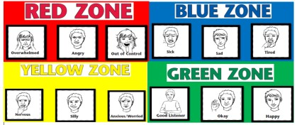  We will encourage children to show resilience and perseverance. | We will continue to explore the season of Autumn. We will observe the change in seasons and begin to look at how Winter changes the environment around us.  We will look at celebrations such as  Halloween, Bonfire Night and Christmas.    We will also look at world maps and compare countries from around the world. |  | We will use a range of different media and materials creatively including pens, pencils, crayons, paint and chalk.  We will encourage your child to develop their own ideas and then decide which materials to use to express them.  Children will be encouraged to draw with increasing complexity and detail, such as representing a face with a circle and including details. We will also explore colour and colour mixing. |  | PE- This half term we will focus on Fundamentals. We will move safely and sensibly in a space with consideration of others. We will run, jump, hop, skip, balance, crawl.  We will practice getting changed independently for PE- getting undressed and dressed  We will expect children to zip up and unzip their coats independently  We will expect children to use a knife and fork at dinner time.  We will use small tools such a scissors, pens and pencils with increasing control.
Important things to consider
PE kit – named and in a bag
Book bags- named and in every day. Please check them often
Water bottle- named and FULL of water (not juice)
We go outside to play everyday– please make sure your child is suitably dressed for this e.g. waterproof coat, hat, scarf
Uniform- ALL children need to wear school uniform. If you have any questions please speak to class teacher (please ensure the uniform is named including school shoes).
How you can support your child at home:  Home learning is provided weekly- your child will receive their home learning on Fridays to be brought back by Wednesday at the latest.  Home learning will include: English/ topic work or Maths and details of how to complete each piece will be given.  Your child will choose a library book each week. This will be a fiction or non-fiction text, which you can share together.  Some children also have a book for them to practise reading at home. Each time they read, it needs recording in their reading record book. (checked on Fridays)  Books will be changed weekly on a Friday- therefore please ensure the book is in your child’s book bag ready to be changed.  Encourage your child to be independent by-  - using a knife and fork to eat with  - getting dressed and undressed  - zipping up and unzipping their coat  - Writing their name |  |  |  | Contacting your child’s teacher  You can speak to your child’s class teacher at the start or end of the school day (we may need to ask you to wait) or by phoning or emailing the school office who will pass on your question so the teacher can contact you.

