Literacy |  | Communication and Language |  | Maths
This half term we will listen to stories, discuss what is happening and retell them. We will look at the different features including title, author and blurb.  We will read ‘We’re going on a bear hunt’ by Michael Rosen. We will retell the story.  We will have lots of opportunities to mark make both indoors and out.  Read Write Inc is the scheme we use to teach your child to read and write. In Read, Write Inc we will begin to learn letter sounds. We will learn how to recognise and write them. There are many online resources to support your child; we will send these out throughout the year.   |  | To help children to develop their communication and language skills we will share longer stories and see what they can remember. We will sing a range of songs including core nursery rhymes such as 5 currant buns, Old McDonald and 2 little dicky birds. We will encourage children to use longer sentences including 4 to 6 words.  When talking with children adults will encourage and support them to speak in sentences.  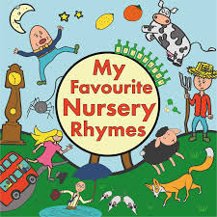 |  | This half term we will explore pattern and early number. We will compare and sort objects by looking at their size, colour, and pattern. We will develop fast recognition of up to 3 objects and count within 3 accurately. We will also create representations of these numbers using objects and counters. We will also learn how to write numbers within 3. Here are the number songs we sing for you to do at home.  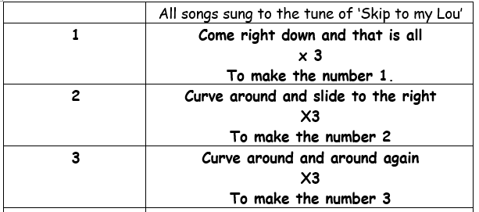
Personal, Social and Emotional Development | Understanding the World |  | Expressive Art |  | Physical Development
We will support all children with the transition into Reception after the Summer Holiday.  We will be discussing Reception’s rules and routines, especially the 5 k’s- Kind hands, Kind feet, Kind words, Kind actions and Kind thoughts.  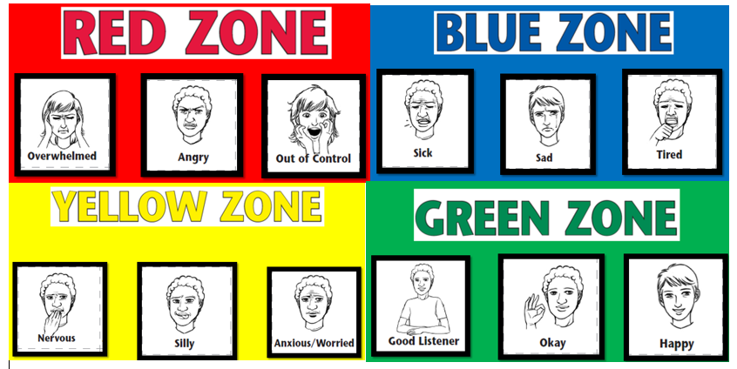  We will support children to play with others and make new friends. We will also support children to talk about and recognise their feelings. We do so through the Zones of Regulation. | To help children to settle and to get to know them this term we will focus on a topic called ourselves. We will encourage children to talk about themselves, their family and the people who are special to them.  We are very lucky to have a big outdoor area, which we use daily. Please send your child wearing weather appropriate clothing. Whilst in the outdoor area we will explore the change in season and begin to look at how Autumn changes the environment around us.   |  | We will use a range of different media and materials creatively including: pens, pencils, crayons, paint and chalk. We will be encouraged to draw people in more detail including eyebrows, freckles, glasses etc.      We will also explore the artist Andy Goldworthy and use different natural resources to recreate his images. |  | Physical development is a very important part of our learning.  P.E- We will practice getting changed independently for PE- getting undressed and dressed. Please ensure your child’s PE kit is in school every day. This half term we will focus on core strength and balance.  Outdoor area- We will practice kicking, throwing, catching and hitting balls, climbing, making obstacle courses, digging, sweeping and large mark making.  Dinner time- We will encourage children to independently, use a knife and fork- please support your child to do this at home.
How you can support your child at home:  Practise using a knife and fork to eat with  Support your child to become more independent by encouraging them to get dressed and undressed independently  Counting aloud with your child to 3 and beyond  Play games with a dice so your child can recognise number patterns  Play I spy with my little eye…  Share a book with your child each night |  |  |  |  |  | Dates for your diary:  Please see your child’s transition booklet for key dates for the first 2 weeks of school.
Important things to consider  PE kit – named and in a bag  Book bags- named and in every day. Please check them often  Water bottle- named and full of water  We go outside to play everyday– please make sure your child is suitably dressed for this e.g. waterproof coat, sunhat, sun lotion already applied if necessary  Uniform- ALL children need to wear school uniform. If you have any questions please speak to class teacher (please ensure the uniform is named including school shoes). |  |  |  | Contacting your child’s teacher  You can speak to your child’s class teacher or another adult in the setting at the start or end of the school day (we may need to ask you to wait) or by phoning or emailing the school office who will pass on your question so the teacher can contact you.
