English |  | Maths |  |  | Science
This half term we will be reading ‘Send for a Superhero’ by Michael Rosen and Katharine McEwen and ‘Stanley Stick’ by John Hegley.  With these books we will learn the importance of being able to think, say and independently write sentences.  It is important children know about:  All  Capital letters, finger spaces, full stops, question marks and exclamation marks to demarcate sentences.  Y2 only  Commas to separate items in a list and suffixes -ful, -less, -ness, as well as apostrophes to mark where letters are missing in spelling and to mark singular possession in nouns and contractions  For example, ‘The girl’s name is Anna’ or ‘He’s got an umbrella because it’s raining’.  Here is a list of words that the children will be learning to use and understand:  Sentence, conjunction, noun, verb, adjective, adverb, verb, tense, apostrophe and comma.  Support at home by:  Reading with your children regularly. Five minutes a day will make all the difference.  Please practise saying the words with your child so that they can use them in their homework or written work. |  | This half term we will continue learning about:  Numbers by, reading, writing, comparing and ordering them to 20 (Y1) and within 100 (Y2). We will continue to teach addition and subtraction and the different ways we can do calculations. We want children to be quick at recalling number bonds to 10 (Y1) and 20 (Y2). Please practise using NumBots.  We will use efficient ways to calculate, using number lines, pictures and part- part whole.  We will explore tens and ones and how 2-digit numbers are formed (Y2).  Continue to support your child at home by:  looking at fact families e.g.  14 + 6 = 20 6 + 14 = 20  20 - 14 = 6 20 - 6 = 14  Practise counting, adding, subtracting, halving and doubling real objects and quantities, e.g. their toys or real money. |  |  | In Science this half term we will  - identify and name a variety of common animals including fish, amphibians, reptiles, birds and mammals  - learn what the words carnivores, herbivores and omnivores mean  - Describe and compare a variety of common animals (fish, amphibians, reptiles, birds and mammals, including pets).  We will also be look at ways to record work findings and results using charts, tables and diagrams. Here are some of the different ways children might record their work:  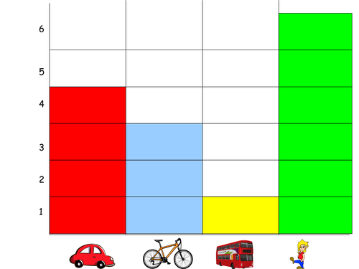  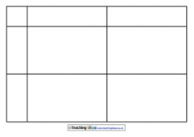  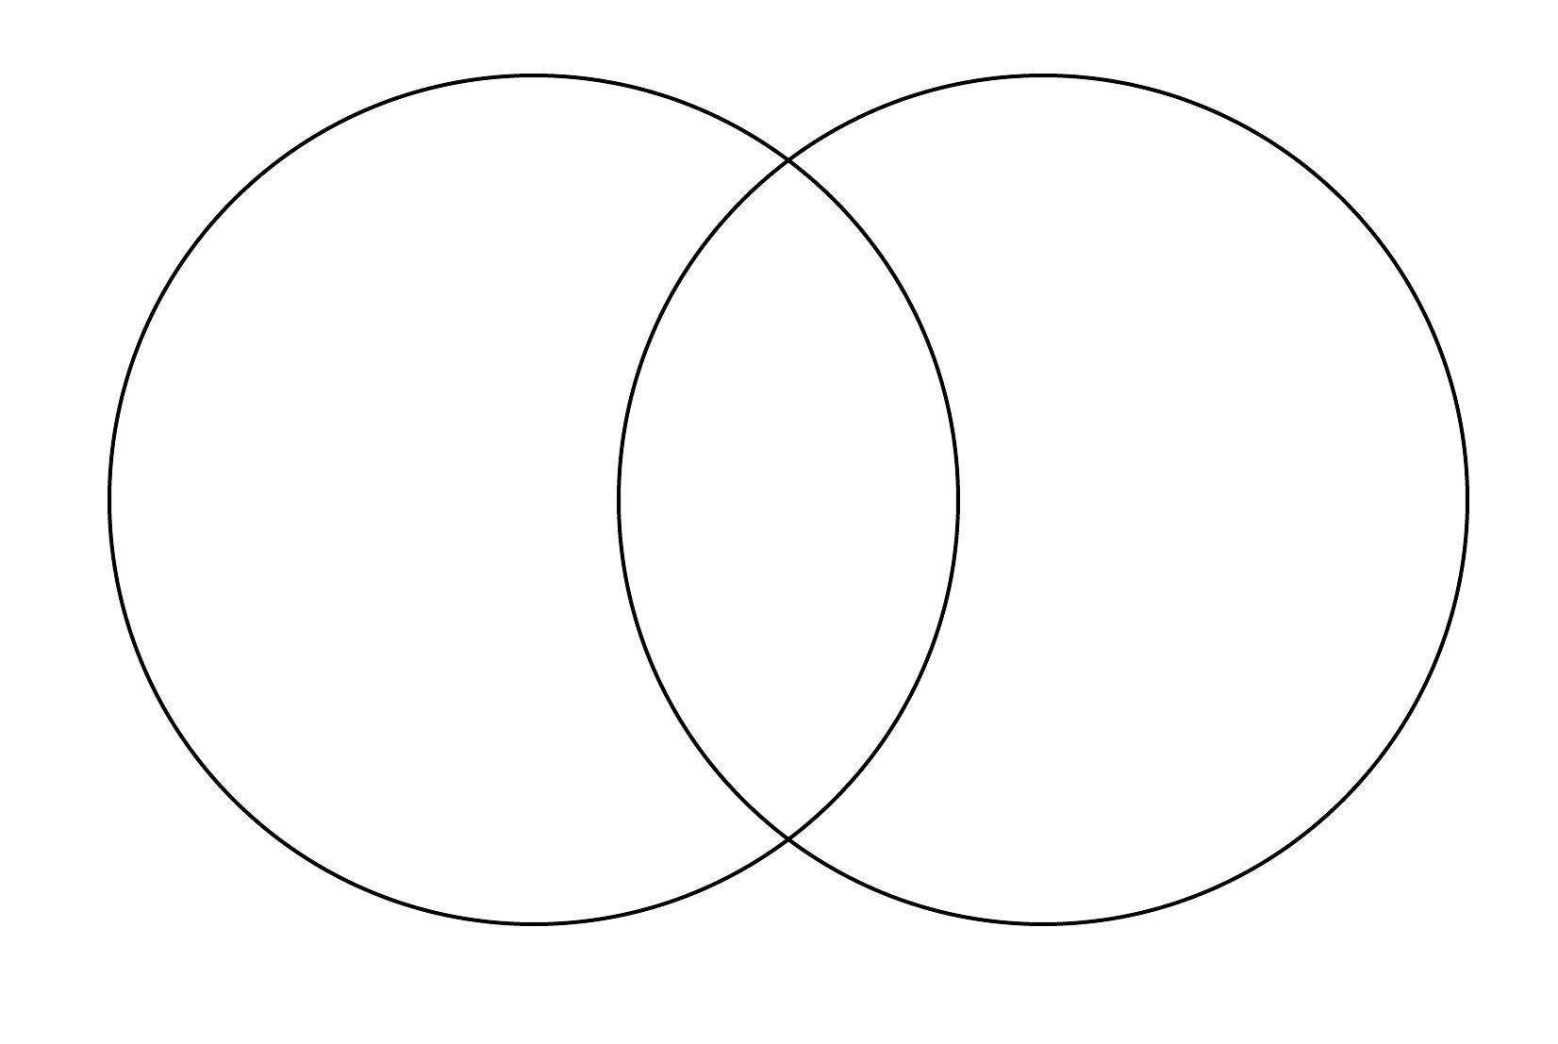
 |  |  |  |  | Computing
 |  |  |  |  | We will be holding a computing day where children will learn about capturing and changing digital photographs for different purposes.
RSHE | Humanities |  | Creative |  |  | PE
In this R.E unit, pupils will learn about the concept of gospel and the good news of forgiveness, peace and love that Christians believe Jesus brings.  In RSHE, we will be focusing on teaching children about friendships and answering questions such as:  Who is my friend?  What makes a good friend?  Should friends tell us what to do?  How do we stop bullying? (Anti bullying weeks) | We will be learning that:  History is the story of the past. Family trees tell us who lived in the past.  Archaeology - looking at books, pictures and other sources (sources are used to find out about the past).  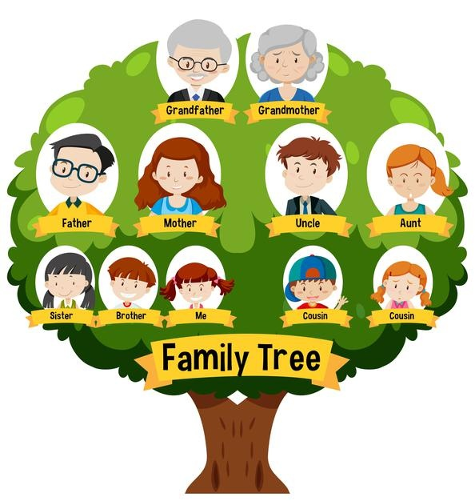  Finally, to understand what life was like in the past where we live. |  | In Art we are learning that lines are basic tools.  We will describe different lines, and we will explore different materials for making lines.  The skills we are developing:  - draw different lines with different materials  - drawing lines with a ruler  - painting and colouring neatly inside shapes  - drawing from the imagination.  We will look at the work of artists such as Rembrandt, Miro and Klee. |  |  | In indoor P.E this half term, we will be focusing on ‘Dance’, where children will explore travelling actions, movement skills and balancing. They will understand why it is important to count to music and use this in their dances. They will copy and repeat actions linking them together.  In outdoor P.E this half term, we will be focusing on ‘Sending and Receiving’, where children will develop their throwing and catching, rolling, kicking, tracking and stopping a ball. Pupils will be given opportunities to work with a range of different sized balls.
Useful Information  PE days: PE days: Mrs Birch – Thurs and Fri, Mrs Turner– Wed and Thurs, Miss May – Mon and Thurs and Miss Bingham – Tues and Thurs.  Homework will be given out on a Friday and we ask that it is returned to school by the following Wednesday so it can be marked.  Please ensure book bags are brought to school everyday and all RWI books and reading records are kept safely in the book bags.  Please read with your child and comment in their reading records.  On P.E days, ensure earrings and jewellery have been removed.A |  |  |  |  |  | Dates for your diary:  04.12.25 – Christmas Disco  10.12.25 – Pantomime  15.12.25 – Santa Dash  16 – 17.12.25 Nativity Performance  17.12.23- Christmas Dinner and Jumper Day
Website links:  - Y2 – Y6 TTRockstars: https://play.ttrockstars.com/auth/school/student/2498  - Y1 – Y2 Numbots: https://play.numbots.com/#/account/school-login/2498 |  |  |  | Contacting your child’s teacher  You can speak to your child’s class teacher at the end of the school day or by emailing the school office who will pass on your question or queries so the teacher can contact you.  Thank you.

