English |  | Maths |  |  | Science
This half term we will be reading the stories Cave Baby by Julia Donaldson and Emily Gravett and Lost and Found by Oliver Jeffers.  With these books we will learn the importance of being able to think, say and independently write sentences.  It is important children know about:  Capital letters, finger spaces, full stops, question marks and exclamation marks to demarcate sentences and commas (Y2) to separate items in a list.  Apostrophes (Y2) to mark where letters are missing in spelling and to mark singular possession in nouns  For example, ‘The girl’s name is Anna’ or ‘He’s got an umbrella because it’s raining’.  Here is a list of few words that the children will be learning to use and understand:  Sentences, conjunctions (word or group of words that joins together words or clauses.), expanded noun phrases (add more detail to the noun), verbs (words that tells about an action or a state), adjectives (word that modifies or describes a noun or pronoun)  Support at home by:  Reading with your children regularly. Five minutes a day will make all the difference.  Please practise saying the words with your child so that they can use them in their homework or written work. |  | Year 1 will be learning  Numbers to ten  •Represent, compare and explore numbers within 10 •One more and one less •Doubling and halving  Addition and subtraction  •Represent and explain addition and subtraction  •Commutativity (For example, we will get the same answer whether you are adding 1 + 2 or 2 + 1)  •Addition and subtraction facts  Shape and Pattern  •Identify, describe, sort and classify 2-D and 3-D shapes •Investigate repeating patterns •Use and follow instructional and positional language  Year 2 will be learning  Place Value read, write, represent, partition, compare and order numbers to 100 •Explore patterns including, odds and evens, tens and ones.  Addition and subtraction of 2-digit numbers  Apply number bonds to add and subtract •Represent and explain addition and subtraction of two 2-digit numbers. •Add three 1-digit numbers  Addition and subtraction word problems  Introduction to bar models as a representation •Create, label and sketch bar models |  |  | We will be immersing ourselves in ’The Human Body’. We will be naming the external body parts, learning about our senses and how our body works.  We will also be doing simple experiments and looking at ways to record experiments and results using charts, tables and diagrams. Here are some of different the different ways children might record their work:  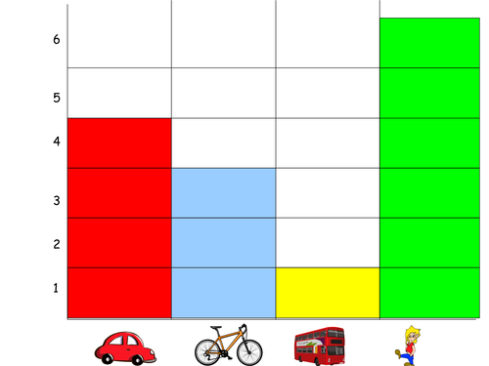  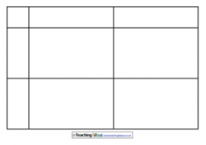  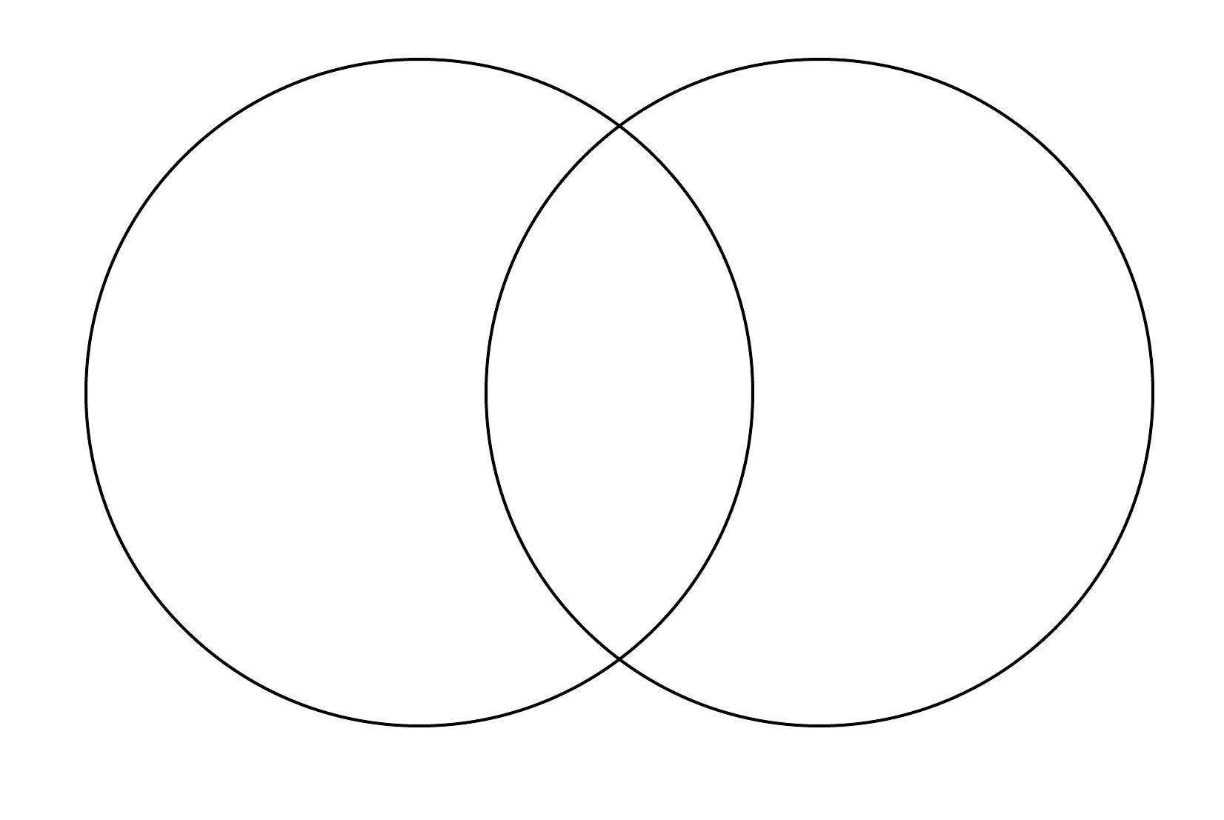
 |  |  |  |  | Computing
This term we will be looking at E-safety and how to keep safe on the internet.
- Screen time, Personal information, Safety online, Fake news

Information technology around us
Identifying IT and how its responsible use improves our world in school and beyond.
RSHE/RE | Humanities |  | Creative |  |  | PE
We will be focusing on establishing classroom and school rules, where do feelings come from, who am I and what helps me to be happy.  The 5 K’s will help us do that. The 5K’s are: Kind thoughts, Kind words, Kind hands, Kind actions & Kind feet.  We will also learn how to play with friends on the playground and how to resolve conflicts that might occur. At home you could help by playing games with your child, e.g. tag, hide and seek, boards games, chasing games, ball games, etc.  In RE we will be learning what is the good news Christians say Jesus brings. | 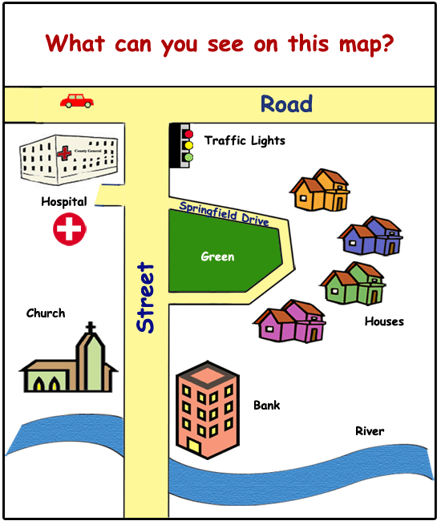  In Geography we will be learning about aerial views, maps and symbols.  We will create maps of the local area and explore map work. |  | In Art we are learning about primary and secondary colours. We will explore different tints and shades. We will look at how artists such as Mondrian, Van Gogh, David Hockney and Monet used colours in their paintings.  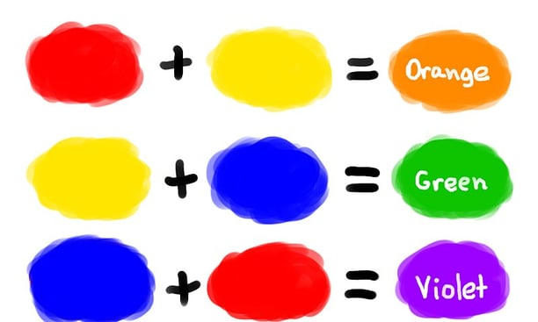 |  |  | This term we will be taking part in one weekly indoor session focusing on fundamental skills such as balancing, jogging, jumping and skipping and one outdoor P.E lesson, focusing on ball skills.  Please remember to have the correct PE kit in school every day in case of changes to PE times.  All jewellery must be removed on the days your child has P.E.  Please look in the useful information box to see when your child has P.E
Useful Information  PE days: Mrs Birch – Thursday and Friday, Mrs Turner – Wednesday and Thursday, Miss May– Monday and Thursday and Miss Bingham – Tuesday and Thursday.  Homework will be given out on a Friday and we ask that it is returned to school by the following Wednesday so it can be marked. |  |  |  |  |  | Dates for your diary:  Thurs 16th Oct – 2.45pm  Parental Engagement
Website links:  - Y2 – Y6 TTRockstars: https://play.ttrockstars.com/auth/school/student/2498  - Y1 – Y2 Numbots: https://play.numbots.com/#/account/school-login/2498  - Y1 – Y6 Sumdog: https://play.sumdog.com/student/sign_in |  |  |  | Contacting your child’s teacher  You can speak to your child’s class teacher at the end of the school day or by emailing the school office who will pass on your question so the teacher can contact you. Thank you.

