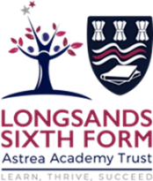

Physics Year 12 into 13 Transition work 2026

For Physics they will be doing one AS past paper per week as follows;

2016 Breadth
2016 Depth
2017 Breadth
2017 Depth
2018 Breadth
2018 Depth

