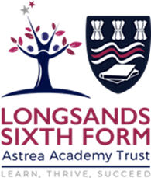

Y12 into Y13 Maths Summer Work
- Complete the full set of OCR AS 2021 Maths exam papers (Pure and Stats, Pure and Mechanics). These do not need to be done in exam conditions.
- Complete minimum of 3hrs work on Up Learn. This should include the tasks set, plus your own choice of additional tasks.
- It is important you come back in September as good at maths as you are right now. The more maths you do over the summer the more confident you will feel. Use Up Learn, your textbook, Integral and past papers to keep your skills up.

