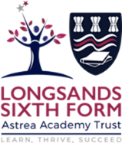
History A Level Summer work for Year 12 into 13.
1H Tsarist and Communist Russia, 1855-1964

All scholars need to complete the following over their summer break:
- One Past Paper Interpretation Question
- One Past Paper Essay Question
- Reading Log for every week (at least 4 different books or articles)
- Completion of Revision Notes/Flashcards or other Revision Tool for all Y12 Content

All scholars have been given a choice of past paper questions, as well as those available in their textbooks.
The Reading Log is available on Teams for students to download.

English Civil War / NEA Summer Transition Work

Listen to the following BBC In Our Time episodes and complete the Data Capture Sheet for each one. We will discuss these in September. These can be accessed via BBC Sounds or BBC iPlayer.

- The Levellers
- The Thirty Years War
- Frederick Douglas
- The Book of Common Prayer
- The Putney Debates
- Calvinism
- The Trial of Charles I

Title of show | Guest 1 (name and title) | Guest 2 | Guest 3
  Questions by Melvyn  (try to include time stamps) | Opinions, quotes, key evidence
How I would summarise this historian’s view
Key points from the episode  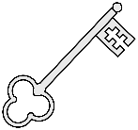 |  | Things to find out more about

