

OCR Level 3 Cambridge Advance National (AAQ) in Health and Social Care
Handbook



Contents
Introduction to the course and overview Pg. 3
Course Contents Pg 4-5
Subjects that complements the course Pg 6
Types of courses you may progress to Pg 6
What you need to do Pg 7
Homework and marking policy Pg 8
How to revise for Health and social care Pg 9-13
Revision material Pg 14
Health and social care command words Pg 15-16
Exam style questions Pg 17-18

Overview

Who this qualification is for

The Cambridge OCR Level 3 Alternative Academic Qualification Cambridge Advanced National in Health and Social Care (Extended Certificate) is for students aged 16-19 years old.

It will develop knowledge, understanding and skills that will help prepare you for progression to undergraduate study and are relevant to the health and social sector.

You might be interested in this qualification if you want to apply what you learn to practical, real-life contexts, such as:

• Using a person-centred approach to recommend care and support.
• Recommending support for individuals.
• Creating and presenting advice and guidance.
• Creating and presenting an outline proposal to address a public health challenge.
• Creating diet and activity plans to support individuals with meal planning.

The qualification will also help you develop independence and confidence in using skills that are relevant to the sector and that prepare you for progressing to university courses where independent study skills are needed. You will develop the following transferable skills that can be used in both higher education and other life and work situations:

• Communicating and collaborating effectively with individuals.
• Creating and presenting/delivering information to an individual.
• Independent learning and self-directed study, spending time outside of lessons completing
research solve problems.
• Researching topic areas and recording research sources, then using them to interpret findings
and present evidence.
• Recommending care and support for individuals.
• Presentation skills by presenting recommendations to others.
• Problem solving health and social care problems for others.
• Evaluating own work, using self-reflection and feedback.
• Time management.
• Critical thinking.
• Referencing.

This qualification will complement other learning that you're completing at Key Stage 5. If you are a full-time student, it will be part of your studies along with A Levels and/or other Level 3 qualifications.

Course Content

F090: Principles of health and social care

This unit is assessed by an exam.
In this unit you will learn about the key topics that are important to develop underpinning
knowledge and understanding relevant to health and social care. Topics include:
o Topic Area 1 Equality, diversity, and rights in health and social care settings
o Topic Area 2 Managing hazards, health and safety in health and social care settings
o Topic Area 3 Legislation in health and social care settings
o Topic Area 4 Best practice in health and social care settings

• F092: Person-centred approach to care

This unit is assessed by an assignment.
In this unit you will learn the principles and values that underpin a person-centred approach to
care and the practical tools that can be used to develop care plans for individuals. You will
explore how to communicate in health and social care, how to build relationships and the
barriers that need to be overcome to achieve person-centred care. You will learn to write
outline care plans to suit individuals, using person-centred approaches and develop your
reflective practice skills.
Topics include:
o Topic Area 1 Taking a person-centred approach
o Topic Area 2 Meeting needs and providing support in a person-centred way
o Topic Area 3 Communication skills needed to offer person-centred care

• F093: Supporting people with mental health conditions

This unit is assessed by an assignment.
In this unit you will learn about how individuals with mental health conditions can be cared for
and supported in a way which is suitable for their needs. You will do this through exploring the
meaning of mental health and mental health needs, and considering the main types of mental
health conditions and how these may affect the life of individuals. You will explore the different
ways that individuals may be supported to promote their mental well-being, manage their
illness, and different forms of treatment that may be available.
Topics include:
o Topic Area 1 Definitions and views of mental health
o Topic Area 2 Mental health conditions
o Topic Area 3 Provision of mental health services
o Topic Area 4 Treatment and support for mental health conditions

F091: Anatomy and physiology for health and social care

This unit is assessed by an exam.
In this unit you will learn about the arrangement of body systems and the structure and
function of the component parts. You will learn about key processes within each body system,
that enable them to function properly. You will then explore conditions affecting these systems,
specifically learning about the biological basis, monitoring, treatment and impact on lifestyle
and independence.
Topics include:
o Topic Area 1 Cardiovascular system
o Topic Area 2 Respiratory system
o Topic Area 3 Digestive system
o Topic Area 4 Musculoskeletal system
o Topic Area 5 Control and regulatory systems
o Topic Area 6 Reproductive system

F096: Supporting people in relation to sexual health, pregnancy and postnatal health

This unit is assessed by an assignment.
In this unit you will learn about and research the most important aspects of sexual health
including relationships, the law, consent, sexual health, sexually transmitted infections,
contraception, pre-conceptual care, birth, and the immediate care of the baby, and how to
obtain support for these. You will also learn to produce advice and guidance that is
personalised for specific individuals with issues related to sexual health and pregnancy, birth
and postnatal health. You will develop skills needed to deliver advice and guidance in a
sensitive and professional way and review the process of doing this.
Topics include:
o Topic Area 1 Advice and guidance on sexual health issues
o Topic Area 2 Advice and guidance on pregnancy, birth and post-natal issues
o Topic Area 3 Plan, deliver and review an advice and guidance session

F097: Supporting healthy nutrition and lifestyles

This unit is assessed by an assignment.
In this unit you will learn about the healthy eating guidelines, physical activity guidelines,
nutritional labelling and the sources of nutrients. You will learn how to use this information to
plan healthy and balanced meals for service users with different nutritional needs. You will
investigate some of the barriers facing service users to eat healthy meals and the support that
individuals may require to eat healthy meals.
Topics include:
o Topic Area 1 Dietary and activity needs of individuals
o Topic Area 2 Factors that influence dietary choices and physical activity levels
o Topic Area 3 Supporting individuals to plan meals that meet their needs

The subjects that complement this qualification:

These subjects might complement this qualification:
• Applied Science
• Biology
• Child Development
• Law
• Psychology
• Sociology
• Sport

The types of courses you may progress to:

Both the subject-specific knowledge, understanding and skills, and broader transferable skills
developed in this qualification will help you progress to further study in related areas such as:
• BSc Nursing (Adult/Child/Learning disabilities/Mental health)
• BSc Midwifery
• BSc Health and social care
• BSc Healthcare and Health Science
• BSc Health Sciences
• BSc Paramedic Science
• BSc Public Health and Wellbeing
• BA Social Work

What you need to do
Attend 100% of classes and arrive punctually for each class.
• Ask if you do not understand any part of the work.
• Revise your notes thoroughly each week.
• Read and research each topic whenever the opportunity arises.
• Contribute in class – your opinions and ideas are valuable.
• If you are going to be absent or late for an unavoidable reason, please email/call your tutors in
advance.
Folder Check
You need to organise your Health and social care folder using the checklist below
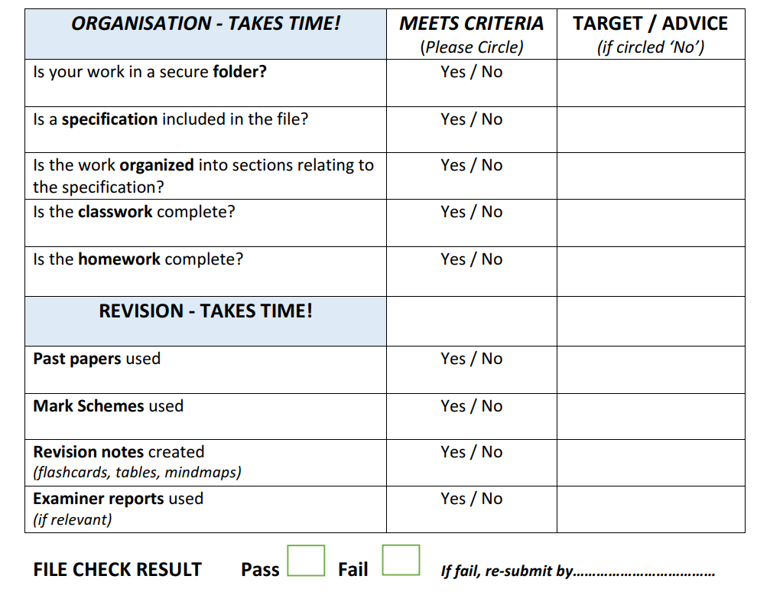

Homework and Marking Policy
Your teachers will set between 2-3 hours of homework per week. You will be expected to complete all homework, pre-reading and learning prep when it is due in. All homework will be set on Teams.
In addition, you will be expected to complete 2-3 hours of independent work as well. The most successful students complete on average five hours of work per subject per week (including homework)
What does independent study look like?
- Making notes
- Organising your folder
- Research
- Reading
- Completing homework
- Revision techniques
- Creating revision resources
- Practising past questions
This will be 4 large assignments of coursework and 2 external exam papers.
You will be expected to correct all assessed work using green pen to improve exam
technique.

Revision for Health and Social Care AAQ F090 & F091

Understanding the Units
- F090 usually focuses on:
  - Principles of health and social care
  - Human development
  - Communication
  - Equality, diversity and rights
  - Person-centred care
- F091 usually focuses on:
  - Working in health and social care
  - Safeguarding
  - Legislation and policies
  - Roles of professionals
  - Meeting individual needs
  - Reflective practice

How to Revise Effectively

1. Create Topic Summaries

For each topic:
- Write 1-page notes
- Use headings and bullet points
- Include:
  - Definitions
  - Examples
  - Key legislation
  - Advantages/disadvantages
  - Real-life scenarios
Example topics:
- Safeguarding
- Communication barriers
- Life stages
- Equality and diversity
- Types of abuse

2. Use Flashcards
Flashcards help with key terminology.
Write:
- Front: “What is safeguarding?”
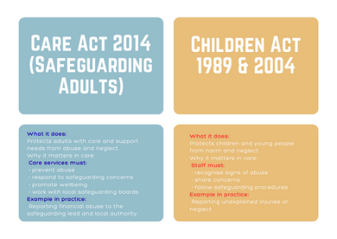
- Back: “Protecting individuals from harm, abuse and neglect.”
Good for:
- Legislation
- Definitions
- Care values
- Roles of professionals
Apps:
- Quizlet
- Anki
3. Practice Exam Questions
This is one of the best revision methods.
Practice:
- Short-answer questions
- Case studies
- Extended responses
When answering:
- Use PEEL paragraphs:
  - Point
  - Evidence
  - Explain
  - Link
Example:
“Person-centred care is important because it focuses on individual needs. This helps service users feel respected and valued…”

4. Revise Key Legislation
Important laws often appear in exams.
Examples include:
- Care Act 2014
- Equality Act 2010
- Data Protection Act 2018
- Children Act 1989
Revise:
- What the law is
- Why it exists
- How it protects people

5. Learn Through Case Studies
Many questions use scenarios.
Practice identifying:
- Needs of the individual
- Types of support required
- Risks
- Safeguarding concerns
- Communication methods
Ask yourself:
- What should the care worker do?
- Which care value applies?
- What legislation links to this?

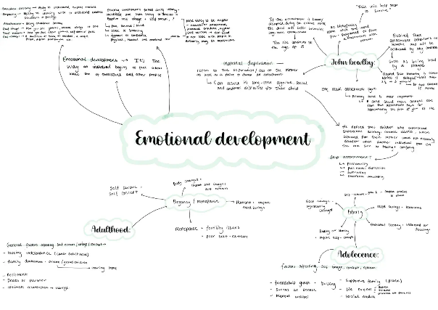
6. Make Mind Maps
Mind maps help connect topics.
Put a main topic in the centre:
- “Safeguarding”
- “Communication”
- “Life stages”
Then branch out with:
- Definitions
- Examples
- Effects
- Professionals involved

7. Use Active Revision
Don’t just reread notes.
Better methods:
- Teach someone else
- Answer questions from memory
- Blurting (write everything you remember)
- Timed practice

8. Focus on Keywords
Examiners look for subject terminology.
Important vocabulary:
- Confidentiality
- Empathy
- Discrimination
- Advocacy
- Duty of care
- Holistic care
- Inclusion
- Empowerment
Try using these naturally in written answers.

Example Weekly Revision Plan
Day | Focus
Monday | Human development
Tuesday | Communication
Wednesday | Safeguarding
Thursday | Legislation
Friday | Case study practice
Saturday | Mock questions
Sunday | Review weak topics

Exam Tips
- Read the command word carefully:
  - Describe
  - Explain
  - Analyse
  - Evaluate
- Use examples in answers
- Link points back to the scenario
- Manage your time
- Answer every question

Best Revision Technique for These Units
A strong method is:
- Learn the content
- Make flashcards
- Practice exam questions
- Mark your answers
- Repeat weak areas
That combination works especially well for Health and Social Care because exams test both knowledge and application.

Revision Material
We recommend the below textbooks for the AAQ Health and social care course – available from amazon

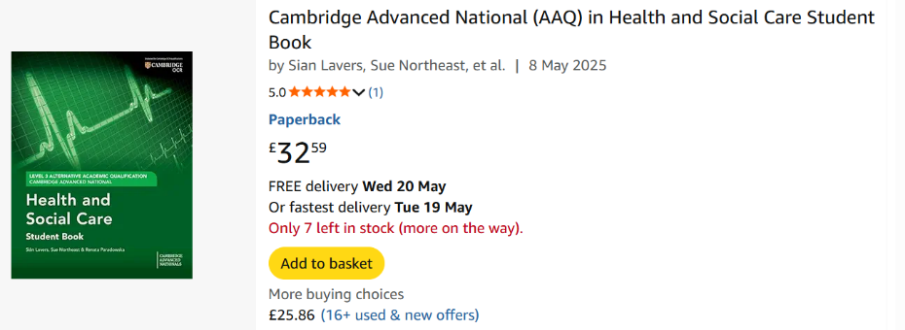

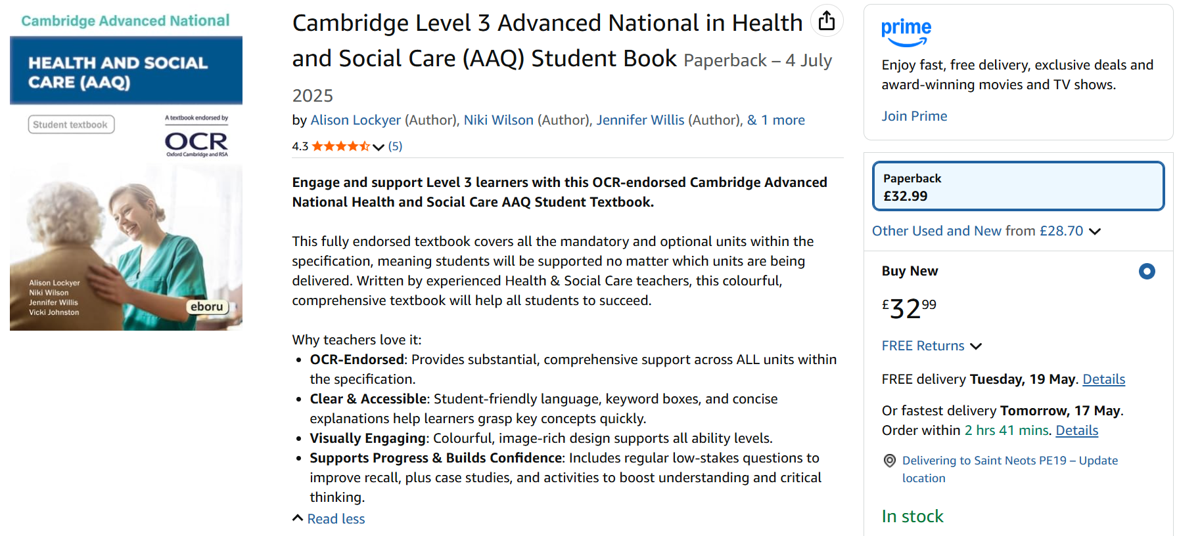

Command Words used for Assignments and Exams
In Health and Social Care, AAQ Level 3 assignments and exams often use specific command words that tell you exactly how to answer a question. Here are the most common ones and what examiners expect.
Command word | What it means | What you should do
Identify | Name or state something | Give brief factual points
Outline | Give the main features | Short summary with key points
Describe | Give detailed characteristics | Explain what something is like
Explain | Show how or why | Give reasons and make links
Discuss | Explore different viewpoints | Include advantages, disadvantages, and balanced points
Analyse | Break down into parts and examine relationships | Go deeper into causes, effects, and importance
Compare | Show similarities | Explain what is alike
Contrast | Show differences | Explain what is different
Evaluate | Judge strengths, weaknesses, and overall value | Give evidence and reach a conclusion
Assess | Consider importance or effectiveness | Weigh up evidence before concluding
Justify | Give reasons to support a choice or opinion | Use evidence/examples
Summarise | Give the main points briefly | Keep concise and focused
Define | Give the meaning | Provide a clear definition
Recommend | Suggest the best option | Explain why it is suitable
Review | Examine and comment on | Consider effectiveness and outcomes
Interpret | Explain the meaning of information/data | State what the evidence shows

How marks usually increase with command words
- Low-mark questions → Identify, define, outline
- Middle-mark questions → Describe, explain, compare
- High-mark questions → Analyse, discuss, evaluate, assess

Example
Question:
“Evaluate the importance of person-centred care in health settings.”
A strong answer would:
- Explain person-centred care
- Give benefits
- Mention possible challenges
- Use examples
- Reach a judgement/conclusion

Quick revision tip
A useful memory guide:
- Describe = WHAT
- Explain = WHY/HOW
- Analyse = BREAK IT DOWN
- Evaluate = JUDGE IT

Exam Style questions

Exam-Style Questions FO90

1. Explain Question (6 marks)
Explain how person-centred care supports the rights of individuals in a care setting.

2. Analyse Question (8 marks)
Analyse the impact of poor communication on service users in health and social care settings.

3. Discuss Question (10 marks)
Discuss the importance of health and safety procedures in a residential care home.

4. Evaluate Question (12 marks)
Evaluate how legislation helps protect individuals from discrimination in health and social care environments.
Possible legislation:
- Equality Act 2010
- NHS policies
- Safeguarding procedures

Exam-Style Questions FO90
- Cardiovascular system
- Respiratory system
- Digestive system
- Musculoskeletal system

1. Describe Question (4 marks)
Describe the main functions of the respiratory system.

2. Explain Question (6 marks)
Explain how the cardiovascular system transports oxygen around the body.

3. Analyse Question (8 marks)
Analyse the effects of asthma on the respiratory system and daily life of an individual.

4. Evaluate Question (12 marks)
Evaluate the effectiveness of treatments available for coronary heart disease.
You could include:
- Lifestyle changes
- Medication
- Surgery
- Rehabilitation

High-Mark Exam Tip
For 8–12 mark questions:
- Make clear points
- Use health terminology
- Apply examples
- Link back to the question
- Finish with a judgement/conclusion

Scenario 1 — FO90 Residential Care Home
Mrs Ahmed is 78 years old and lives in a residential care home. She has arthritis and early-stage dementia. Recently, staff members have noticed that she has become withdrawn and refuses to join activities. One support worker often speaks to her very quickly and does not give her enough time to respond. During mealtimes, another resident has made negative comments about Mrs Ahmed’s religious clothing, and no staff member challenged the behaviour.
The manager is concerned that Mrs Ahmed’s wellbeing may be affected and wants staff to improve their practice.

Questions

1. Describe Question (4 marks)
Describe two ways staff could support Mrs Ahmed’s emotional wellbeing.

2. Explain Question (6 marks)
Explain how person-centred care could improve Mrs Ahmed’s quality of life.

3. Analyse Question (8 marks)
Analyse the effects poor communication and discrimination may have on Mrs Ahmed.

4. Evaluate Question (12 marks)
Evaluate how policies and procedures in the care home could help protect Mrs Ahmed from discrimination and unsafe practice.
You may refer to:
- Equality Act 2010
- Safeguarding procedures
- Staff training
- Complaints procedures

FO90 — Scenario 2 — Hospital Setting
Jordan is a 19-year-old patient recovering from surgery in hospital. He has autism and experiences anxiety in unfamiliar environments. Staff are very busy, and some forget to explain procedures before carrying them out. Jordan becomes distressed when routines change unexpectedly. One nurse uses clear communication and provides visual schedules to help him understand what will happen during the day.

Questions

1. Outline Question (4 marks)
Outline two communication methods that could support Jordan.

2. Explain Question (6 marks)
Explain why maintaining confidentiality is important in Jordan’s care.

3. Discuss Question (10 marks)
Discuss the importance of equality and diversity when caring for individuals with additional needs.

4. Assess Question (12 marks)
Assess how effective staff communication can improve outcomes for Jordan during his hospital stay.

FO91 — Anatomy and Physiology

Scenario 1 — Respiratory and Cardiovascular Health
Leah is 52 years old and has smoked for over 25 years. She often experiences shortness of breath, chest pain, and tiredness. After visiting her GP, she is diagnosed with chronic obstructive pulmonary disease (COPD) and high blood pressure. Leah’s doctor advises her to stop smoking, improve her diet, and increase physical activity.

Questions

1. Describe Question (4 marks)
Describe the function of the respiratory system.

2. Explain Question (6 marks)
Explain how smoking can damage the respiratory and cardiovascular systems.

3. Analyse Question (8 marks)
Analyse the effects COPD may have on Leah’s daily life and wellbeing.

4. Evaluate Question (12 marks)
Evaluate the effectiveness of treatments and lifestyle changes that could improve Leah’s health.
You may include:
- Medication
- Oxygen therapy
- Exercise
- Smoking cessation
- Dietary changes

FO91 — Scenario 2 — Musculoskeletal System
Ben is 17 years old and plays football regularly. During a match, he falls awkwardly and damages ligaments in his knee. After the injury, Ben experiences swelling, pain, and difficulty walking. He is worried because he may not be able to continue playing sports while recovering.

Questions

1. Identify Question (2 marks)
Identify two functions of the musculoskeletal system.

2. Explain Question (6 marks)
Explain how ligaments help support movement in the body.

3. Analyse Question (8 marks)
Analyse the physical and emotional effects Ben’s injury may have on him.

4. Evaluate Question (12 marks)
Evaluate the effectiveness of rehabilitation methods that could support Ben’s recovery.
You may include:
- Physiotherapy
- Rest and gradual exercise
- Pain management
- Emotional support

Exam Technique for Long Scenario Questions

For 8–12 mark questions:
Use the PEEL structure:
- Point
- Evidence/example from scenario
- Explain
- Link back to question

Evaluation questions should include:
- Advantages
- Disadvantages
- A supported conclusion

