Autumn
Term
Spring
Term
Summer
Term

P3 – The US Constitution
The origins and nature of the US Constitution. Key features of the US Constitution. Debates surrounding the Constitution and Federalism.
P2 - Conservatism
The core ideas and principles of Conservatism. The different strands of Conservatism, and tensions within. Key Conservative thinkers.

P3 – The US President
The role and powers of the US President. The role of the cabinet. Relations between the presidency, Supreme Court and Congress. Imperial presidency.
P1 - Socialism
The core ideas and principles of Socialism. Strands of Socialism. Key Socialist thinkers
P3 – The US Congress
The structure and functions of Congress. Legislation, representation, and oversight. Debates around the roles and powers of Congress.
Y13 Summer Exam

Further study
- Qualifying Politics or International Relations Degree (Honours Based)
Career paths
- Civil Service, Local or National Government, Public Relations, Lobbying, Human Rights Advocate, NGOs, Think Tanks and Research, Political Analyst. Law, Management, Charity, Journalism, Teaching
Revision
Year 13
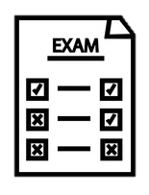
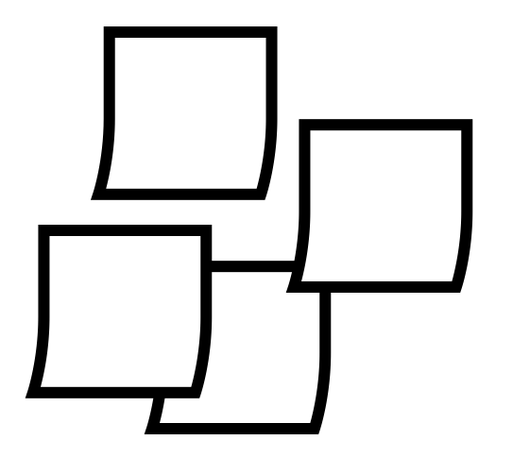

P1 - Feminism
Core ideas and principles of feminism. Different types and key feminist thinkers
P3 – USA Democracy & Participation
Policial parties and Elections in the USA. The role of pressure groups and lobbying

Paper 1 Revision

Mock Exams

P3 – US Supreme Court
The nature and role of the US Supreme Court. The appointment process and impact of the Supreme Court. The protection of rights and liberties in the US.
Paper 2 Revision

Mock Exams
What’s assessed?
Paper 1: UK Politics
Paper 2: UK Government
Paper 3: USA Comparative theories

P1 – Liberalism
The core ideas and principles of Liberalism. Strands of Liberalism. Tensions within liberalism. Key Liberal thinkers.

