Autumn
Term
Spring
Term
Summer
Term

Mechanics
Forces and Motion
Moments

Pure
Trig identities
Proof

Statistics
Normal distribution
Mechanics
Projectiles
Pure
Integration 2, Functions, Differential Equations
Mechanics
Friction
Pure
Further differentiation
Vectors 2

Y13 Summer Exam

Further study
- Maths degree
- Engineering, Computer Science, Physics, Accountancy or other mathematical degree
Career paths
- Finance, engineering, computing, big data, data analyst
Revision
Year 13
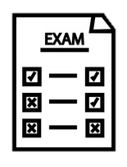
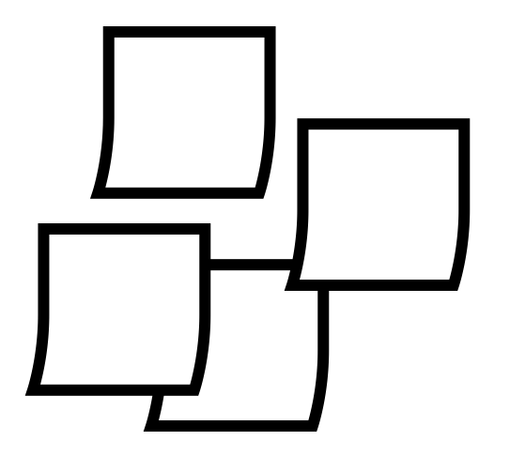

Pure: Numerical Methods
Mechanics: Kinematics 2
Statistics: Hypothesis Testing 2

Revision lessons – topics in depth and method selection
Mock Exams

Throughout the year:
“Weekly Review” revision lessons built in
Up Learn
Topic Assessments
Textbook fluency exercises
Weekly past papers
Senior Maths Challenge (UKMT)

Oxbridge interview prep

Admissions test support
What’s assessed?
Paper 1: Pure Mathematics
Paper 2: Pure & Statistics
Paper 3: Pure & Mechanics

Mock Exams

Y2 Pure (cont)
Sequences and Series, Parametric Equations

