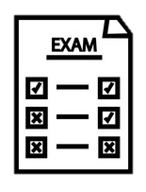
The Longsands Academy A-Level Politics Learning Journey
Autumn
Term
Spring
Term
Summer
Term

P2 – The Constitution

The nature and sources of the UK Constitution e.g. the Magna Carta. Changes to the Constitution. The roles and powers of devolved governments, and debates on further reforms.
P2 – Relations between branches
The functions of the Supreme Court, and the role of judicial review.
The impact of the EU on UK government, and the location of UK Sovereignty

Y12 Exam

An introduction to political ideologies
Introduction to the core concepts of Liberalism, Conservatism and Socialism
An introduction to the USA
Introduction to the origins of the USA and the Constitution

Year 12


What’s assessed?
Paper 1: UK Politics
Paper 2: UK Government
Paper 3: USA Comparative Theories

P1 – Voting Behaviour and the Media
Case studies of three key general elections.
Factors which explain the outcomes of elections e.g. social class, age, ethnicity.
The influence of the media on politics.

Key skills
• Critical analysis, critical thinking, communication of arguments, problem solving, presentation skills, source analysis, evaluation, comparison and forming judgments

P2 – Parliament
The roles and functions of the House of Commons and House of Lords. The comparative powers of both houses. The Legislative process and the work of Committees.

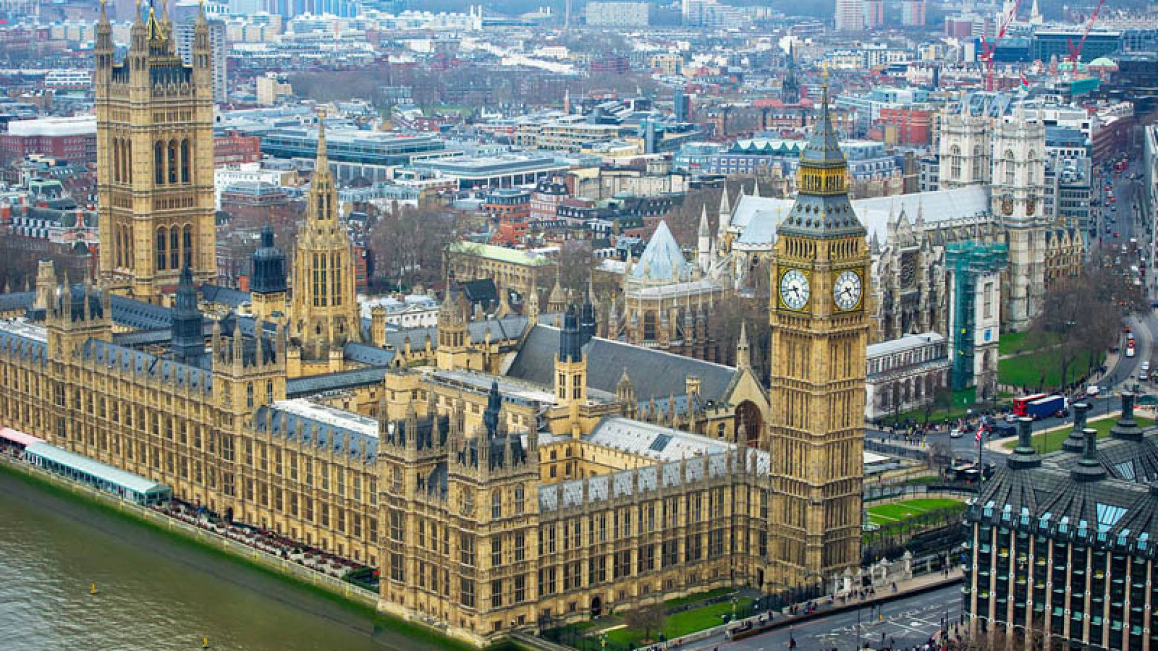

P2 – The Prime Minister
The roles and powers of the Executive. Individual and Collective Ministerial Responsibility.
A case study of Prime Ministers

. P1 – Political Parties

The functions and features of political parties in the UK. How parties are funded and the development of a multi-party system. The origins and historical development of the Conservative, Labour and Liberal Democrat parties. The impact and importance of minor parties in the UK and devolved government.

P1- Electoral Systems
Referendums, General Elections e.g. First Past the Post, STV and the impact on party representation

P1 Democracy and Participation

What is democracy and how do citizens participate? Major milestones in civil rights. Pressure groups, lobbying and think tanks.

