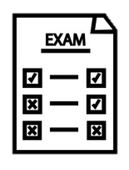
The Longsands Academy A-Level Law Learning Journey
Autumn
Term
Spring
Term
Summer
Term

Judicial & Parliamentary Law-Making

Statutory interpretation. Judicial precedent. Parliamentary law-making. Delegated Legislation. European Union
Negligence
Rules of negligence
Injury and damage to property
Psychiatric injury
Economic Loss)
OLA
Occupiers’ Liability Act 1957 (lawful visitors)
Occupiers’ Liability Act 1984 (trespassers)

Vicarious Liability
Vicarious liability
Civil defences (warning notices, consent, contributory negligence)
Y12 Exam

Assessment practice
Applying rules of criminal and tort law to determine liability

Year 12


What’s assessed?
Paper 1: CRIMINAL LAW
Paper 2: TORT LAW
Paper 3: HR/CONTRACT LAW

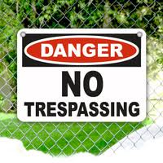
Private nuisance
Rylands v Fletcher
Civil defences
Civil defences (warning notices, consent, contributory negligence)

Key skills
• Critical analysis, critical thinking, problem solving, presentation skills, creating legal arguments

Fatal Offences Against the Person
Murder,
Involuntary manslaughter (unlawful act manslaughter & gross negligence manslaughter)
Voluntary manslaughter (diminished responsibility & loss of control)

. Non-Fatal Offences Against the Person
Rules of criminal law (Actus Reus, Mens Rea
Assault, Battery, ABH
GBH S.20 , GBH with intent


Property and attempted offences
Theft Act 1968
Robbery
Attempted Offences

. Access to Justice and Funding

Alternative Dispute. Resolution (negotiation, mediation, tribunals)
Law Reform. Role and training of solicitors, barristers and legal executives. Selection and appointment process of juries and magistrates. Types of judges in criminal and civil cases.
Criminal Defences
Capacity defences
Incapacity defences

English Court System

Identify the criminal courts in the English Legal System.
Identify the civil courts in the English Legal System.
Punishment of offenders.

