

A-LEVEL GERMAN HANDBOOK
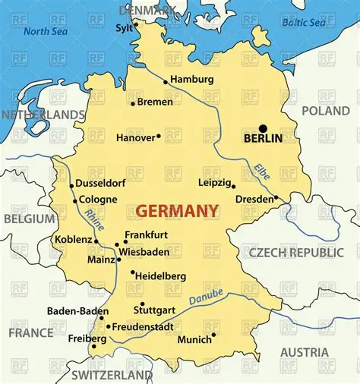

Contents

Course Outline ………………..…………………………………………………………………………………. 3
Resources ………………….……………………………………………………………………………….……… 4-5
Organisation …………………………………….………………………………………………………..……… 6
How the course is delivered and department expectations …..……………………………… 7
Independent Learning …………………………………………………………………………………………. 8
Films & Key websites …………………………………………………………………………………………… 9
Grammar ………………..…………………………………………………………………………………………… 10
Exam Breakdown Year 13 …………………………………………..……………………………………….. 11
Speaking Mark schemes Year 13 …………………………………………..………………………….… 12-13
Clever Bits ……………………..…………………………………………..……………………………………….. 14-17

2
Course Outline
A-Level Year 1
Social issues and trends | Political and artisctic culture
The changing state of the family (Familie im Wandel)  - Beziehungen innerhalb der Famile  - Partnerschaft und Ehe  - Verschiedene Familienformen | Festivals and traditions (Feste und Traditionen)  - Feste und Traditionen – ihre Wurzeln und Ursprünge  - Feste und Traditionen – ihre soziale und wirtschaftliche Bedeutung heute  - Vielfältige Feste und Tradtionen in verschiedenen Regionen
The digital world (Die digitale Welt)  - Das Internet  - Soziale Netzwerke  - Die Digitalisierung der Gesellschaft | Art and architecture (Kunst und Architektur)  Künstler und Architekten  Kunst und Architektur im Alltag  Kunst und Architektur – Vergangenheit, Gegenwart, Zukunft
Youth culture: fashion and trends, music, television (Jugendkultur: Mode, Musik und Fernsehen)  - Moder und Image  - Die Bedeutung der Musik für Jugendliche  - Die Rolle des Fernsehens | Cultural life in Berlin, past and present (Das Berliner Kulturleben damals und heute)  - Berlin geprägt durch seine Geschichte  - Theater, Musik und Museen in Berlin  - Die Vielfalt innerhalb der Bevölkerung Berlins
Students will study the film “Goodbye Lenin” by Wolfgang Becker
A-Level Year 2
3
Current issues | Aspects of political life
Immigration (Einwanderung)  - Die Gründe für Migration  - Vor- und Nachteile der Einwanderung  - Die Rolle des Fernsehens | Germany and the European Union (Deutschland und die Europaïsche Union)  - Die Rolle Deutschlands in Europa  - Vor-und Nachteile der EU für Deutschland  - Die Auswirkungen der EU-Erweiterung auf Deutschland
Integration (Integration)  - Maßnahmen zur Integration  - Hindernisse für die Integration  - Die Erfahrungen verschiedener Migrantengruppen | Politics and youth (Die Politik und die Jugend)  - Politisches Engagement Jugendlicher  - Schwerpunkte der Jugendpolitik  - Werte und Ideale
Racism (Rassismus)  - Die Opfer der Rassismus  - Die Ursprünge des Rassismus  - Der Kampf gegen Rassismus | German re-unification and its consequence (Die Wiedervereinigung und ihre Folgen)  - Friedliche Revolution in der DDR  - Die Wiedervereinigung – Wunsch und Wirklichkeit  - Alte und neue Bundesländer – Kultur und Identität
Students will study the play “Andorra” by Max Frisch
Individual research project
Students identify a subject or a key question which is of interest to them and which relates to a country or countries where German is spoken. Students will demonstrate their ability to initiate and conduct individual research by analysing and summarising their findings, in order to present and discuss them in their speaking assessment.
Resources
The following books will be used through the course.
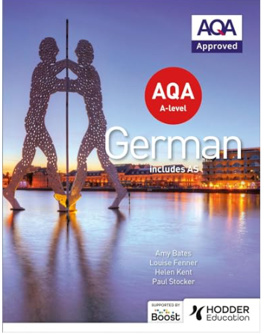 |  | 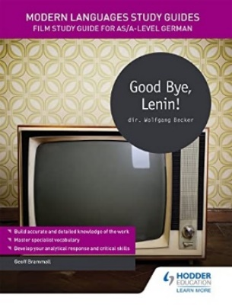 | 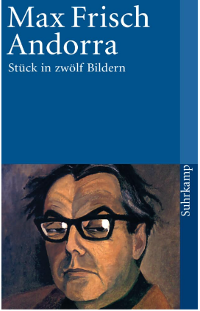 | 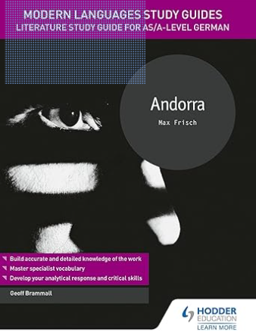
TO BUY: AQA A-level German (includes AS)  Amy Bates (ISBN  9781471858024) | You will be loaned a German copy of Goodbye Lenin towatch the film again in your own time. | We strongly recommend you buy this study guide for the film.  Geoff Brammall (ISBN 1471891844 ) | TO BUY if you wish to annotate  Andorra by Max Frisch  (ISBN 2253117188) | We strongly recommend you buy this study guide for the film.  Geoff Brammall  (ISBN 1510435638)

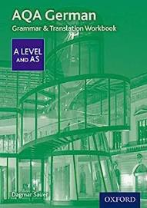
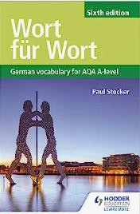
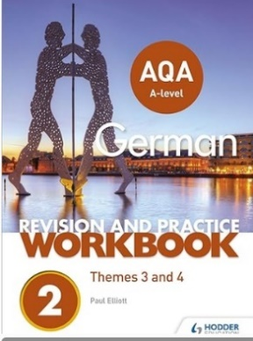
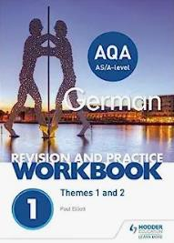
If you wish to purchase any further resources to support you, we recommend the following:
AQA A-level German Revision and Practice Workbook: Themes 1 and 2 and Themes 3 and 4
AQA German A Level and AS Grammar & Translation Workbook

Wort für Wort: German Vocabulary for AQA A-level

4
Online resources and apps
These are also a great way to support your language learning, so please download useful ones and use them.

 | WordReference is a free online dictionary and an essential app for studying A Level French. There are also a verb conjugations to help check your verbs.
 | Memrise is a great vocabulary learning tool. It uses spaced repletion to help you learn words. Join the class group and get learning!
 | Quizlet is another great website for learning vocabulary and phrases. Create your own or follow a set list.
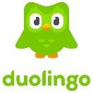 | Duolingo is also a useful resource for independent language learning. They also create podcasts on cultural French topics, which can enhance your listening skills.

Top 5 to follow
- https://dict.leo.org/german-english/
- https://quizlet.com/class/2012571/
- http://www.dartmouth.edu/~deutsch/Grammatik/Grammatik. html
- https://twitter.com/slowgerman
- https://www.nachrichtenleicht.de/

5
4
Organisation
A well organised folder is the key to success at A Level. If you keep to the guidelines below, you will be fully prepared for lessons and meeting work expectations.
Please label your file dividers as follows:
- Student Handbook containing course overview and exam breakdown
- Topics (including knowledge organisers, vocabulary and assessments):
  - 1. Familie im Wandel
  - 2. Digitale Welt
  - 3. Jugendkultur (Mode, Musik und Fernsehen)
  - 4. Feste und Traditionen
  - 5. Kunst und Architektur
  - 6. Das Berliner Kulturleben damals und heute
- Grammar
- Goodbye Lenin
- Andorra
- Revision
You can work on file paper, which needs to be filed in your folder.
- When you are given hand-outs, please ensure that they are filed in the appropriate section of your folder.
- If you miss a lesson for any reason, it is your responsibility to get a copy of anything handed out.
- It is essential that you bring your file to every lesson. As you work through the course your folder will get very full. You may want to leave the large file at home or in an MFL classroom and just bring a smaller file to school on a daily basis.
- Weekly homework will be set on Teams. You will be set approximately one hour’s homework
for every hour you have in class. Homework must be submitted on time.

6
How the course is delivered

- You will be taught for 5 hours per week by two teachers.
- You will cover one main theme with each teacher using the AQA-linked textbook by Oxford University Press, online resources and a variety of other supplementary material.
- Your teachers will cover all necessary grammar, the literature study, the film study and the independent research project over your two-year course.

Departmental expectations

- Students will attend all classes promptly and with all necessary resources.
- Students will be expected to learn vocabulary and grammar for regular tests in class.
- Students will meet deadlines for all homework and will do individual study of at least one hour for each hour of classes. Teachers will contact parents if any issues with deadlines or work completion arise.
- Work must be organised systematically in files.

- Individual study must include all four skills of listening, speaking, reading and writing, using a variety of resources.
7
7

Independent Learning
Classroom learning is only part of your A Level French course. To truly excel in the subject, we expect you to complete some super curricular learning.
Below are some ideas of what you can do to learn French independently:

 | Online streaming has made it easier for us to watch French TV series and films. Netflix  has some great German series.
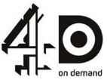 | Channel 4’s streaming service, 4oD, also has a great choice of world dramas, including those from Germany, Switzerland and Austria.
 | Lyrics Training is a great app for language learners who also enjoy music. It creates gap fill tasks, which train both your listening skills and vocabulary simultaneously. It is a great way to complement they music topic and find out about French musicians.
 | YouTube also contains a varied amount of German material, from Easy German videos to grammar explanations. Exploring its German content will complement your understanding of the cyber-société topic. You may enjoy following Germany’s most successful YouTubers, Cyprien and Norman, listening to Sarah’s French cover songs or to Damon and Jo who  teach you how to sound more French when you speak.

You will also have a speaking lesson once a week to practise speaking French. This is a compulsory lesson. This is also where you will be planning and prepping your IRP project.
8
Films
In addition to studying your set film in Year 12, it would be good to watch another German film on your own. Here are some suggestions. The ones in bold are taken from the AQA specification:

- Zonenkinder by Jana Hensel
- Russendisko, by Wladimir Kaminer
- Fundburo by Siegfried Lenz
- Almanya by Yasemin Samdereli
- Das Leben der Anderen by Florian Henckel von Donnersmarck

Key websites
https://www.dw.com/de/deutsch-lernen/nachrichten/s-8030:
Daily news spoken slowly in German with audio transcripts for support
www.memrise.com for vocabulary practice
https://www.lightbulblanguages.co.uk/resources-german.htm for general reading and grammar practice
http://www.wordreference.com/ or https://www.collinsdictionary.com for vocabulary
www.youtube.com don’t just use this to search for songs and film clips, you will also find a wealth of grammar explanations, debates, documentaries and news in German
Planet Wissen range of topics from politics, to art and culture. Current and informative.

9
Grammar
Knowledge and understanding of grammar are essential to success at A Level. It will take lots of learning and practise to get to grips with the grammar, but your hard work will pay off. Below is a list of all the grammar you will cover in Year 12 and Year 13.
Unit 1: Family and Relationships | Present tense Modal verbs Perfect tense  Word order (main clause, questions and commands, variation for emphasis, position of pronouns/ adverbials/ nicht)  Time phrases  Qualifiers and particles eg doch
Unit 2: The Digital World | word inversion and time-manner place rule subordinating and coordinating conjunctions prepositions with cases  prepositional adverbials eg darauf nouns and cases, weak masculine nouns definite and indefinite articles  alle/ viel/ welcher etc possessives  future tense  simple future
Unit 3: Youth Culture | pronouns (reflexive, personal, relative, possessive, demonstrative, indefinite, interrogative)  verbs and cases  using the imperative
Unit 4: Festivals and Traditions | passive imperfect  separable and inseparable verbs reflexive verbs  word formation (nouns from adjectives/ verbs, verbs from nouns/ adjectives)  compound nouns
Unit 5 : Cultural life of Berlin | Adjectival endings  Adjectives with the dative eg es ist mir Adjectives with prepositions eg stolz auf Infinitive construction with/ without zu  subjunctive
Unit 6: Art and Architecture | Word order with subordinate clauses Comparatives and superlatives Pluperfect  Conditional  Conditional perfect
Unit 7: Immigration | weak masculine nouns complex adjectival phrases  adjective endings
Unit 8: Germany and the EU | perfect imperfect pluperfect  da + preposition  future perfect
Unit 1: Integration | possessive adjectives interrogative adjectives subjunctive in indirect speech  word order
Unit 2: Politics and Young People | passive  modal particles  word order
Unit 3: Racism | relative pronouns interrogative pronouns present tense  future tense
Unit 4 : Reunification and its consequences | Pluperfect Conditional Cases  Imperfect and pluperfect subjunctive
10

Exam Breakdown – Year 13

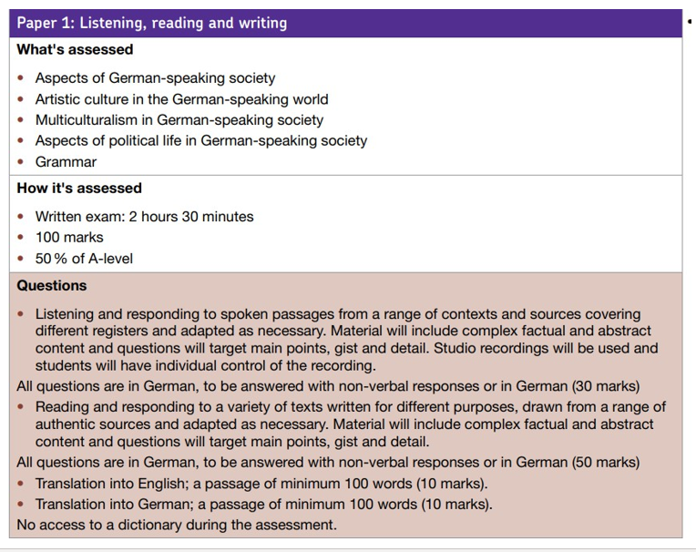

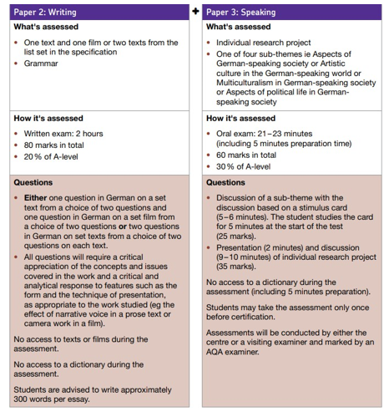
11

Paper 3 (Speaking)
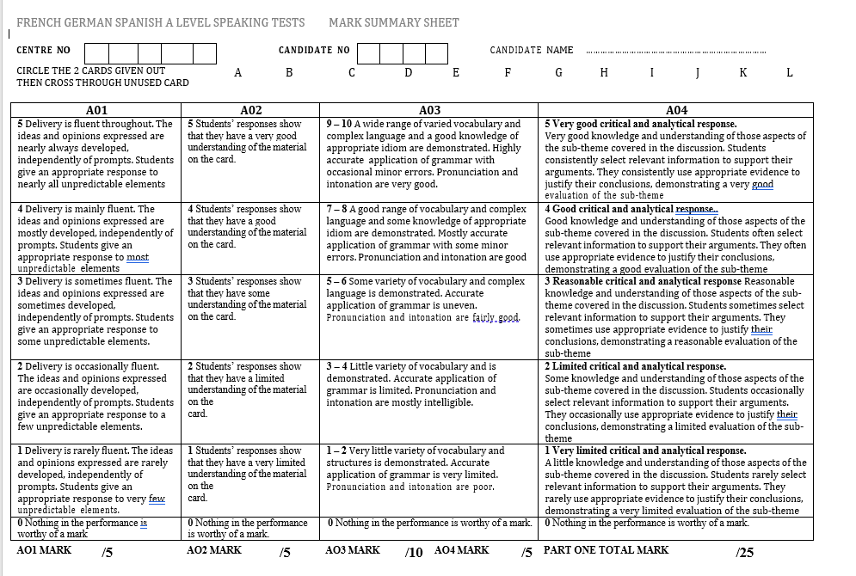
12

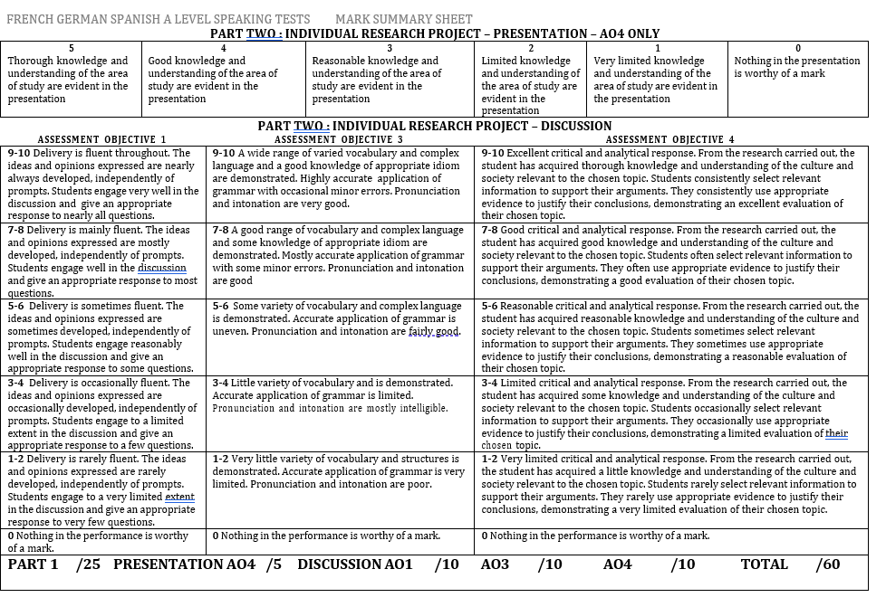
13
Language to support A level speaking exam
14
Structuring ideas
Erstens/zweiten/drittens/ | Firstly/secondly/thirdly
Als erstes fällt auf, dass… | The first thing that strikes one is that…
Einerseits/andererseits | On the one hand/on the other hand
Auf der einen Seite/auf der anderen Seite | On the one hand/on the other hand
Jedoch/immerhin | However/nevertheless
Jedoch ist es nicht außer Acht zu lassen, dass… | However it cannot be ignored that
Trotz der Vorteile gibt es natürlich auch Nachteile | Inspite of the advantages there are of course disadvantages, too.
Sentence starters
Momentan wird viel über…debattiert | At the moment there is a lot of debate about…
Als erstes fällt auf, dass… | The first thing that strikes one is that…
Im Bezug auf (+acc.) | In relation to…
Bezüglich (+gen.) | Regarding…
Es steht fest, dass… | It is clear that…
Es liegt auf der Hand, dass… | It’s obvious that…
Die damit verbundenen Schwierigkeiten sind nicht zu unterschätzen. | The difficulties connected with it are not to be underestimated.
Es gibt natürlich Probleme/Hindernisse, die man lösen /überwinden muss | There are of course problems/obstacles which one must solve/overcome.
Kritiker bemängeln, dass… | Critics argue/complain that…
Laut + dative e.g. Laut der Organisation X…. | According to e.g. according to the X organisation…
Experten zufolge ist/sind… | According to experts….is/are…
Man behauptet, _______ sei (+ adjective) | One claims ________is (+ adjective)
Der Einfluss auf das Publikum muss auch in Betracht gezogen werden | The influence of the public must also be taken into consideration.
Ich habe in einem Artikel, der (im November 2022/ im Spiegel/ in der süddeutschen Zeitung etc.) veröffentlicht wurde, gelesen, dass… | I read in an article, which was published (in November 2022/ in the Spiegel/ in the süddeutsche Zeitung), that…
Es gibt gewisse Tendenzen, die man erkennen kann. | There are certain tendencies which one can recognise.
Viele Leute haben Angst davor….zu + INF | Many people are afraid of… (verb in ‘ing’ form e.g. afraid of speaking)
Viele Leute interessieren sich dafür,….zu + INF | Many people are interested in….(verb in ‘ing’ form e.g. visiting museums)
X ist besonders relevant für Touristen/die Region etc. | X is particularly relevant to tourists/the region.
Developing your point/drawing conclusions
Es lohnt sich, dieses Thema genauer zu betrachten | It is worth considering this theme/topic more precisely.
Noch wichtiger ist die Tatsache, dass… | More important (still) is the fact that…
Wenn wir X berücksichtigen, wird sofort klar, dass… | If we take into consideration X, it becomes immediately clear that…
Wenn wir die Tatsache berücksichtigen, dass…kommt man zu dem Schluss, dass… | If we take into consideration the fact that…one comes to the conclusion that…
Dazu kommt noch das Problem der/des…(genitive) | In addition there is the problem of…
Es gibt einen (klaren) Zusammenhang zwischen X und Y | There is a (clear) relationship between X and Y
X ist mit Y verbunden und das heißt, dass… | X is connected to Y and that means that…
Die Statistik macht klar/zeigt, dass… | The statistics make clear/show that…
Wie die Statistik klar macht/zeigt, (….verb….) | As the statistics make clear/show…
Wenn (die Regierung) mehr gemacht hätte, um die Situation zu ändern, wäre das Leben viel (einfacher) gewesen. | If (the government) had done more to improve the situation, life would have been much (easier).
Wer hätte jemals gedacht, dass… (+conditional) | Who would have ever thought that…
X hat dazu geführt, dass man/die Bürger… | X lead to one/the citizens (doing…)
Um dieses Problem zu lösen sollte die Regierung vor allem…(+INF) | To solve this problem the government should above all…
Alles in allem kommt man zu dem Schluss, dass… | All in all, one comes to the conclusion that…
Zusammenfassend kann man sagen, dass… | In conclusion one can say that…
Die Nachteile überwiegen eindeutig die Vorteile | The advantages clearly outweigh the advantages
Wenn man diese Situation ändern will, muss man darauf achten, dass… | If one wants to change this situation one must pay attention to…

Extra vocabulary:
- angeblich – supposedly
- eigentlich – actually
- es scheint also, dass… - it therefore appears that
- genauso wichtig (wie dies) ist… - just as important (as this) is…
- gleichzeitig – at the same time
- grundsätzlich – fundamentally
- im Allgemeinen – in general
- im Durchschnitt – on average
- in der Tat – in fact
- in diesem Fall – in this case
- infolgedessen – as a result of this
- kurz gesagt – in short
- möglicherweise – possibly
- tatsächlich – indeed
- vermutlich – presumably
- verständlicherweise – understandably
- zweifellos – without a doubt

15
SPEAKING CARD GUIDANCE
1st Bullet Point
Es springt ins Auge, dass | You notice that
Es ist mir klar (geworden), dass | It is (has become) clear that
Hier erfahren wir … | Here we learn
Man sieht sofort, dass … | You see straight away that
In der Überschrift steht, dass | In the title it says that
Die Bilder zeigen uns, dass … | The pictures show us that
Auf dem Foto sieht man | In the photo you can see
Was … betrifft … | As far as … is / are concerned …
Wir lernen von den Aussagen, dass … | We learn from the comments that
Es steht fest, dass … | It is stated that …
Hier wird … mit … verglichen | X and Y are compared her
Hier wird gefragt, ob … | Here the question is being asked whether …
Man betont hier … | It is emphasised here
Man will hier ausdrücken, dass … | They want to say here that
Man merkt schnell, dass … | You can quickly see that …
Das geht um … / Es handelt sich (im Text) von … | It (the text) is about
Es fällt (mir) auf, dass … | I can see that …
Hier wird das Thema … diskutiert | The theme of … is discussed here
mit anderen Worten | in other words
Es geht in erster Linie darum, dass … | Primarily it is about
Von Interesse hier ist die Tatsache, dass … | An interesting fact here is that
Mehr als die Hälfte (der Leute) … | More than half (of the people) …
die Mehrheit / eine Minderheit | the majority / a minority
im Durchschnitt / durchschnittlich | on average
Weniger als ein Drittel | Less than a third
doppelt so viel | twice as many

2nd Bullet Point

meines Erachtens | In my opinion
Ich bin der Meinung, dass | I think that
Ich meine / nehme an, dass … | I think that
Ich bin davon nicht überzeugt, dass … | I am not convinced that
Es ist vor allem wichtig, dass … | Above all it is important that
Hauptsache ist, dass … | The main thing is that …
Ohne Zweifel lohnt es sich …. zu … denn … | Without doubt it is worth … because …
Man darf nicht vergessen, dass | We must not forget that
Einerseits … andererseits … | On one hand … on the other hand …
…. hat Recht, wenn er sagt | … is correct when he says
Ich hätte nichts dagegen, wenn … | I would have nothing against it if
Man könnte sagen, dass | You could say that
Ich kann es (kaum) glauben, dass … | I can (hardly) believe that …
Ich könnte mir vorstellen, dass … | I could imagine that
Es stört mich (nicht), dass / wenn … | I am (not) bothered that / if …
Es macht mir nichts aus, wenn … | I am not bothered if …
Ich weiß aus eigener Erfahrung, dass … | I know from experience that …
Es liegt daran, dass … | It is because …
Ich halte es für … | I think it is …
Das kann man keineswegs rechtfertigen | You cannot justify that
Es versteht sich von selbst, dass … | It is obvious that …
Ohne Zweifel … | Without a doubt

3rd Bullet point
16
während meiner Recherche | during my research
Wir haben im Unterricht herausgefunden, dass | In lessons we found out that
Ich habe gelesen / gehört, dass ... | I read / heard that …
Man sollte nicht vergessen … | You should not forget
Laut einer Umfrage | According to a survey
Es ist (in Deutschland) behauptet worden, dass | It has been claimed (in Germany) that
Mir ist aufgefallen, dass | I have noticed that
überraschungsweise | surprisingly
Was mich überrascht hat, ist, dass … | What surprised me is that …
Wußten Sie, dass … | Did you know that …?
Vielleicht wußten Sie nicht, dass … | Perhaps you didn’t know that …
Was manche vielleicht nicht wissen, ist dass … | What some perhaps do not know is that …
häufig / gewöhnlich / regelmäßig | ferquently / usuallly / regularly
vor kurzem / neulich / in letzter Zeit | recently
in den letzten paar Jahren | in the last few years
unter Jugendlichen / Erwachsenen | among young people / adults
In Deutschland gilt X als … | In Germany X is considered to be …
X zählt zu den besten … | X is seen as one of the best …
Wenn Sie … besuchen würden, würden Sie … | If you visited … you would …
Man hat die Gelegenheit … zu +INF | You can …
Nichts wäre besser als … zu +INF | Nothing would be better than …
Man muss unbedingt … | You really must …
In (München) lässt es sich gut (einkaufen) | In (Munich) you can have a good time (shopping)
Es würde Ihnen bestimmt Spaß machen … zu +INF | You would certainly enjoy …

17

