
A-LEVEL FRENCH HANDBOOK
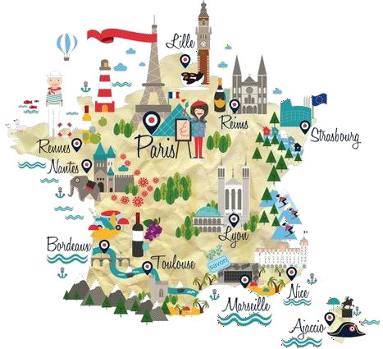

Contents

Course Outline ………………..…………………………………………………………………………………. 3
Resources ………………….……………………………………………………………………………….……… 4
Online Resources …………………………………….…………………………………………………………. 5
Organisation …………………………………….………………………………………………………..……… 6
How the course is delivered …..……………………………………………………………………………. 7
Department expectations ……………………………………………………………………………………. 7
Independent Learning …………………………………………………………………………………………. 8
Films & Key websites …………………………………………………………………………………………… 9
Exam Breakdown Year 13 …………………………………………..……………………………………….. 10-12
Grammar ………………..…………………………………………………………………………………………… 13
Clever Bits ……………………..…………………………………………..……………………………………….. 14

2
Course Outline
A-Level Year 1
3.1.1 Aspects of French-speaking society:  current trends | 3.2.1 Artistic culture in the French-speaking  world
The changing nature of family (La famille en voie de  changement)  - Grands-parents, parents et enfants – soucis et problèmes  - Monoparentalité, homoparentalité, familles recomposées  - La vie de couple – nouvelles tendances | A culture proud of its heritage (Une culture fière de  son patrimoine)  - Le patrimoine sur le plan national, régional et local  - Comment le patrimoine reflète la culture  - Le patrimoine et le tourisme
The ‘cyber-society’ (La « cyber-société »)  - Qui sont les cybernautes ?  - Comment la technologie facilite la vie quotidienne  - Quels dangers la « cyber-société » pose-t-elle ? | Contemporary francophone music (La musique  francophone contemporaine)  - La diversité de la musique francophone contemporaine  - Qui écoute et apprécie cette musique ?  - Comment sauvegarder cette musique ?
The place of voluntary work (Le rôle du bénévolat)  - Qui sont et que font les bénévoles ?  - Le bénévolat – quelle valeur pour ceux qui sont aidés ?  - Le bénévolat – quelle valeur pour ceux qui aident ? | Cinema: the 7th art form (Cinéma : le septième art)  - Pourquoi le septième art ?  - Le cinéma – une passion nationale ?  - Evolution du cinéma – les grandes lignes
Students will study the film « La Haine » by Mathieu Kassowitz
A-Level Year 2
3
3.1.2 Aspects of French-speaking society:  current issues | 3.2.2 Aspects of political life in the French-  speaking world
Positive features of a diverse society (Les aspects  positifs d’une société diverse)  - L’enrichissement dû à la mixité ethnique  - Diversité, tolérance et respect  - Diversité – un apprentissage pour la vie | Teenagers, the right to vote and political commitment  (Les ados, le droit de vote et l’engagement politique)  - Pour ou contre le droit de vote ?  - Les ados et l’engagement politique – motivés ou démotivés ?  - Quel avenir pour la politique ?
Life for the marginalised (Quelle vie pour les  marginalisés ? )  - Qui sont les marginalisés ?  - Quelle aide pour les marginalisés ?  - Quelles attitudes envers les marginalisés ? | Demonstrations, strikes – who holds the power?  (manifestations, grèves – à qui le pouvoir ? )  - Le pouvoir des syndicats  - Manifestations et grèves – sont-elles efficaces ?  - Attitudes différentes envers ces tensions politiques
How criminals are treated (Comment on traite les  criminels)  - Quelles attitudes envers la criminalité ?  - La prison – échec ou succès ?  - D’autres sanctions | Politics and immigration (La politique et  l’immigration)  - Solutions politiques à la question de l’immigration  - L’immigration et les partis politiques  - L’engagement politique chez les immigrés
Students will study the novel « Un secret » by Philippe Grimbert
Individual research project
Students identify a subject or a key question which is of interest to them and which relates to a country or countries where French is spoken. Students will demonstrate their ability to initiate and conduct individual research by analysing and summarising their findings, in order to present and discuss them in their speaking assessment.
Resources
The following books will be used through the course.
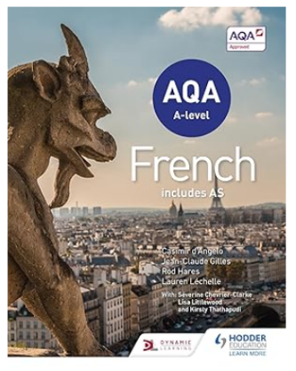 |  | 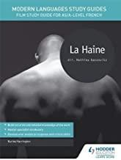 | 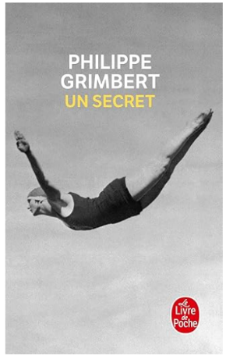
TO BUY: AQA A-level French (includes AS)  Kirsty Thathapudi, Séverine Chevrier-Clarke (authors) (ISBN 1471857956) | You will be loaned a French copy of « La Haine », to watch the film again in your owntime. | We strongly recommend you buy this study guide for the film.  Karine Harrington (ISBN 1471889947) | TO BUY if you wish to annotate  « Un secret» Philippe Grimbert  (ISBN 2253117188)

If you wish to purchase any further resources to support you, we recommend the following:
AQA A-level French Revision and Practice Workbook: Themes 1 and 2, 3 and 4.
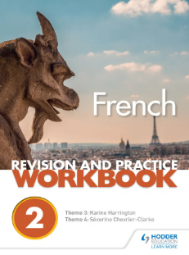
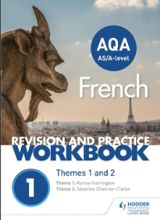

AQA French A Level and AS Grammar & Translation Workbook

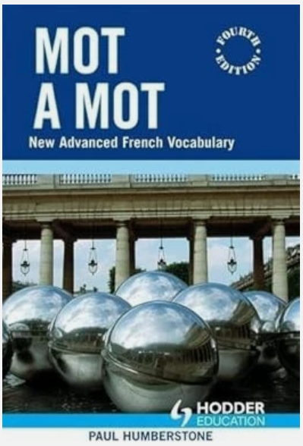
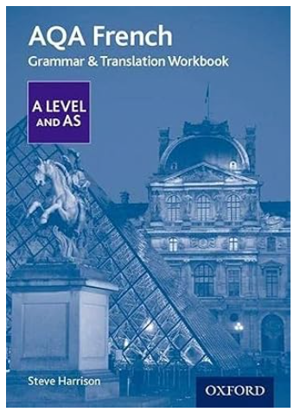

Mot A Mot: French Vocabulary for A-level AQA

4
Online resources
Online resources and apps are also a great way to support your language learning, so please download useful ones and use them.

 | WordReference is a free online dictionary and an essential app for studying A Level French. There are also a verb conjugations to help check your verbs.
 | Memrise is a great vocabulary learning tool. It uses spaced repletion to help you learn words. Join the class group and get learning!
 | Quizlet is another great website for learning vocabulary and phrases. Create your own or follow a set list.
 | Duolingo is also a useful resource for independent language learning. They also create podcasts on cultural French topics, which can enhance your listening skills.
 | Languages online is great for practising grammar and the verb busters are great for drilling verbs: https://www.languagesonline.org.uk/French
5
Organisation
A well organised folder is the key to success at A Level. If you keep to the guidelines below, you will be fully prepared for lessons and meeting work expectations.
Please label your file dividers as follows:
- Student Handbook containing course overview and exam breakdown
- Topics (including knowledge organisers, vocabulary and assessments):
  - 1. La Famille en voie de changement
  - 2. La « cyber-société »
  - 3. Le rôle du bénévolat
  - 4. Une culture fière de son patrimoine
  - 5. La musique francophone contemporaine
  - 6. Cinéma : le septième art
- Grammar
- La Haine
- Un secret
- Revision
You can work on file paper, which needs to be filed in your folder.
- When you are given hand-outs, please ensure that they are filed in the appropriate section of your folder.
- If you miss a lesson for any reason, it is your responsibility to get a copy of anything handed out.
- It is essential that you bring your file to every lesson. As you work through the course your folder will get very full. You may want to leave the large file at home or in an MFL classroom and just bring a smaller file to school on a daily basis.
- Weekly homework will be set on Teams. You will be set approximately one hour’s homework
for every hour you have in class. Homework must be submitted on time.

6
How the course is delivered

- You will be taught for 5 hours per week by three teachers.
- You will cover one main theme with each teacher using the AQA-linked textbook by Oxford University Press, online resources and a variety of other supplementary material.
- Your teachers will cover all necessary grammar, the literature study, the film study and the independent research project over your two-year course.

Departmental expectations

- Students will attend all classes promptly and with all necessary resources.
- Students will be expected to learn vocabulary and grammar for regular tests in class.
- Students will meet deadlines for all homework and will do individual study of at least one hour for each hour of classes. Teachers will contact parents if any issues with deadlines or work completion arise.
- Work must be organised systematically in files.

- Individual study must include all four skills of listening, speaking, reading and writing, using a variety of resources.
7

Independent Learning
Classroom learning is only part of your A Level French course. To truly excel in the subject, we expect you to complete some super curricular learning.
Below are some ideas of what you can do to learn French independently:

 | Online streaming has made it easier for us to watch French TV series and films. Netflix  has some great French series, such as Call My Agent, and Lupin and films, such as Amélie and Untouchables. Just make sure that you select the French soundtrack and English subtitles. You can also find many French films on Amazon Prime too.
 | Channel 4’s streaming service, 4oD, also has a great choice of world dramas, including those from France, Belgium and Luxembourg. There are a number of crime dramas that will greatly enhance the crime topic,
 | There are a number of podcasts for French learners, which allow you to follow a transcript at the same time. These include Duolingo, Coffee Break, News in Slow French, French Blabla.
 | 1jour1actu is a news website for children, but it is a great way to learn the basics about any topic, from immigration to festivals and from politics to prisons.
 | Lyrics Training is a great app for language learners who also enjoy music. It creates gap fill tasks, which train both your listening skills and vocabulary simultaneously. It is a great way to complement they music topic and find out about French musicians.
 | France 24 is a French news channel in English. It is a great way of keeping up with global stories that are affecting French-speaking countries. The BBC news website is also a good place to keep up with the key events taking place in France.
 | BFMTV is a French digital news channel and a good way to keep up with the headlines affecting France.
 | YouTube also contains a varied amount of French material, from Easy French videos to grammar explanations. Exploring its French content will complement your understanding of the cyber-société topic. You may enjoy following France’s most successful YouTubers, Cyprien and Norman, listening to Sarah’s French cover songs or to Damon and Jo who  teach you how to sound more French when you speak.

You will also have a speaking lesson once a week to practise speaking French. This is a compulsory lesson. This is also where you will be planning and prepping your IRP project.
8
Films
In addition to studying your set film in Year 12, it would be good to watch another French film on your own. Here are some suggestions. The ones in bold are taken from the AQA specification:
- Les 400 coups - François Truffaut (1959)
- Au revoir les enfants - Louis Malle (1987)
- Le Fabuleux Destin d’Amélie Poulain – Jean-Pierre Jeunet (2001)
- L’auberge espagnole - Cédric Klapisch (2002)
- Un long dimanche de fiançailles - Jean-Pierre Jeunet (2004)
- Entre les murs - Laurent Cantet (2008)
- Les Choristes – Christophe Barratier (2004)
- Intouchables – Olivier Nakache et Éric Toledano (2011)
- La famille Bélier – Éric Lartigau (2014)

Key websites
www.1jour1actu.com current affairs, news clips, animations and articles
http://www.lemonde.fr/ French newspaper Le Monde website
https://www.france24.com – French – for news, articles and current affaires
http://www.lepoint.fr/ French magazine Le Point for articles on current affairs and politics
http://www.energivores.tv/ for all things energy related
http://www.momes.net/ an online French magazine
www.memrise.com for vocabulary practice
http://www.lightbulblanguages.co.uk/resources-french.htm for general reading and grammar practice http://www.wordreference.com/ or https://www.collinsdictionary.com for vocabulary http://www.conjugation-fr.com/ to conjugate French verbs into all tenses
www.youtube.com don’t just use this to search for songs and film clips, you will also find a wealth of grammar explanations, debates, documentaries and news in French.

9
11

Exam Breakdown – Year 13
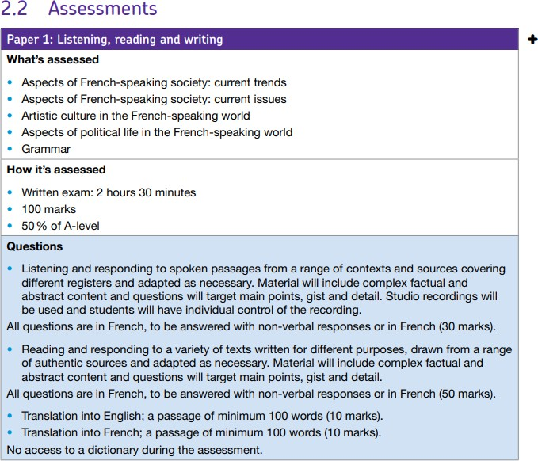
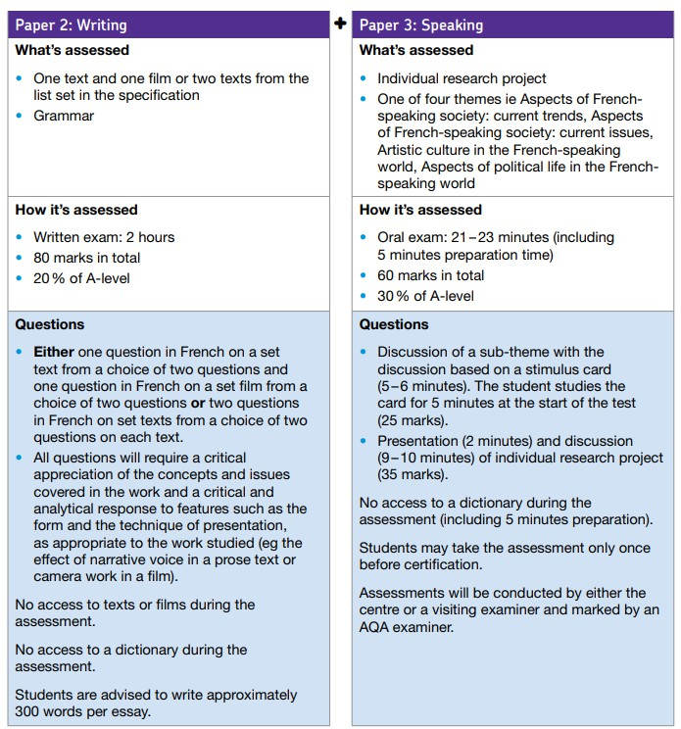
10

Paper 3 (Speaking)
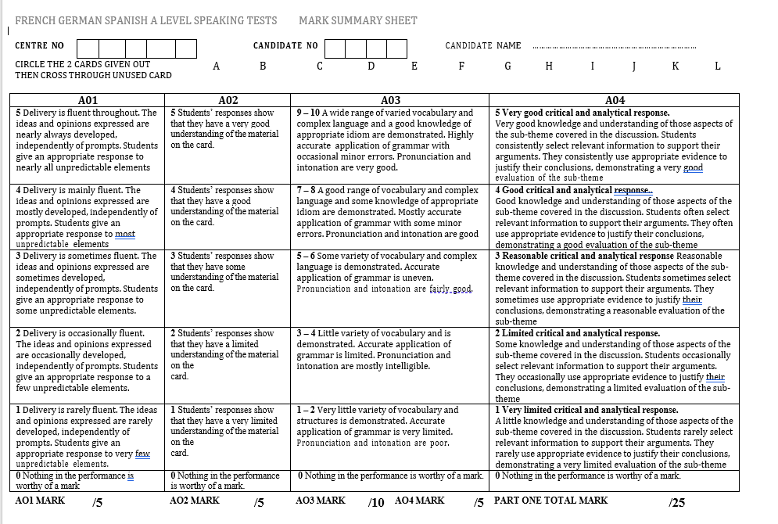
11
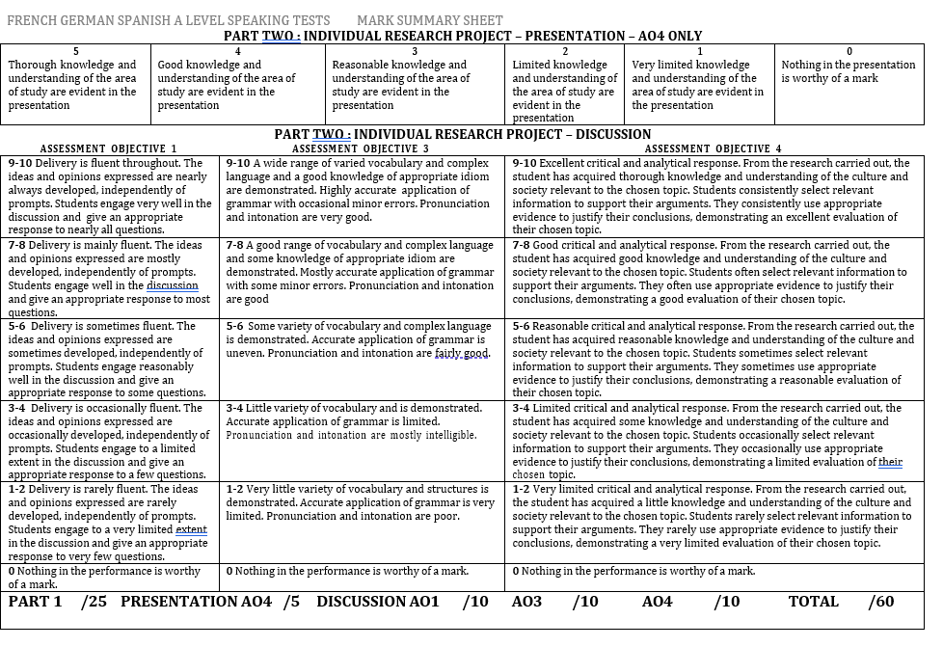
12
Grammar
Knowledge and understanding of grammar are essential to success at A Level. It will take lots of learning and practice to get to grips with the grammar, but your hard work will pay off. Below is a list of all the grammar you will cover in Year 12 and Year 13.

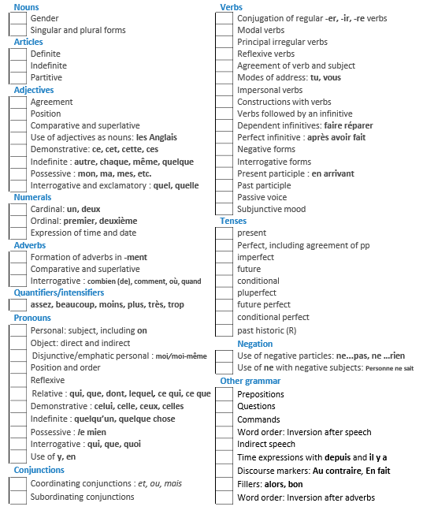
13
Clever Bits: For the top marks, you need to show that you are using more complex A Level structures.
- ‘Si’ clauses Si + present, future
Si on regarde trop de télévision, on deviendra très paresseux.
Si + imperfect, conditional
Si tout le monde ne faisait pas d’exercice, le taux d’obésité augmenterait.
Si + pluperfect, conditional perfect
Si je n’avais pas regardé la télé hier soir, j’aurais fait mes devoirs !
- Perfect infinitive Après avoir + past participle
Après avoir terminé leurs études, la plupart des élèves les continuent à la fac.
Après être + past participle
Après s’être divorcés, les parents de mon ami ont continué d’être amicaux.
- venir de = to have just Je viens de lire un roman politique.
- En + present participle En lisant le journal, je me tiens au courant de ce qui se passe dans le monde.
- Quand + future, future Quand je rentrerai en vacances, je parlerai anglais comme un Anglais.
- Depuis + present J’apprends le français depuis six ans.
- Infinitive Au lieu de + inf
Au lieu de regarder la télé, les jeunes préfèrent être sur ligne.
Avant de + inf
Avant de manger le petit déj, mon père regarde toujours les infos à la télé.
pour/afin de + inf
Les publicités se passent à la télé, afin de vendre les produits.
Infinitive as subject of the sentence
Ecouter la musique est un passe-temps préféré des jeunes aujourd’hui.
Trop fumer est mauvais pour la santé.
- Dont La façon dont…
… dont on a besoin.
… dont je parle.
… dont je me sers.
… dont je me souviens.
- Subjunctive Bien qu’il soit…/Quoiqu’il soit
Bien qu’il soit important de manger sainement, on peut manger ce qu’on
veut de temps en temps.
Pour qu’on puisse …
À moins qu’il n’y ait …
Pourvu que/À condition que je fasse … Je ne pense pas que…
Je ne crois pas que… on puisse…
Il est nécessaire que… ce soit…
Il est important que… il y ait…
Il semble que
14

