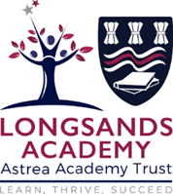
A LEVEL VISUAL ARTS HANDBOOK: PHOTOGRAPHY
Name:
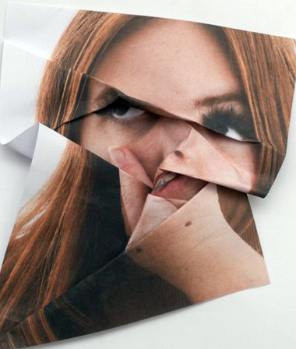
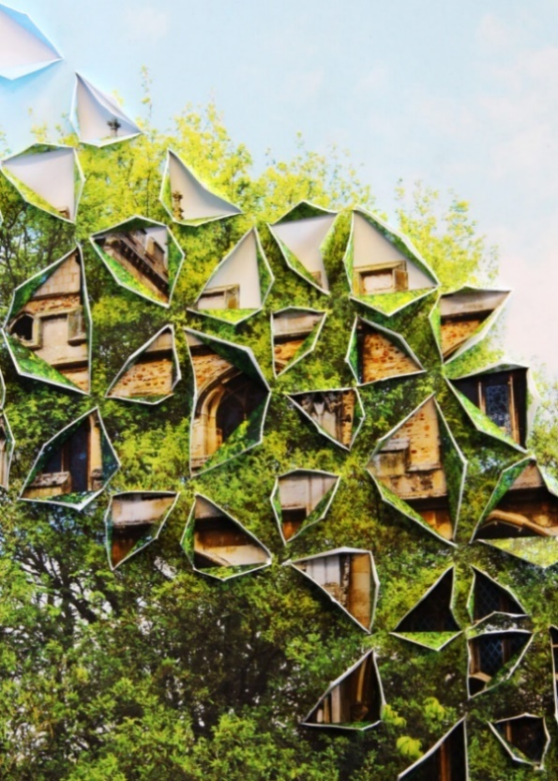

Contents
Introduction to the course ………………………………………………………………………..4
Year 12 Curriculum Map …………………………………………………………………………..5
Year 13 Curriculum Map …………………………………………………………………………..6
Equipment, What to Do, Expectations ……………………………………………………..4
Component 01: Personal investigation ………………………………. ……………………5
Component 02: Externally set task………………………………………………………….…10
Assessment…………………………………………………………………………………………….…11
Suggested Reading List ………………………………………………………….……….…………12
Related Study Writing Guide……………………………………………………………………..13
A Level Related Personal Study Marking Guide…………………………….………..….18
Photography Artist Research Image Analysis ……………………………………….….…19
Y13 Exam Preparation Timetable Example…………………………………….……………20
3 Ingredients for correct exposure ……………………………………………………………..22
Shutter Spead ……………………………………………………………………………………………23
Aperture ……………………………………………………………………………………………………24
Flash Studio Settings …………………………………………………………………………………25
Photoshop Tool Bar …………………………………………………………………………………..26
Target Sheet ………………………………………………………………………………………………27
Careers………………………………………………………………………………………………………22

INTRODUCTION TO THE COURSE
The aims and learning outcomes for Visual Arts A Level are to enable scholars to develop:

- intellectual, imaginative, creative and intuitive capabilities
- investigative, analytical, experimental, practical, technical and expressive skills, aesthetic understanding and critical judgement
- independence of mind in developing, refining and communicating their own ideas, their own intentions and their own personal outcomes
- an interest in, enthusiasm for, and enjoyment of art, craft and design

- the experience of working with a broad range of media
- an understanding of the inter-relationships between art, craft and design processes and an awareness of the contexts in which they operate
- knowledge and experience of real world contexts and, where appropriate, links to the creative industries
- knowledge and understanding of art, craft, design and media and technologies in contemporary and past societies and cultures

Scholars will develop a deep understanding of their chosen specialism and the ability to critically evaluate their own work and the work of others. Scholars will be able to tailor their course to fit their individual needs, choices and aspirations in order to follow their chosen progression route through to Further or Higher Education or the workplace.
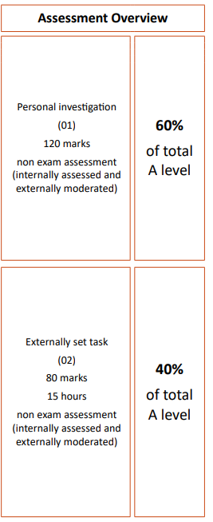
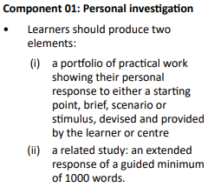
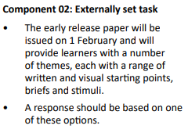

Year 12 Curriculum Map

Y13 Curriculum Map
Equipment
You must bring the following to all lessons:
• Stationary - Pen, pencil, rubber, ruler, sharpener, green pen,.
• Camera - provided by the visual arts department or use your own.
• Target sheets – provided by the visual arts department.

What you need to do
Attend 100% of classes and arrive punctually for each class.
• Ask if you do not understand any part of the work.
• Revise your notes thoroughly each week.
• Read and research each topic whenever the opportunity arises.
• Contribute in class – your opinions and ideas are valuable.
• If you are going to be absent or late for an unavoidable reason, please email/call your tutors in
advance.
Expectations and Workload
We are delighted you have chosen to study Fine Art. You will explore a diverse range of methods, materials and techniques under the guidance of subject specialists. In return we expect you to fully engage with all of the studio sessions with an open mind and an eagerness to explore all that is made available to you. It is expected that you will make use of your private study sessions to independently extend your learning, and that you will dedicate sustained periods of time outside of school, to your sketchbooks and larger scaled pieces. Your final outcome will be the culmination of 2 years’ consistent application of effort and independent determination. The work you do outside of your lessons will have a very significant impact on your results.
Your teachers will set between 6 hours of homework per week. You will be expected to complete all homework and learning prep when it is due in. All homework will be set on Teams.
What does independent study look like?
- Researching ideas for your project
- Gathering and printing images
- Artist and contextual Research
- Reading around the genre studied
- Completing homework
- Taking own photographs
- Completing artwork started in lessons.
In Visual Arts, scholars will undertake personal work to build their own unique portfolio. This means that you will be producing artwork that will be different to your classmates. This is the exciting part of being in a Visual Arts class – whilst you are guided on how and what to produce, the final decisions are down to you!
Component 01: Personal investigation
This component comprises two discrete but linked elements.
Element 1: Practical portfolio

This is a practical portfolio with supporting contextual research in which scholars are expected to develop a personal response based on the centre-set or scholar-set theme leading to a finished realisation(s) or outcome(s).
This portfolio will consist of a sustained project, theme, or course of study. It may be presented in appropriate formats for the specialism and area of study chosen using, for example, sketchbooks, mounted sheets, maquettes, prototypes, digital presentations, animation, scale models or illustrated written work.
There is no restriction on the scale of work produced but scholars should carefully select, organise, and present work to ensure that they provide evidence of meeting all four assessment objectives.
Scholars must show they have:
• independently developed ideas through sustained and focused investigations in response to a given starting point
• produced material informed by contextual and other sources that informs the development of their practical work
• explored ideas, techniques, or processes appropriate to their chosen specialism(s)
• recorded observations from sources relevant to intentions
• critically reviewed and refined their work as it progresses
• used their planning and preparation to produce coherent realisation(s)/outcome(s).
For the purposes of assessment, scholars will provide evidence of all the assessment objectives through the careful selection and presentation of their work. The practical portfolio should be viewed as a whole and judgements regarding the extent to which all the assessment objectives have been met should be made across the submission as a whole.

Element 2: Related study
Scholars are required to establish through this written and, where appropriate, illustrated component, the related context in which their chosen practical portfolio exists.
This may be established by exploring the genre, subject matter, movement, or historical framework of the overarching starting point, course of study or theme selected.
The aim of the related study is to enable scholars to develop their ability to communicate their knowledge and understanding of art historical movements, genres, practitioners, and artworks, considering the way that these change and evolve within chronological and other frameworks. It also builds their understanding of the relationship between society and art: art historical terms, concepts and issues; methods of researching, investigating and analysing; and how works are interpreted and evaluated.
The related study should be separate and clearly identifiable from the contextual research embedded in the development of the practical portfolio. Scholars should also highlight their own work and clearly distinguish it from collected or transposed material.
Scholars may produce the related study in an appropriate form of which the following are some examples: an illustrated essay, digital presentation/ blog, illustrated study sheets or written report.
It is a requirement of the related study that all source material and research are listed and acknowledged in a bibliography and should be clearly identifiable in the work presented for assessment.

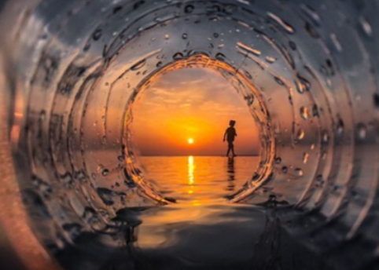

Component 02: Externally set task
For this component, an early release paper will be despatched to centres based on estimated entries made and will also be available on the OCR website from 1 February.
This paper can be given to scholars at the discretion of centres any time on or after 1 February in the year of certification. Scholars will be given a period of approximately 12 weeks for preparatory study prior to undertaking the 15-hour supervised time period.
The paper will give scholars a choice of seven themes, each with a choice of written and/or visual starting points, briefs or stimuli. From this paper, scholars are expected to choose one option for which they will generate an appropriate personal response for assessment.
Planning and preparation
During the preparatory period scholars will research, plan and develop ideas for their own response to the option they have chosen. During this preparatory period teachers may give limited guidance. Guidance should be given to scholars about availability and choice of materials, health and safety, avoidance of plagiarism and completion of work in accordance with specification requirements and procedures. However, it should be remembered that scholars are required to reach their own judgements and conclusions and must work independently to produce their own personal response.
All work must be completed by the designated finishing time set by the centre. Dates and deadlines for preparatory work and the 15-hour supervised time must be set by centres in order to facilitate the completion of marking and internal standardisation by the OCR-set deadline.
Scholars can continue to work on their preparatory work until the first period of supervised time commences. Scholars must refer to their preparatory work during the supervised 15-hour period. Preparatory work should not be amended or developed further during or after the timetabled 15 hours supervised time. No additional work should be brought into the supervised sessions. Preparatory work and outcome(s) should be kept under secure conditions at all times when not in use and once the supervised time period is completed.
Realising intentions
Scholars will have up to fifteen hours in which to independently realise their response(s). The 15-hour supervised time is divided into two full days, Periods 1-5.
Scholars are required to provide evidence of all assessment objectives in response to their chosen starting point, brief or stimulus, within the 15-hour supervised time period. It is expected that during the supervised time period, scholars will realise their intentions to an outcome(s). All selected work produced for the component, including the research, planning and development work produced in the preparatory period, must be submitted for assessment.

Assessment
There are four assessment objectives in OCR’s A Level in Art and Design. These are detailed in the table below. Scholars are expected to demonstrate their ability to:
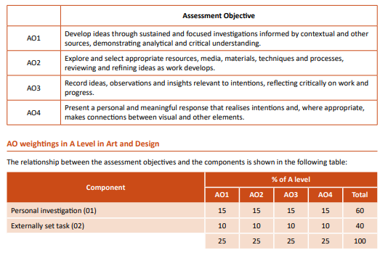

Additional resources and reading list:

Suggested Reading List
Below are the links to materials we would encourage you engage with throughout the two-year course:
Art communities:
https://www.artlex.com/ A comprehensive dictionary containing definitions of more than 3000
art terms, along with illustrations, pronunciation notes and quotations
• https://artuk.org/ Art UK is the online home for every public art collection in the UK
• https://www.behance.net/ Graphics portfolios including branding, illustration, design for print,
interactive graphics, photography
• https://www.directoryofillustration.com/ Find the World's Best Illustrators & Animators
• https://www.scholarartguide.com/ A really useful site which compiles new ideas, best practice
and helpful learning strategies for Art scholars
Art Galleries:
• The Design Museum London: https://designmuseum.org/
• Northampton Museum and Art Gallery, Northampton: www.northamptonmuseums.com
• The National Gallery London: https://www.nationalgallery.org.uk/
• The National Portrait Gallery London: https://www.npg.org.uk/
• Royal Academy London: https://www.royalacademy.org.uk/
• Saatchi Gallery London: https://www.saatchigallery.com/
• The Tate Gallery London: https://www.tate.org.uk/
• Victoria and Albert Museum London: https://www.vam.ac.uk/
Journals and magazines are a good way of keeping up to date and become aware of artists and issues which can have a great impact on your studies . You can subscribe for a year or buy individual editions. We recommend:
• Aesthetica: Aesthetica is a worldwide destination for art and culture. In-depth features foreground today’s most innovative practitioners across art, design, photography, architecture, music and film. https://aestheticamagazine.com/
• Art Review: one of the world’s leading international contemporary art magazines https://artreview.com/ 11
• Art Forum: Artforum is an international monthly magazine specializing in contemporary art. https://www.artforum.com/
• Frieze Magazine: a leading magazine of contemporary art and culture. https://www.frieze.com/
• Tate Etc. Tate’s art magazine, published three times a year https://www.tate.org.uk/tate-etc

Related Study Writing Guide

Introduction…………………………………………………………………………………………………………………………………………………………………………………………………………………………………………………………..

Outline the purpose, focus or mission of your study to set the scene. Make it PERSONAL: communicate distinctly personal opinions, insights, judgements and responses, demonstrating a clear engagement with the artwork studied.
- Include question/s you are going to answer;
- Themes you are going to explore;
- Issues you hope to address etc.
- Include reasons for selecting a topic and give an indication of how / why the topic is of personal relevance or interest to the scholar.

“I first encountered Sarah Lucas whist briskly strolling through the crowded rooms of the Tate. Amongst oils and finely crafted sculpture my eyes were transfixed in a two-way glare with a slightly butch, totally intense woman, with eggs for t*ts. Ever since then I’ve been hooked.”
- The context of your subject – your background understanding, for example why your chosen artist/designer has a reputation and for what. What were the innovations and aspects of his/her/their style/media/art that makes them significant contributors to Art.
- How will you undertake the study. This should include visits you intend to make, books and resources you will use. WEBSITES should not be used as a major source and any information taken from them should be check for accuracy.
- Make a prediction about what you will discover in the study which you must make reference to in the conclusion. It does not matter if you are right or wrong here but it is there as a focus for the study

Analysis…………………………………………………………………………………………………………………………………………………………………………………….
Body: This is the main part of the Personal Study and will need careful thought. It is organised into separate sections (which may be formal chapters, or simply different areas of a visual study), usually with individual headings and sub-headings.

Analysis of the artwork does not mean ‘description of artwork’. Use the following to deconstruct the artwork to make personal observations and judgements to connect to the theme or focus of the related study. How do the following elements support/suggest meaning?
Composition is the placement or organisation of visual elements within an artwork – how has the artwork been composed, combined or ‘put together’. Is the Composition instinctual or the result of elaborate planning (or a combination of both)? AREA OF INTEREST, AREA OF INTEREST, FRAMING, DISTANCE, SPACE, NEGATIVE SPACE, LEADING LINES
Format is the overall shape, size and orientation (portrait or landscape) of an artwork. Is the Format influenced by practical considerations (i.e. the nature and shape of the object or scene depicted)? Does this help to the artist to help communicate a particular meaning or idea?
Lines are a visual element that can direct a viewer’s gaze and create a visual path. These can direct attention to a focal point and create depth through perspective or horizon lines. Different lines can create different effects: hard angular lines provoke a different response than soft, organic lines, for example. Repetition of lines can create a sense of movement or rhythm. What examples are seen in the artwork?
Shape: a visual element that is created by the junction of lines or changes in tone: the perceived boundaries of form. Larger shapes can become dominant focal points within an artwork; similar shapes can be repeated to create balance and create unity / visual harmony. Shapes can be symbolic, i.e. they can represent more complex forms and carry meaning. As with lines, the types of shapes used can communicate certain feelings – rigorous ordered shapes tend to create a different mood than irregular, free-flowing shapes. Shapes might also be used to create borders / frames and boundaries that connect, overlap or intersect, perhaps helping to draw viewers from the foreground / middle-ground to background. What examples can you see?
Space – the absence of form – is an often overlooked visual element. Described as being either positive (the space contained within the boundary of an object) or negative (the background space in and around an object), space can determine how busy and cluttered a painting is. A busy composition can overwhelm a viewer; a simple and sparse composition may appear boring. Careful integration of space is fundamental to any artwork.
Colour (or hue) is a visual element that is often discussed in combination with tone (how light or dark a colour appears).
- Does colour association affect the mood?
- Is tone used to communicate a sense of distance (items that are further away generally appear lighter – due to ‘atmospheric perspective’)?
- Does the colour and tone create contrast within the artwork to attract the viewer’s attention and create focal areas?
- Are harmonious, peaceful non-contrasting areas created? Use of light and shadow or warm and cool might also be an important area to discuss…
Texture: explore the use of this within the artwork:
- Is it real (the result of brush strokes, irregularities in materials, and the application of a range of materials) or implied…i.e. a surface that is made to look textured?
- Is the texture an aesthetically pleasing addition to an artwork or does it reflect something deeper?
- REMEMBER: Surface qualities – along with other detailed areas and intricate patterns – are only able to be appreciated fully when viewed in person.

Cultural context / influences…………………………………………………… ………………………………………………………………………………………………………
Demonstrate an understanding of cultural context – an understanding that an artist does not create work in isolation, but rather creates work that is shaped and influenced by the circumstance/s they finds themselves in.
- Does the setting of the artwork provide information regarding issues/messages explored?
- Is the artist influenced by natural, social, political or cultural environments?
- Is the artist the influenced by other artists? What are the similarities & differences between the artworks?
- Can you make comparisons between artwork that has been created to similar or differing contexts?
- Can you make any connections to your analysis of the artwork to support your suggestions?
“The setting itself creates an intoxicating atmosphere with the rows of fluorescent light bulbs and layers of luminous signs that form an endless maze of gaudy colours. However, the setting does not overwhelm the two models who draw my eyes despite the signs above them. They create the focal point of the image through the use of the rule of thirds as they are placed off-centre and through their quirky appearance which magnetises the eye towards them. They seem to belong to a different world to the passersby behind them with their flare of red hair and audacious choice of feathered flittered clothes. Akif has further crafted the image through the use of makeup as their chalk white faces further segregates and emphasises their surreal doll-like appearances.…Akif’s pictures are reminiscent of Japanese cinema which he says he is so influenced by. “I like…its writhed and crazy stories; I feel very close to that way of looking at the world.” This photograph is particularly mystical due to the vibrant and decorative bokeh of Hong Kong’s street lights in the background.”
………………………………………………………………………………………………………………………………………....
- Does the artist / piece of work belong to an obvious historical movement?
- Give a summary of the art movement.
- State what the artist does to fit in with the movement – refer back to your analysis:
  - Formal elements
  - Techniques
  - Composition
  - Suggested meanings
• Did this piece help to influence other artists, and if so explain how?
- Is the artist influence by any other particular artists or art movements?

Conclusion…………………………………………………………………………..……………………………………………………………………………………………………………….
Summarize key points from the project, arrive at final conclusions and make considered personal judgements about what has been learnt.
- Say what you expected to find when you started your investigation. Did it turn out this way? Have you learnt new things?
- Revisit your predictions from your introduction.
- Discuss any surprises or discoveries you have made and why.
- Write about the practicalities and challenges you faced in undertaking your study and how you overcame them – be positive – state how this has helped you to develop as an artist.
- What is next? How will this help you in your Personal Investigation?

Bibliography / References / Acknowledgements. This should list any resources that scholars have used in their project, including books, websites, articles and videos. It might also include sources of first-hand information, such as museums, galleries or websites, as well as acknowledgements, thanking the artist for their time.

A Level Related Personal Study Marking Guide

21-24 | - Sophisticated and sustained communication of ideas with thorough exploration, refinement and excellent critical and contextual understanding.  - Extensive and sophisticated handling of specialist language and vocabulary in recording is demonstrated.  - An accomplished level of structured and reasoned knowledge and understanding is shown when presenting the study and realising intentions.  - Connections, where appropriate, between visual and other elements are sophisticated.
17-20 | - Well-considered communication of ideas with insightful exploration, refinement and critical and contextual understanding.  - Extensive and well-considered use of specialist language and vocabulary in recording is demonstrated.  - A high level of structured and reasoned knowledge and understanding is shown when presenting the study and realising intentions.  - Connections, where appropriate, between visual and other elements are fully developed and insightful.
13-16 | - Detailed communication of ideas with informed exploration, refinement and critical and contextual understanding.  - Purposeful use of specialist language and vocabulary in recording is demonstrated.  - Evidence of knowledge and well-developed understanding is shown when presenting the study and realising intentions.  - Connections, where appropriate, between visual and other elements are well developed and purposeful.
9-12 | - Effective communication of ideas, with appropriate exploration and clear evidence of critical and contextual understanding.  - Accurate and mainly structured recording when using specialist language and vocabulary are demonstrated.  - Evidence of knowledge and some understanding is shown when presenting the study and realising intentions.  - Connections, where appropriate, between visual and other elements are appropriately developed.
5-8 | - Limited coherence when communicating ideas, with some exploration and limited evidence of critical and contextual understanding.  - Limited accuracy and partially structured recording when using specialist language and vocabulary are demonstrated.  - Some evidence of knowledge and understanding is shown when presenting the study and realising intentions.  - Connections, where appropriate, between visual and other elements are limited.
1-4 | - Simplistic ability to communicate ideas, with minimal exploration of critical and contextual understanding.  - Some inaccuracy and incoherence in recording when using specialist language and vocabulary are demonstrated.  - Simplistic knowledge and understanding are shown when presenting the study and realising intentions.  - Connections, where appropriate, between visual and other elements are minimal.
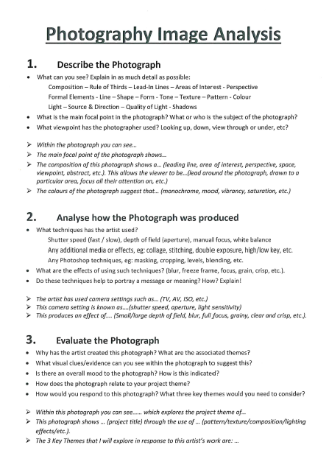

Y13 Exam Preparation Timetable 2026
Component 02: Externally set task
1_Week beginning Mon 3rd Feb
AO1 Mind Map 1x double page
Select your preferred exam title and create a Mind Map. Explore ideas related to your chosen Exam Theme through words and your own drawings, etc. Present your ideas creatively and as fully as you can, to show the breadth of your investigations.
2_Week beginning Mon 10th Feb
AO3 Visual Recording 1x double page
Take a range of high-quality photographs to explore ideas on your Mind Map. Work from these to present high quality drawing techniques to record your ideas. Be create with composition & angles. Annotate the page to help explain how your ideas link to the exam title. This page must be full and well composed with titles and annotation.

Hwk_Half Term (Mon 17th Feb)
AO1 Artist Research 1x single page – double if desired
Present your research on a chosen artist, with detailed written analysis of one key image. Copy details/sections of the artist work.
3_Week beginning Mon 24th Feb
AO2/3 Artist Response 1x double page
You should identify the key themes and ideas that you have learnt from your artist and review your response against these. Create a response that is original and injects your own ideas with that of the artists.
4_Week beginning Mon 3rd Mar
AO2/3 Experimentation 1 x double page
Following on from your Artist Response, where do you want to take your project next? What ideas have come out of your work so far? Where is the focus of your ideas and techniques?
What – is the content, subject matter or message of your work?
How – are you going to represent these ideas through the visual image – technique, mood, style and presentation?
Why – be clear about the meaning, message or concept behind your work, linking back to the exam title.
5_Week beginning Mon 10th Mar
AO2/3 Development and Refinement 1x double page
Show evidence that you are refining your ideas and skills towards your Final Outcome. Use your annotation to review your work and to plan the way forward.
Or AO1 Further Artist Research
Look at another artist to support the development of your artistic response to the exam title.
What is the message or concept behind your idea? What materials and techniques do you want to focus on? Work on your strengths. Ensure you have explored two different mediums so far..
6_Week beginning Mon 17th Mar
AO2/3 Development and Refinement 1 x double page
Show that you have practised and refined your skills through experimentation with materials and techniques – Hand-drawn techniques; Photography; Photoshop manipulation; Printing, Textiles, etc.
Ensure your project has a clear sense of purpose: what is the meaning of the project? What do you need to produce in order for this to be clear? Annotate your work, ensuring the aim and purpose of each page is clear.
7_Week beginning Mon 24th March
AO2 Reviewing and Refining 1 x double page
Your project should now be clearly refined. Make sure you know what you are going to do in the exam, as well as how you are going to do it. Show evidence in your sketchbook that you have practised the ideas and techniques that you plan to use in the exam. Link to a third artist to help you consider ways to present your ideas.
8_Week beginning Mon 31st March
AO2/4 Final Outcome Planning 1 x double page

Present your ideas for your revised Final Outcome showing how your Artist Research has informed your project development. Plan and execute any final Photo Shoots over the next few weeks.
Easter Break (5th – 21st April)
9_Week beginning Tues 22nd April
AO3/4 Visual Recording 1 x double page

Take your final photographs for the exam and upload to your exam account. Present your photographs in PowerPoint, through contact sheets and key individual photographs.
Practise and develop your skills and ideas towards your Final Outcome.
10_Week beginning Mon 28th April
AO4 Final Outcome Planning 1 x double page

Take your final photographs for the exam and upload/print/present contact sheets into your sketchbook. Practise and develop sections of these ideas towards your Final Outcome.
EXAM Week beginning Tues 6th May
Your preparation work must be completed and submitted before the start of the exam. You can refer to a printed copy of this powerpoint during the exam. Work created during the exam will be saved to your exam account.
AO4 Exam 15 hours – Wed 7th, Thurs 8th & Fri 9th May in E2.2

AO1 |  | Develop ideas through sustained and focused investigations, informed by contextual and other sources, demonstrating analytical and critical understanding
AO2 |  | Explore and select appropriate resources, media, materials, techniques and processes, reviewing and refining ideas as work develops
AO3 |  | Record ideas, observations and insights relevant to intentions, reflecting critically on work and progress
AO4 |  | Present a personal and meaningful response that realises intentions and, where appropriate, makes connections between visual and other elements

