
A LEVEL PSYCHOLOGY HANDBOOK
Name:



Contents
Contents

Introduction to the course 3
Equipment 6
Textbooks 6
What you need to do to succeed 7
Homework and Marking Policy 8
How to revise for Psychology 9
Additional resources and reading list: 13
Course Skills 14
Why study psychology? 14
Exam advice 15
AQA Psychology Command words 16
How to answer the different types of questions in psychology 17
Super curricular Guide 19
Notes 20

Introduction to the course
A Level Psychology (AQA 7182) offers an in-depth exploration of human behaviour, mental processes, and the scientific methods used to study them. You will investigate key approaches and issues in psychology, including social influence, memory, attachment, and psychopathology, while developing critical thinking and research skills. This handbook supports your studies in topics such as “Introductory Topics in Psychology,” “Psychology in Context,” and “Issues and Debates in Psychology,” helping you connect classic and contemporary research to real-world applications.

The course is broken into three parts as outlined below:
1. Introductory topics in psychology
Social influence
Students learn how and why people change their behaviour in response to others. This includes:
- Types and explanations of conformity (compliance, identification, internalisation; normative and informational social influence).
- Obedience to authority (Milgram’s research, situational variables such as proximity, location and uniform).
- Resistance to social influence and the role of social support and locus of control.
- How social influence processes explain social change (e.g. minority influence).
Memory
This topic examines how memory is structured, how it works and why it can fail. It usually covers:
- Models of memory, especially the multi-store model (sensory register, short-term memory, long-term memory) and the working memory model.
- Types of long-term memory (episodic, semantic, procedural).
- Explanations of forgetting (interference and retrieval failure).
- Factors affecting eye-witness testimony (misleading information, anxiety).
- Ways to improve accuracy of eyewitness testimony (cognitive interview).
Attachment
Students explore how early relationships form and why they matter. Content typically includes:
- Caregiver–infant interactions and the development of attachment (stages of attachment).
- Explanations of attachment (learning theory, Bowlby’s monotropic theory, internal working model).
- Ainsworth’s strange situation and types of attachment (secure, insecure-avoidant, insecure-resistant).
- Cultural variations in attachment.
- Bowlby’s theory of maternal deprivation and the effects of institutionalisation (e.g. Romanian orphan studies).
Clinical Psychology and Mental Health
This topic focuses on how abnormality is defined and explained. It usually includes:
- Definitions of abnormality (e.g. deviation from social norms, failure to function adequately).
- Characteristics, explanations and treatments for specific disorders, such as phobias, depression and OCD.
- Behavioural, cognitive and biological approaches to explaining and treating these disorders.

2. Psychology in context
Approaches in psychology
Students study the main schools of thought that explain behaviour. This typically covers:
- Origins of psychology as a science and the work of early psychologists.
- Major approaches: behaviourist, social learning theory, cognitive, biological, psychodynamic and humanistic.
- Key assumptions, methods and applications of each approach.
- Comparison of approaches in terms of issues such as determinism, nature–nurture and scientific methods.
Biopsychology
This section links biology and behaviour. Content usually includes:
- Structure and function of the nervous system and endocrine system.
- Neurons, synaptic transmission and neurotransmitters.
- Localisation of function in the brain and hemispheric lateralisation.
- Plasticity and functional recovery after brain injury.
Research methods
Students learn how psychologists design and evaluate research. This involves:
- Experimental methods (laboratory, field, natural, quasi), variables, controls and experimental design.
- Non-experimental methods: observations, self-reports (questionnaires, interviews), correlations and case studies.
- Sampling techniques and ethical issues.
- Data handling and analysis (types of data, descriptive statistics such as measures of central tendency and dispersion, graphical displays).
- Introduction to statistical testing, significance and probability, critical values and decision-making in simple tests.
- Features of scientific work such as reliability, validity and peer review.

3. Issues and options in psychology
Issues and debates in psychology
This part encourages students to think critically about psychological theory and research. Typical issues include:
- Gender and culture in psychology (universality vs bias).
- Free will vs determinism.
- Nature vs nurture.
- Holism vs reductionism.
- Idiographic vs nomothetic approaches.
- Ethical implications of research and theory (including socially sensitive research).
Option topics
Schools and colleges select three applied topics from several options. Examples include:
- Relationships: factors affecting attraction, theories of romantic relationships, virtual relationships, parasocial relationships.
- Schizophrenia: classification, symptoms, biological and psychological explanations, therapies.
- Aggression: explanations for aggressive behaviour ranging from evolutionary to biological, how genes can affect aggression levels as well as media influences.
Each option requires:
- AO1: understanding of key concepts, theories and studies in that area.
- AO2: application to real-world behaviours and scenarios.
- AO3: evaluation of explanations and treatments, using research evidence and considering wider issues and debates.

Equipment
You must bring the following to all lessons:
• Stationary - Pen, pencil, rubber, ruler etc
• Exercise book
• Textbooks and Workbooks as prescribed
• Summary sheets and law folder

Textbooks
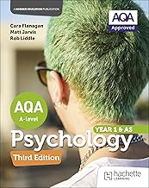
The textbook required for your course
Prescribed Textbook:
AQA Psychology for A Level : Year 1 and AS Third edition
by Cara Flanagan , Rob Liddle, et al. | 20 Jun 2025
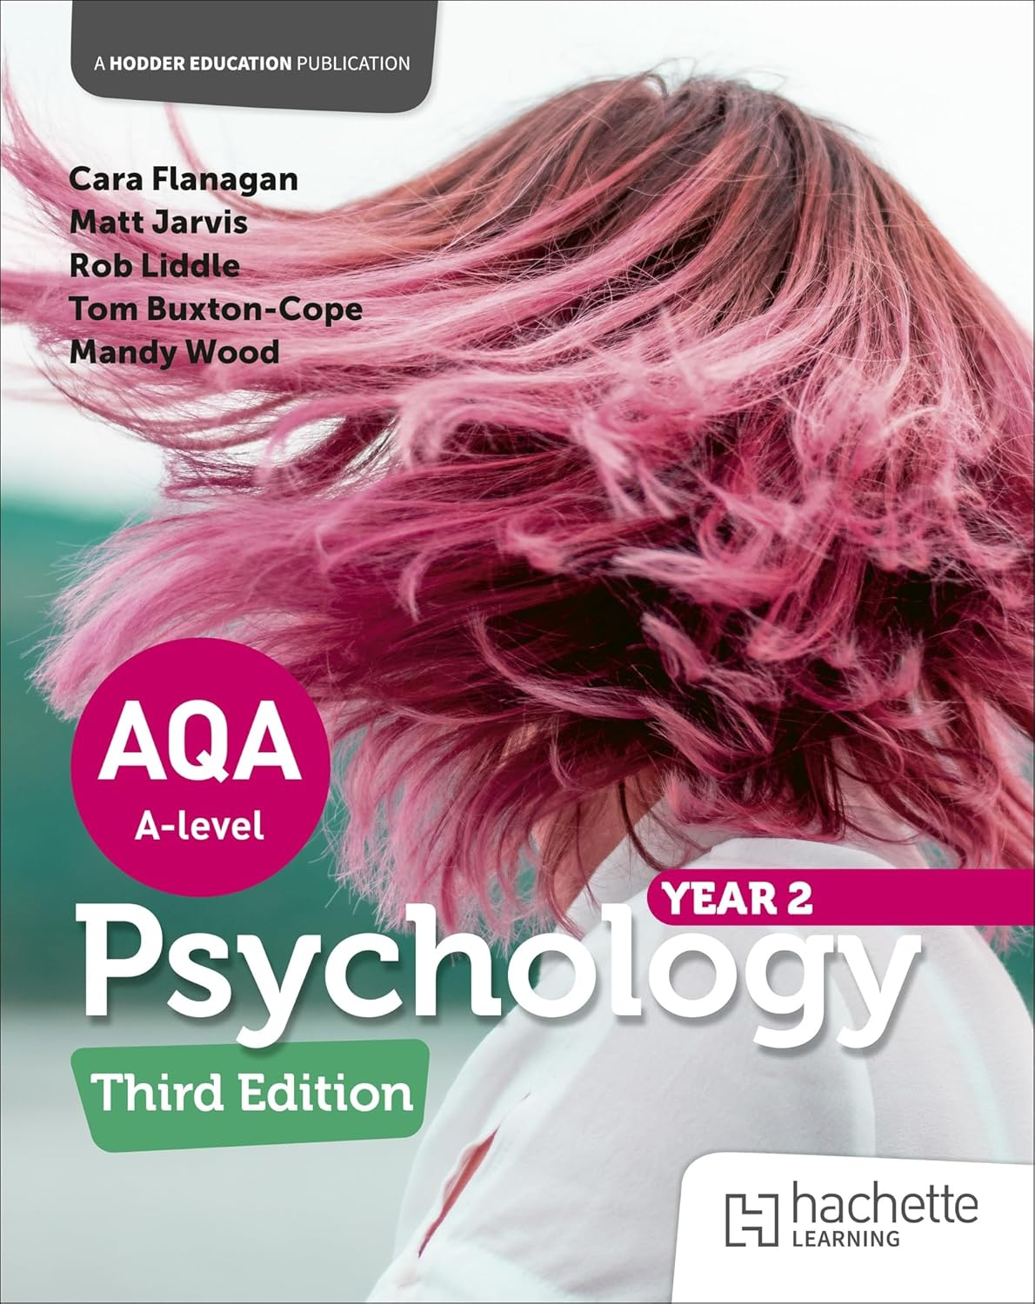

AQA Psychology for A Level: Year 2 Third edition Paperback – 27 Feb.
2026
by Cara Flanagan (Author), Matt Jarvis (Author), Rob Liddle (Author)

What you need to do to succeed
Attend 100% of classes and arrive punctually for each class.
• Ask if you do not understand any part of the work.
• Revise your notes thoroughly each week.
• Read and research each topic whenever the opportunity arises.
• Contribute in class – your opinions and ideas are valuable.
• If you are going to be absent or late for an unavoidable reason, please email/call your tutors in
advance.
Folder Check
You need to organise your law folder using the checklist below
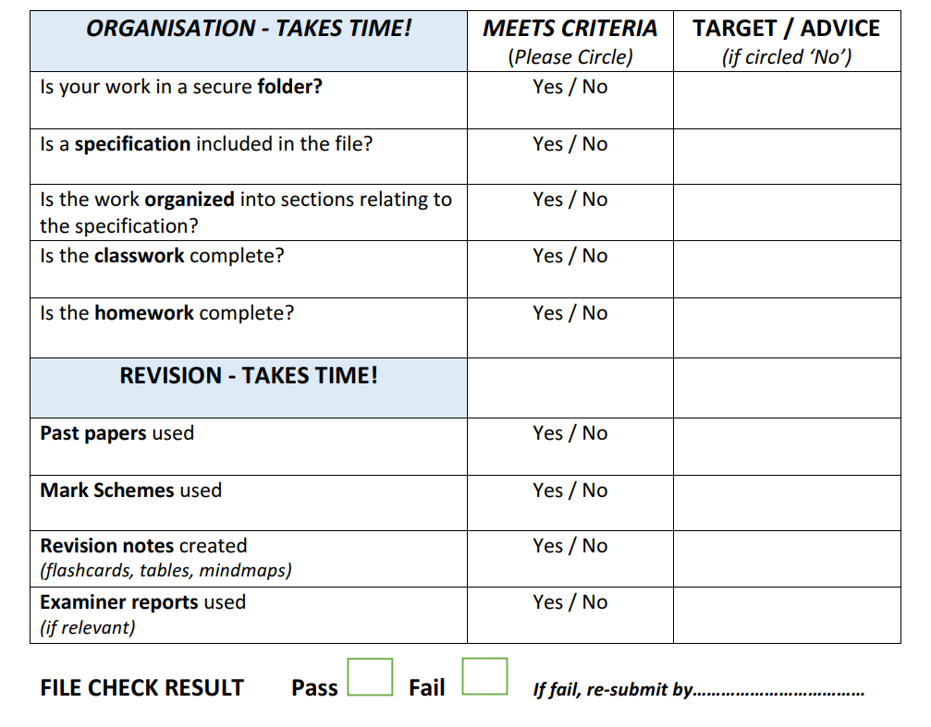

Homework and Marking Policy
Your teachers will set between 2-3 hours of homework per week. You will be expected to complete all homework, pre-reading and learning prep when it is due in. All homework will be set on Teams.
In addition you will be expected to complete 2-3 hours of independent work as well. The most successful students complete on average five hours of work per subject per week (including homework)
What does independent study look like?
- Making notes
- Organising your folder
- Research
- Reading
- Completing homework
- Revision techniques
- Creating revision resources
- Practising past questions
A level psychology you will complete a formal assessment at the end of each topic, which will be formally marked by teachers. This is in addition to the work you are completing outside of lessons.
You will be expected to correct all assessed work using green pen to improve exam technique.

How to revise for Psychology
Revising for A-Level Psychology can at times appear demanding, given the breadth and depth of content required. You are expected to master key theories, studies, and research methods, accurately apply psychological concepts to a range of contexts, and produce coherent, well-structured analytical and evaluative responses under timed conditions.
Nonetheless, revision need not be disorganised or unnecessarily stressful. With a systematic, evidence-informed approach, you can consolidate your understanding, enhance long-term retention of material, and improve the quality of your examination performance.
In this article, we will consider the importance of revision, outline core principles of memory relevant to effective learning, examine empirically supported revision strategies, and illustrate how these can be applied specifically to AQA A Level Psychology.

Why Students Need to Revise in Psychology
Even if you understand a topic in class, your brain will not store that information permanently unless you return to it. Information you have understood once does not stay easily accessible by itself; your memory fades over time. Revision strengthens your memory so that when you reach the exam, you can recall key studies, theories, concepts, and evaluation points quickly and accurately under pressure.
This is especially important in psychology, where the difference between a good answer and an excellent one is often the precision of your recall and how clearly you can explain and evaluate psychological research. Revision helps you store and organise this knowledge so that you can retrieve it confidently and apply it to the stem or scenario in the question.
How Memory Works (and Why This Matters When Revising Psychology)
To revise successfully, it helps to understand what your brain is actually doing when you learn. When you first encounter new information – for example, Bowlby’s theory of maternal deprivation – it enters your working memory. Your working memory is like a mental notepad; it can only hold a small amount of information at once. If you do not do anything with new information, it fades very quickly, sometimes within minutes.
Your goal when revising is to transfer information from working memory into your long-term memory, where it can be stored more permanently. However, information does not move into long-term memory just by re-reading notes or watching videos. It moves there when your brain actively processes and retrieves the information.
Once information is stored in your long-term memory, you still need to be able to recall it and bring it back into working memory when you need it. This is exactly what happens in an exam. The question appears, and your brain has to quickly locate the relevant studies, theories, and evaluation points from long-term memory, and pull them into working memory so you can write about them clearly and analytically.
This is why active recall is one of the most effective revision methods. When you test yourself – for example, by blurting, using flashcards, or answering exam-style questions – you train your brain to retrieve information. Every time you successfully recall something, the memory becomes stronger and faster to access.
In other words:
- Revision stores the information in long-term memory.
- Active recall teaches you how to bring it back into working memory when needed.
This ability to retrieve information quickly and accurately is exactly what you need in an exam.
Passive revision (re-reading, highlighting, listening to videos) can make you feel like you know something, but it does not train your brain to recall it. This often leads to the exam experience of recognising a topic but being unable to remember the key study names, findings, or evaluation points in enough detail to gain high marks. Active recall helps prevent this from happening.
Example: Applying This When Revising Attachment
Imagine a student, Lena, revising attachment. She learns Bowlby’s monotropic theory of attachment, including the concepts of an internal working model, critical period, and the idea that attachment is adaptive and innate.
At first, this sits in her working memory. If Lena simply reads it again later, it will not fully stick.
Instead, she:
- Creates flashcards for key terms (e.g. “internal working model”, “critical period”, “monotropy”) and key studies related to attachment.
- Blurts everything she can remember about Bowlby’s theory and the supporting or contrasting research without looking at her notes.
- Checks what she missed, adding missing details in a different colour so the gaps stand out.
- Then answers an exam-style question, for example: “Outline and evaluate Bowlby’s monotropic theory of attachment,” or applies the theory to a short scenario involving a caregiver and infant.
Each of these steps forces the information into long-term memory and strengthens her ability to recall and use it.
So, when she sits down in the exam and sees: “Outline and evaluate Bowlby’s monotropic theory of attachment” or a 16-mark question on attachment, she can immediately bring:
- the key concepts,
- the main supporting and contradicting studies,
- and the evaluation points
back into working memory to construct a confident, accurate, and well-structured answer.

Effective Revision Techniques (and Why They Work)
The best revision techniques are those that actively engage your brain, promote long-term retention, and closely match exam demands, such as active recall, spaced practice, and regular exam-style questions with feedback.
Mind maps
A mind map is a visual diagram that organises information around a central topic. For psychology, you might put a topic like Attachment in the centre and create branches for key theories (Bowlby, learning theory), studies, and evaluation points, then add smaller branches for definitions, findings, and criticisms. Mind maps work well because they show connections between ideas, help you see the overall structure of a topic, and make it easier to recall information visually while forcing you to decide what is important and how it fits together.
Summary sheets
A powerful way to revise psychology is to create one-page summary sheets for each topic. Whatever the topic (e.g. Clinical Psychology and Mental Health, Memory, Social Influence), it is almost always possible to compress your notes into a single page in brief note form rather than full sentences, stripping each section down to the key concepts, studies, and evaluation. You can keep only essential study names and key points here, and use separate resources for detailed research notes if needed. One-page summaries make the content feel more manageable, give you a clear overview to return to later, and are easy to revisit quickly; taking photos of them and keeping them on your phone means you can review them whenever you have a spare few minutes.
Flashcards
Flashcards are small cards with a question or prompt on one side and the answer on the other. For psychology, you might write “What is the multi-store model of memory?” or “Outline Asch’s conformity study” on one side, and the definition, procedure, findings, or evaluation on the back; you can make these on paper or using digital apps. Flashcards are effective because they rely on active recall: you have to bring the answer up from memory rather than just recognise it, and repeatedly testing yourself in this way strengthens memory traces and improves long-term retention.
Blurting
Blurting is a self-testing technique where you cover your notes and write down everything you can remember about a topic. For example, you might choose “Depression” in Clinical Psychology and Mental Health, set a timer, and write everything you can recall about symptoms, explanations, and treatments, then compare what you wrote to your notes or mind map and highlight what you missed. This technique trains direct recall from long-term memory, exposes gaps in your knowledge, and reinforces learning each time you revisit the topic, which builds confidence for recalling information under exam pressure.
Practice exam questions
Completing practice exam questions means applying your knowledge to real or past-paper questions, ideally under timed conditions. In psychology, this could involve answering 4-, 8-, or 16-mark questions, using stems and scenarios to apply theories and studies and practising AO1 (knowledge), AO2 (application), and AO3 (evaluation) together. This technique helps you turn knowledge into exam performance by improving your structure, timing, and ability to select relevant studies and evaluation points quickly, so that recalling and applying psychology becomes more automatic.
Marking your work
Marking your work involves comparing your answers with mark schemes, model answers, or teacher feedback. When you mark, you identify missing content, inaccurate points, weak evaluation, or poor structure, then add in corrections and improvements so your notes for that question become a better version of the answer. This process helps you learn from mistakes, consolidate the correct material, and focus your revision where it is most needed, while also building a clear sense of what examiners are looking for and increasing your confidence over time.

A Step by Step Revision Cycle
Use this process for any topic:
- Use the exam checklists to ensure you have notes and understand all topic areas.
- Turn notes into summary sheets, flashcards or a mind map
- Learn from them actively (test yourself, recite aloud)
- Blurt the topic from memory
- Compare to original notes and fill gaps in a different colour
- Complete a practice exam question
- Mark your answer & correct mistakes in a different colour
- Improve your exam technique by reading through Examiners’ reports
Repeat this cycle regularly and develop your long term memory and recall skills.

Additional resources and reading list:
Listed below are a range of resources you might find helpful to support your psychology study – these will suit a variety of different learning styles and preferences.
Websites:
- Simply Psychology
- Tutor2u Psychology (paid for resources)
- PsychBoost (Also on YouTube)
- Seneca Learning (AQA Psychology courses)
- BPS Research Digest

Psychology books and wider reading:
- Thinking, Fast and Slow – Daniel Kahneman (dual-process thinking, biases, decision making)
- The Man Who Mistook His Wife for a Hat – Oliver Sacks (neurological case studies, brain and behaviour)​
- The Little Book of Psychology – Emily Ralls & Caroline Riggs (clear overview of key ideas and thinkers)​
- Pioneers of Psychology – Raymond Fancher & Alexandra Rutherford (history of major theories and theorists)​
- Opening Skinner’s Box – Lauren Slater (revisits famous psychological experiments and their implications)​

These books are a few examples amongst many which are ideal for building curiosity, deepening understanding of core A Level topics, and giving strong examples and evaluation material for essays.

Course Skills
This qualification:
- develops competence in using psychological skills during the study of approaches, topics and issues in AQA A Level Psychology, including research methods, core theories and key studies.
- requires learners to demonstrate their ability to analyse a stem or scenario by identifying the key features of behaviour, cognition or experience to which psychological concepts can be applied.
- requires learners, when constructing an argument, to explain and evaluate psychological research, including assessing methodology, validity, reliability, ethics and the quality of evidence.
- requires learners, in each topic they study (for example, Social Influence, Memory, Attachment, Clinical Psychology and Mental Health, Biopsychology and Issues and Debates), to analyse, apply and evaluate the relevant theories and explanations, breaking them into their key components and applying them accurately to hypothetical or real-life situations. Evaluation involves formulating a reasoned, balanced argument supported by appropriate research evidence.
- requires learners to construct clear, concise and logical psychological arguments that are substantiated by research, using appropriate psychological terminology.

Why study psychology?
Students will learn about a wide range of topics including social influence, memory, attachment, Clinical Psychology and Mental Health, approaches in psychology, biopsychology and issues and debates in psychology. Psychology students develop skills such as applying theories and research to explain behaviour, analysing and evaluating psychological evidence, and considering the strengths and limitations of different explanations. Studying A Level Psychology offers many benefits: it links to everyday life and many other subjects, and it helps students build transferable skills such as critical thinking, analytical skills, attention to detail, research skills, data handling, essay writing and the ability to present a balanced argument. It is a valuable qualification with applications in many fields, not just psychology and mental health–related careers.

Exam advice
AQA A Level Psychology is assessed by three written exam papers at the end of Year 13. Each paper is 2 hours long, worth 96 marks, and contributes one third of your final A level grade, and all three include a mix of multiple-choice, short-answer and extended-writing questions (including 16-mark essays).
Paper 1 (Introductory Topics in Psychology) tests social influence, memory, attachment and clinical psychology and mental health, usually in four sections worth 24 marks each.
Paper 2 (Psychology in Context) focuses on approaches in psychology, biopsychology and research methods, again using a combination of data-response items, application to scenarios and longer written answers.
Paper 3 (Issues and Options in Psychology) assesses issues and debates plus three option topics you have studied (for example relationships, schizophrenia, aggression), and also uses scenario-based questions and essays that require you to apply and evaluate research.
Across all three papers, exams are marked using assessment objectives: AO1 for knowledge and understanding, AO2 for application to stems and scenarios, and AO3 for analysis and evaluation, with 16-mark questions typically requiring a balance of these skills

Further advice and exam papers can be found on the link below
A-level Psychology | Specification | AQA
Past Papers

AQA Psychology Command words

Identify / Name / State / Give – Pick out or recall a fact, term or feature; usually a brief, one- or two-word answer.
​Describe / Outline – Give a clear account or summary of a theory, study, process or feature, covering the main points.
​Explain / Explain how / Explain why – Give reasons or mechanisms; show how or why something happens using psychological ideas.
​Apply / Use your knowledge / Refer to the stem – Use your psychology knowledge to make links to the scenario or data given in the question.
Analyse – Break information into parts, show key features or patterns, and explain how they relate to each other.
​Compare / Distinguish – Show similarities and/or differences between two theories, concepts or findings.
​Discuss – Present key points, arguments and evidence, usually including both strengths and weaknesses and often linked to a scenario.
Evaluate / Assess / Comment / Justify – Judge how good something is using evidence; give strengths and limitations, reach a supported conclusion, or defend a particular view with reasons.

How to answer the different types of questions in psychology
Multiple-choice questions (MCQs)
- Read the question stem carefully and underline key words (e.g. most, least, first, main).
- Eliminate obviously wrong options, then choose the best remaining answer based on precise knowledge.
- Watch out for very similar answers – check details like numbers, definitions, and wording.
Short-answer AO1 questions (knowledge)
- Command words: identify, name, state, outline, describe.
- Give clear, accurate psychological content: definitions, features, key concepts or brief study details.
- Match the number of marks: usually 1 clear point per mark, written in full sentences or concise bullet-style lines.
Application questions (AO2)
- Command words often say “refer to the stem” or “apply your knowledge”.
- First, pick out the relevant details from the scenario (what the person is doing, thinking or feeling).
- Then link these details directly to a theory, concept or study, using psychological terminology and making the connection explicit.
Evaluation / discussion questions (AO3 – shorter)
- Command words: evaluate, assess, discuss, comment.
- Use mini-PEEL paragraphs: Point (strength/limitation), Evidence (study or idea), Explanation (why this matters), Link back to the question.
- Focus on quality over quantity: a few well-developed points are better than many undeveloped ones.
8-mark questions
- Usually require AO1 + AO3 or AO1 + AO2 + AO3.
- Aim for 2–3 clear AO1 points (definitions, features, brief study outlines) and 2–3 well-developed AO3 or AO2 points.
- Keep paragraphs focused: one main idea per paragraph, clearly linked to the question.
16-mark essays
- Typically “outline and evaluate” / “describe and evaluate” / “discuss”.
- Plan briefly: decide your AO1 content (theory/studies) and main AO3 points (strengths, weaknesses, issues and debates, research methods).
- Structure:
  - Intro: briefly state what the answer will cover.
  - AO1 paragraphs: clear, accurate description of theories/studies.
  - AO3 paragraphs: developed evaluation using evidence, explanation and a link to the question.
  - Brief conclusion: overall judgement or summary sentence that directly answers the question.
Data and research methods questions
- Read any tables, graphs or procedures carefully and translate them into simple language first.
- Use correct methods terminology (e.g. independent variable, sampling method, reliability, validity, ethical issues).
- When asked to “design” or “suggest”, give specific, practical details (what you would do, how you would measure, how you would improve).

Super curricular Guide
- Explore Psychology: Studying Psychology at University – many universities offer open-access online taster courses and lectures from UK universities that introduce degree-level psychology and research.
- University outreach platforms – many psychology departments host online enrichment resources and taster sessions similar to HE+ (for example, mini-lectures on memory, mental health, or social behaviour).
- Popular psychology blogs and magazines – such as the BPS Research Digest or university psychology blogs, which explain current research in clear, accessible language.
- Psychology video series – recorded lectures, public talks and YouTube channels by psychologists that discuss real studies and how they apply to everyday life.
- Attend public talks or events – look for local university public lectures, psychology societies, or science festivals where psychologists present their work.
- Volunteering or experience – any role that involves working with people (schools, youth groups, care settings, helplines) can help you see how psychological ideas apply in real life, but it is not required or expected.
- Supercurricular project ideas – for example, reading a psychology book and writing a short reflection, keeping a “research diary” of studies you find interesting, or completing an online course, which can all help you deepen your interest and prepare for future applications.

Notes

