

A LEVEL MATHEMATICS HANDBOOK (OCR A – H240)
Name: ___________________________

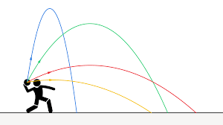

Contents
- Introduction to the course
- Equipment and textbooks
- What you need to do and folder checklist
- Homework and marking policy
- How to revise for Mathematics
- Additional resources and support
- Recommended online revision resources
- Course structure and assessment
- Course skills
- Exam advice
- Mathematical command words
- How to answer the different types of questions in Mathematics
- Super‑curricular guide

Introduction to the course
OCR A Level Mathematics A (H240) develops your skills in Pure Mathematics, Statistics and Mechanics and prepares you for university study and mathematically demanding careers. The course builds on the full GCSE (9–1) Mathematics content and expects you to connect algebra, geometry, calculus, statistics and mechanics across different topics and exam papers. You will learn to use appropriate technology such as scientific/graphical calculators, graphing software and spreadsheets while still presenting clear analytical working in your solutions.
The course is linear, meaning it is assessed by exams at the end of y13.

Equipment and textbooks
You must bring the following to all lessons:
- Black or blue pens, pencil, rubber, ruler and highlighters
- An exercise book (these are provided)
- An organised Mathematics ring‑binder/folder for assessed materials
- Calculator: an A Level standard scientific calculator; the department recommends the Casio fx‑991CW
Textbooks (loaned by the department):
- Hodder Education A Level Mathematics for OCR A textbooks (Year 1/AS and Year 2), which are written specifically for the OCR A (H240) specification and include explanations, worked examples, exercises and exam‑style questions.
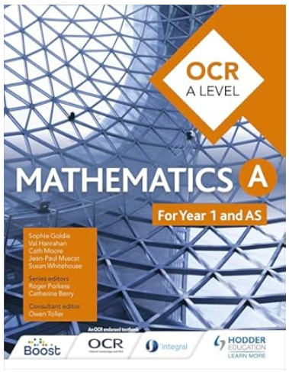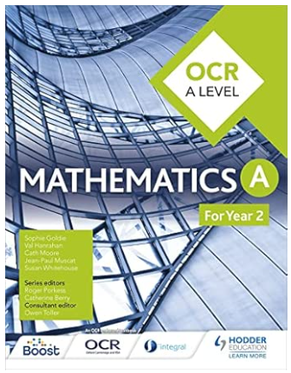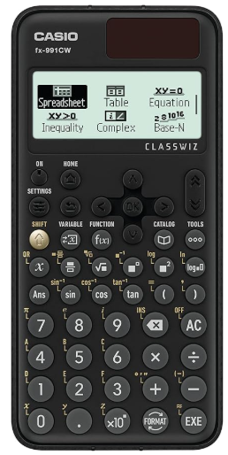

What you need to do and folder checklist
To be successful in A Level Mathematics you are expected to:
- Attend 100% of classes where possible and arrive punctually and fully equipped
- Engage actively in lessons: ask questions, contribute to discussions, and attempt all tasks
- Review class notes each week so that new learning is reinforced while it is fresh
- Use Up Learn on a weekly basis to find knowledge gaps and address them
- Complete all homework, revision tasks and assessments on time
- Do regular independent work (beyond homework) to consolidate and extend your understanding
Folder checklist
Your Maths folder should be clearly divided and regularly maintained. A suggested structure is:
- Section 1 – Course information
  - Specification outline and topic checklists
  - Assessment calendar and key dates
  - Copy of the formula sheet
- Section 2 – Pure Mathematics (Section 1 of the spec)
  - 1.01 Proof
  - 1.02 Algebra and functions
  - 1.03 Coordinate geometry
  - 1.04 Sequences and series
  - 1.05 Trigonometry
  - 1.06 Exponentials and logarithms
  - 1.07 Differentiation
  - 1.08 Integration
  - 1.09 Numerical methods
  - 1.10 Vectors
- Section 3 – Statistics (Section 2 of the spec)
  - Notes on sampling, data presentation, probability, binomial and normal distributions, hypothesis tests and the Large Data Set (LDS)
- Section 4 – Mechanics (Section 3 of the spec)
  - Notes on kinematics, forces, Newton’s laws, moments and projectiles
- Section 5 – Homework and assessments
  - Topic tests and end‑of‑unit assessments, with feedback and corrections in a different coloured pen
- Section 6 – Revision resources
  - Summary sheets, retrospective revision timetable, formula lists, practice papers, revision plans and examiner‑style guidance
Folders may be checked during the year to ensure they are complete and well organised.

Homework and feedback policy
Homework is essential for success in A Level Maths and is carefully structured to support both new learning and long‑term fluency.
Each week you will be expected to complete:
- 2-3 hours of textbook‑based homework
  - Questions from the Hodder OCR A Level Mathematics textbooks and/or department worksheets, focused on current teaching topics. This should be self-marked and corrected, and you are expected to bring issues that you can’t resolve to lessons for additional help.
- 2 hours of revision of past learning on Up Learn
  - Revisiting and consolidating previously taught content using Up Learn’s structured videos, quizzes and practice questions to strengthen retention and understanding.
- 1 hour of Weekly Reviews (Year 13 only)
  - Tailored to the department’s curriculum, these Weekly Reviews focus on key topics that can become barriers to new learning if not fully fluent, ensuring that important foundations remain secure.
In addition, students will complete a Topic Assessment at the end of each unit, used to assess knowledge and progress, identify strengths and diagnose any learning gaps that require further support. You are expected to complete all homework and revision on time, and to correct errors and misconceptions in a different colour in response to teacher feedback.
Persistent failure to complete homework or revision will be followed up in line with sixth form expectations and intervention procedures.

How to revise for Mathematics
Revising for A Level Maths is about understanding methods, practising problems and learning to recall and apply techniques accurately under time pressure. Your brain does not store material permanently after one lesson; you need to revisit it regularly so that it moves into long‑term memory. Passive revision (only re‑reading notes or watching videos) feels comfortable but does not reliably train you to recall methods and formulae in an exam.
Effective strategies include:
- Independent practice. The best way to revise maths is to do maths. The more practice you get, the better, so long as you are marking your work regularly and getting help on knowledge gaps (eg via Up Learn or from teachers at Maths Clinic)
- Topic checklists: Use specification checklists (e.g. 1.02 Algebra and functions, 1.07 Differentiation) and tick off each point as you gain confidence.
- Retrospective Revision Timetable: this system builds in spaced repetition and will help you spot which topics you need to prioritise.
  - See detailed explanation here: https://aliabdaal.com/studying/how-to-study-the-power-of-retrospective-revision-timetables/
- Summary sheets: Reduce each topic (e.g. binomial expansion, normal distribution, kinematics) to a one‑page summary with formulae, key methods, common question types and typical errors.
- Flashcards: these are helpful for the small number of areas of the curriculum that involve memorisation. Create cards for definitions, identities, conditions (e.g. when a quadratic has repeated roots), and standard results (e.g. common integrals and derivatives). Use them for quick‑fire testing. Flashcards can also be useful for practicing method selection: eg what method would help with this integral?
- Exam practice: Regularly complete exam‑style questions and full past papers under timed conditions, marking them carefully afterwards to identify specific weaknesses to address.
A helpful revision cycle is:
- Check topic against the specification and notes.
- Create or review summary sheets / flashcards if appropriate.
- Work through an exercise of questions that you have answers for: could be textbook or the Integral Additional Exercises. Mark your work as you go and do corrections. If you identify a knowledge gap use Maths Clinic, Up Learn or a TL Maths video (see link below) to get help before moving on.
- If you have needed help and now understand the topic better, go back to some independent practice questions and check you can do some independently before moving on.
- Attempt an exam‑style question, for example from ALevelMathsRevision.com (see below)
- Mark it using a mark scheme or model solution.
- Identify and fill gaps, then revisit the topic later (spaced practice).

Recommended online revision resources
These online platforms are recommended to support your learning alongside lessons and textbooks:
- TLMaths – A Level Maths
High‑quality video explanations and fully worked examples covering A Level Maths content, organised by topic.
  - Link: https://sites.google.com/view/tlmaths/home/a-level-maths
- Integral Maths (Integral)
A subscription platform, offering teaching notes, interactive practice, assessments and exam‑style questions mapped to OCR Mathematics A.
- Up Learn – A Level Maths
A structured online course with video lessons, quizzes and exam‑style practice designed to help students make rapid progress towards high grades in A Level Mathematics.
- ALevelMathsRevision.com – Categorised Exam Questions
  - Link: https://alevelmathsrevision.com/maths-categorised-exam-questions/
Use these resources strategically: to pre‑learn or review topics, to get an alternative explanation when something in class was unclear, or to find extra practice questions on weaker areas.
Additional resources and support
The maths department offers high levels of support to help you achieve your potential in A Level Mathematics.
- You will benefit from exceptional support from your teachers, who are available to clarify misconceptions, provide extra practice, and advise on revision strategies and university preparation.
- The department runs a weekly Maths Clinic after-school, open to all sixth formers, where you can:
  - Get help with specific knowledge gaps or homework questions
  - Ask about topics you find difficult or confusing
  - Complete focused, productive Maths revision in a supportive environment
You are strongly encouraged to attend Maths Clinic whenever you need clarification, want to consolidate learning, or simply need a quiet, focused space to work on your Mathematics.

Course structure and assessment
OCR A Level Mathematics A is a linear qualification: all exams are taken at the end of Year 13. The content is divided into three main areas:
- Pure Mathematics – roughly two‑thirds of the course
- Statistics – part of the applied component
- Mechanics – part of the applied component
You will sit three 2‑hour written papers at the end of Y13, each worth 100 marks and each contributing one third of the total A Level grade:
- Paper 1: Pure Mathematics (H240/01)
  - Assesses Pure Mathematics only: algebra, functions, coordinate geometry, sequences and series, trigonometry, exponentials and logarithms, differentiation, integration, numerical methods and vectors.
- Paper 2: Pure Mathematics and Statistics (H240/02)
  - Section A: Pure Mathematics (as above)
  - Section B: Statistics, including sampling, data presentation and interpretation, probability, binomial and normal distributions, and hypothesis testing, with questions linked to the OCR Large Data Set (LDS).
- Paper 3: Pure Mathematics and Mechanics (H240/03)
  - Section A: Pure Mathematics (as above)
  - Section B: Mechanics, covering kinematics, forces, Newton’s laws and moments.
Calculators are permitted in all three papers, and it is expected they can handle iterative methods and binomial/normal probabilities. The Casio FX 991/CW is recommended. Each paper includes shorter questions, multi‑step problems and synoptic questions that bring together ideas from different parts of the specification.
Questions that state ‘this question requires detailed reasoning’ require every part of the solution to be showed explicitly, so while calculators can be used to check final answers, you will need to be able to show the step-by-step method.

Course skills
A Level Mathematics develops a wide range of transferable skills that are highly valued in higher education and employment:
- Mathematical reasoning and proof – constructing logical arguments, using correct notation, and understanding proof by deduction, exhaustion and contradiction (including classic proofs such as the irrationality of the square root of 2).
- Problem solving and modelling – recognising mathematical structure in real situations, forming and using models, and evaluating the assumptions and limitations of those models (for example, in statistics and mechanics).
- Data analysis and statistics – interpreting data, using sampling methods, calculating and interpreting summary statistics, and performing hypothesis tests using binomial and normal distributions.
- Mechanics and physical understanding – analysing motion, forces and moments through diagrams and equations to understand real‑world physical problems.
These skills support progression into degrees such as Mathematics, Engineering, Physics, Computer Science, Economics and many other quantitative subjects.

Exam advice
All three OCR A Level Mathematics A exam papers:
- Are 2 hours long and worth 100 marks each.
- Allow appropriate scientific or graphical calculators.
- Include a mix of short questions and longer, structured problems, including questions that assess problem solving and modelling skills.
Using the formula sheet
Each paper includes a formula sheet at the front of the exam paper, containing standard results such as trigonometric integrals, series, and distribution properties. You should become familiar with this sheet during the course so you know what is provided and where to find it quickly. In the exam, refer to the formula sheet efficiently rather than trying to memorise everything, and focus on correct application and clear working.
General exam tips:
- Read every question carefully; underline key information, especially in statistics and mechanics contexts.
- Turn word questions into algebra or a clear diagram, as appropriate, to help you see what method is required. Diagrams are an essential first step in mechanics questions.
- Show all working clearly, using correct notation and steps – unsupported final answers may not receive full credit.
- When you use your calculator, write down the expression or key values you have inputted so that your method is visible.
- Use diagrams and sketches (graphs, force diagrams, etc.) where they help to structure your reasoning.
- Use the marks as a guide to time (roughly 1 minute per mark). If you are stuck, move on and return later.
- Check units, signs and reasonableness of answers, especially in mechanics and statistics.

Mathematical command words
Understanding command words helps you give answers at the required level of detail.
Command word | What you must do in Maths
Find / Solve / Calculate | Obtain a value or expression. Working may be required but a full written justification is not always needed; appropriate calculator use is allowed.
Determine | Obtain a result and show sufficient reasoning or working; an unsupported answer is not enough.
Show that | Use algebra or other reasoning to reach a given result, demonstrating all key steps clearly.
Prove | Provide a complete, logically structured mathematical argument from assumptions to conclusion.
Verify | Substitute a given value or expression to confirm an identity or solution.
Give / State / Write down | Provide a short answer, often obtainable directly from previous work, a diagram, or standard knowledge, without full working.
Sketch | Produce a diagram showing the key features of a graph (e.g. intercepts, asymptotes, turning points) but not necessarily to scale.
Hence | Use the previous result to answer the next part.
Hence or otherwise | Choose either to use the previous result to answer the next part or to use a different valid method.

Always simplify expressions (e.g. exact surd or π form where requested) and give equations in standard forms (e.g. y=mx+c or ax+by+c=0 for the equation of a line) unless told otherwise.

How to answer the different types of questions in Mathematics
Different question styles appear across the three papers; adjusting your approach can maximise marks.
1. Short skills questions (algebra, calculus, trig, etc.)
- Identify the key topic (e.g. completing the square, differentiating a product, solving a trig equation).
- Write down any standard results or formulae you will use, then apply them step by step.
- Give your final answer in the form requested (e.g. exact value, factorised form, completed square, simplified surd).
2. Statistics questions (including Large Data Set)
- Decide whether the question is about sampling, data representation, probability, distributions, or hypothesis testing.
- For LDS‑related questions, use your familiarity with the context (variables, units, typical patterns) to interpret results, but remember you are not expected to know the raw data by heart.
- In hypothesis tests, clearly state H0 and H1, define p, state the significance level, test statistic, critical region or p‑value, and write the final conclusion in using the context of the question.
3. Mechanics questions
- Begin by drawing a clear diagram or force diagram with all forces and directions, labelling known and unknown quantities.
- Translate the physical situation into equations (e.g. using constant acceleration formulae or Newton’s second law), then solve systematically.
- Interpret your answers in context, including units and sign (e.g. negative velocity meaning motion in the opposite direction).
For all extended questions, a helpful structure is: Identify → Set up → Solve → Interpret

Super‑curricular guide
Super‑curricular activities go beyond the classroom and help you develop the depth and independence expected by top universities.
The most important way to prepare for Mathematics at a highly selective university is to do more challenging mathematics: tackle difficult problems, explore unfamiliar questions and practise writing clear, logical solutions. Working regularly on harder questions (such as Olympiad‑style problems or university admissions‑test style questions where appropriate) builds the persistence and creativity that admissions tutors look for.
For broader insight and enjoyment, the University of Cambridge recreational mathematics reading list provides many accessible books that illustrate how mathematical ideas have developed over time and how they connect to the wider world. This list is not about learning extra syllabus content but about seeing how mathematical knowledge is built and how mathematicians think.
- Cambridge Mathematics Recreational Reading List (PDF):
https://www.maths.cam.ac.uk/undergrad/admissions/files/admissions/reading-list.pdf
Within the department you will also have access to structured enrichment and application support, such as:
- Guided work on challenging extension problems that go beyond standard A Level exam questions
- Preparation for university admissions tests where appropriate (e.g. STEP, MAT, TMUA), focusing on deep problem solving and proof
- Extensive Oxbridge interview support from an experienced and successful department with a strong track record of students progressing to study Mathematics and related subjects at these universities, including mock interviews and opportunities to practise explaining your reasoning clearly.
Engaging regularly in these activities will help you develop the independence, resilience and depth of understanding that top universities value.

