
A LEVEL LAW HANDBOOK
Name:

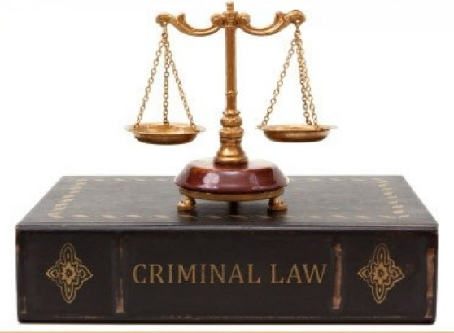

Contents
Introduction to the course ………………………………………………………………………………………..3
Equipment and textbooks …………………………………………………………………………………………..4
What you need to do and folder checklist …………………………………………………………………5
Homework and marking policy…………………………………………………………………………………...6
How to revise for law………………………………………………………………………………………………….7-10
Additional resources and reading list ………………………………………………………………………….11
Course skills ………………………………………………………………………………………………………………..12
Exam advice…………………………………………………………………………………………………………………13
Law command words……………………………………………………………………………………………………14
How to answer the different types of questions in law………………………………………………15-30
Super-curricular guide…………………………………………………………………………………………………31-33

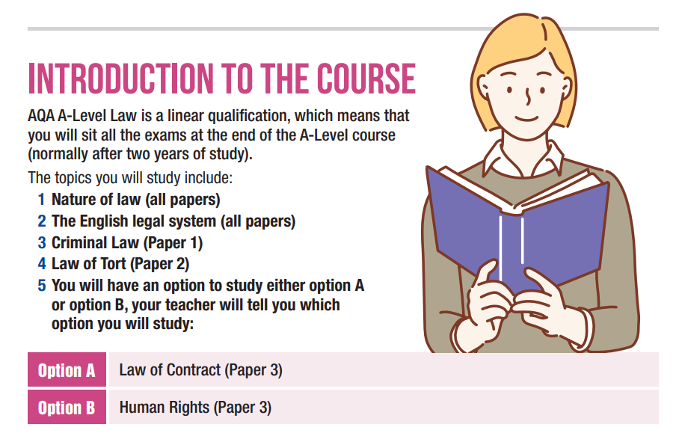
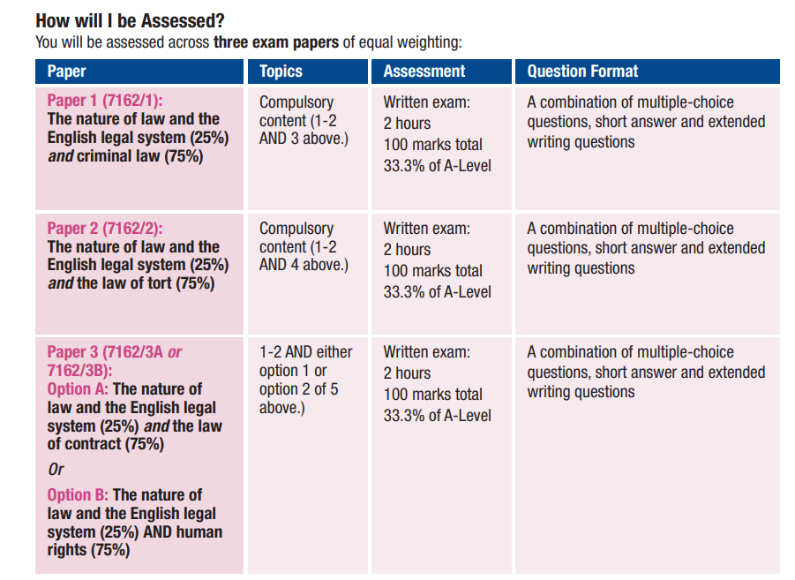
Equipment
You must bring the following to all lessons:
• Stationary - Pen, pencil, rubber, ruler
• Exercise book
• Textbooks and Workbooks as prescribed
• Summary sheets and law folder

Textbooks
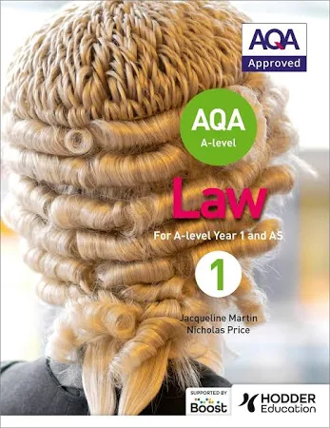
The textbook required for your course
Prescribed Textbook:
AQA A-level Law for Year 1/AS: Jacqueline Martin and Nicholas Price
(ISBN 1510401644 )
AQQ
AQA A-level Law for Year 2 (Paperback)
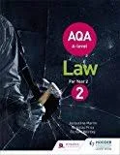
Jacqueline Martin (author), Richard Wortley (author), Nicholas Price
(ISBN 9781510401747)

A free digital copy of the textbook
Textbook

What you need to do
Attend 100% of classes and arrive punctually for each class.
• Ask if you do not understand any part of the work.
• Revise your notes thoroughly each week.
• Read and research each topic whenever the opportunity arises.
• Contribute in class – your opinions and ideas are valuable.
• If you are going to be absent or late for an unavoidable reason, please email/call your tutors in
advance.
Folder Check
You need to organise your law folder using the checklist below
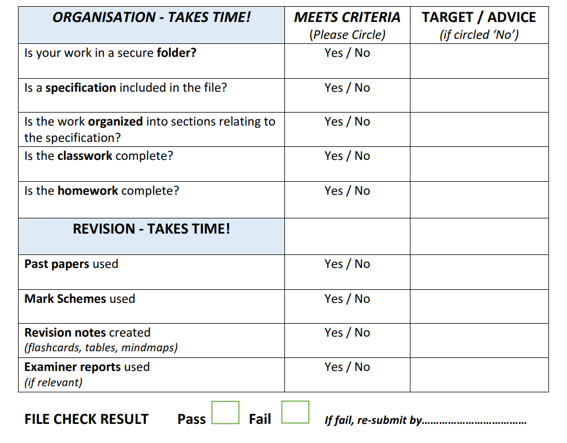

Homework and Marking Policy
Your teachers will set between 2-3 hours of homework per week. You will be expected to complete all homework, pre-reading and learning prep when it is due in. All homework will be set on Teams.
In addition you will be expected to complete 2-3 hours of independent work as well. The most successful students complete on average five hours of work per subject per week (including homework)
What does independent study look like?
- Making notes
- Organising your folder
- Research
- Reading
- Completing homework
- Revision techniques
- Creating revision resources
- Practising past questions
A level law will aim for you all to do one piece of assessed work every two weeks and a formal assessment at least twice in a half term, which will be formally marked by teachers.
You will be expected to correct all assessed work using green pen to improve exam technique.

How to revise for Law
Revising for A-Level Law can sometimes feel overwhelming. You are expected to remember legal rules, apply them to scenarios, recall cases (including names and legal rules), and construct clear legal arguments in exam conditions. However, revision does not have to be stressful or confusing. With the right approach, you can revise efficiently, develop confidence in your knowledge, and improve your exam performance. In this article we will explore why revision is essential, how memory works, which revision strategies are scientifically proven to work best and ultimately how to revise law.

Why Students Need to Revise
Even if you understand a topic in class, your brain will not store that information permanently unless you return to it. Information you have understood once does not stay accessible by itself, your memory fades over time. Revision strengthens your memory so that when you reach the exam, you can recall case law, principles and evaluation points quickly and accurately under pressure.
This is especially important in law, where the difference between a good answer and an excellent one is often the precision of your recall and being able to clearly state legal rules and support them with relevant cases. Revision helps you store and organise this knowledge so that you can retrieve it confidently.

How Memory Works (and Why This Matters When Revising Law)
To revise successfully, it helps to understand what your brain is actually doing when you learn. When you first encounter new information for example, the definition of murder, it enters your working memory. Your working memory is like your mental notepad; it can only hold a small amount of information at once. If you don’t do anything with new information, it fades very quickly, sometimes within minutes.
Your goal when revising is to transfer information from working memory into your long-term memory, where it can be stored more permanently. But information does not move into long term memory just by re-reading notes or watching videos. It moves there when your brain actively processes and retrieves the information.
Once information is stored in your long term memory, you still need to be able to recall it and pull it back into working memory when you need it. This is exactly what happens in an exam. The question appears, and your brain has to quickly locate the right rule, principle and case from your long term memory, and bring it into working memory so you can write about it.
This is why active recall is the most effective revision method. When you test yourself, for example, by blurting, flashcards, or answering exam questions, you train your brain to retrieve information. Every time you successfully recall something, the memory becomes stronger and faster to access.
In other words:
- Revision stores the information in long-term memory
- Active recall teaches you how to bring it back into working memory when needed
- This ability to retrieve information quickly is exactly what you need in an exam

Passive revision (re-reading, highlighting, listening to videos) can make you feel like you know something, but it does not train your brain to recall it. This often leads to the exam experience of being able to recognise a topic but then unable to remember the actual law or precise legal rules and cases. Active recall prevents this from occurring.
Example: Applying This When Revising Murder
Imagine a student, Aisha, revising the law of murder. She learns the basic rule: Murder is the unlawful killing of a human being under the Queen’s peace with malice aforethought.
At first, this sits in her working memory. If Aisha simply reads it again later, it won’t stick.
Instead, she:
- Creates flashcards for actus reus, mens rea and key cases
- Blurts (writes everything she remembers without looking)
- Checks what she missed, adding missing details in a different colour
- Then answers a scenario question applying the law to facts
Each of these steps forces the information into long-term memory and strengthens her ability to recall it.
So, when she sits down in the exam and sees: “Discuss whether D is liable for murder,”
she can immediately bring:
· the definition,
· the elements,
· and the key cases
back into working memory to construct a confident, accurate answer.
Effective Revision Techniques (and Why They Work)
The most effective revision strategies are active, meaning they require your brain to work.
Mind Maps
A mind map is a visual diagram that organises information around a central topic. To create one, start with the main topic in the centre (e.g., Law of Murder) and draw branches for key elements such as actus reus, mens rea, and key cases. Add smaller branches for definitions and case law examples (add in evaluation too if needed). Mind maps are effective because they show connections between ideas, help you see the bigger picture, and make it easier to recall information visually. They also encourage active engagement with the material as you decide what to include and how to organise it.
Summary Sheets
A successful way to revise for law is to create One-page summary sheets
Whatever topic you study, however large you think it is, it is always possible to reduce your notes down to a single page. This one-page summary should be in note form, not in full sentences, with the information reduced down as far as possible.
You only need to include case names in this summary, as you will also have made a separate resource for case studies (see the next tip). This one-page summary not only makes the content seem more accessible and easier to digest, it also creates a fantastic revision resource to refer to in future.
Take a picture of each one-page summary you create and save it on your phone. You can then read through them whenever you have a spare 5 minutes.
Flashcards
Flashcards are small cards with a question or prompt on one side and the answer on the other. For law, you could write the name of a case on one side and the legal principle on the back. You can make them physically on card or digitally using apps like Quizlet. Flashcards are effective because they force you to actively recall information rather than just recognise it. Testing yourself repeatedly with flashcards strengthens memory pathways and improves long-term retention.
Blurting
Blurting is a self-testing technique where you cover your notes and write down everything you can remember about a topic. After writing and blurting, compare your answers to your notes or mind map, and highlight missing information. This technique is effective because it directly trains your recall from long-term memory, helps identify knowledge gaps, and reinforces learning through repeated retrieval. It also makes you more confident in recalling information under exam conditions.
Practice Exam Questions
Completing practice exam questions involves applying your knowledge to real or past-paper questions under timed conditions. You can find these in textbooks, past papers, or online resources. This technique is effective because it helps you transfer knowledge into application, improves exam technique, and allows you to practice structuring answers, applying cases to scenarios, and including evaluation points. Regular practice questions make you exam ready and improves your ability to recall and apply the law.

Marking Your Work
Marking your work involves checking your answers against model answers, mark schemes, or teacher guidance. When marking, identify missing content, incorrect statements, or areas that could be improved, and then add corrections or missing points. This is effective because it allows you to learn from mistakes, consolidate correct information, and focus your revision on areas that need improvement. It also mirrors exam conditions, helping you develop accuracy and confidence.

A Step by Step Revision Cycle
Use this process for any topic:
- Use the exam checklists to ensure you have notes and understand all topic areas.
- Turn notes into summary sheets, flashcards or a mind map
- Learn from them actively (test yourself, recite aloud)
- Blurt the topic from memory
- Compare to original notes and fill gaps in a different colour
- Complete a practice exam question
- Mark your answer & correct mistakes in a different colour
- Improve your exam technique by reading through Examiners’ reports
Repeat this cycle regularly and develop your long term memory and recall skills.

Additional resources and reading list:
Listed below are a range of resources you might find helpful to support your legal study – these will suit a variety of different learning styles and preferences!
- e-lawresources.co.uk
- A Level Law - The Law Bank
- Law | tutor2u
- Legal Cheek - law firm insight, news, careers, events
- The Supreme Court of the United Kingdom
- Review Educational Magazines for Students - Tips and Advice | Hachette Learning
- Law | The Guardian

Legal Books:
- Barnard, O’Sullivan and Virgo, What about Law?
- Bingham, The Rule of Law
- Bradney A and others, How to Study Law
- Lord Denning, Landmarks in the Law
- Grant T, Jeremy Hutchinson’s Case Histories
- Heinrichs J, Winning Arguments
- Hutchinson A, Is Eating People Wrong? Great Legal Cases and How They Shaped The World
- Kennedy H, Eve Was Framed
- McBride N, Letters to a Law Student
- Robertson G, The Justice Game
- Slapper G, How Law Works
- Smith and Bailey, Modern English Legal System
- The Secret Barrister, The Secret Barrister: Stories of the Law and How it’s Broken

Course Skills
This qualification:
• develops competence in using legal skills during the study of the nature of law, legal issues and the English legal system, and the private and public areas of substantive law.
• requires learners to demonstrate their ability to analyse a factual scenario by identifying the key facts from which legal issues arise.
• requires learners, when formulating a legal argument, to be able to analyse legislation by applying the rules and principles of statutory interpretation; and analyse case law by applying the doctrine of precedent.
• requires learners, in respect of each private and public area of substantive law they are required to study, to analyse, apply and evaluate the legal rules and principles of that area of law. Analysis and application must include the ability to identify and breakdown into constituent parts the relevant legal rules and principles for each area of law and apply those legal principles to a hypothetical scenario. Evaluation must require learners to formulate a reasoned argument to support a particular proposition by reference to the relevant legal rules and principles that support that argument.
• requires learners to construct clear, concise and logical legal arguments that are substantiated by legal authority, using appropriate legal terminology.
Why study law?
Students will learn about the legal system, law making, the nature of law, criminal law, the law of tort and human rights law or the law of contract. Law students develop a range of skills including the application of legal rules and principles to present an argument, analysis and evaluation of the law, legal issues and concepts. There are many benefits of studying AS and A Level Law. It links all aspects of society. It helps students develop a range of transferable skills: analytical skills, attention to detail, logical thinking, research skills, essay writing skills and the ability to produce a balanced argument. It is a useful qualification that has application in many fields, not just the legal profession.

Exam advice
Structure of all Papers 1, 2, 3A or 3B is identical:2 hours/100 marks
(75/25% substantive law/non-substantive)
• Qu01-02 MCQ substantive (2 x 1 mark)
• Qu03-05 MCQ non-substantive (3 x 1 mark)
• Qu06 non-substantive/non-scenario (5 marks)
• Qu07 substantive/scenario (5 marks)
• Qu08 substantive/scenario (10 marks)
• Qu09 non-substantive + substantive/non-scenario (15 marks)
• Qu10 substantive/scenario (30 marks)
• Qu11 substantive/scenario [23] + non-substantive [7]) (30marks)
Assessment Objectives
• AO1 (40%) knowledge and understanding
• AO2 (27%) application
• AO3 (33%) analysis and evaluation

Further advice and exam papers can be found on the link below
A-level Law 7162 | Specification | AQA
Past Papers

AQA Law Command words
The questions that you will be asked in the examinations will contain ‘command words’. These words are extremely important to the way in which you answer the question. The following Is a guide to the words used and their meaning to you:
• EXPLAIN
✚ Used in extended questions, worth 5 marks. ✚ AO1
✚ Question 6 on all papers.
✚ Meaning: Display knowledge and understanding of a specific aspect of the nature of law, the ELS or substantive law.
Advice: Explain two characteristics and provide an example
• SUGGEST
✚ Used in scenario/problem questions, worth 5 marks. ✚ AO1 (2 marks) + AO2 (3 marks)
✚ Question 7 on all papers.
✚ Meaning: Display and apply knowledge and understanding of rules and principles of substantive law to support or deny a conclusion given in the instructions
• ADVISE
✚ Used in scenario/problem questions, worth 10 marks.
✚ AO1 (3 marks) + AO2 (4 marks) + AO3 (3 marks) ✚ Question 8 on all papers.
✚ Meaning: Display knowledge and understanding, supported by analysis and evaluation, and application of relevant rules and principles of substantive law to construct a legal argument on which advice as to criminal or legal liability is given.
• EXAMINE & DISCUSS
✚ Used in extended questions, worth 15 marks. ✚ AO1 (5 marks) + AO3 (10 marks)
✚ Question 9 on all papers.
✚ Meaning: Analyse some aspect of non-substantive law to provide a detailed basis for a required evaluation of substantive law
• CONSIDER
✚ Used in scenario/problem questions, worth 30 marks. ✚ AO1 (10 marks) + AO2 (10 marks) + AO3 (10 marks)
✚ Question 10 & 11 on all papers. Q11 will include two parts (ASSESS) ✚ Meaning: Display knowledge and understanding, supported by detailed analysis evaluation and application of relevant rules and principles, to construct a legal argument allowing a well-reasoned conclusion.

How to answer the different types of questions in law
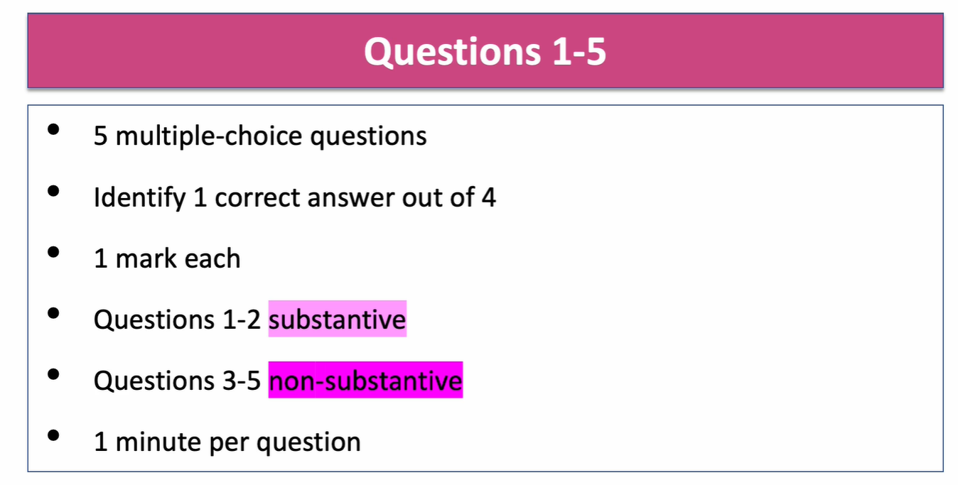
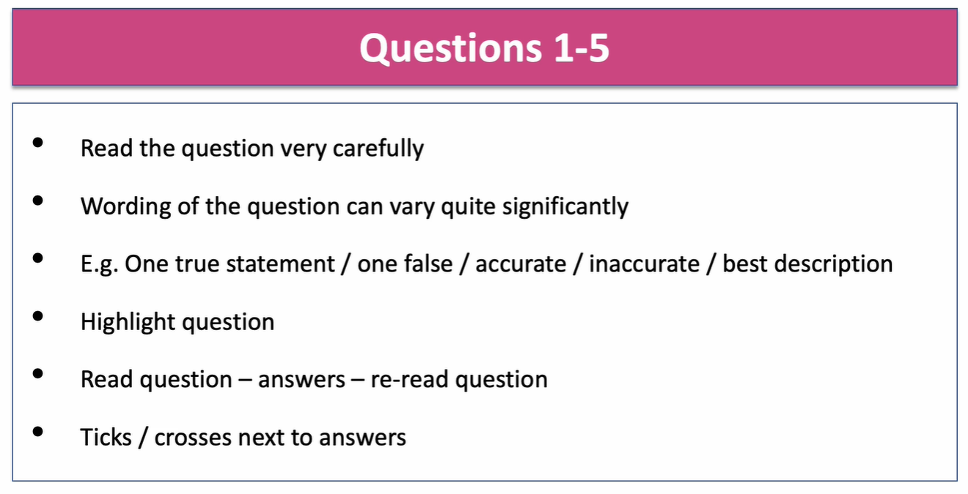

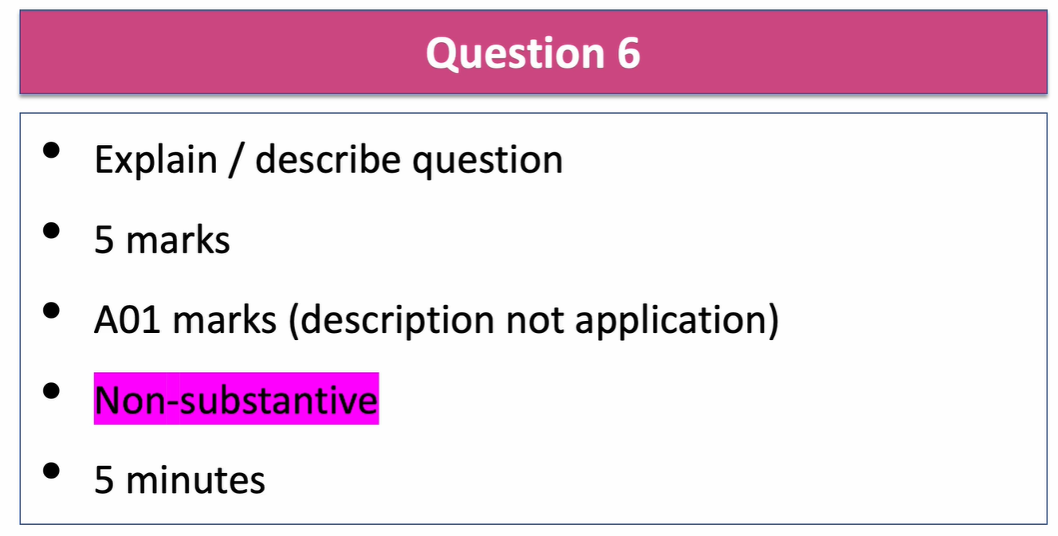

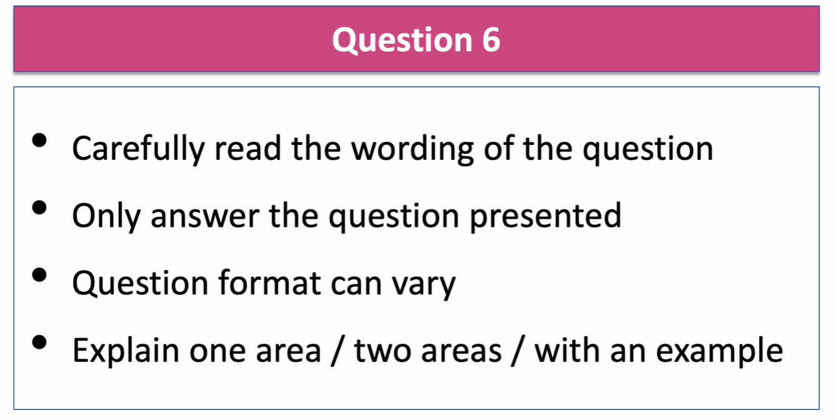
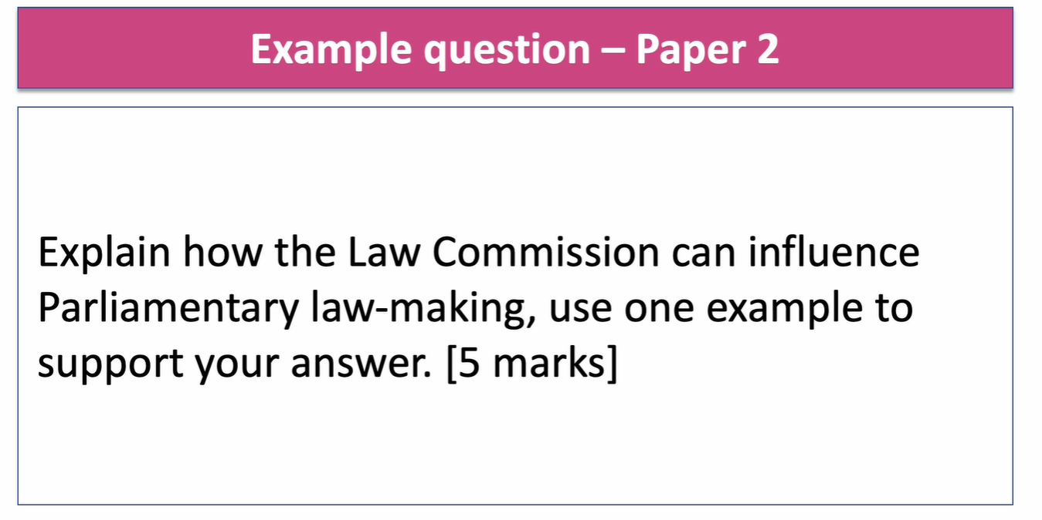

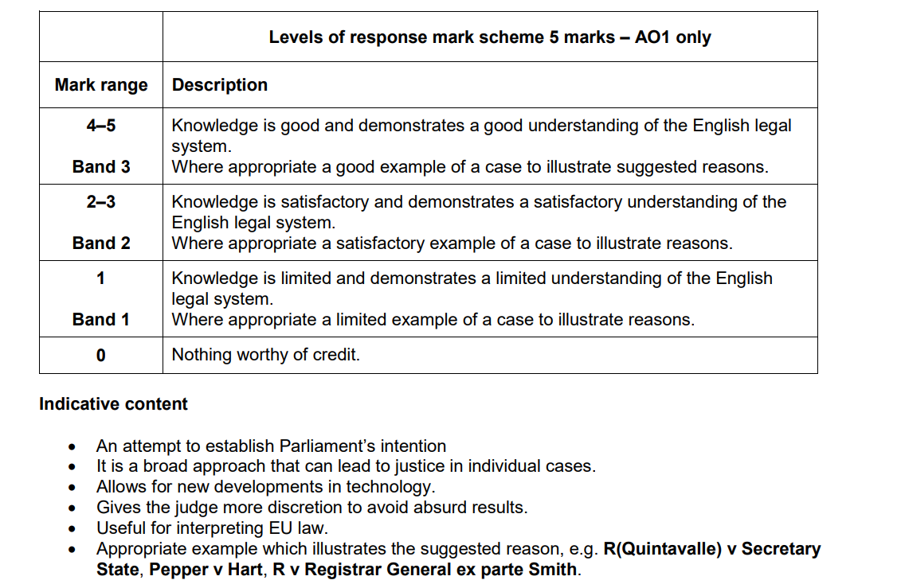

Example of a top band answer
The purposive approach to statutory interpretation is a modern version of the mischief rule. It is an attempt to establish Parliament’s intention when an Act of Parliament has passed. The purposive approach allows the judge to add or ignore words in a statute and make a decision in line with what the act seeks to achieve.
It is a broad approach that can lead to justice in individual cases. The purposive approach gives the judge more discretion to avoid absurd results.
In R v Registrar-General, ex parte-Smith (1990) the courts adopted the purposive approach to prevent a convicted murderer from accessing his birth certificate to track down his biological mother. Even though the law allowed him to see his birth certificate when he was 18, the courts decided not to grant him access because it was thought he might try and kill his mother and it would not have been parliament’s intention to promote a serious crime.

Explain the advantages and disadvantages of the small claims track. [5 marks]

The Small Claims track deals with low value claims and disputes under £10,000, except for personal injury claims which are under £1000
The procedure is quicker than for other types of case – These cases are seen much more quickly than other cases and it should take less than a day. This saves all parties time and takes out a lot of the stress.
One advantage is that claimants can take their own case to court and represent themselves so they don’t need to hire a lawyer and pay fees
One advantage of the small claims procedure is that the costs involved are fairly low, especially if the claim is under £1,000, and if you lose you do not have to pay all the costs of the other side. However, if you win there is no guarantee you will get your money from the other side as only about 60% of claimants actually receive the money awarded by the court.
One disadvantage is that although lawyers are discouraged, businesses will often use a lawyer which can put an unrepresented individual at a disadvantage. The District Judge should help the individual in such cases and explain the case, but research suggests this is not always the case, leading to possible injustice.

Substantive/Scenario questions
The following questions are scenario questions
- Qu07 substantive/scenario (5 marks)
- Qu08 substantive/scenario (10 marks)
- Qu10 substantive/scenario (30 marks)
- Qu11 substantive/scenario [23] + non-substantive [7]) (30marks)
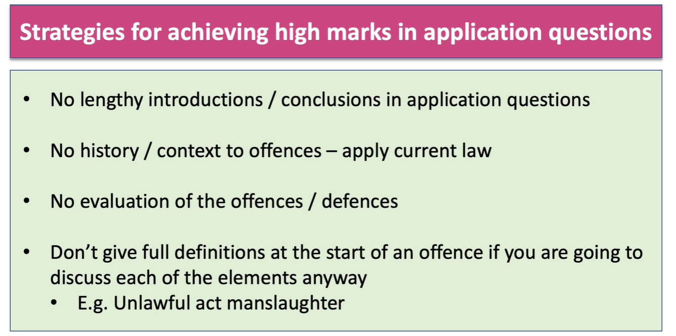
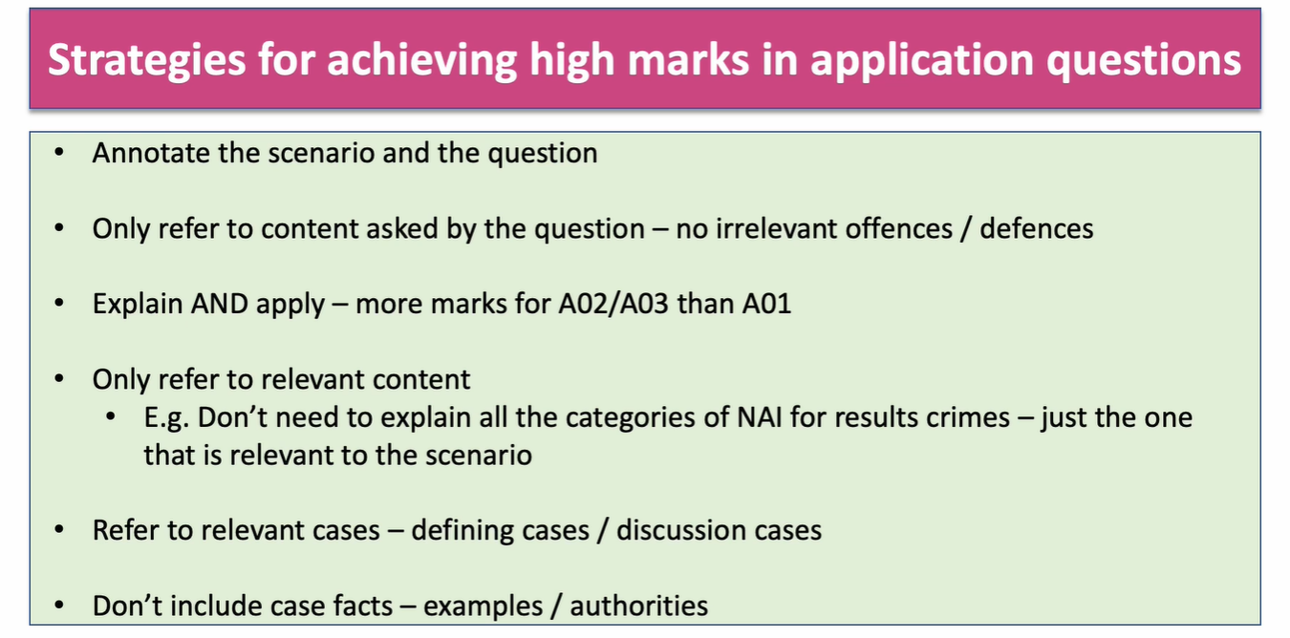
- For ALL scenario questions you are advised to use IDEAS acronym
- I- Identify the Law/ Problem
- D- Define the law
- E- Explain the law (Use case studies to support your answer)
- A- Apply the law to the scenario.
- S- Summarise (Eg State whether the D is guilty based on your analysis)
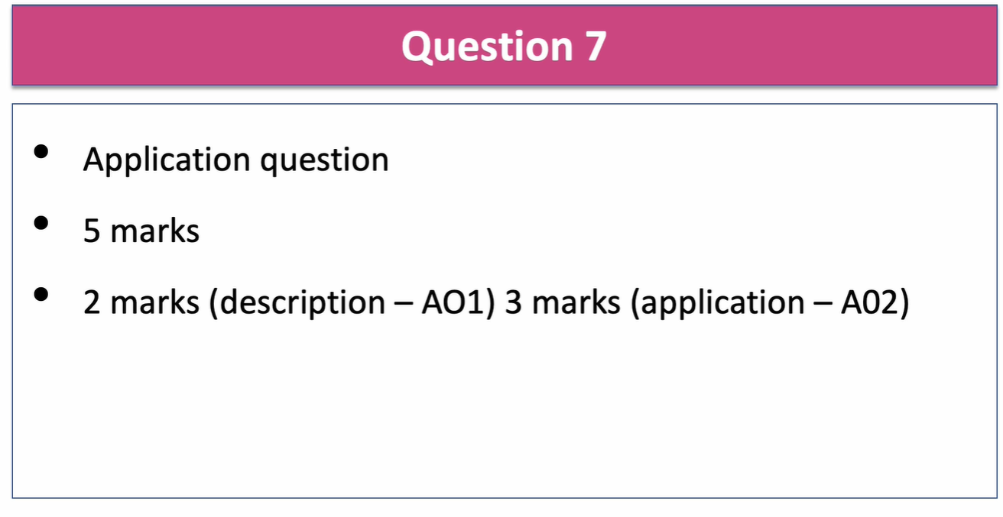
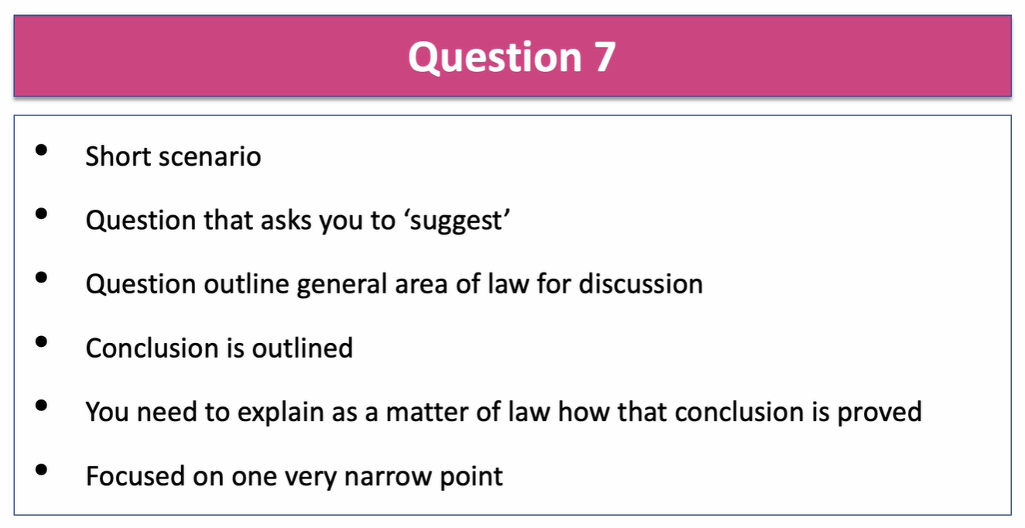
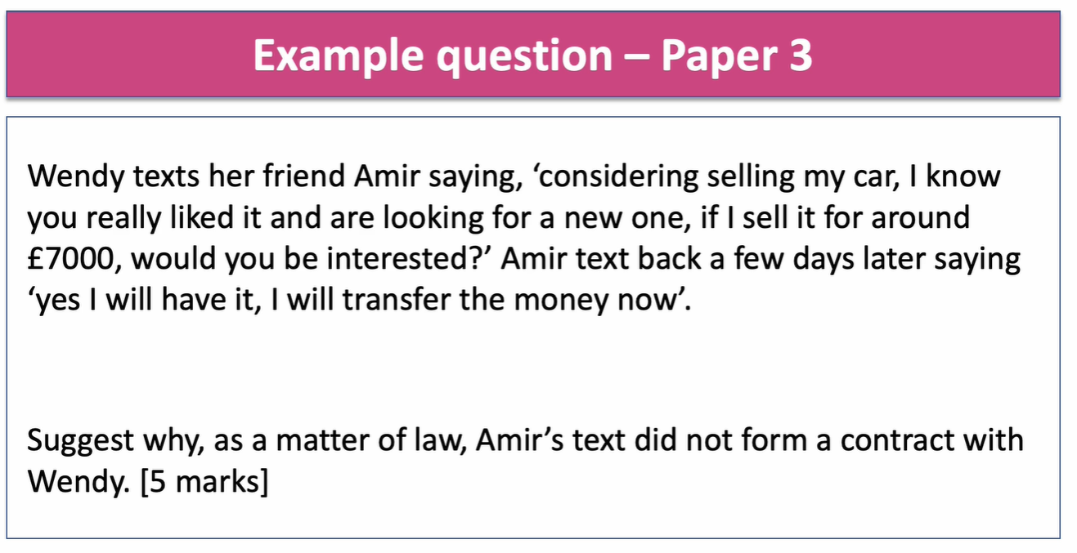
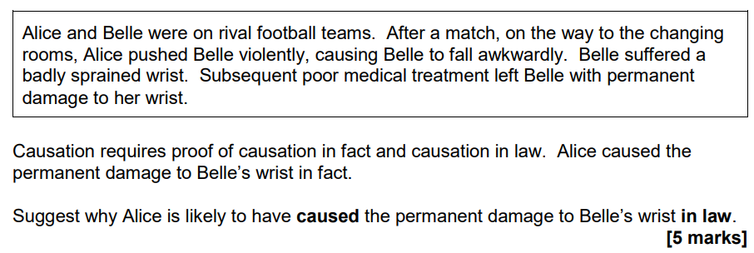
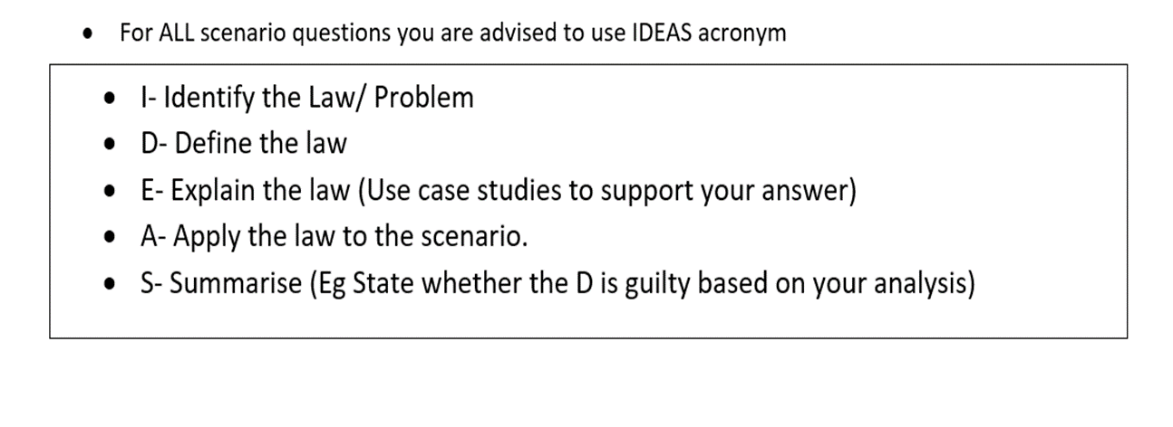Tips:
- What is the legal principle? causation
- Explain what is meant by legal causation (substantial and operative cause?)
- Apply these principles to Belle’s injuries? Will the medical treatment break the chain of causation
- Summarise: Is Alice criminally liable? If so of what?

I- In English law for someone to be criminally liable of a consequence crime they need to be the factual and legal cause of the consequence. This is known as causation.

D- Legal causation means that the defendant’s conduct must be the “substantial and operative” cause of the harm suffered by committing an unlawful act. It is based on the de minimis principle.

E- To satisfy the requirements of legal causation the act must be a more than minimal cause of the consequence which means that it must be more than a slight or trifling link (R v Hughes 2013). It also does not have to be the main cause providing it is a cause. The chain of causation can be broken by: an act of a third party or the victim’s own act or a natural but unpredictable event. Medical treatment is unlikely to break the chain of causation unless it is so independent of the defendant’s acts and ‘in itself so potent in causing death’ that the defendant’s acts are insignificant (R v Cheshire 1991)

A- In our scenario Alice pushed Belle resulting in injury which in turn required medical treatment. The push is certainly more than a minimal cause and so satisfies the test in R v Hughes. The question is whether the poor medical treatment acts as a novus actus interveniens to break the chain of causation. Poor medical treatment is capable of breaking the causal link, however we know from R v Jordan (1956) and R v Cheshire (1991) that the chain will only break where the treatment is so independent and so potent that it makes the defendant’s act insignificant. This certainly does not seem to be the case here. We are told only that the medical treatment was poor. This is not enough to reach the threshold required as established by Jordan and Cheshire.
S- In conclusion it is likely that Alice will be found criminally liable to have caused the damage to Belle’s hand and convicted of ABH or GBH. It should be noted that medical negligence rarely breaks the chain and so it seems probable that Alice will be held to have caused the injury to Belle. Alice caused the consequence to happen. The subsequent intervening act of the negligent medical treatment was not significant or independent enough of Alice’s actions to be deemed to have broken the chain of causation

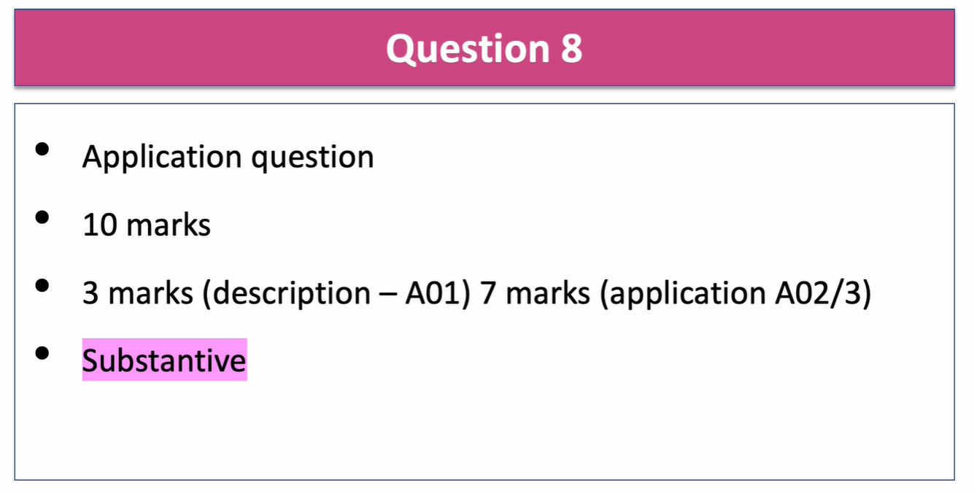

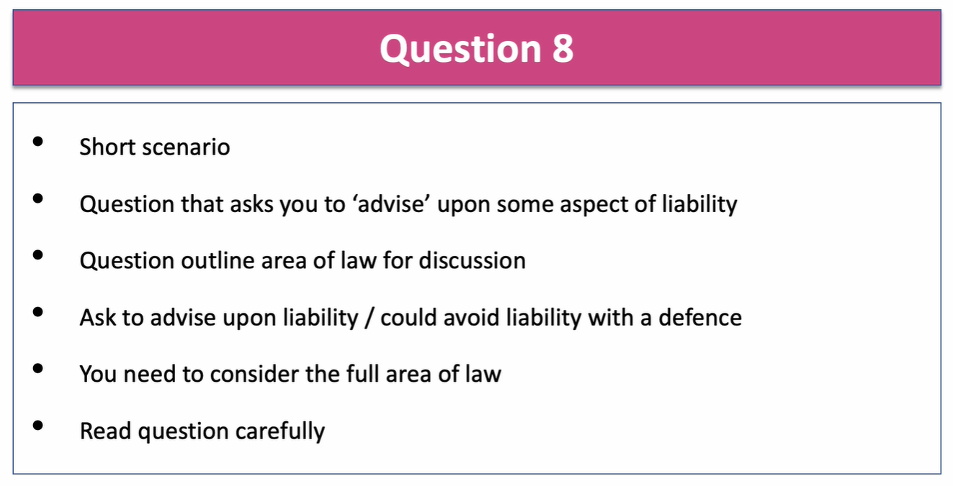
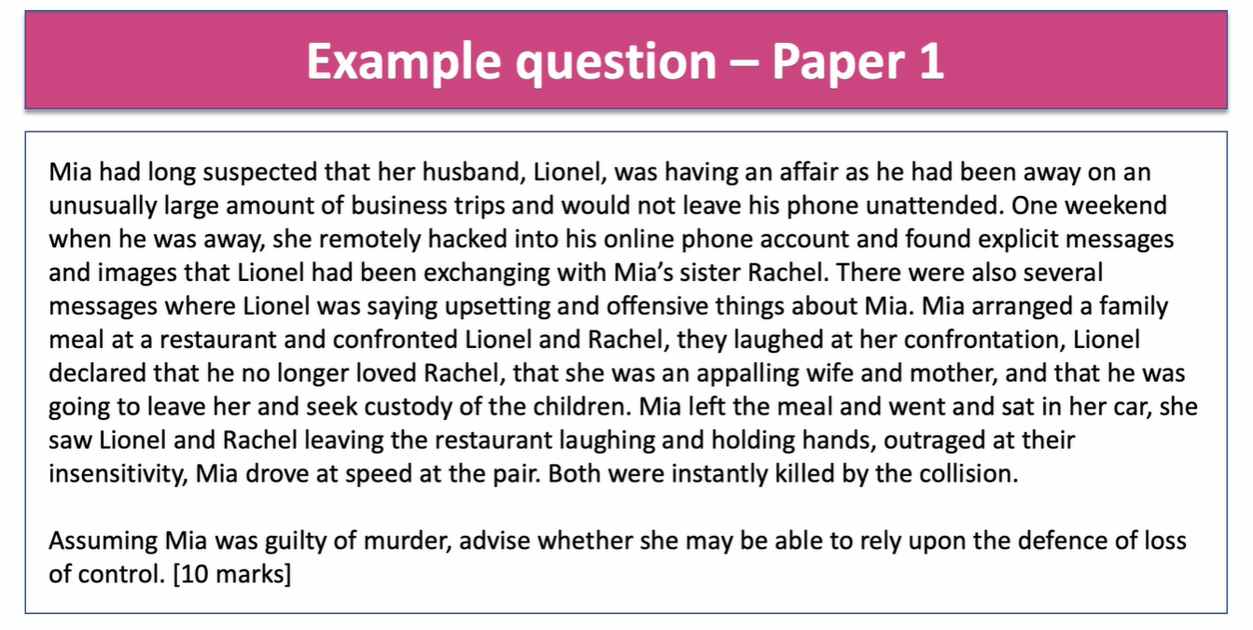

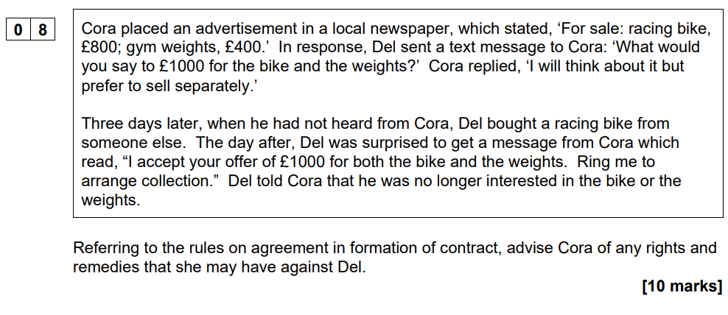
In determining Cora’s rights and remedies the courts would have to decide if there is valid offer and acceptance which would make a legally binding contract
An offer is a statement of willingness by offeree to enter into a legally binding agreement. Acceptance is an expression of absolute and unconditional agreement to all the terms set out in the offer. Offers must also be distinguished from invitations to treat.
An advertisement is an invitation to treat. An indication that one person is willing to negotiate a contract with another by inviting them to make an offer. It is not legally binding. When Cora placed the advertisement in the paper, it is an invitation to treat (Partridge v Crittenden 1968) Cora is inviting people to make offers.
The next issue is whether Del then makes an offer when he says “what would you say to £1000 for the bike and the weights?” or whether this was a request for information. If the courts decide this was a request for information then there would be no contract (Harvey v Facey 1893) However the language does sound like it is an offer.
Cora clearly does not accept the offer and says she wants time to think about it. She has clearly then not accepted Del’s offer. Del waits three days and then decides to buy a bike from someone else. An offer can come to an end through revocation. This is where the offer gets withdrawn by the offeror by communicating it to the offeree ( Routledge v Grant 1828) Del has not said anything to Cora so he could be liable for breach of contract as he has not communicated to Cora that he has withdrawn (revoked his offer) An offer can also come to an end by lapse of time. Whether or not a delay of four days was a sufficient lapse of time (an unreasonable length of time not to communicate an acceptance) will be up to the courts to decide. It is possible the courts would say four days is reasonable.
Del may be liable to pay damages as to the difference (if any) between the price agreed (£1000) and any lesser sum for which Cora could sell the two items
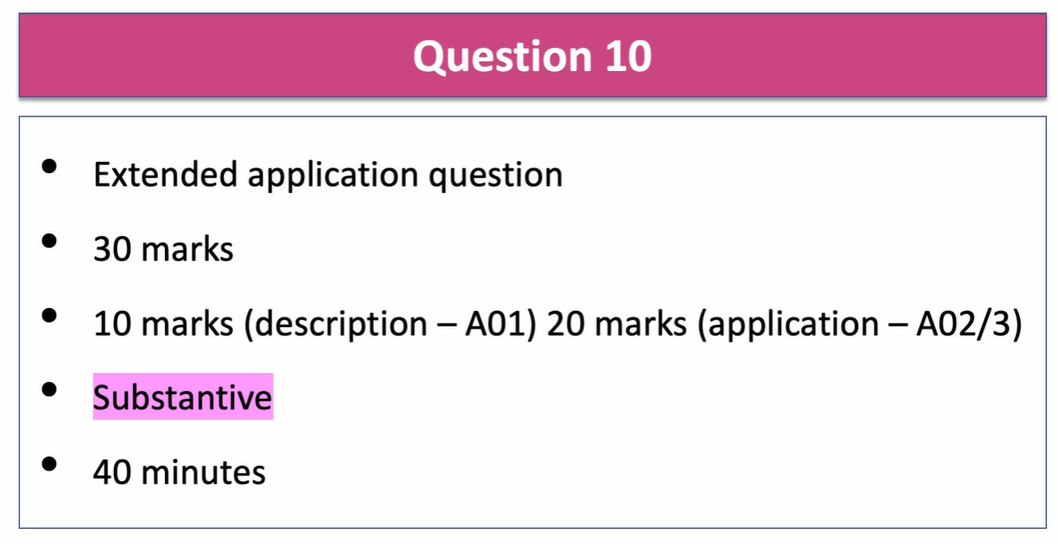

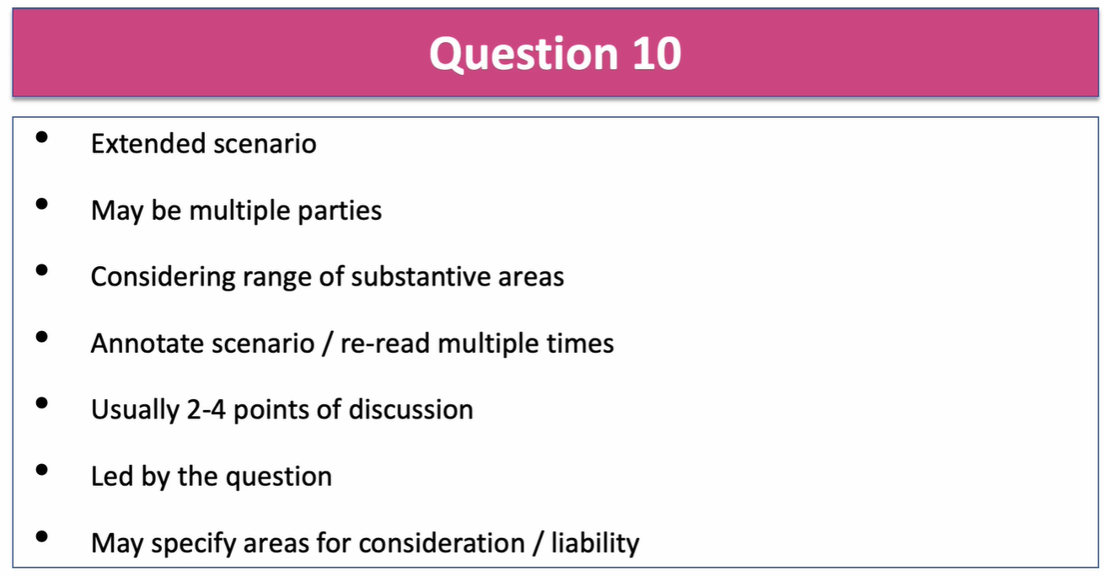
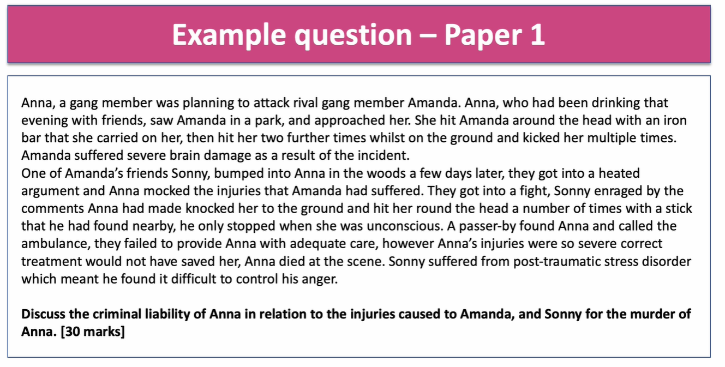

Sergio held a party at his new house to welcome his neighbours, including Carlos. During the party, Carlos told Sergio that he was studying for a degree in the history of pottery. Sergio then asked Carlos to advise him on the value of a vase which he had inherited from an aunt and which he wanted to sell. Carlos advised Sergio that it was worth about £50. The following week, Sergio sold the vase to Ben, a local antiques dealer, for £40 but Sergio later discovered that it was in fact very rare and worth £10000.
Consider the rights and remedies, if any, of Sergio against Carlos in connection with the vase (30)
gio could try to sue Carlos for giving him a negligent misstatement which las lead to pure economic loss. To do this he would firstly have to prove Carlos owed a duty of care which was breached and the breach caused the damage and was not too remote. In addition as this loss is PEL, Carlos would have to prove that there was a special relationship for the purposes of a negligent misstatement.
Economic losses come in two forms: consequential and pure economic loss. A consequential loss arises following some form of physical loss. A pure economic loss is often known as a “stand alone” loss as it is not the result of a physical loss. From the case of Spartan Steel v Martin, it was ruled that you could not get compensation for your pure economic losses. However, in the case of Hedley Byrne v Heller (HB), guidelines were set out where a PEl is recoverable. For HB, it was ruled you could get compensation if there was a “negligent statement” and a “special relationship” between the advisor and the advisee. In Sergio’s case there is clearly a statement as Carlos said they were worth £50 when they were worth a lot more. To prove that the “special relationship” or “relationship of proximity” exists an additional three elements must be present.
Your neighbour is anyone closely and directly affected by your acts or omissions and is in your contemplation while doing so. (Donoghue v Stevenson). The Caparo guidelines are also used to secede whether a duty of care arises. Sergio is clearly Carlos neighbour at he was affected by the quote Carlos gave. However, as Sergio is seeking compensation for his economic loss, there are extra elements he must prove.
As Carlos owes Sergio a duty, it must then be proved he breached the duty. A breach of duty is when the standard of care falls bellow what the ORP would expect of the defendant (Blythe). D will be judged against the reasonably competent advisor in this context. To weigh this up, the courts use many factors. The cost and practicality of Carlos doing some research beforehand would have been negligible (Latimer) and a reasonable person would expect him to undertake this research. Also the probability of harm is high if the advice is wrong (Bolton v Stone) and the magnitude of the loss is potentially very high to the claimant (Paris v Stepney). Therefore , the ORP would expect D to take more care before giving the advice and he has therefore breached his duty.
Finally, it must be proved that the breach caused foreseeable damage. The two tests to be deployed here are both satisfied. “But for” test (Barnet) D’s negligent advice, C would not have lost out on the money and this financial loss is not too remote (Wagon Mound), due to relationship of proximity between D and C
The first element is that D must possess a specialist skill. The skill must be in the advice they are giving (Mutual Life v Evett). It is arguable whether Carlos had a specialist skill as he was currently studying for a degree, but he was not yet qualified. However, the specialist skill can be extended to a “social setting” as seen in the case of Chaudry v Prabhakar, so the fact he was giving the advice at a party makes no difference. The courts would have to decide if studying for a degree gives the defendant “specialist skills”, but as he must have had lots of training in pottery, I believe it does.
If the court found that D has the specialist skill, next it would have to be proved that C has relied on D’s advice to their detriment, and that D knew of the reliance and it was reasonable for him to do so. If the claimant has not entirely relied on just d’s advice, D will not be liable, as was seen in JEB Fasteners. I think Sergio did rely on Carlos’s advice to his detriment as it was only a week later he sold the vase and he would not have sold it that cheaply if it was not for Carlos’s advice. I also believe that D knew of the reliance because Sergio directly asked for advice on the price of the vase as he must have wanted to sell it, and therefore it must have been clear to Carlos why the advice was sought.
A defendant will normally only be liable if he knows when making a statement the identity of the person who will rely on the statement. The advice is communicated directly to C and not through a 3rd party (Goodwill v British Pregnancy Advisory Service 1996). This is the case here as Sergio gives the advice directly to Carlos. The defendant will also only be liable if he knows or should know what his statement will be used for. In this case Sergio clearly knows that Carlos intends to sell the vase so he is aware how his advice may be used.
D is therefore liable and C should be compensated for their pure economic loss. However D should not just have relied on a student’s evidence and should have had the vase valued by an accredited dealer. Therefore the damages should be considerably reduced due to C’s contributory negligence.

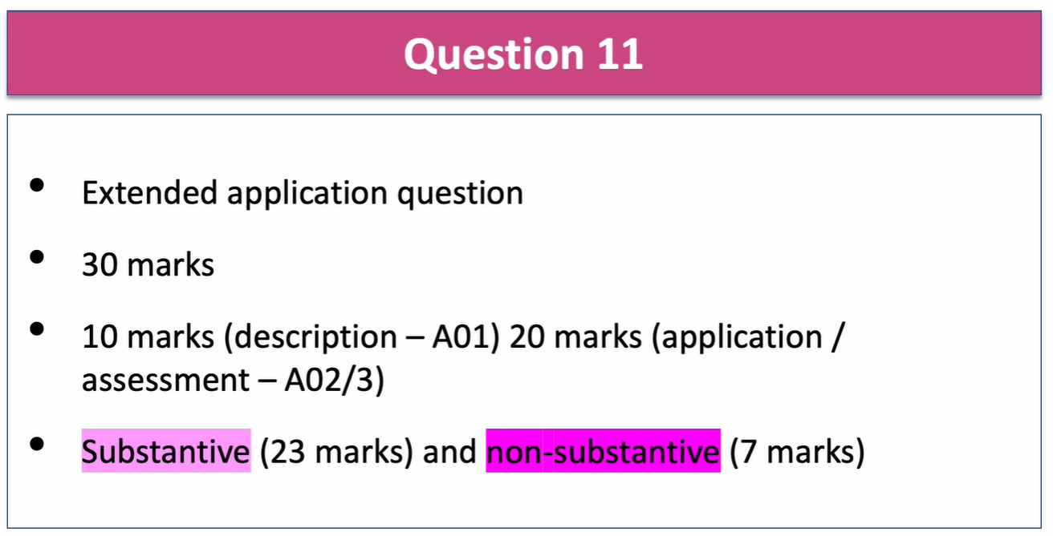

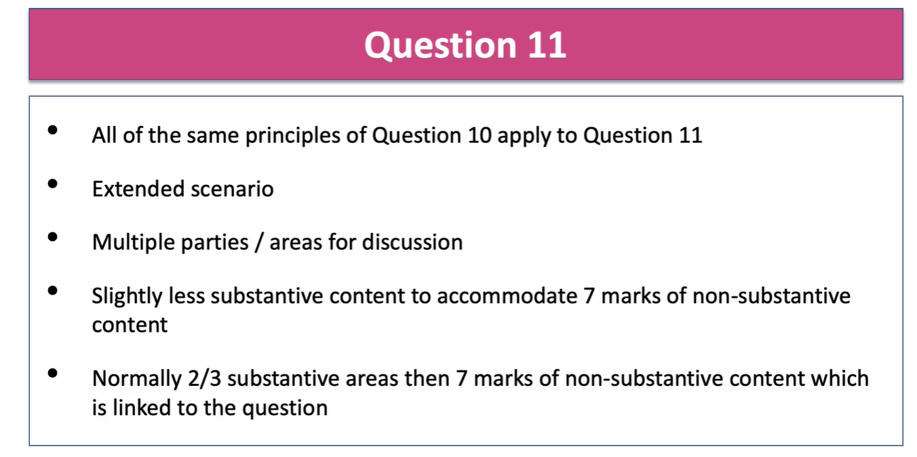
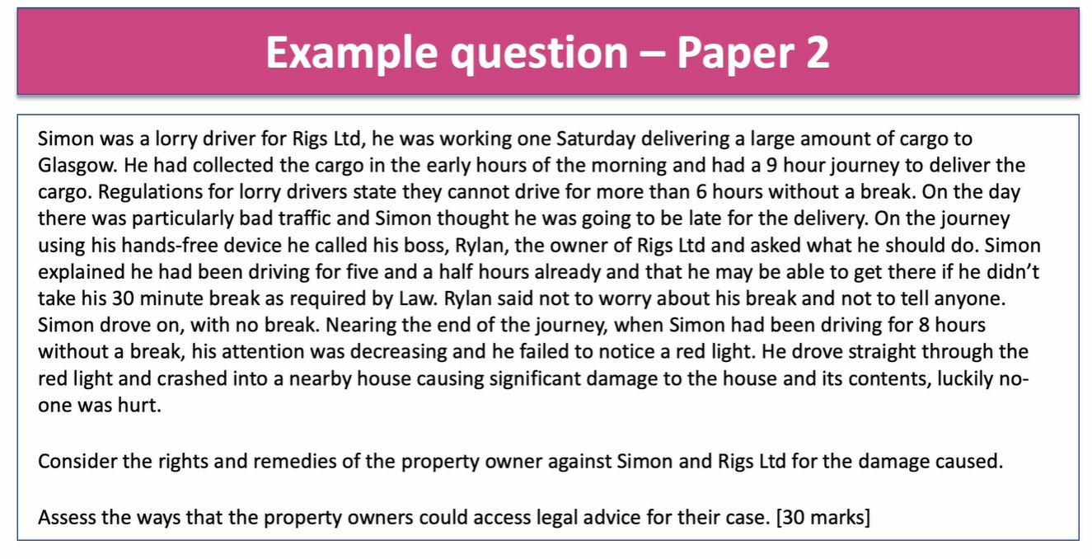

Over the last few months Harry and Isobel’s relationship had become increasingly strained as Harry’s behaviour had become unpredictable and often violent towards her. One evening, Isobel read a message on Harry’s phone from her sister. The message read ‘thank you for a wonderful evening, darling’. Isobel confronted Harry, who laughed at her. He said, “I’m moving out to live with your sister anyway. You can look after the kids because I don’t want them”.
Harry drank a few more beers but before he went to bed he told Isobel that he would beat her up in the morning. About an hour later, when Harry was asleep, Isobel was furious about the events of the evening and the threat he had made to her. She was also worrying about what would happen the next morning. Isobel took a kitchen knife and stabbed Harry several times, before fleeing from the bedroom and calling for an ambulance. Harry was rushed into hospital but a junior doctor gave him the wrong type of blood in a blood transfusion and Harry died.

11. Consider Isobel’s criminal liability for the murder of Harry.
Assuming that Isobel is found guilty, assess the sentencing powers available to the court. (30)

- Read scenario.
- Underline and annotate potential criminal offences.
- Underline and annotate any legal principles (eg causation/possible defences)
- Murder (AR + causation+ MR)
- Causation? Is there a intervening act? Eg bad medical treatment
- Loss of control defence
- Sentencing powers of court if convicted of murder/voluntary manslaughter etc
- IDEAS
- 40 mins
- Do question 10/11 first
This is a top band paragraph to the question looking at the loss of control defence
I- However in order to reduce her liability, Isobel may rely on the defence of a loss of control. Loss of control is a partial defence to murder which would reduce the conviction to voluntary manslaughter.
D- For a defence of loss of control to be successful, Isobel would need to prove that she lost control, the loss of control had a qualifying trigger and that a person of Isobel’s sex and age, with a normal degree of tolerance and self-restraint, might have reacted in the same or a similar way to Isobel. All these points need to be proved or the defence will fail.
E & A: Loss of control refers to the loss of the ability to act with considered judgement or normal powers of reasoning (R v Jewell). This is evident when Isobel stabs Harry several times with a knife as he has clearly lost her judgment. There has to be a “trigger” for the loss of control. S55 sets out two key triggers which are permitted; the defendant’s fear of serious violence from the victim or there was something done to the victim that constituted circumstances of an extremely grave character; and caused the defendant to have a justifiable sense of being seriously wronged (S55(4) The fact that Harry had been violent before and had threatened to beat up Isobel in the morning could be sufficient for the first trigger as Isobel may have been scared of being hurt so she stabbed him first. Harry had also told Isobel he was having an affair with her sister and that he was leaving the kids with her. Sexual infidelity is not enough on its own for a defence of loss of control but it can be taken into account, providing there are other trigger factors as well that lead to a defendant feeling justifiably wronged (R v Clinton) In this case, the fear of violence combined with the sexual infidelity and the comments about leaving the children with Isobel would almost certainly be enough for the qualifying trigger threshold to be reached.
Isobel would also need to prove that a personal of Isobel’s age and sex, with a normal degree of tolerance would have acted in the same way. When confronted with these facts, the courts may decide that a normal person would have lost control but a reasonable person wouldn’t have stabbed Harry several times (Van Dongen) If this is the case Isobel may still be liable for murder
Summarise: Isobel will certainly be found guilty of murder but her conviction is likely to be reduced to voluntary manslaughter if the courts decide that a reasonable person would have acted in a similar way.

DON’T FORGET THE ASSESS PART!
If Isobel is found guilty of murder, the courts will have to give her a mandatory life sentence. The judge will give out a minimum term she must serve before she is eligible for parole. Usually this is about 15 years and will be based on the aggravating and mitigating factors
If Isobel’s murder charge is reduced to voluntary manslaughter, the maximum sentence the judge can hand out is a discretionary life sentence. It would be likely though that this would be significantly less than a life sentence though as there were a number of mitigating factors. The judge may even give Isobel a community order instead of a custodial sentence.
The verdict would therefore have a huge impact on Isobel’s sentence

Qu09 non-substantive + substantive/non-scenario (15 marks)

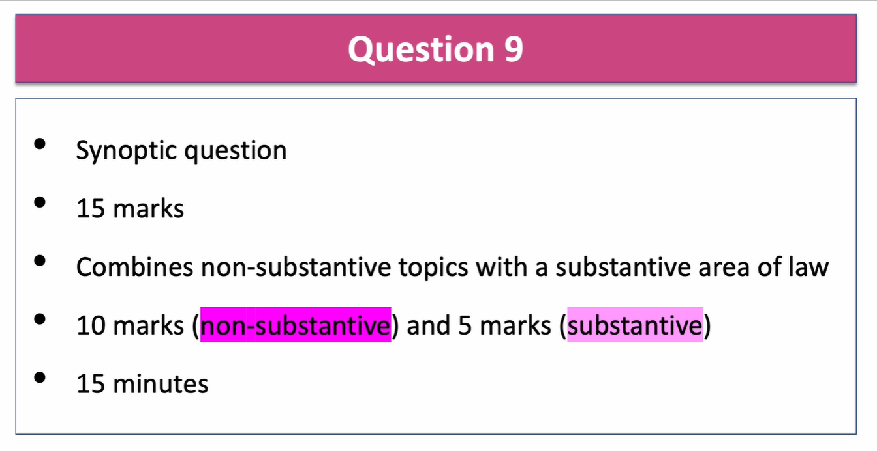

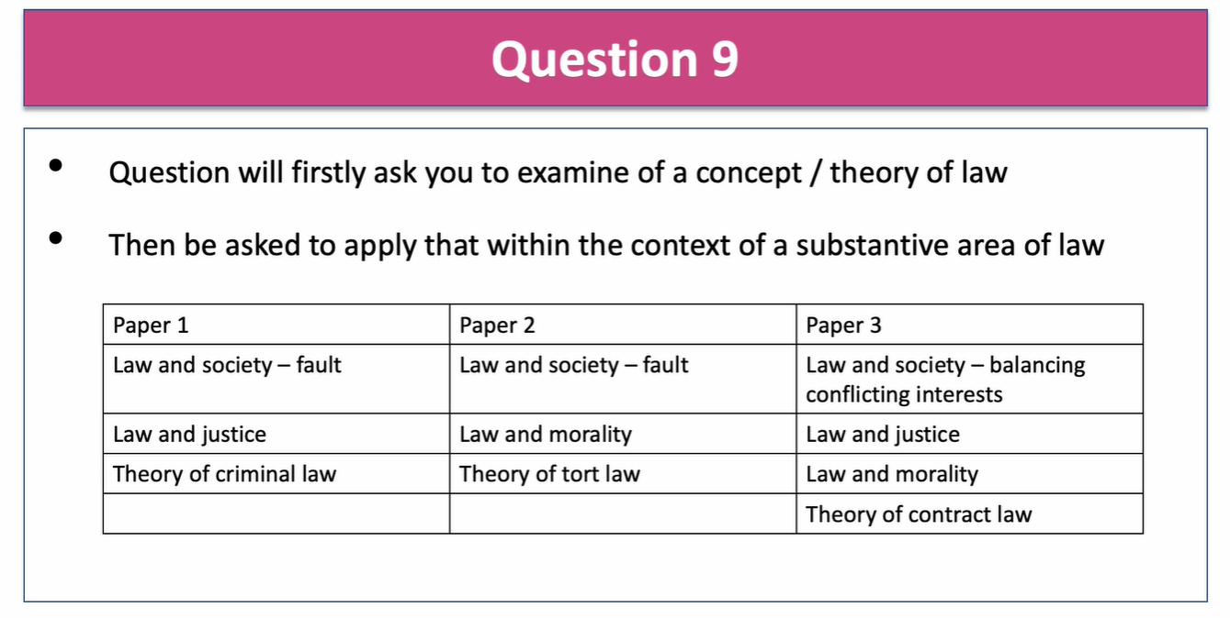
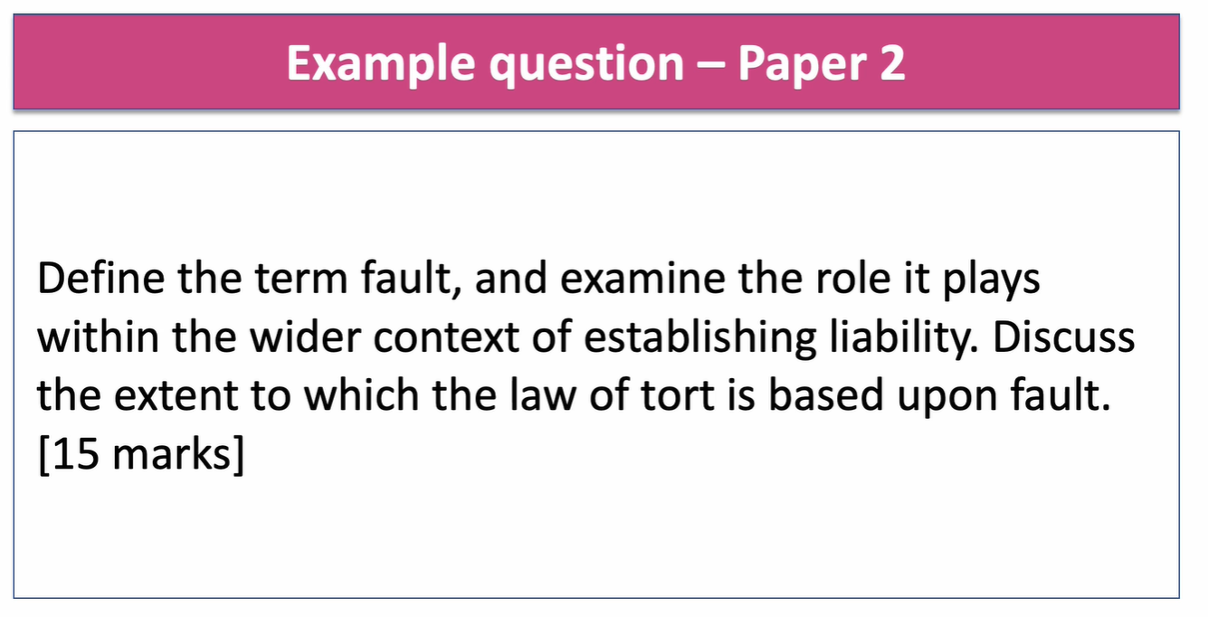
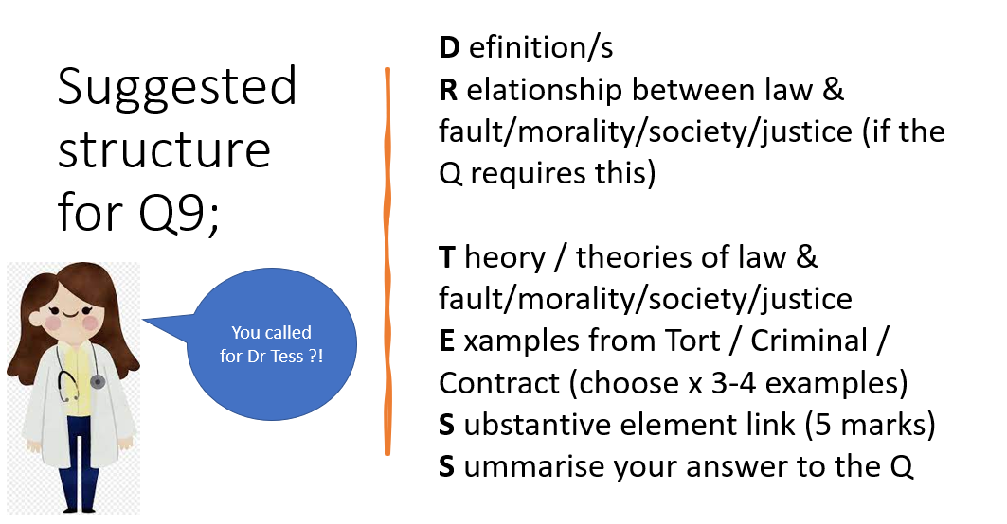

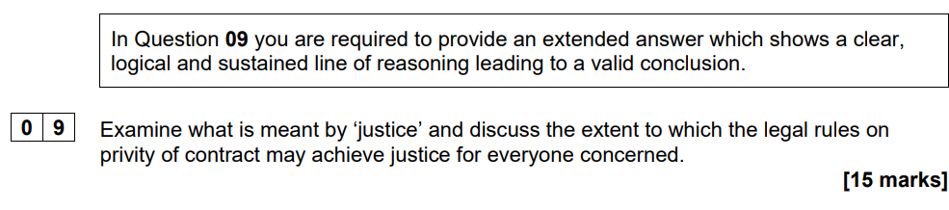
Justice is a concept that can be described simply by a synonym such as fairness, equality or even handedness.
There is a strange relationship between the law and justice, the legal system strives to achieved justice, however, justice is not always synonymous with law; it is possible for a law to be unjust and viewed as immoral as per Re A (conjoined twins). Some laws are not viewed as just such as strict liability offences and some laws don’t give justice eg R v Gotts (1991) A boy who killed because he was threatened by his father was convicted of murder as duress wasn’t available
There are several theories which help to give meaning to the term justice but do not fully explain it.
Distributive justice is concerned with the fair allocation of benefits and responsibilities in life and is a form of justice articulated by Aristotle. Aristotle believed in the ideal of achieving proportion according to each person’s individual claim. The allocation of resources should not be determined by need but by contribution. This view of justice is one similarly shared by Karm Marx. An example of distributive justice founded upon the idea of proportionality within the legal system is the sentencing proportionate to fault, for example the difference between sentences for s18 and s20 GBH, also the process of enforcing fines in accordance with earnings.
Aquinas believed in the natural law of justice, a belief that the law derives from a divine source which is superior to man-made law and is based on moral rules. Laws could be unjust if the law is contrary to the human good, which would mean it was not a true law at all. A law could also be unjust if goes against God’s will. Diane Pretty’s case on euthanasia would potentially be termed unjust by many and also goes against the commandment of thou shall not kill.
Utilitarianism is a philosophy on justice that developed in the 19th century, largely based upon the writings of Jeremy Bentham and John Stuart Mill. According to a utilitarian, justice is the ‘greatest happiness of the greatest number’. An example of utilitarianism in practice is Sarah’s Law, this law created a Child Sex Offender Disclosure Scheme, which allows parents, carers and guardians to ask the police to tell them if someone has a criminal record for child sexual offences. Arguably here the benefit of society generally, outweighs the personal freedom of the individual whose detaisl are being disclosed.
Corrective justice is sometimes known as restorative justice and is when the law restores the imbalance between two individuals or an individual and the state.
There is a clear system in place in criminal law which allows defendants to appeal. In criminal cases heard in the Magistrates Court defendants may appeal against conviction or sentence on a point of law but an appeal may lead to a more severe sentence. Under the CJA (1998) the prosecution may appeal against Unduly lenient sentences. The Court of Appeal will also retry cases where new evidence comes to light. This means that many cases achieve justice even after a wrongful conviction although there are still miscarriages of justice where innocent people have spent years in prison for crimes they didn’t commit.
Justice can be seen to be done in various aspects of the law, both procedurally and substantively.
Procedurally, the jury system allows for all indictable offences to be tried by a group of randomly sampled and objective peers, this ensures that a defendant’s right to a fair trial.
The law of defences creates justice because it recognises that there are circumstances which excuse what would otherwise amount to criminal conduct, this effectively balances the interests of the different party’s thus achieving proportionality and distributive justice. For example, self-defence is available and can exonerate a defendant’s liability where it is proved that their use of force is necessary and objectively reasonable.
Traditionally a person could not sue unless they were party to the contract. The Rights of 3rd Parties Act 1999 – allows third parties to enforce rights to prevent injustices Jackson v Horizon Holidays 1975. Someone who is not party to a contract (a third party) may enforce the contract if…
1.The third party is mentioned by name in the contract
2. The contract expressly provides that the third party may enforce the contract
3.The contract term is an attempt to confer the benefit of the term on the third party
This Act may seem to give justice to everyone concerned but in consumer contracts, there are often rights where goods are bought for someone else. Often the parties to the contract have the right to exclude the act from benefitting a third party. Most commercial contracts now include such a term so the Act is not as useful as might be hoped in achieving justice.

Super curricular Guide
- Exploring Law: Studying Law at University, an innovative, open-access online course designed by the Faculty of Law primarily for 16 to 18-year-olds who are considering studying law at university in the UK.
- Cambridge University HE+, online resources for subject exploration developed by Cambridge academics;
- Public Law for Everyone, blog exploring public law ideas in plain English, written by Cambridge Law Professor Mark Elliott;
- Law in Focus, video series from the Faculty of Law;
- Attend a local courtroom session, which are free and open to the public;
- Work experience may be an interesting way for you to view the legal profession, but it is not in any way expected.
- Check out our Think Cambridge Law blog for supercurricular suggestions to help get you started

Compete in law competitions
- Robert Walker Essay Prize
- The Cambridge Centre for Animal Rights Law Essay Competition
- The John Locke Institute Essay Competition

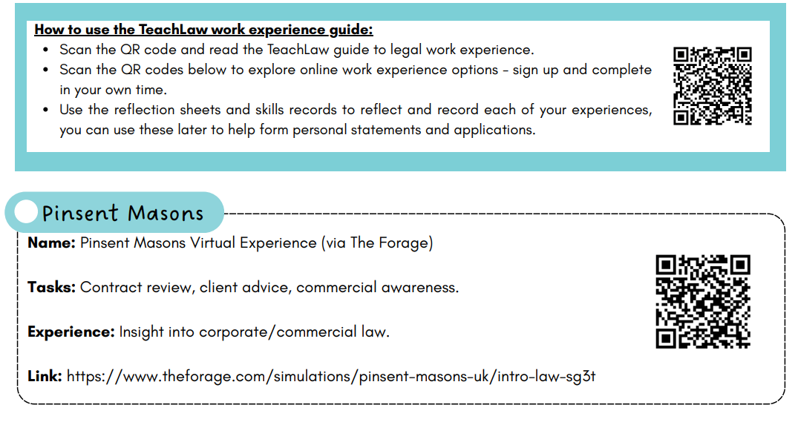
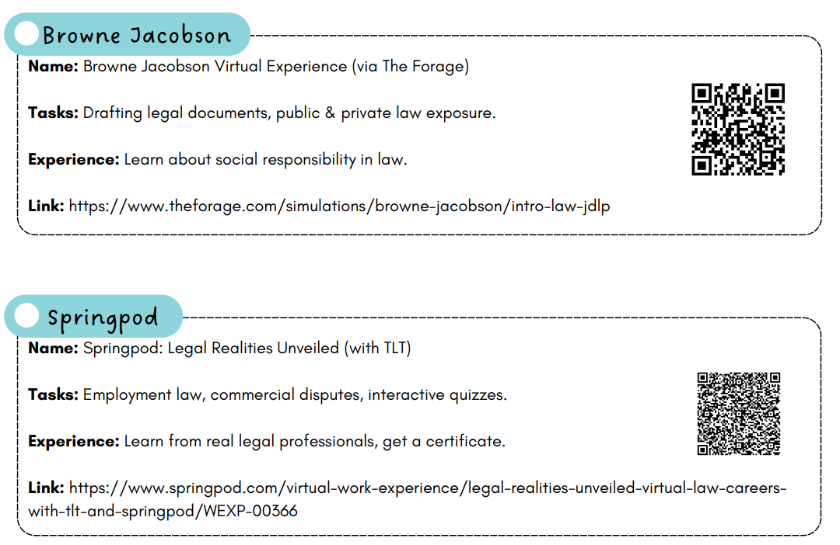

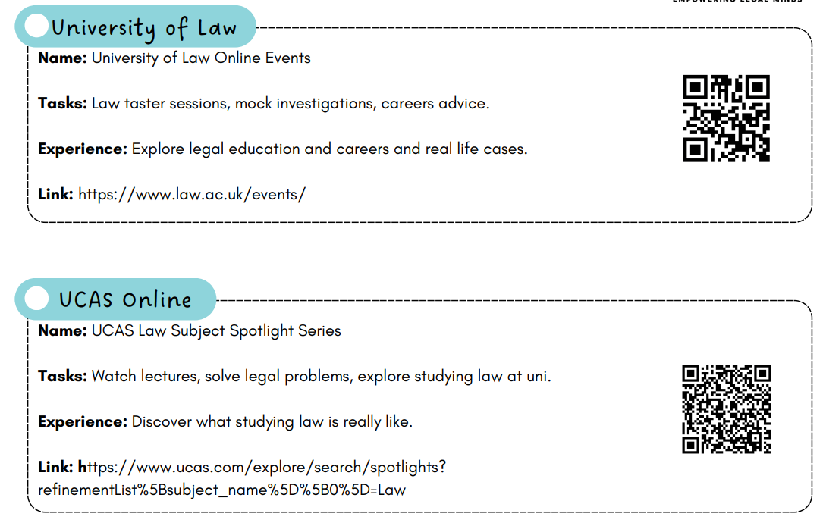

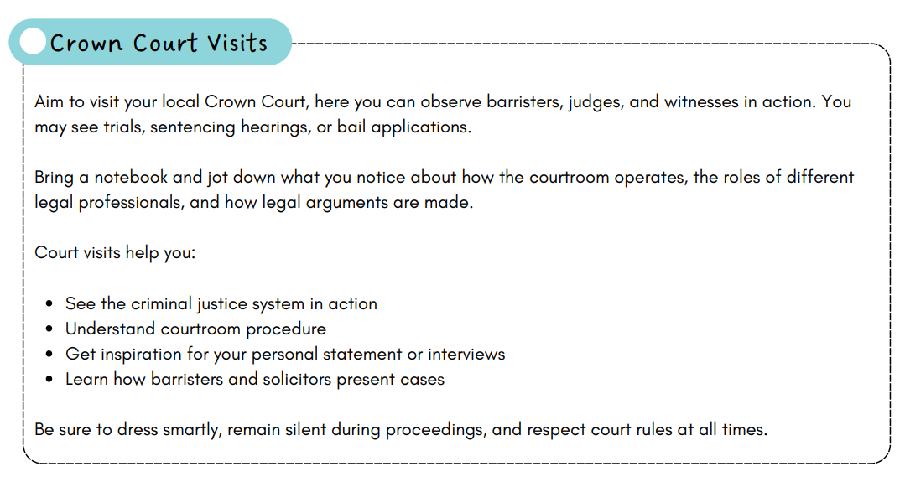

Notes

