
A LEVEL CHEMISTRY
HANDBOOK
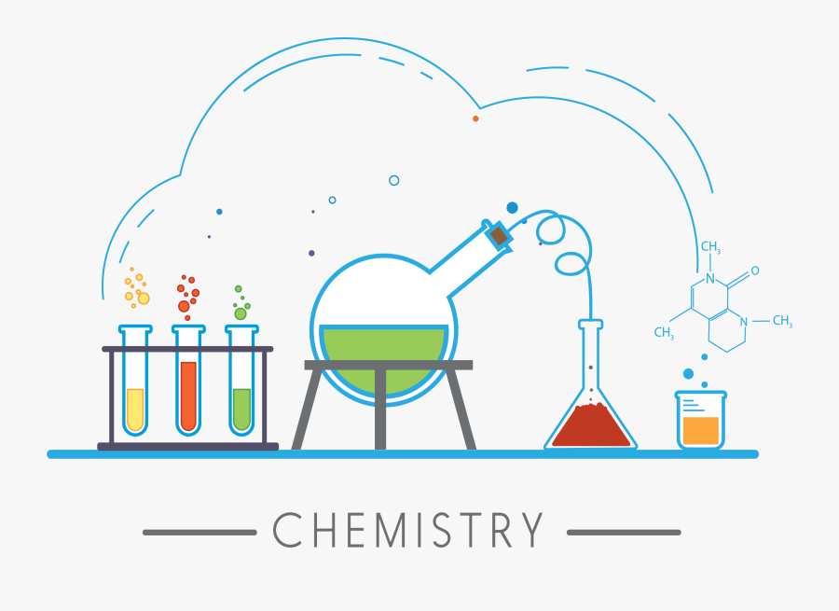
Name

Contents

Introduction to the course 3
Equipment 5
Textbooks 5
What you need to do to succeed 5
Homework and Marking Policy 6
How to revise for Chemistry 7
Additional resources and reading list: 13
Course Skills 14
Why study Chemistry? 14
Exam advice 15
OCR Chemistry Command words 17
How to answer the different types of questions in Chemistry 18
Super curricular Guide 21

Introduction to the course
A Level Chemistry (OCR H432) provides a comprehensive understanding of the behaviour of substances, the principles that govern chemical reactions, and the experimental techniques used to study the material world. You will explore the foundations of physical, inorganic and organic chemistry, developing analytical, mathematical and practical skills essential for higher-level scientific study. This handbook supports your learning across modules such as Foundations in Chemistry, Chains, Energy and Resources, and Rings, Polymers and Analysis, helping you connect theoretical ideas to real-world applications in fields such as medicine, materials science, and environmental chemistry.
The course is divided into three main components as outlined below:

1. Foundations in Chemistry
This section introduces the core ideas that underpin all later chemistry topics. Students will gain confidence in essential skills such as:

Atoms, compounds and reactions
Content typically includes:
- Atomic structure and electron configuration.
- The periodic table and trends in elements.
- Chemical bonding (ionic, covalent and metallic) and intermolecular forces.
- Types of chemical reactions and equations, including redox processes.

Amount of substance
Students learn the quantitative side of chemistry, including:
- The mole and molar calculations.
- Empirical and molecular formulae.
- Reacting masses, gas volumes and concentration calculations.

Acids, bases and redox
This usually covers:
- Properties of acids and bases, neutralisation reactions and titrations.
- Oxidation, reduction and redox equations.
- Practical skills in volumetric analysis.

2. Chemistry in Depth: Physical and Inorganic Chemistry
This part builds on the foundations to explore the principles that determine chemical behaviour.

Physical chemistry
Students study the forces and energy changes involved in chemical reactions, including:
- Enthalpy changes and calorimetry.
- Reaction rates and the factors affecting them.
- Chemical equilibrium and Le Chatelier’s principle.
- Equilibrium constants (Kc and Kp).
- Electrochemistry and standard electrode potentials.

Inorganic chemistry
This area focuses on the structure and reactivity of elements across the periodic table, including:
- Periodicity and trends in groups and periods.
- Properties and reactions of Group 2 and Group 7 elements.
- Transition metals: complex ions, redox behaviour and catalyst properties.
- Qualitative analysis and identification of ions.

3. Organic Chemistry and Analysis
Students investigate the chemistry of carbon-based molecules and the analytical techniques used to identify substances.

Basic organic principles
This generally includes:
- Naming organic compounds and understanding functional groups.
- Reaction mechanisms (nucleophilic substitution, electrophilic addition, elimination).
- Isomerism, including structural and stereoisomerism.

Developing organic chemistry
Students learn how simple molecules can be built into more complex structures:
- Alcohols, haloalkanes and alkenes.
- Aldehydes, ketones, carboxylic acids and esters.
- Aromatic chemistry, amines and polymers.

Analytical techniques
This section focuses on how chemists determine the identity and structure of molecules:
- Infrared (IR) spectroscopy.
- Mass spectrometry (MS).
- Nuclear magnetic resonance (NMR) spectroscopy.
- Chromatography and combined analytical methods.

Equipment
You must bring the following to all lessons:
• Stationary - Pen, pencil, rubber, ruler etc. and a scientific calculator
• Exercise book and practical book (when required)
• Textbooks and Workbooks as prescribed
• Data sheet (provided later)

Textbooks
The textbook required for your course
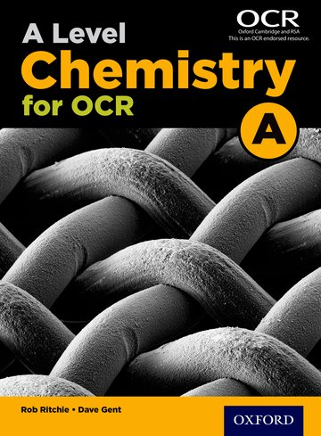
Prescribed Textbook:
A Level Chemistry for OCR - Rob Ritchie and David Gent

What you need to do to succeed
Attend 100% of classes and arrive punctually for each class.
• Ask if you do not understand any part of the work.
• Revise your notes thoroughly each week.
• Read and research each topic whenever the opportunity arises.
• Contribute in class – your opinions and ideas are valuable.
• If you are going to be absent or late for an unavoidable reason, please email/call your tutors in
advance.
Folder Check
You need to organise your Chemistry folder using the checklist below
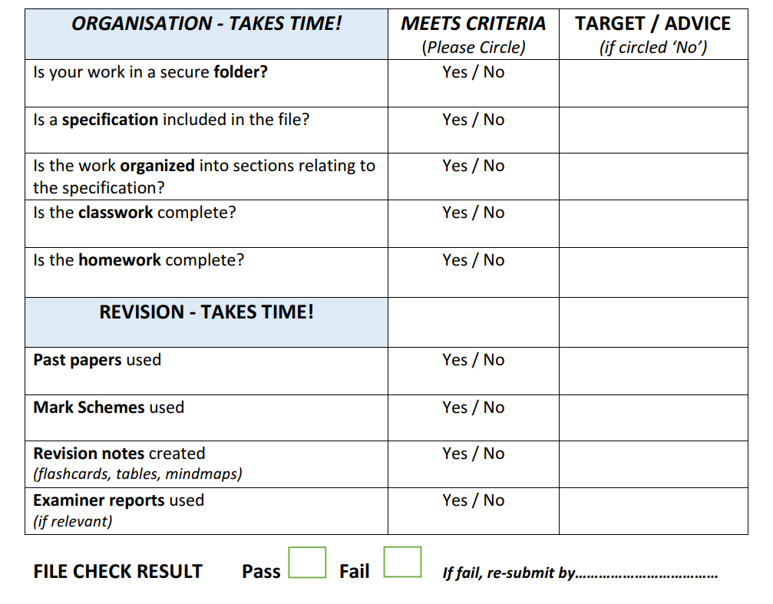

Homework and Marking Policy
Your teachers will set between 2-3 hours of homework per week. You will be expected to complete all homework, pre-reading and learning prep when it is due in. All homework will be set on Teams.
In addition you will be expected to complete 2-3 hours of independent work as well. The most successful students complete on average five hours of work per subject per week (including homework)
What does independent study look like?
- Making notes
- Organising your folder
- Research
- Reading
- Completing homework
- Revision techniques
- Creating revision resources
- Practising past questions
A level Chemistry you will complete a formal assessment at the end of each topic, which will be formally marked by teachers. This is in addition to the work you are completing outside of lessons.
You will be expected to correct all assessed work using green pen to improve exam technique.

How to Revise for A-Level Chemistry
Revising for A-Level Chemistry can sometimes feel demanding due to the quantity of content, the range of calculations, and the level of precision expected in your answers. You are required to understand fundamental principles, apply chemical concepts to unfamiliar situations, recall essential equations and mechanisms, and produce accurate, well-structured responses under timed exam conditions.
However, revision does not need to feel overwhelming. With a systematic, evidence-based approach, you can strengthen your understanding, improve long-term memory of key content, and significantly enhance your exam performance.
In this guide, we will explore the importance of revision, outline core memory principles that support effective learning, examine proven revision strategies, and show how these apply specifically to OCR A-Level Chemistry at Longsands Academy.

Why Students Need to Revise in Chemistry
Even if a concept makes sense in class, your brain will not retain that information long-term unless you revisit it. Chemistry contains many interlinked ideas — such as bonding, equilibria, organic mechanisms, redox, and spectroscopic interpretation — and these need repeated retrieval to remain accessible.
Understanding something once does not guarantee you can recall it quickly in an exam. Without revisiting topics, your memory fades. Revision strengthens your long-term memory so that, under exam pressure, you can accurately recall:
- definitions (e.g., enthalpy change, electronegativity)
- key equations and mathematical methods
- organic mechanisms and reagent conditions
- trends in groups and periods
- steps in practical procedures
- spectroscopy interpretation methods
This quick and accurate recall is often the difference between a good grade and an excellent one.
Chemistry exams reward students who can not only remember content but also apply it to unfamiliar situations — something that requires strong, well-organised memory.

How Memory Works (and Why This Matters When Revising Chemistry)
To revise effectively, it helps to understand what your brain is doing when you learn new content.
When you meet new material in class — for example, the mechanism for nucleophilic substitution — it first enters your working memory. Working memory is like a temporary mental workspace: limited and easily overloaded. If you do not actively process the information, it fades rapidly.
Your goal when revising is to shift information from working memory into long-term memory, where it becomes more durable. Crucially, information does not enter long-term memory simply by re-reading notes or watching videos — these create a feeling of familiarity, not actual learning.
Information becomes stored in long-term memory when you effortfully retrieve, process, and reuse it.
Even once stored, you must still practise recalling it when needed. In an exam, your brain must quickly pull equations, mechanisms, and reasoning steps from long-term memory back into working memory so that you can apply them clearly and accurately.
This is why active recall is one of the most powerful revision strategies for Chemistry. When you test yourself — by doing past paper questions, using flashcards, drawing mechanisms from memory, or solving unfamiliar calculation problems — you strengthen both the memory and the speed of retrieval.
In summary:
- Revision moves information into long-term memory.
- Active recall allows you to bring it back out when needed.
Passive revision techniques (re-reading, highlighting, watching videos) may feel productive but do not prepare you for the demands of Chemistry exams, where retrieval and application are essential.

Example: Applying This When Revising Organic Mechanisms
Imagine a student, Sam, revising organic chemistry — specifically nucleophilic addition to aldehydes and ketones.
In class, Sam understands the steps. Initially, this information is in working memory. If Sam only re-reads the notes later, it will fade.
Instead, Sam uses active recall:
- Draws the mechanism from memory, including curly arrows, charges, and intermediate species.
- Uses flashcards for reagents, conditions, and functional group tests.
- Blurts everything known about the reaction onto a blank page, then checks for missing elements.
- Practises exam-style questions, such as:
“Outline the mechanism for the reaction between propanal and CN⁻.”
- Applies understanding to unfamiliar molecules to build flexibility.
Each time Sam recalls or uses the mechanism, the memory becomes stronger.
So when faced with an exam question such as:
“Outline the mechanism for the reaction between ethanal and HCN.”
Sam can instantly recall:
- The key steps of the mechanism
- Correct curly-arrow notation
- Reagents and conditions
- The name and structure of the product
allowing for a clear, accurate, high-quality response.
This is the exact skill set needed for success in OCR A-Level Chemistry at Longsands Academy.

Effective Revision Techniques (and Why They Work) – A-Level Chemistry at Longsands Academy
The most effective revision techniques are those that actively engage your brain, strengthen long-term memory, and closely mirror what the OCR Chemistry exams expect you to do. For chemistry, the most powerful methods include active recall, spaced practice, and regular practice with exam-style calculation and mechanism questions, followed by clear feedback.
Below are the key revision tools that work especially well for A-level Chemistry.

Mind Maps
A mind map is a visual tool that organises information around a central topic.
For chemistry, you might put “Enthalpy Changes”, “Organic Mechanisms”, or “Group 7” at the centre, then create branches for:
- Key definitions (e.g., standard enthalpy change of formation)
- Required equations
- Experimental methods (e.g., calorimetry)
- Trends and explanations
- Examples of reactions
- Common exam pitfalls
Mind maps are effective because they:
- Help you see how concepts connect
- Highlight the structure of a topic
- Allow your brain to recall information visually
- Force you to summarise and prioritise what matters
They are especially useful in chemistry for topics like periodicity, organic pathways, energetics, and redox reactions.

Summary Sheets
One-page summary sheets are an excellent way to condense complex chemistry content.
Whatever the topic — Bonding, Kinetics, Equilibrium, Infrared Spectroscopy, Halogenoalkanes — you should aim to reduce your notes to a single A4 page using concise bullet points and diagrams.
A strong summary sheet might include:
- Reactions and reagent/condition summaries
- Essential equations (e.g., Kc, pH, Gibbs free energy)
- Mechanisms in simplified form
- Colour changes and test results
- Key definitions (always tested!)
- Typical exam questions for that topic
Summary sheets give you a clear overview, reduce overwhelm, and are perfect for quick review. Many students photograph them so they can revise whenever they have a few minutes spare.

Flashcards
Flashcards involve a question or prompt on one side and the answer on the other.
For chemistry, flashcards are particularly powerful for:
- Definitions (e.g., electronegativity, rate-determining step)
- Organic mechanisms (name + conditions on one side; steps on the other)
- Spectroscopy features (e.g., IR peaks, NMR splitting patterns)
- Reagents and conditions
- Colour changes and ion tests
- Calculation steps or key equations
Flashcards work because they require active recall: you must retrieve the answer from memory rather than simply recognise it. This strengthens memory pathways and improves long-term retention — crucial for chemistry exams where precision matters.
Digital flashcard apps (e.g., Anki) also allow spaced repetition, which automatically schedules cards for maximum retention.

Blurting
Blurting is a self-testing technique where you cover your notes and write everything you can remember about a topic from scratch.
For example, you might choose “Equilibrium” or “Alcohols and Oxidation”, set a timer, and write:
- Definitions
- Key equations
- Conditions
- Colour changes
- Mechanisms
- Trends
- Worked examples
Then compare your blurt to your notes and highlight the gaps in a different colour.
Blurting is powerful because it:
- Tests pure recall from long-term memory
- Quickly exposes weaknesses
- Helps you structure your thinking without relying on notes
- Builds exam-style recall under time pressure
This method is ideal for challenging topics such as energetics, equilibria, and spectroscopy.

Practice Exam Questions
Practising real chemistry exam questions is one of the most important components of successful revision.
In chemistry, this means answering:
- Structured calculation questions
- Multi-step mechanism questions
- Interpretation questions using unfamiliar contexts
- Data analysis problems
- Extended responses about trends or energetics
- Questions using spectroscopic data (IR, MS, NMR)
Practising exam questions improves:
- Timing
- Structure
- Use of correct chemical terminology
- Mathematical fluency
- Ability to apply knowledge to new situations
- Familiarity with common OCR question styles
Chemistry rewards students who practise enough that calculations and mechanisms become automatic and precise.

Marking Your Work
Marking your own work against:
- Mark schemes
- Model answers
- Examiner’s reports
- Teacher feedback
helps you understand exactly what examiners want and where you are losing marks.
When you mark your work, you should:
- Identify missing steps in calculations
- Correct incomplete explanations
- Add precise chemical terms (e.g., “lower activation enthalpy”)
- Improve mechanism diagrams
- Fix errors in units or significant figures
- Add corrections in a different colour
Self-marking accelerates improvement and builds exam confidence.

A Step-by-Step Revision Cycle
Use this cycle for any topic in A-level Chemistry:
- Check the specification list to ensure you understand every part of the topic.
- Turn your notes into summary sheets, flashcards, or a mind map.
- Learn from them using active recall (test yourself, say ideas aloud, cover and repeat).
- Blurt the entire topic onto a blank page.
- Compare your blurt to your notes, filling gaps in a different colour.
- Complete a practice exam question on that topic.
- Mark your answer, adding corrections and improvements.
- Improve your exam technique by reading relevant Examiner’s reports.
Repeat this cycle regularly to build strong long-term memory, faster recall, and exam-ready confidence.

Additional resources and reading list:
Listed below are a range of resources you might find helpful to support your psychology study – these will suit a variety of different learning styles and preferences.
Websites:
- www.chemguide.co.uk
- MaChemGuy website (also on Youtube)
- Physics & Maths Tutor
- 2. OCR Revision Guides | chemrevise

Introductory and Accessible Chemistry Reading

1. The Elements — Theodore Gray
A visually stunning introduction to the periodic table. Each element is presented with photography, uses, and real-world context. This book helps build familiarity with trends, properties and applications — ideal for students who want to understand periodicity beyond abstract theory.

2. Moles: The Chemistry of Numbers — Peter Atkins
A short, readable guide that explains one of the most important ideas in chemistry: the mole. Clear explanations reinforce A-level quantitative chemistry and help students feel more confident with amount-of-substance calculations.

3. What is Chemistry? — Peter Atkins
A concise yet engaging exploration of the key foundations of chemistry, including structure, bonding, and energy. Excellent for strengthening Year 12 knowledge in a clear, accessible way.

Course Skills
This qualification:
- develops competence in applying chemical principles across the OCR A Level Chemistry course, including physical, inorganic and organic chemistry, as well as essential mathematical, analytical and practical skills.
- requires learners to analyse chemical data, unfamiliar scenarios, and experimental results, identifying the relevant concepts—such as bonding, energetics, equilibrium, redox, mechanisms, or spectroscopy—and applying them accurately.
- requires learners, when constructing explanations, to use precise chemical terminology and to support their reasoning with balanced equations, mechanisms, enthalpy profiles, particle-level explanations, or referenced experimental evidence as appropriate.
- requires learners, for every topic they study (such as bonding, energetics, kinetics, organic mechanisms, periodic trends, redox chemistry and analytical techniques), to break down concepts into key components and apply them logically to both theoretical and real-world chemical contexts. Evaluation may involve analysing experimental methods, discussing sources of error or uncertainty, comparing models, or justifying why certain conditions or reagents are used.
- requires learners to produce clear, concise and logically structured chemical arguments, supported by appropriate calculations, diagrams, mechanisms and scientific reasoning.

Why study Chemistry?
A-level Chemistry students develop valuable skills such as:
- applying chemical theories to explain observations and predict outcomes
- solving multi-step calculations with precision
- analysing and interpreting experimental data
- evaluating practical methods and identifying sources of error
- constructing mechanisms and balanced equations
- using scientific models to explain trends, patterns and behaviours
Studying A-level Chemistry offers many benefits: it links strongly to everyday life—materials, medicines, fuels, climate science—and complements subjects such as Biology, Physics, Mathematics and Geography. It also helps students develop highly transferable skills, including problem-solving, quantitative reasoning, critical thinking, logical communication, attention to detail, practical competence and data analysis.
Chemistry is a valued qualification for a wide range of future pathways. It is essential for careers in medicine, dentistry, veterinary science, chemical engineering, biochemistry, pharmacology and materials science, but it is also respected in fields such as finance, law, computing and environmental science because of the rigorous analytical skills it develops.

Exam Advice – OCR A Level Chemistry A
OCR A Level Chemistry A is assessed through three written examination papers at the end of Year 13. Together, these papers test your understanding of physical, inorganic and organic chemistry, as well as your ability to apply chemical principles, carry out calculations, analyse data and interpret experimental and spectral information.
All three papers include a mixture of multiple-choice questions, short structured calculations, data-response items and extended written answers. Questions often require you to apply your knowledge to unfamiliar contexts, analyse experimental results, or justify chemical reasoning with appropriate terminology.

Paper 1: Periodic Table, Elements and Physical Chemistry
This paper assesses content from Modules 1, 2, 3 and 5, focusing on:
- foundations in chemistry (atomic structure, bonding, redox, moles)
- periodicity and Group chemistry
- energetics, kinetics and equilibria
- electrochemistry and transition metals

Paper 2: Synthesis and Analytical Techniques
This paper covers Modules 1, 2, 4 and 6, with emphasis on:
- organic chemistry (mechanisms, functional groups, reactions and synthesis pathways)
- polymers, aromatic chemistry and organic analysis
- analytical techniques including IR, MS, and both ¹H and ¹³C NMR spectra

Paper 3: Unified Chemistry
This synoptic paper draws on all six modules and tests your ability to link ideas across the course. Questions often integrate physical, inorganic and organic chemistry within the same problem. Unified Chemistry demands:
- flexible application of knowledge
- confident manipulation of data
- evaluation of experimental methods
- clear chemical reasoning across multiple topics
This paper rewards students who understand the connections between concepts and can think beyond memorised facts.

Assessment Objectives (AOs)
Across all three papers, marks are allocated according to the following assessment objectives:
- AO1 – Demonstrate knowledge and understanding of chemical facts, terminology, theories, practical techniques and procedures.
(e.g., definitions, equations, trends, mechanism steps)
- AO2 – Apply knowledge and understanding to analyse and solve chemical problems, including interpreting data, justifying conditions, or predicting outcomes.
(e.g., using equilibrium concepts in unfamiliar contexts, analysing spectra, applying redox rules)
- AO3 – Analyse, interpret and evaluate scientific information, experimental methods, and evidence.
(e.g., discussing uncertainties, evaluating practical techniques, assessing reliability, comparing synthetic routes)
Strong exam performance typically requires a balance of these skills: secure knowledge (AO1), accurate application (AO2) and clear analysis/evaluation (AO3).

Further advice and exam papers can be found on the link below:
https://www.ocr.org.uk/qualifications/as-and-a-level/chemistry-a-h032-h432-from-2015/specification-at-a-glance/

OCR A-Level Chemistry Command Words

Identify / Name / State / Give

Recall a chemical fact, term, equation, or feature; usually a short, precise answer (e.g., name a reagent, give an oxidation state, state a colour change).

Describe / Outline

Provide a clear account of a process, trend or method, covering the essential points.
Examples include describing trends across a period, outlining a practical procedure, or summarising a reaction mechanism in words.

Explain / Explain how / Explain why

Give reasons using chemical principles.
Show how or why something happens by referring to ideas such as bonding, intermolecular forces, collision theory, equilibrium principles, electron transfer, or mechanistic steps.

Apply / Use your knowledge / Refer to the data or scenario

Use your chemistry knowledge to interpret information in the question, such as applying equilibrium principles to a graph, predicting a product from a reaction scheme, or interpreting spectral data.
Often requires linking theory to unfamiliar contexts.

Analyse

Break information or data into components, identify patterns or relationships, and explain their significance.
Examples include analysing titration data, interpreting graphs, or breaking down spectra to identify functional groups.

Compare / Distinguish

Identify similarities and/or differences between chemical concepts, reactions, structures, trends, or methods.
For example, comparing electrophilic addition with nucleophilic substitution, or distinguishing between strong and weak acids.

Discuss

Present key chemical ideas, arguments, or interpretations, often considering more than one viewpoint or factor.
May include reference to conditions, limitations, advantages, disadvantages, or links to data provided.

Evaluate / Assess / Comment / Justify

Judge the quality, effectiveness, or validity of chemical information or methods using evidence.
May require weighing strengths and limitations of a practical method, assessing the reliability of data, commenting on the feasibility of a synthetic route, or justifying reaction conditions or mechanisms with reasoned chemical argument.

How to Answer the Different Types of Questions in OCR A-Level Chemistry A

Multiple-choice questions (MCQs)
- Read the question stem carefully and underline key terms (e.g., most, least, correct, best explanation, oxidised, reduced).
- Eliminate clearly incorrect options using your knowledge of equations, trends, or definitions.
- Look closely at similar options — check oxidation numbers, charges, units, number of moles, and key details in wording.
- Use quick chemical logic: approximate calculations, periodic trends, reagent knowledge, or conservation principles (atoms/charge).

Short-answer AO1 questions (knowledge)
- Command words: identify, name, state, give, outline, describe.
- Provide accurate chemical content: definitions, trends, equations, conditions, observations, colours, or functional group names.
- Match the number of marks: typically one correct, concise point per mark.
- Write clearly using correct chemical terms (e.g., “electrophile”, “enthalpy change”, “oxidising agent”).

Application questions (AO2)
- Command words often say: “use your knowledge”, “refer to the data”, “apply your understanding”, or “predict”.
- First, identify relevant information in the table, graph, spectrum, or scenario (e.g., peaks in IR, splitting patterns in NMR, rate data, equilibrium changes).
- Then directly connect these details to chemical principles:
  - Use bonding or structure to explain trends.
  - Apply Le Chatelier’s principle to predict shifts.
  - Use collision theory to explain rate changes.
  - Apply mechanism knowledge to predict products or intermediates.
- Make the chemical reasoning explicit — don’t assume the examiner will infer your logic.

Evaluation / discussion questions (AO3 – shorter)
- Command words: evaluate, assess, discuss, comment, justify.
- Use structured, concise reasoning:
PEEL-style mini paragraphs work well:
  - Point: State the limitation/advantage or judgement.
  - Evidence: Refer to data, an equation, a principle, or a specific experimental detail.
  - Explanation: Explain why this matters chemically (e.g., precision, yield, purity, equilibrium position).
  - Link: Connect back to the question or conclusion.
- Focus on quality, not quantity — well-developed chemical reasoning scores more highly than many undeveloped statements.

6-mark and 8-mark extended responses
- Usually require a combination of AO1 + AO2 + AO3.
- Aim for:
  - 2–3 AO1 points (definitions, equations, mechanisms, key ideas).
  - 2–3 AO2/AO3 points applying or evaluating knowledge.
- Keep paragraphs focused:
  - One main idea per paragraph.
  - Use equations, diagrams, or mechanisms where relevant.
- Typical topics include: explaining trends, comparing methods, discussing reaction pathways, evaluating practical procedures, or interpreting spectral data.

Extended calculation questions
- Read the whole question carefully — later parts often depend on earlier steps.
- Always:
  - Write the formula you are using.
  - Substitute values clearly.
  - Show each step.
  - Use correct units and significant figures.
- Check for common traps:
  - Converting cm³ to dm³.
  - Using molar ratios.
  - Accounting for limiting reagents.
  - Signs for enthalpy changes.
  - Logarithms in pH calculations.

Mechanism / organic synthesis questions
- Use correct curly-arrow notation.
- Include charges and lone pairs where needed.
- Clearly draw intermediates and products.
- When predicting synthetic routes:
  - State reagents and conditions precisely.
  - Show functional group interconversions.
  - Justify why specific conditions are required.

Spectroscopy and analysis questions
- Break down data step by step:
  - IR → identify key functional groups.
  - MS → use molecular ion peak for Mr.
  - NMR → analyse chemical shift, splitting, and integration.
- Combine clues logically to reach a final structure.
- If asked to annotate spectra, show reasoning clearly (e.g., “triplet → CH₂ next to CH₃”).

Data, practical, and experimental-design questions
- Read any tables, graphs, or procedures carefully and mentally translate them into simple steps.
- Use correct practical terminology:
accuracy, precision, uncertainty, repeatability, reproducibility, control variables, systematic/ random errors, calibration, standard solution, concordant titres.
- When asked to “suggest”, “design”, or “improve” an experiment:
  - Give specific actions (not vague statements).
  - Describe what you would measure, how you would control variables, or how to reduce uncertainty.
  - Refer to realistic apparatus and techniques from the course (e.g., reflux, titration, filtering under reduced pressure, heating to constant mass).

Super-Curricular Guide for A-Level Chemistry Students
• Explore Chemistry: Studying Chemistry at University – Many UK universities offer free online taster courses, sample lectures, and masterclasses covering topics such as reaction mechanisms, spectroscopy, green chemistry, and chemical engineering. These provide a realistic insight into what a chemistry degree involves.
• University outreach platforms – Chemistry departments often host online enrichment materials, problem-solving workshops, and recorded talks on areas like medicinal chemistry, atmospheric chemistry, catalysis, and emerging materials. Platforms similar to HE+ frequently include mini-lectures, challenge tasks, and guided reading designed to stretch sixth-form students.
• Popular science blogs and magazines – Websites from the Royal Society of Chemistry (e.g., Chemistry World), university chemistry blogs, and research digest sites explain current discoveries in accessible language. These are excellent for keeping up to date with developments such as battery technologies, pharmaceutical breakthroughs, or new synthetic methods.
• Chemistry video series and lectures – Many universities and professional chemists publish public talks, outreach lectures, and YouTube videos that explore real chemical research. These may cover NMR spectroscopy, materials science, chemical kinetics, or the chemistry of everyday products. Hearing scientists explain how ideas apply to real-world challenges can deepen your understanding.
• Attend public talks or events – Look for public lectures at nearby universities, Royal Society of Chemistry community events, science festivals, or local STEM societies. Researchers often present on topics such as sustainability, energy storage, drug discovery, polymers, or environmental monitoring.
• Volunteering or experience – Although not required, involvement in science-related activities (STEM clubs, mentoring younger science students, science fairs, laboratory open days, museum volunteering) can help you see how chemistry links to industry, education, and research. Any experience that strengthens your analytical thinking or communication skills is beneficial.
• Super-curricular project ideas – You might write a reflection on a chemistry book or article, keep a research journal of interesting concepts or discoveries, complete an online short course, or investigate a question that links to your A-level content (e.g., “How does NMR distinguish between structural isomers?” or “Which catalysts are used in sustainable industrial processes?”). These activities help deepen your interest, develop independence, and prepare you for future university applications.

