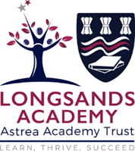
A LEVEL Classics HANDBOOK
Name:
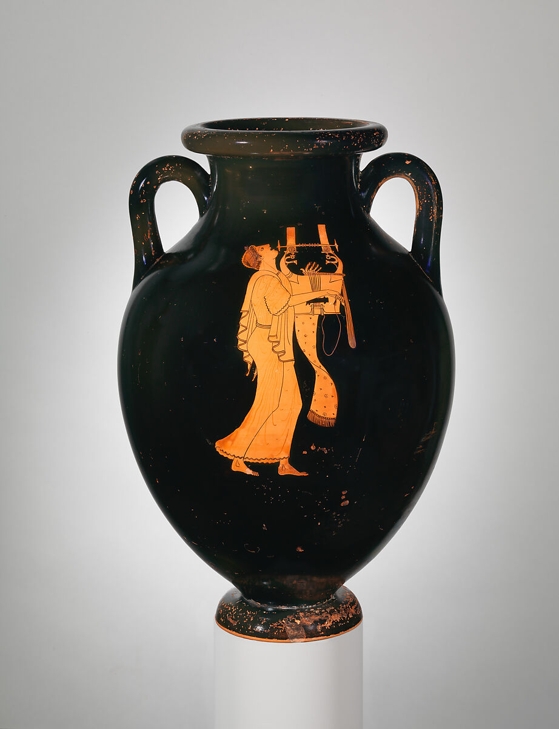

tents
Introduction to the course ………………………………………………………………………………………..3
Equipment and textbooks …………………………………………………………………………………………..4
What you need to do and folder checklist …………………………………………………………………5
Homework and marking policy…………………………………………………………………………………...6
How to revise for law………………………………………………………………………………………………….7-10
Additional resources and reading list ………………………………………………………………………….11
Course skills ………………………………………………………………………………………………………………..12
Exam advice…………………………………………………………………………………………………………………13
Law command words……………………………………………………………………………………………………14
How to answer the different types of questions in law………………………………………………15-30
Super-curricular guide…………………………………………………………………………………………………31-33

Introduction to the Course
A Level Classical Civilisation (OCR H408) provides an in-depth exploration of the literature, beliefs, religious practice, and performance culture of ancient Greece. You will investigate the heroism, rituals, and dramatic spectacle that shaped ancient thought and continue to influence the modern world. This handbook supports your studies in "World of the Hero," "Greek Religion," and "Greek Theatre (Bacchae, Oedipus Rex & Frogs)".​

Equipment and Textbooks
Bring to all lessons:
- Writing materials and folders, with dividers for the subsections of each unit. You will need a separate A3 Level Arched Folder for each unit.
- Prescribed translations of Homer or Virgil (for World of the Hero), and set texts for Greek Theatre (Euripides’ Bacchae, Sophocles’ Oedipus Rex, Aristophanes’ Frogs). You will be issued with the correct translations of each play or poem which we need to study
- Sourcebooks or handouts on Greek Religion.
- Booklets, notes and summaries which should all be filed within your folders.
Unit Overviews
World of the Hero (H408/11)
- In-depth study of Homer’s Iliad or Odyssey and Virgil’s Aeneid (if offered).
- Major themes: heroism and its values (timē, kleos), fate, the gods, mortality, relationships, women, war, and justice.
- Study of narrative techniques, speeches, similes, and the social/cultural context of the epics.
- Assessment: A mix of passage-based analysis, thematic essays, and comparative questions.​
Greek Religion (H408/31)
- Exploration of gods, rituals, sanctuaries, festivals, and beliefs about the afterlife.
- Study of religious practice: sacrifices, festivals, the role of priests and priestesses, and communal worship.
- Consideration of the interaction between religion and politics, personal belief, and representations of the divine in art and literature.
- Types of questions: Source-based responses, analysis of significance, and extended essays using material and literary evidence.​
Greek Theatre (Bacchae, Oedipus Rex & Frogs) (H408/21)
- Requires in-depth study of three plays (Euripides’ Bacchae, Sophocles’ Oedipus Rex, Aristophanes’ Frogs).
- Examination of dramatic structure, performance context (festival/theatre), role of the chorus, gods, fate, social/cultural values, and themes such as power, justice, and comedy versus tragedy.
- Source analysis: discussion of set scenes and performance evidence, plus longer essays comparing themes or dramatic techniques.​

Assessment Objectives
- AO1: Demonstrate knowledge and understanding of classical texts, contexts, and visual/material culture.
- AO2: Critically analyse and interpret primary sources, including literary and visual material.
- AO3: Use evidence to construct clear, substantiated arguments about ancient ideas, values, and society.​

What you need to do
Attend 100% of classes and arrive punctually for each class.
• Ask if you do not understand any part of the work.
• Revise your notes thoroughly each week.
• Read and research each topic whenever the opportunity arises.
• Contribute in class – your opinions and ideas are valuable.
• If you are going to be absent or late for an unavoidable reason, please email/call your tutors in
advance.
Folder Check
You need to organise your Classics folder using the checklist below
- Copy of Specification / intro information
- Work / resources in logical order
(possible exception=workbook which may be separately filed but should still be in your folder and should be chronological)
- All booklets issued so far. Ideally, holepunched and integrated with other resources so they do not get lost.
- Revision material filed separately for ease of reference
- Exam Technique Section
- Markschemes for relevant parts of the course.
- Marked Work (ideally filed together to encourage you to reflect on one set of feedback to improve the next essay
- Evidence of responses to feedback (green pen etc).
What went well:

Areas to improve:

Homework and Marking Policy
Your teachers will set between 2-3 hours of homework per week across both sides of the subject. You will be expected to complete all homework, pre-reading and learning prep when it is due in. All homework will be set on Teams.
In addition you will be expected to complete 2-3 hours of independent work as well. The most successful students complete on average five hours of work per subject per week (including homework)
What does independent study look like?
- Making notes
- Organising your folder
- Research
- Reading
- Completing homework
- Revision techniques
- Creating revision resources
- Practising past questions
A level Classics teachers will aim for you all to do one piece of assessed work every two weeks and a formal assessment at least twice in a half term, which will be formally marked by teachers.
You will be expected to correct all assessed work using green pen to improve exam technique.
Independent Study and Revision
- Use active recall (e.g. with flashcards for passages, concepts, and characters), summary sheets (theme maps, festival tables), and regular essay planning/practice.
- For Greek Theatre, create character/theme profiles and plot grids for each play; for Greek Religion, practice source analysis on sanctuaries, rituals, and objects; for Heroic Epic, develop summary tables of heroes, gods, and key episodes.
- Seek out super-curricular opportunities: recorded Greek drama, museum sites, podcasts on Greek religion, or classics lectures. Mr Morton recommends starting with Natalie Hayle Stands Up for the Classics and going from there…

How to Revise for A Level Classical Civilisation
Revising for A Level Classical Civilisation is a demanding but rewarding process. You are expected to remember a wide range of material—including ancient texts, religious practices, material culture, and scholarly interpretations—and use this knowledge to construct analytical, evidence-based arguments under exam conditions. With the right strategies, revision not only becomes efficient but intellectually stimulating, helping you form deeper insights into the ancient world and express them effectively in examinations.
This guide will show how revision strengthens memory, how to revise actively and systematically, and how to apply these strategies specifically to The World of the Hero, Greek Religion, and Greek Theatre.

Why Students Need to Revise
Even if a concept makes sense when first introduced—such as Odysseus’ heroism, the function of Greek sanctuaries, or the civic role of Athenian theatre—your memory will fade unless you revisit and reinforce that knowledge. Revision ensures that quotations, arguments, and contextual details remain accessible under exam pressure.
In Classical Civilisation, precision and recall are vital. An excellent essay depends not only on thematic understanding but also on specific, accurate examples: citing a line from The Aeneid, describing the sculptural reliefs of a temple, or referencing Aristotle’s theories of tragedy. Systematic revision helps you store, organise, and retrieve such information with accuracy.

How Memory Works (and Why This Matters When Revising Classics)
When you first learn a new idea—say, the moral vision of Achilles in The Iliad or the role of the oracle at Delphi—it enters your working memory. This short-term system can only hold a few items at once, and if you don’t revisit the material, it soon fades.
Long-term memory forms when information is actively processed, not passively received. You make something memorable when you test, retrieve, or connect it meaningfully with what you already know. Once in long-term memory, you still need to practise bringing it back—which is exactly what exam performance depends on.
So:
- Revision stores information in long-term memory.
- Active recall—testing yourself—trains you to access it in the exam.
Passive revision (re-reading, highlighting, listening to lectures) can feel productive but doesn’t build recall strength. Active strategies like blurting, flashcards, and timed essay writing ensure lasting retention.

Applying This to Each Unit
1. The World of the Hero
Use active methods to retain detail and argument about the epics. The challenge here is not only to remember plot but to engage with themes, characterisation, values, and critical perspectives.
Example: Revising Homer’s Odyssey
Student A begins by creating flashcards for each book:
- Events (Book summaries from 1–24).
- Key quotations.
- Themes: nostos, xenia, identity, divine justice.
- Characters and relationships: Odysseus, Penelope, Telemachus, Athena.
She blurts what she recalls about “Odysseus as a hero,” checks it against her notes, fills in what she missed in another colour, and then writes a short essay plan. Repeating this active retrieval ensures confident recall in the exam.
For The Aeneid, this approach might involve:
- Mind maps linking Aeneas’ pietas to political themes.
- Timeline grids showing how personal and imperial destinies intersect.
- Flashcards comparing Homeric and Virgilian heroism.
Exam practise should centre on argument development: e.g. “To what extent does Virgil glorify Augustus through Aeneas?” Each answer should retrieve and apply examples from key episodes such as Dido’s tragedy or the fall of Troy.

2. Greek Religion
Greek Religion tests not only your knowledge of rituals and cults but your ability to interpret the relationship between humans and gods, the function of sanctuaries, and the integration of religion into civic life.
Active Techniques:
- Mind Maps: Start with the central concept (e.g. “Worship”) and branch out to “Sacrifice,” “Festivals,” “Sanctuaries,” and “Personal Religion.” Under “Sacrifice,” list key examples: animal sacrifice at Olympia, the Thesmophoria, or the Panathenaia procession.
- Summary Sheets: Create one-page overviews for each core area—Sanctuaries, Rituals, Festivals, Religion and Society—organised by key evidence (literary, archaeological, visual).
- Flashcards: Test definitions (“What is miasma?” / “What was the purpose of a temenos?”), important sites (Delphi, Eleusis, Olympia), and divine epithets (e.g. Athena Polias, Zeus Xenios).
- Blurting: Write down everything you remember about “The role of the priest” or “Functions of a sacrifice,” then identify missing evidence or misconceptions.
Practice questions are essential. For example:
“How far do Greek festivals reveal the unity of the polis?”
Working under timed conditions trains you to retrieve factual knowledge, evaluate continuity between civic and religious life, and form coherent arguments referencing evidence like vase scenes or inscriptions.

3. Greek Theatre
Greek Theatre requires linking drama, performance, and context. Understanding plays means integrating textual study with knowledge of staging, religious purpose, and civic identity.
Active Methods:
- Mind Maps: Place the name of each play (Oedipus the King, Medea, Frogs) at the centre. Create branches for plot, key scenes, themes, stagecraft, and moral questions.
- Flashcards: Put key quotes, character traits, and literary devices on one side, and their interpretative significance or context on the other.
  - Example: “Jason’s speech after Medea’s first confrontation”—What values does it show? How does Euripides challenge audience expectations?
- Blurting: Attempt a recall exercise on “Functions of the chorus,” “Staging challenges in Greek tragedy,” or “The portrayal of gods.”
- Comparative Grids: Compare tragic heroes (e.g. Oedipus vs. Medea) across themes such as hubris, justice, and fate.
When practising exam questions—e.g. “How and why does Aristophanes use comedy to comment on Athenian society?”—focus on retrieving relevant textual evidence and context (festival setting, Dionysian worship, political satire). Write under time constraints to simulate real exam recall.

Marking and Self-Assessment
After each essay or paragraph exercise, compare your work against OCR mark schemes and exemplar essays. Check whether you:
- Used enough specific primary evidence (quotations, visual, archaeological).
- Integrated scholarly views rather than just describing content.
- Built analytical argumentation rather than descriptive summaries.
Highlight missing evidence in a different colour, annotate successful structures, and rewrite improved paragraphs. This reflective marking consolidates understanding and enhances essay performance.

A Step-by-Step Revision Cycle
For each unit, follow this structured process:
- Use OCR topic checklists to confirm coverage of all themes, sources, and contexts.
- Turn detailed notes into summary sheets, mind maps, or flashcards.
- Engage in active recall (quizzes, blurting, oral recitation).
- Compare recall with your source material and mark missing content in a new colour.
- Attempt a timed practice essay or short-answer question.
- Mark your work, annotate missed evidence or structural problems.
- Read Examiners’ Reports to identify common pitfalls and refine technique.
- Repeat the cycle across units, rotating topics to strengthen long-term memory links.

Introductory Reading List
- Mary Beard – SPQR: A History of Ancient Rome (good for broad Roman context and big-picture thinking)
https://www.profilebooks.com/products/spqr-mary-beard-9
- Edith Hall – Introducing the Ancient Greeks (accessible overview of Greek culture, values, and historical development)
https://www.bodleyhead.co.uk/titles/edith-hall/introducing-the-ancient-greeks/9781847921552/

Fiction and retellings
- Madeline Miller – The Song of Achilles (Trojan War and Achilles–Patroclus relationship, complements epic/hero study)
https://www.bloomsbury.com/uk/song-of-achilles-9781408821985/
- Natalie Haynes – The Children of Jocasta / A Thousand Ships (tragedy and Trojan War from new viewpoints, useful for themes and characterisation)
https://www.panmacmillan.com/authors/natalie-haynes

Podcasts
- Natalie Haynes Stands Up for the Classics (BBC Radio 4 / BBC Sounds; funny, fast-paced episodes on key figures like Odysseus, Medea, Sappho, and more)
https://www.bbc.co.uk/programmes/b077x8pc/episodes/downloads​
- In Our Time – Classics episodes (panel discussions with scholars on topics such as the Ilias﻿, Odysseia﻿, Greek tragedy, and Greek philosophy)
https://www.bbc.co.uk/programmes/b006qykl/episodes/player​
- Literature and History – Ancient Greek Theater (Episode 26) (clear, story-driven introduction to Greek theatre, festivals, and the Athenian stage)
https://literatureandhistory.com/episode-026-ancient-greek-theater/​
- HistoryExtra podcast – Ancient Greek theatre (Q&A-style episode on performance, audiences, and Dionysus)
https://www.historyextra.com/podcast/ancient-greek-theatre-everything-you-wanted-to-know/​

Short videos and YouTube channels
- Crash Course Theater – Thespis, Athens, and the Origins of Greek Drama (lively overview of where Greek drama comes from; great for Greek Theatre units)
https://www.youtube.com/watch?v=VeTeK9kvxyo​
- Ancient Greek theatre: everything you wanted to know (video version linked from HistoryExtra; good visual complement to the podcast)
https://www.youtube.com/watch?v=0iKzL_zuF6U​
- Introductory videos on Homer’s Odyssey
  - “Homer, Introduction to the Odyssey” (lecture-style, suitable for motivated A Level students)
https://www.youtube.com/watch?v=6HcWVDAfQeQ​
  - “Homer’s Odyssey: Introduction (1/6)” (clear overview of plot, themes, and epic context)
https://www.youtube.com/watch?v=6K4Bz0Lrwko​

Course Skills
This qualification:
- develops competence in using classical studies skills through the analysis of literature, visual/material culture and historical sources from the ancient world, with a focus on Greek and Roman society, religion, politics and values.
- requires learners to demonstrate their ability to analyse a source or passage by identifying key details, issues and ideas from which interpretative and contextual arguments arise.
- requires learners, when formulating an argument about the ancient world, to be able to analyse literary, historical and material sources, evaluating how authors, artists and communities present events, characters and ideas, and how this shapes meaning.
- requires learners, in respect of each topic or component they are required to study, to analyse, apply and evaluate the relevant evidence, concepts and scholarly interpretations. Analysis and application must include the ability to identify and break down into constituent parts the relevant themes, arguments and features of a text, image or site, and apply these to a question or hypothesis about the ancient world. Evaluation must require learners to formulate a reasoned argument, supported by precise reference to primary sources and scholarly views.
- requires learners to construct clear, concise and logical arguments about the ancient world that are substantiated by accurate evidence and explanation, using appropriate classical terminology.
Why study Classics?
Students will learn about key aspects of the ancient Greek and Roman worlds, for example epic and tragic literature, Greek religion, Greek theatre, and the historical and cultural contexts in which these texts and practices developed. Classics students develop a range of skills including close analysis of sources, application of evidence to a line of argument, and critical evaluation of interpretations and ideas. There are many benefits to studying AS and A Level Classical Civilisation: it links literature, history, philosophy, art and politics, and encourages students to think critically about both the ancient and modern world. It helps students develop transferable skills such as analytical thinking, attention to detail, logical reasoning, research and reading skills, structured essay writing and the ability to produce a balanced, evidence-based argument. It is a valuable qualification with applications in many fields, not only in university study of Classics and related disciplines.

Super-curricular Guide – Classics
- Visit key classical collections within easy reach of Cambridge and London, such as the Fitzwilliam Museum in Cambridge (Greek and Roman galleries) and the Museum of Classical Archaeology at the University of Cambridge, both of which house sculpture, vases and other material culture directly relevant to your course. These visits help you connect visual and material evidence with topics such as Greek Religion and Greek Theatre.​
- Take day trips to major London museums with world-class classical collections, including the British Museum (Parthenon sculptures, Greek vases, temple architecture), the Victoria and Albert Museum (classical sculpture and decorative arts), and the Museum of London (Roman London). These will deepen your understanding of sanctuaries, temples, cult statues and imagery of gods and heroes.​
- Explore free lectures, taster days and online resources from nearby universities, for example the Cambridge Faculty of Classics outreach pages, the Warwick Classics Network, and London-based institutions that offer classics masterclasses and public lectures. These often include sessions on epic, tragedy and Greek religion, and are excellent preparation for university-level study.​
- Engage with classical texts beyond the syllabus by reading accessible translations of other Greek tragedies and comedies, additional books of Homer or Virgil, or modern scholarship aimed at sixth-formers. Look out for outreach booklets and guides produced to support the OCR Classical Civilisation specification, which often include background reading and suggested activities.​
- Take advantage of digital resources such as online image databases
Digital image databases and virtual resources
- Take advantage of digital resources such as online image databases of Greek vases and sculpture, virtual tours of museums, and podcasts on the ancient world, which allow you to explore further topics like heroism, ritual and performance even when you cannot travel. These provide a rich bank of examples you can use in essays and personal statements.
- The British Museum Collection Online – searchable database with high-quality images of Greek vases, sculpture, coins and other objects.
- The Beazley Archive Pottery Database – an Oxford-based database of Attic vase painting, ideal for Greek Religion and Greek Theatre imagery.
- Fitzwilliam Museum Collections Explorer – access to Greek and Roman objects (vases, sculpture, jewellery) in Cambridge.
- The Acropolis Museum virtual collection – digital access to sculpture and artefacts from the Athenian Acropolis.
Virtual museum tours
- British Museum virtual galleries – explore Greek and Roman rooms online.
- Louvre Greek, Etruscan and Roman virtual tour – virtual walks through key classical galleries.
- Podcasts and video series
- The History of Rome – podcast covering Rome from its origins to late antiquity.
- The History of Ancient Greece Podcast – episodes on politics, religion and culture.
- In Our Time – Classics Archive – BBC Radio 4 discussions on Homer, Greek tragedy, Greek religion and more.
- Warwick Classics Network videos – short talks on epic, tragedy and classical themes.
Compete in classics and humanities competitions
- Compete in classics and humanities competitions
Enter essay competitions or creative response competitions in classics, ancient history, or related humanities subjects run by colleges of the University of Cambridge, Oxford, and other universities. Many of these invite sixth-formers to explore themes such as myth, tragedy, or the legacy of the classical world, and can be excellent super-curricular experiences that demonstrate curiosity and independent thought.
Examples include:
- Cambridge and Oxford classics competitions
- Cambridge Faculty of Classics essay competitions hub – central page linking to current and past competitions run by Cambridge colleges.
- Fitzwilliam College Ancient World & Classics Essay Competition – questions often on epic, myth, tragedy or ancient history.
- St Hugh’s College, Oxford – Mary Renault Classical Reception Essay Competition – essays on how the ancient world is received in later literature, art and culture.
- National and regional competitions
- Gladstone Memorial Essay Prizes (Omnibus / Classical Association) – questions on topics such as Greek tragedy, belief, masculinity or Homer.
- Cambridge & District Classical Association Ancient History and Classical Civilisation Essay Competition – specifically aimed at students studying Ancient History or Classical Civilisation.
Other classics / ancient world opportunities
- St Hugh’s College, Oxford – Sixth Form Essay Competitions overview – includes History and Classical Reception options.
- Minds Underground Classics Competition – an essay and creative-writing competition on themes from the ancient world.

