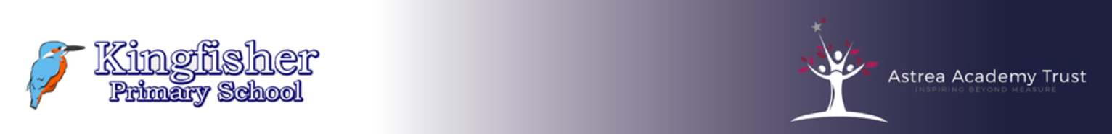

**Kingfisher Primary School**

**Science Policy**

***“The science of today is the technology of tomorrow” – Edward Teller***

**Rationale**

Science is an integral area of the curriculum through which we can develop the innate curiosity of children so that they can learn to make sense of the world around them. At Kingfisher, we aim to provide the opportunity for all children to develop scientific attitudes, skills and knowledge. We aim to do this by ensuring lessons are rooted in enquiry, with practical hands-on experiences, which embed references to the real world so that the pupils recognise science around them and how this is an integral part of today’s society.

**Intent:**

As a school we aim to:

* Teach science in a way that is engaging, education and relevant throughout the school
* Have pupils leaving primary school with the right knowledge and investigative schools for the secondary education
* Show pupils the relevance of science in their own lives and enable them to imagine future science-related careers
* Provide pupils with a strong understanding of the world around them, whilst helping them to think scientifically
* Build scientific enquiry skills into each topic and these are revisited and developed throughout their time at school.

**Implementation:**

We aim to ensure that all pupils are provided with:

* Provide opportunities to explore and understand the world we live in
* Develop pupils’ enthusiasm, and enjoyment of science
* Enable pupils to see the relevance of the subject in their own lives in order to imagine future science-related careers
* Create lessons so that they can be enjoyed by all pupils and are rooted in practical and hands-on experiences
* Ensure science is eagerly anticipated in a weekly session.
* Provide learning which is fun, engaging and exciting, whilst teaching the scientific concepts.

**Impact:**

We believe our pupils will:

* Acquire a love and enjoyment of science
* Follow a progressive Science curriculum that meets the needs of all pupils
* Develop their ability to think and act scientifically
* Have an appreciation of how science has developed over time
* Build curiosity about the world around them.

**Objectives**

* To provide stimulating, good quality science lessons and activities which are hands on and practical, where children can explore their real world.
* To focus on the development of scientific skills to aid investigations.
* To provide children with opportunities for critical reflection and to enable them to recognise and, where appropriate, to devise their own fair test.
* To provide opportunities for children to gain confidence in their application of appropriate scientific skills and vocabulary.
* To enable children to develop independence in the selection and use of scientific equipment and resources.
* To ensure that children use a wide variety of methods to record their findings, including the use of computing wherever appropriate. To involve science practitioners and outside providers in children’s learning wherever possible.

**Science-Policy into Practice**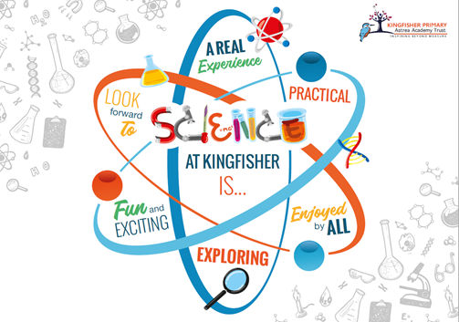

Science lessons and experiences are planned with reference to the ‘Knowledge & Understanding of the World’ strand of the Early Years Foundation Stage Curriculum (Nursery & Reception) and Key Stage 1 & 2 Programmes of Study.

Here at Kingfisher, there is a big focus on making science lessons as practical as possible, to allow the children to develop curiosity and enquiry-based thoughts linked to the world around them. This learning should provide computing opportunities where appropriate. Opportunities for Science to inform cross-curricular work will also be actively promoted through our new creative curriculum.

In their planning of practical activities, teachers should refer to the relevant safety guidance. Children should always be encouraged to consider safety when they plan and carry out their own investigations.

At Kingfisher, the Science curriculum is enriched in a number of ways including school visits, guest speakers/ theatre company involvement, annual Science Week events and extra-curricular activities. It is also greatly enlivened by experiences such as class cooking sessions and by our school environment itself with its wild garden area and mini- beast habitat.

**Equal Opportunities**

In line with the school’s Equal Opportunities Policy, we aim to ensure that all children are able to successfully access the Science curriculum at Kingfisher, irrespective of age, gender, race, cultural or religious background and ability. Science lessons will be differentiated appropriately to provide support for bilingual learners and those children with specific individual needs. Provision will also be made to ensure that more able pupils are appropriately challenged by means of open-ended investigations, appropriate questioning and extension activities.

**Assessment, Recording and Reporting**

We have developed a whole school approach to both Formative and Summative assessment.

Summative Assessment- will be carried out during each Science unit. Teachers will use a ‘Show me what you know’ activity at the end of each unit to highlight what the children have learnt at the end of each unit of learning.

Formative Assessment- During each science lesson, different formative assessment strategies will be used (e.g. show me, discussion, questioning)

Foundation Stage Assessment- Children will be assessed through continuous observation against the statements in the ‘Knowledge & Understanding of the World’ strand of the Early Years Foundation Stage curriculum.

**Resources**

The effective delivery of science will be made through appropriate and selective use of resources. A full inventory will be updated and attached to the policy annually.

**Monitoring and Evaluating the Curriculum**

Leaders measure the impact of the science curriculum through:

* Learning walks (how well the curriculum intent is imbedded)
* Book looks (as part of triangulation with learning walks and assessment)
* Pupil voice (enables us to listen to pupil’s voice about how well curriculum content is taught and understood)
* Extended pieces of writing (to demonstrate independent understanding and application of learning)
* Summative assessment and quizzes – show me what you know)
* Lesson observations and IRIS (to show how well children can articulate ideas)
* Last Lesson, Last Unit, Last Year retrieval activity to be used frequently to support retention of knowledge over the long term.