Personal, Social, Health and Economic Education (PSHE) policy

Kingfisher Primary

Date | April 2024
Written by | Catherine Skinn
Review Date | July 2025



Aims

The importance of personal, social, health, and economic education is to give pupils the knowledge, skills and understanding they need to lead confident, healthy, independent lives and to become informed, active, responsible citizens. Pupils are encouraged to take part in a wide range of activities and experiences across the curriculum, contributing fully to the life of their schools and communities. In doing so, they learn to recognise their own worth, work well with others and become increasingly responsible for their own learning. They reflect on their experiences and understand how they are developing personally and socially, tackling many of the spiritual, moral, social and cultural issues that are part of growing up. They also find out about the main political and social institutions that affect their lives and about their responsibilities, rights and duties as individuals and members of communities. They learn to understand and respect our common humanity; diversity and differences so that they can go on to form the effective, fulfilling relationships that are an essential part of life and learning.

Statutory requirements
PSHE is a non-statutory subject. However, there are aspects of it we are required to teach. We must teach Relationships Education (RE) Relationships and Sex education (RSE) and Health Education (HE) education under the Children and Social Work Act 2017, in line with the terms set out in statutory guidance. Sex Education is voluntary at Primary school level.
In RE (Relationship Education) we must cover:
- Families and people who care for me
- Caring friendships
- Respectful relationships
- Online relationships
- Being safe
In HE (Health Education) we must cover:
- Mental wellbeing
- Internet safety and harms
- Physical health and fitness
- Healthy eating
- Drugs, alcohol and tobacco
- Health and prevention
- Basic first aid
- Changing adolescent body

What we teach
To enable us to fulfil the new stator requirements, we have chosen a highly quality resource to support teachers in their delivery of PSHE. Here at Kingfisher we use the 1Decision scheme to cover the PSHE curriculum. This is alongside our Kingfisher curriculum where we include the important areas that our children at Kingfisher Primary need. 1Decion is a bank of video-based lessons, which provide distancing techniques to subtly approach topics to enable students to explore sensitive subjects in a safe and structured environment.
Each topic comes under the statutory guidance which include relationships, health and well-being and living in the wider world. Each of these areas will then be broken down into objectives for the children to work towards and achieve. It is stated we’re required to cover the content for relationships and sex education, and health education, please see RSE policy. All content covered for relationships, sex education and health education are set out with statutory guidance.
This guidance can be found at the following link:
https://assets.publishing.service.gov.uk/government/uploads/system/uploads/attachment_data/file/908013/Relationships_Education__Relationships_and_Sex_Education__RSE__and_Health_Education.pdf

See Appendix 1 to view the PSHE objectives that each year group will look at and obtain throughout the children’s time at Kingfisher Primary Academy.

How we teach it
The basis of our PSHE lessons will be through 1Decision. 1Decison provides video and lesson content, together with engaging activities which highlight students’ progression and gaps in their learning. The activities have an emphasis on active learning by including the children in discussions, investigations and problem-solving activities. Children will then record their findings and learning in their Floor books The floor books will be useful to track attainment and progression of the children. 1decison allows provides a ‘self-assessment’ for the children to assess their own learning. PSHE will happen once a week for a minimum of 20 minutes, however this is at the discretion of the teacher.

There are aspects of the PSHE curriculum which will be covered through cross curricular objectives. For example, healthy eating in Year 2 are objective that can be taught within Science using the scientific objectives. There is a big emphasis at ensuring we are not teaching the children the same thing twice, staff ensure that they are looking for cross curricular links where lessons can be taught effectively. Kingfisher Primary Academy has set up a safe-guarding curriculum that runs alongside PSHE, these will be delivered through assemblies. All teaching staff have been introduced to 1decions and shown how to navigate the scheme. Teaching staff are expected to implement the PSHE curriculum and provide adequate planning and resources for adults who may cover the class, however it is an expectation that teaching staff are the ones to be delivering PSHE. Resources that have been provided are a generic task that must be differentiated by the class teacher specifically for their class as and where needed. All teaching staff will remain impartial to the objectives being taught. Staff will not implement their own believes or views onto the children. The emphasis within a PSHE lesson is for the children to make informed decisions around the areas discussed. All PSHE work will be evident within the children’s workbooks. Work and photos should be shared on class blogs and the school twitter. PSHE should be evident within classrooms. This can be through work and photos with a small description of the lesson. This could be an individual display for PSHE or included on the curriculum walls. 1Decision resources should be evident of the PSHE displays. Staff will update the PSHE tracker to show each objective has been met. This should be completed on a regular basis.

Monitor and reviewing

The PSHE lead is responsible for monitoring that PSHE is being taught effectively throughout Kingfisher Primary Academy. This will be carried out through book looks, learning walks, environment walks, blog/twitter scrutiny, tracker checks and pupil voice. Through the 1 decision scheme a work booklet is provided for the children to complete during each session. This will follow the child through to the next year group, this will allow progression to be seen through monitoring and reviewing. It is the responsibility of all staff to ensure that PSHE is being taught effectively and consistently throughout the school. PSHE should be timetabled and delivered once a week for a minimum of 20 minutes.
The PSHE lead is responsible for updating the current plans to remain in line with statutory guidance. All staff are responsible for updating the curriculum plan in line with any amendments made to improve the curriculum overview. Any resources found that can improve the curriculum overview should be added to the resource bank to support others within school.

Links with other policies
See RSE policy for a full outline of the RSE aspect of the PSHE curriculum that Kingfisher Primary delivers.

Appendix 1
Year 1 – Year 3
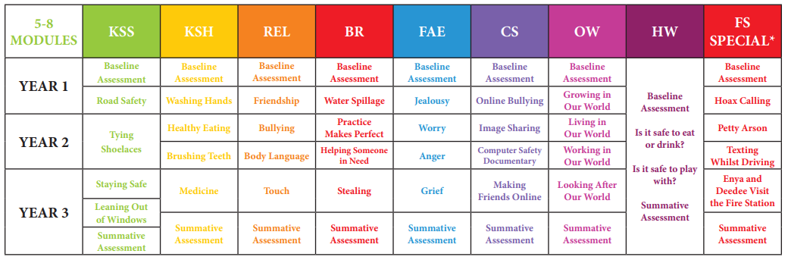

Year 4 – Year 6
