**EYFS & KS1 MFL Overview**

**\*EYFS non-compulsory exploration of ‘Let’s begin’. KS1 Topics to be selected from ‘Let’s explore’** **& identified on MTPs.**

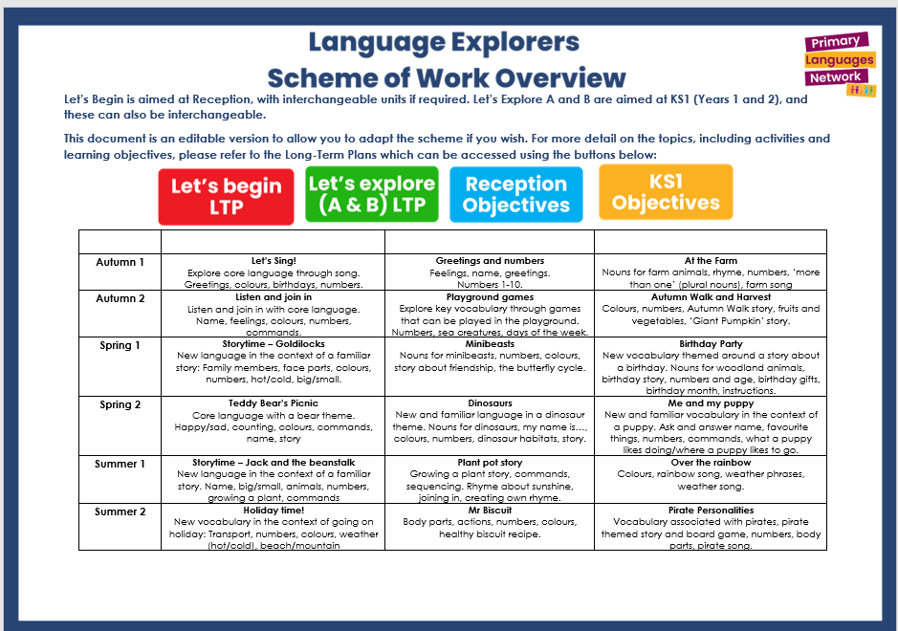

**KS2 MFL Overview**

|  |  |  |  |  |
| --- | --- | --- | --- | --- |
| **French KS2 Scheme of Work Overview**  **This overview shows the coverage of topics across the four stages of language learning in KS2.**  **For detailed information on each stage, refer to the Long-Term Plans linked below.** | | | | |
|  | **Years 3, 4, 5 & 6- 2023/2024**  **then each year subsequently**  **delivered to Year 3** | **Years 4, 5 & 6- 2024/2025 then each year subsequently delivered to Year 4** | **Years 5 & 6- 2025/2026 then each year subsequently delivered to Year 5** | **Year 6- 2026/2027** |
| **Half Term/ Stage** | **Stage 1**  [**LTP**](https://pln.myvle.co.uk/get.php?4L24272a26282525) | **Stage 2**  [**LTP**](https://pln.myvle.co.uk/get.php?4L24272a26282627) | **Stage 3**  [**LTP**](https://pln.myvle.co.uk/get.php?4L24272a26282a25) | **Stage 4**  [**LTP**](https://pln.myvle.co.uk/get.php?4L24272a26292X5) |
| **Autumn 1** | **A new start**  (Greetings, feelings, numbers, colours) | **Welcome to school**  (Recap core language, rooms in a school, classroom objects) | **Talking about us/school subjects**  (Extended feelings, recap personal information, introduce a friend, subjects and opinions) | **Revisiting me/Telling the time/Everyday life**  (Personal info recap, numbers to 60, time phrases, daily routine conversations) |
| **Autumn 2** | **Calendar and celebrations**  (Bonfire colours, commands, days and months, Christmas) | **My town, your town**  (Commands, shops, asking and giving directions) | **Time in the city**  (French city, buying a ticket, directions, descriptions, shopping, festive jumper) | **Homes and houses**  (Rooms in a house, furniture, describe rooms, spooky house story, game, elf on shelf) |
| **Spring 1** | **Animals I like and don’t like**  (Animal nouns, singular and plural, opinions, story) | **Family tree and faces**  (Epiphany, family members, personal info, face parts, describing with colours) | **Healthy eating, going to market**  (Fruit and veg nouns, class survey, prices, market dialogue, recipe) | **Playing and enjoying sport**  (Sport nouns, opinions, verb to play, sports descriptions) |
| **Spring 2** | **Carnival and using numbers**  (Carnival, numbers to 15, core language recap, age, dates, Easter) | **Face and body parts**  (Face and body parts nouns and commands, yoga with body parts, alien creation) | **Clothes**  (Clothes nouns, verb to wear, describe using adjectives, read descriptions, design and write) | **Funfair and favourites**  (Funfair rides, opinions, adjectives, plan and describe theme park, favourite things, tradition) |
| **Summer 1** | **Fruits and vegetables, Hungry Giant**  (Fruit and veg nouns, counting, asking politely, story, board game) | **Feeling unwell/Jungle animals**  (Aches and pains, doctor role play, animal nouns, adjectives, simple sentences, story) | **Out of this world**  (ID cards, personal info conversations, names of planets, adjectives, prior learning recall, planet creations) | **Café culture**  (Café culture in France, opinions, French breakfast, hotel breakfasts, café roleplay) |
| **Summer 2** | **Going on a picnic**  (Picnic story, food items, polite request)  **Aliens in France**  (Explore France, ask and answer ‘where do you live?’)  **Language Puzzle\*** | **The weather**  (Weather phrases, seasons, forecast)  **Ice creams**  (Flavours, opinions)  **Language Puzzle\*** | **Going to the seaside**  (Items for the beach, persuasive sentences, visiting the seaside, read and understand facts about the beach)  **Language Puzzle\*** | **Performance Time**  (Comedy sketch – What a waiter! Mocktails, scavenger hunt, Read all about it – Transition to KS3)  **Language Puzzle\*** |

