Geography Curriculum 2024

Vision Statement

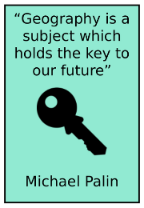

“The study of geography is about more than just memorising places on a map. It's about understanding the complexity of our world, appreciating the diversity of cultures that exists across continents. And in the end, it's about using all that knowledge to help bridge divides and bring people together.”

Barack Obama

Curriculum Intent

As a valued part of our curriculum, Geography is taught discretely. The curriculum is a knowledge rich curriculum focusing on learning substantive knowledge, combined with teaching and applying geographical skills into this context.

We aspire to make Geography learning memorable and to inspire a curiosity about the world we live in. Alongside other subjects of the wider curriculum, our aim at Kingfisher is to support children into becoming curious and considerate global citizens, who will pose questions and seek answers as they explore their immediate locality, as well as the wider world. The curriculum is designed to allow children to deepen their knowledge about Earth’s places, people and resources as well as natural and human environments.

Geography at Kingfisher has been defined in three ways; for Key Stage One, Lower Key Stage Two and for Upper Key Stage Two. This allows pupils to articulate themselves confidently when speaking about the subject.

**KS1:** Geography is learning about different places in our world.

**LKS2:** Geography is learning about places in the world and the relationships between people and their environments.

**UKS2:** Geography is the study of the Earth’s physical properties and how they are affected by human activity.

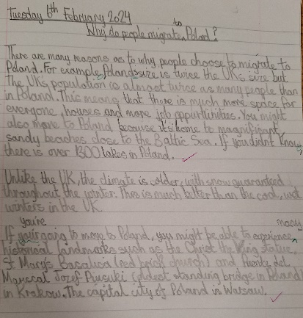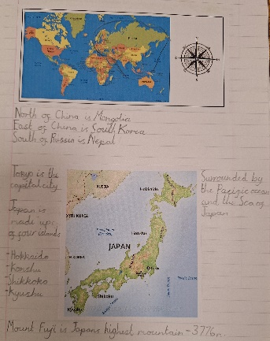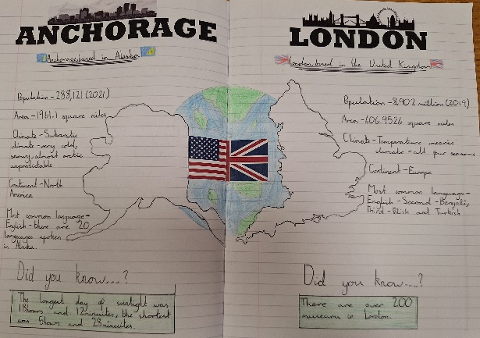

Geography in EYFS

Geography teaching and learning starts in FS1 where they follow the EYFS framework. In the Early Years Foundation Stage, children follow seven areas of learning including Understanding of the World. Within this, children learn about similarities and differences in relation to places. They talk about the features of their own immediate environment and how environments might vary from one another. They make observations, explain why some things occur and talk about changes.

|  |  |  |  |
| --- | --- | --- | --- |
| Geography | | | |
| FS1 | Mathematics | | * Understand position through words alone. For example, “The bag is under the table”, with no pointing. * Describe a familiar route. * Discuss routes and locations, using words like “in front of” and “behind.” |
| Understanding the World | | * Explore natural materials, indoors and outside. * Explore and respond to different natural phenomena in their setting and on trips. * Talk about what they see, using a wide vocabulary * Use all of their senses in hands-on exploration of natural materials. * Begin to understand the need to respect and care for the natural environment and all living things. * Know that there are different countries in the world and talk about the differences they have experienced or seen in photos. |
| FS2 | Understanding the World | | * Draw information from a simple map. * Recognise some similarities and differences between life in this country and life in other countries. * Explore the natural world around them. * Describe what they see, hear and feel when outside. * Recognise some environments that are different to the one in which they live. |
| ELG | Understanding the World | People, Culture and Communities | * Describe their immediate environment using knowledge from observation, discussion, stories, non-fiction texts and maps. * Explain some similarities and differences between life in this country and life in other countries, drawing on knowledge from stories, non-fiction texts and – when appropriate – maps. |
| The Natural World | * Know some similarities and differences between the natural world around them and contrasting environments, drawing on their experiences and what has been read in class. * Understand some important processes and changes in the natural world around them, including the seasons and changing states of matter. |

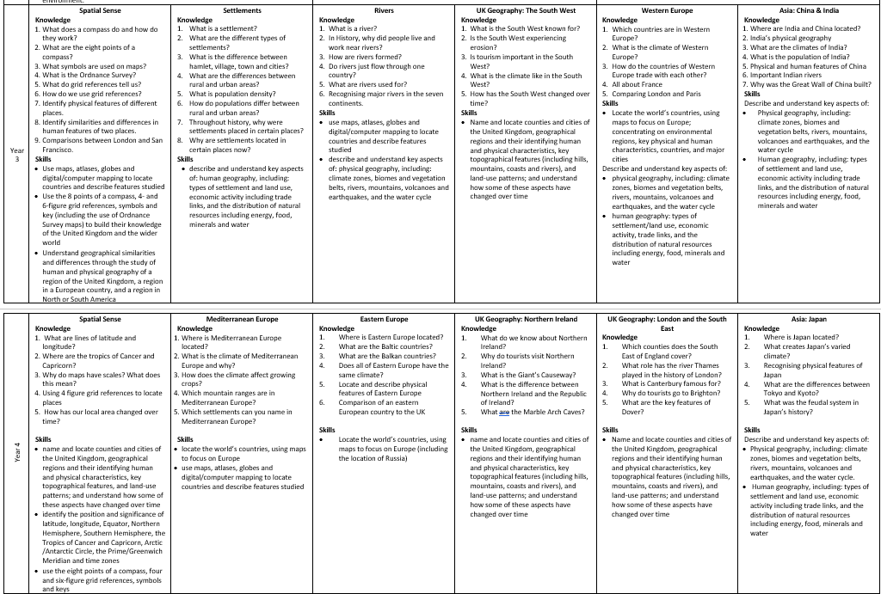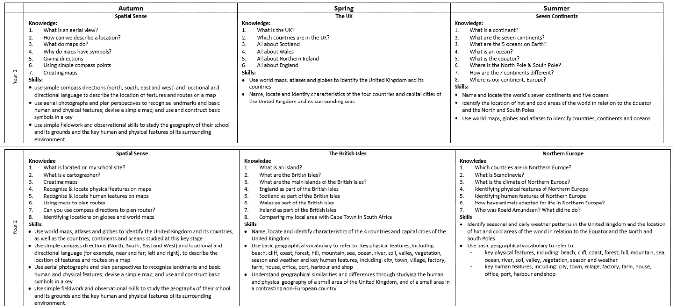 The Geography curriculum at Kingfisher is taken directly from the PKC (Primary Knowledge Curriculum), with the adaptation of local area study units which we feel beneficial to our pupils based upon our local area and other key knowledge and geographical skills which will allow them to be better connected to the world around them.

Geography Curriculum Overview

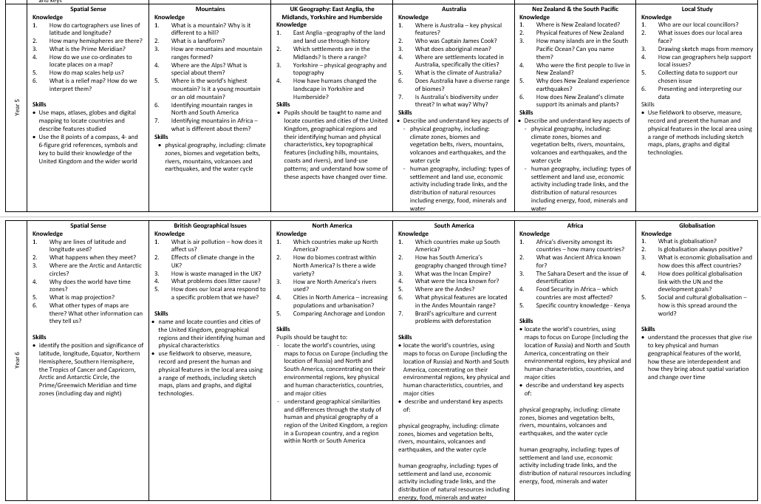

Assessment of Geography

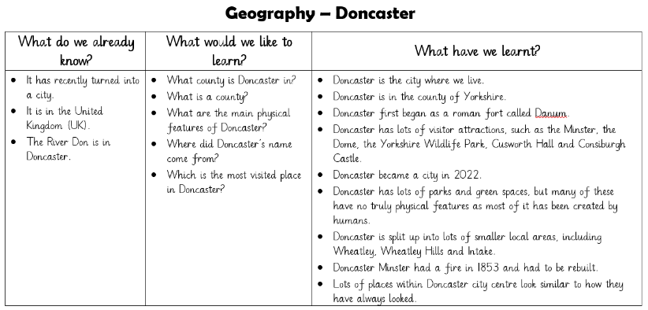As with all other aspects of the wider curriculum, Geography is assessed through constant formative assessment, retrieving previously taught knowledge and using geographical skills in different contexts and making links between prior learning and the current teaching.

When beginning a unit of learning, pupils collaboratively complete a ‘KWL grid’ which identifies any prior knowledge of the geography unit, as well as recognising pupils’ interest and natural curiosity by asking them what they would like to know by the end of the unit. This is then incorporated into the learning for the unit and displayed within the classroom for pupils to refer to.

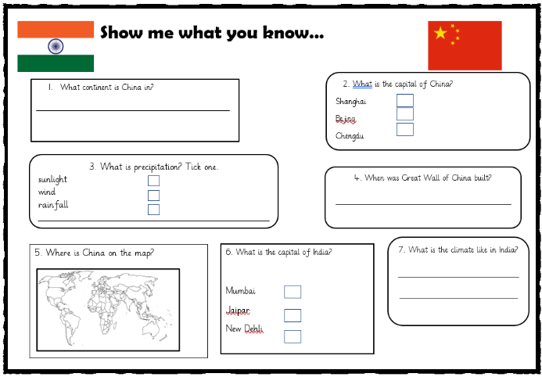

After each unit of learning, pupils take part in a, ‘Show Me What You Know’ activity which gives them the opportunity to demonstrate their learning. They will also complete the KWL grid by articulating knowledge that they have learnt through their geography sessions.

Pupil Voice

We know that if children are becoming knowledgeable geographers, that they will be able to articulate their understanding with confidence. Pupil voice is a vital tool in assessing whether children have made progress and can retain knowledge.

“I love the beach because you can build sandcastles and play in the sea!” – Y2 pupil

“I think living in a rural area would be more boring because there is less there.” – Y3 pupil

“The food from the Mediterranean was delicious!” – Y4 pupil

“I didn’t know Japan was made up of islands, I just thought it was a normal country.” – Y4 pupil

“It’s good for Doncaster to be a city because we can make it even better.” - Y5 pupil

“I didn’t realise there were so many cities in Yorkshire.” – Y5 pupil

“I loved learning about North America because I really want to go there one day.” – Y6 pupil