**[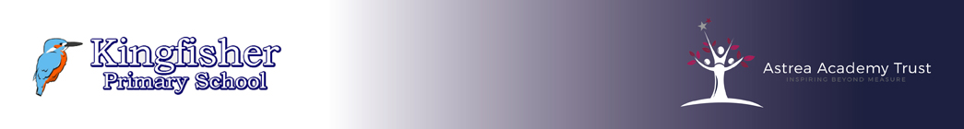](https://www.astrea-kingfisher.org/)**

**Rationale**

The development of an effective literacy skillset is fundamental to the achievement of a rich and fulfilling life. We use these skills every day in order to communicate with, and make sense of the world around us. As such, the better we are at these skills the more successful we can expect to be in life. At Kingfisher, we recognise that improving literacy and learning will have an impact on students’ self-esteem, motivation, behaviour and attainment. It allows them to learn independently and is empowering.

Kingfisher’s curriculum is underpinned by developing students’ abilities to speak, listen, read and write for a wide range of purposes, including using language to learn, communicate, think, explore and organise. Helping students to express themselves clearly, through development of vocabulary, both orally and in writing, enhances and enriches teaching and learning in all subjects and prepares the students for life after school.

At Kingfisher Primary, we want to foster a lifelong love of reading by exposing our children to rich and exciting texts across the entire curriculum. We believe reading opens up a new world for children, allowing them to explore new places, meet new people and gain a clearer and more in-depth understanding of the world around them.

Reading is a key life skill and we strive to embed a culture of reading into the core of what we do. Providing opportunities for children to read both independently and aloud as well as allowing them the chance to discuss and recommend books they have read to their peers. Reading and quality literature is implicitly interwoven into our curriculum through the use of key texts to expose our children to various genres and famous authors and to enhance the variety of exciting topics that we teach.

**English Provision at Kingfisher Primary**

The teaching of English is based on the Statutory Frameworks for the Early Years Foundation Stage and the National Curriculum for England’s Programmes of Study for Years 1-6.

Our sole focus for the teaching of English is to enable our learners to passionately see the purpose of everything they do within the subject. We aim for our pupils to use language powerfully and to think critically about what they are doing and why. We have implemented a Global Citizenship approach to our curriculum, which English feeds into. This has enabled our learners to develop empathy, respect, self-expression and curiosity about the world around them and to empower them to see the impact which they can have, through their use of verbal and written English.