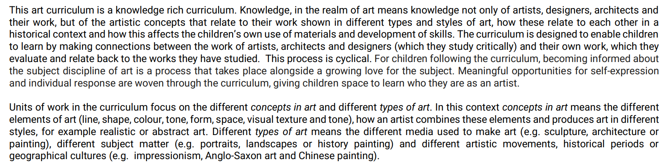

The overall scheme of the curriculum provides a gradual progression in terms of skills (split into, painting, drawing, 3D forms, collage, textiles, print making and mixed media) introducing the children to as diverse a range of materials as possible.