Art Curriculum 2023

Vision Statement

*“The future belongs to young people with an education and an imagination to create”*

*Barack Obama*

Curriculum Intent

At Kingfisher Primary, we aim to offer opportunities for children to:

* Experience a broad and balanced coverage of art within the Kingfisher Curriculum that reflects the National Curriculum.
* Foster an understanding and enjoyment of art, craft and design and provide opportunities for studying contemporary, modern and traditional art.
* Encourage pupils to be innovative, creative and express their thoughts in a variety of ways.
* Have equal opportunities for them to communicate, display and perform their skills and abilities.
* Raise their self-esteem, self-worth and enthusiasm for the arts.

Art at Kingfisher is taught in a number of ways. This allows children to express themselves in a way which is unique to them.

The Foundation Stage

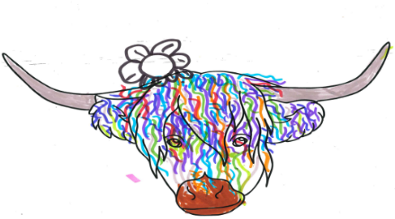The Expressive Arts and Design in the Foundation Stage curriculum ensures the children have a broad coverage of the different aspects of the arts. Opportunities for creative arts flows through all areas of learning and development. Foundation Stage teachers plan and deliver high quality learning opportunities for art using the Early Years Curriculum. There is an emphasis on independence and child-initiated learning, which enables foundation stage children to freely explore resources and pursue their own creative interests and talents in addition to the planned learning experiences.

Key Stage 1 and 2

Staff follow a progression of skills document to support the planning and delivery of art lessons (relating to their current theme). This allows teachers to develop skills by building on what has previously been taught.

Our planning includes:

* A range of different skills using a selection of art mediums.
* Opportunities to study a breadth of artists and designers to help support children’s understanding of the different styles of art.
* Moments to be self-reflective by evaluating their own work, ideas and methods.
* Children seeing their work as being valued, celebrated and displayed around school.

Recording

Each child has their Art sketchbook which follows them through school. This provides a record of the child’s learning and progress in art as part of their art portfolio. Sketchbooks should show the learning journey from the start to the final piece of work which encompasses the skills that have been taught.

Differentiation

The teaching of art needs to consider the varied abilities, attitudes and individual needs of the children. Art lessons can be differentiated by outcome however, if a skill or activity is deemed inappropriate for a child or group of children, alternatives will be planned which best suit their needs.

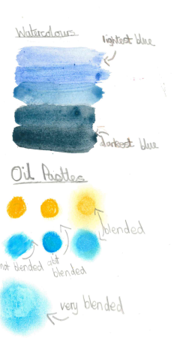 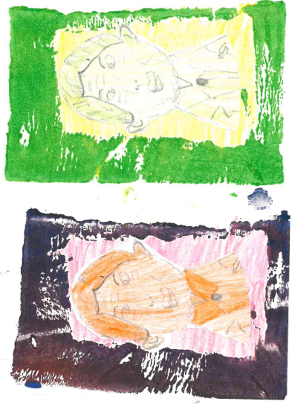

Art in EYFS

Art teaching and learning starts in FS1 where they follow the EYFS framework. In the Early Years Foundation Stage, children follow seven areas of learning including Expressive arts and design. Within this, children will explore different materials and textures, explore colours and colour mixing, experiment with different tools to help develop their fine motor skills and share their creations with others explaining the processes they have done.

|  |  |  |
| --- | --- | --- |
| **Art** | | |
| FS1 | Physical Development | * Use large-muscle movements to wave flags and streamers,   paint and make marks.   * Choose the right resources to carry out their own plan. * Use one-handed tools and equipment, for example, making snips in paper with scissors. * Use a comfortable grip with good control when holding pens and pencils. |
| Expressive Arts and Design | * Explore different materials freely, in order to develop their ideas about how to use them and what to make. * Develop their own ideas and then decide which materials to use to express them. * Join different materials and explore different textures. * Create closed shapes with continuous lines, and begin to use these shapes to represent objects. * Draw with increasing complexity and detail, such as representing a face with a circle and including details. * Use drawing to represent ideas like movement or loud noises. * Show different emotions in their drawings and paintings, like happiness, sadness, fear, etc. * Explore colour and colour mixing. |
| Reception  FS2 | Physical Development | * Develop their small motor skills so that they can use a range of   tools competently, safely and confidently.   * Use their core muscle strength to achieve a good posture   when sitting at a table or sitting on the floor.   * Develop overall body-strength, balance, coordination and agility. |
| Expressive Arts and Design | * Explore, use and refine a variety of artistic effects to express   their ideas and feelings.   * Return to and build on their previous learning, refining ideas   and developing their ability to represent them.   * Create collaboratively, sharing ideas, resources and skills. |

|  |  |  |  |
| --- | --- | --- | --- |
| ELG | Physical Development | Fine  Motor Skills | * Hold a pencil effectively in preparation for fluent writing - using   the tripod grip in almost all cases.   * Use a range of small tools, including scissors, paintbrushes and cutlery. * Begin to show accuracy and care when drawing. |
| Expressive  Arts and Design | Creating  with Materials | * Safely use and explore a variety of materials, tools and techniques, experimenting with colour, design, texture, form and function. * Share their creations, explaining the process they have used. |

Art Curriculum Overview

|  |  |  |  |
| --- | --- | --- | --- |
| **Year** | **AUTUMN TERM** | **SPRING TERM** | **SUMMER TERM** |
| 1 | **RECYCLING**  **Artist: Kandinsky**  **Skills:** collage, weaving   * Creating a piece of artwork in the style of Kandinsky using recycled materials (bottle tops, paper, etc) * Using plastic bags for weaving (class project) | **FARMING**  **Artist: Steven Brown**  **Skills:** Drawing, colour mixing, thickness of brushes, printing   * Printing repeated patterns using objects * Drawing and painting a farm animal in the style of the highland cow | **HABITATS**  **Skills:** Clay techniques   * Tree rubbing * Practising creating textures using clay tiles * Creating a minibeast hotel out of clay to be used in the outside areas (painted and protected) |
| 2 | **WORLD HUNGER**  **Artist: Guiseppe Arcimboldo**  **Skills:** arranging materials,sculpture   * Creating artwork in the style of the chosen artist, not using food in order not to add to food waste – using alternative natural resources. * Using artist’s style to include sculpture objectives (rolled paper, straws, clay) | **HEROES THROUGH TIME**  **Artist: Frida Kahlo**  **Skills:** colour mixing, adding black and white paint, drawing, dip dye + plaiting   * Creating a self portrait of ourselves as heroes (Frida only became an artist after an almost fatal accident) mixing drawing techniques with painting skills. * Plaiting and dip dye skills to link with her as an individual and the vibrant colours she used | **WEATHER PATTERNS**  **Skills:** experiencing chalk, printing using objects   * Creating extreme weather with chalk on black paper, combined with or separate to printing to show extreme weather |
| 3 | **POLLUTION**  **Skills:** textiles, sculpture, painting   * Creating a collaborative clay coral reef * Painting an underwater scene for the coral to sit in (shoebox?) * Class weaving project – underwater art linking to pollution | **HOMELESSNESS**  **Artist: Richard Hutchins**  **Skills:** drawing, using different mediums   * Community project: Art Auction * Creating portraits of famous people based on Richard Hutchins | **FAIRTRADE**  **Skills:** printing, collage   * Printing the Fairtrade logo using polystyrene printing blocks * Creating a collaged sign using Fairtrade logos to create the letters for the Fairtrade Bake Off (DT project) |
| 4 | **BEING A CONSUMER**  **Artist: Andy Warhol**  **Skills:** print, collage   * Creating prints in the mass production style of Andy Warhol of consumer products * Collage in the pop art style of Andy Warhol using product packaging | **POVERTY**  **Skills:** sculpture  Handmade toys by the World’s most resilient children   * Exploring the items made - creating toys using clay that children could use | **SUSTAINABLE ENERGY**  **Artist: Pete McKee**  **Skills:** drawing, painting   * Recreating an image from Pete McKee of a landscape with renewable energy. * Creating two sets of lungs, one filled with sketching of factories, power stations and pollution (charcoal smudging) and one filled with sketching of the ‘future’ – wind turbines etc |
| 5 | **DONCASTER**  **Artist: Nomad Clan**  **Skills**: drawing, oil pastels, sculpture  create a landmark   * Exploring the mural in Doncaster; recreating using sketching and oil pastels to show perspective * Choosing a landmark in Doncaster to recreate in sculpture (creating a city for display) | **MIGRATION**  **Artist: Jacob Lawrence**  **Skills**: painting, collage   * Exploring Lawrence’s work around migration * Painting identical sections (people) to create a tessellation collage to create an image showing migration in the style of Jacob Lawrence | **MEDICINE AND MEDICAL RESEARCH**  **Artist: Banksy (animal testing and celebration of NHS artwork)**  **Skills**: drawing, printing   * Exploring his work around animal testing and the NHS before creating an original piece combining drawing skills and printing |
| 6 | **WAR**  **Skills**: collage (mixed media), printing, drawing   * Sketching of the famous war poster “Your country needs you” – children to create and print their own slogan onto their artwork * Mixed media collage – black and white photography of their hands holding a colourful collaged representation of peace/hope, such as the red poppy, the blue remembrance flower of Europe, a dove, an olive branch, the peace symbol etc | **GLOBAL WARMING**  **Artist: Daniel Mackie**  **Skills**: drawing   * Exploring Mackie’s animal artwork and how he shows each animal, usually with larger features, such as their tail or feet * Sketching the outline of their chosen animal; inside their sketching should represent both the memory of their past habitat and then what that habitat looks like now, due to the effects of global warming | **REFUGEES**  **Skill:** sculpture,textiles  Collaborative project to create animations based on “Ali and the Long Journey”.   * Creating models of refugees out of clay, along with any props required within the animation. * Creating items of clothing or props with materials to support the animation. |

Assessment of Art

As with all other aspects of the wider curriculum, Art is assessed through constant formative assessment, retrieving previously taught skills and using them in different contexts

When beginning a unit of learning, pupils collaboratively complete a ‘KWL grid’ which identifies any prior knowledge of the art unit, as well as recognising pupils’ interest and natural curiosity by asking them what they would like to know by the end of the unit. This is then incorporated into the learning for the unit and displayed within the classroom for pupils to refer to.

After each unit of learning, pupils take part in a, ‘Show Me What You Know’ activity which gives them the opportunity to demonstrate their learning. They will also complete the KWL grid by articulating knowledge that they have learnt through their art sessions.

Pupil Voice

“I enjoyed using oil pastels to make the circles like Kandinsky” - Y1 pupil

“I liked using blue paint and making it go from dark blue to light blue to make a city picture – Y2 pupil

“I leant how to make sculptures from clay, we had to use certain tools and skills.” – Y3 pupil

“I loved using the foam and paint to make a print of the Fair-Trade symbol.” – Y3 pupil

“We’ve been learning about the artist Pete McKee. We’ve drawn pictures like he does which are very creative but he uses very simple details.” – Y4 pupil

“I was really proud of my tessellation pattern.” Y5 pupil

“I worked really hard to create a watercolour shade that matched the colours on the painting.” Y5 pupil

“I found it difficult to mould the clay using one piece into a body shape.” Y6 pupil

“It was quite difficult to get the modelling clay to support its own weight in order to stand up.” Y6 pupil